

THE SECOND SUNDAY AFTER THE EPIPHANY

January 18, 2026, 10:30am

Conflated Matins & Communion (BCP)

Epiphany Theme: “JESUS - REVEALED FOR THE WORLD”

Today’s Subtheme: “The Lamb Who Sees Us”

Website: www.sthildasanglicanchurch.com
Church Email: info@sthildasanglicanchurch.com
Facebook: St. Hilda’s Fairbank Anglican Church

Incumbent: Rev. Canon Kenute Francis (437-488-9657)

kenute@sthildasanglicanchurch.com

Honorary Assistant: Rev. Canon Leonard Abbah

Organist: William “Bill” Khan
Crucifer: Kishmar Miller

Eucharistic Ministers: Ianthe, William, & Errol

1st Reading: Annette Weekes

2nd Reading: Jerry Watts

Gospel: Ianthe Alleyne

Intercession: Richard Morris

Tech Team: Temia Maharaj

Ushers Team 1: Jean Caine Christine Fleming

Eflreda Garriques Marcia Lee

Neville Lowe Beverley Beckford

Dion Robertson Hildred Small

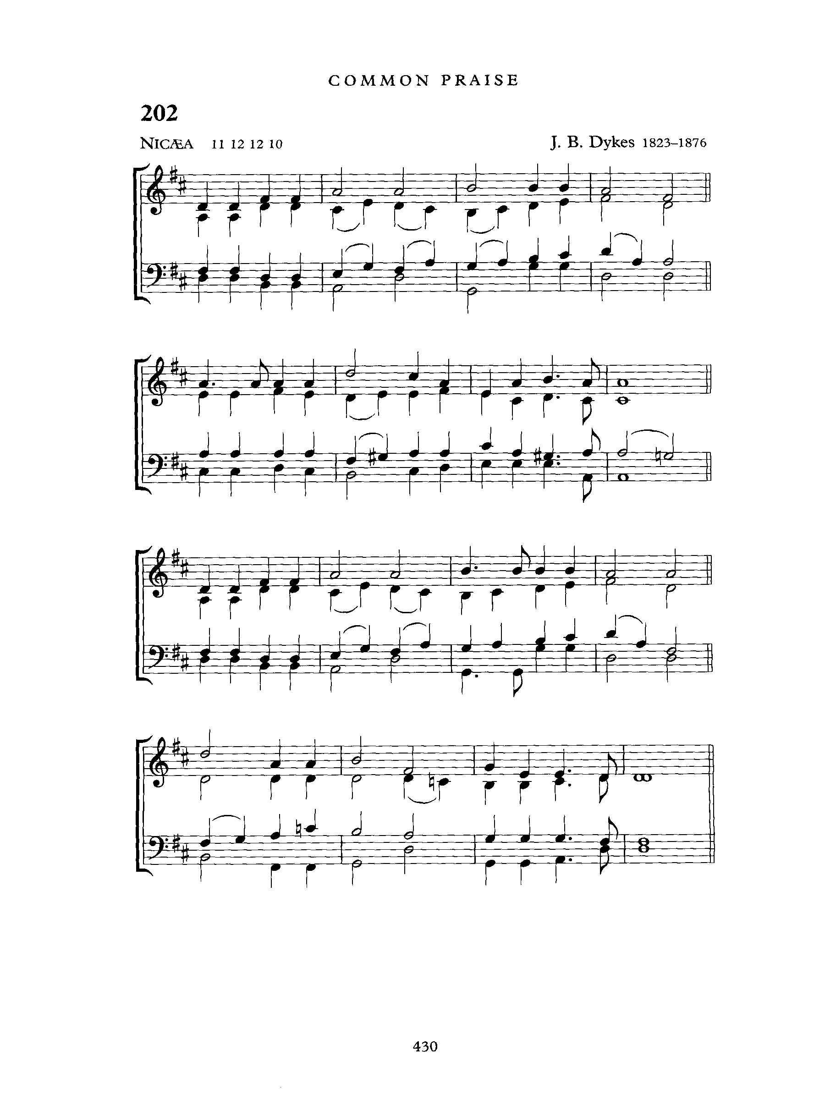

The Order of Service

PRELUDE: Holy, Holy, Holy (NICAEA)

OPENING PRAYER:

God of light and grace, you invite us to come and see.
Meet us in this worship, abide with us in your presence,
and shape us as disciples of Jesus Christ, the Lamb of God.
Amen.

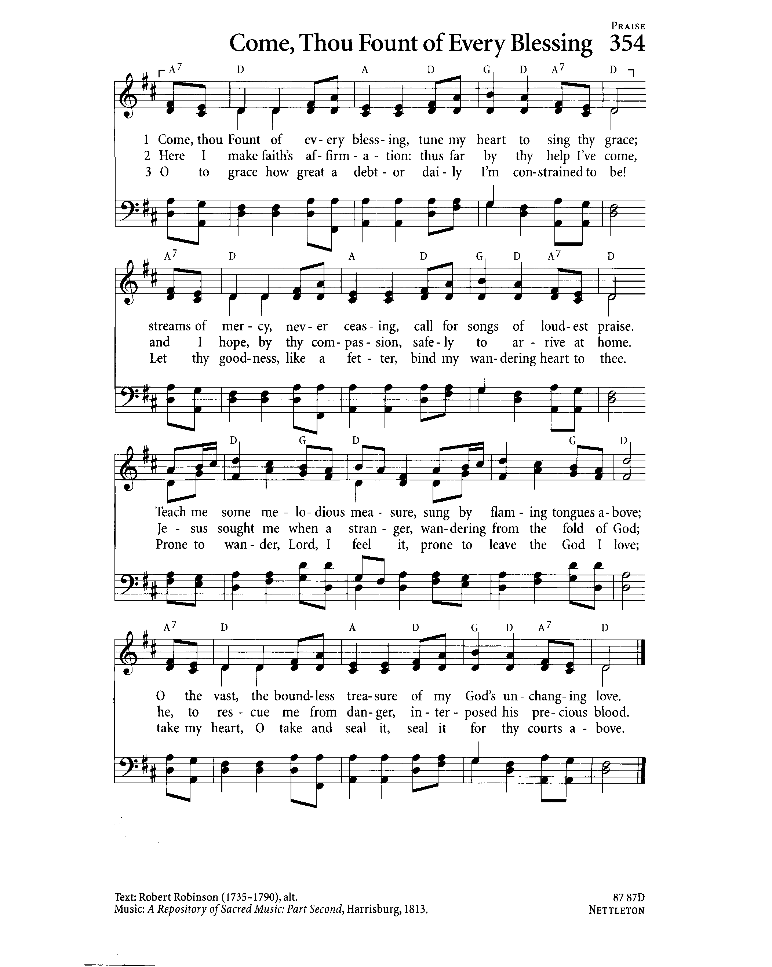
PROCESSIONAL: Come Thou Font of Every Blessing
Words: Robert Robinson; Tune: NETTLETON

Come, thou Fount of every blessing;
Tune my heart to sing thy grace;
Streams of mercy, never ceasing,
Call for songs of loudest praise.
Teach me some melodious sonnet,
Sung by flaming tongues above;
Praise the mount! I’m fixed upon it,
Mount of Thy redeeming love!

Here I raise my Ebenezer;
Hither by Thy help I’ve come;
And I hope, by Thy good pleasure,
Safely to arrive at home.
Jesus sought me when a stranger,
Wandering from the fold of God;
He, to rescue me from danger,
Interposed His precious blood.

Oh, to grace how great a debtor
Daily I'm constrained to be!
Let thy grace, Lord, like a fetter,
Bind my wand'ring heart to Thee:
Prone to wander, Lord, I feel it,
Prone to leave the God I love.
Here's my heart, Lord, take and seal it,
Seal it for Thy courts above.

WELCOME: Canon Kenute

OPENING SENTENCES: Errol Parris ODT

Behold, the Lamb of God,
who takes away the sin of the world.

This is the One John pointed toward.
We come seeking truth, grace, and new life.

We are invited to “Come and see”.
“We are here to Worship Him who was born for us.”

THE CONFESSION: Errol Parris ODT

Let us humbly confess our sin to Almighty God
Almighty and most merciful Father,
we have erred and strayed from thy ways like lost sheep,
we have followed too much the devices and desires of our own hearts.
We have offended against thy holy laws.
We have left undone those things which we ought to have done,
and we have done those things which we ought not to have done;
and there is no health in us.
But thou, O Lord, have mercy upon us, miserable offenders.
Spare thou them, O God, which confess their faults.
Restore thou them that are penitent;
according to thy promises declared unto mankind in Christ Jesu our Lord.
And grant, O most merciful Father, for his sake,
that we may hereafter live a godly, righteous, and sober life,
to the glory of thy holy name. Amen.

THE ABSOLUTION: (Kenute Francis)

Almighty God,
have mercy upon you, pardon and deliver you from all your sins,
confirm and strengthen you in all goodness,
and keep you in eternal life;
through Jesus Christ our Lord.
Amen.

Children’s Talk:

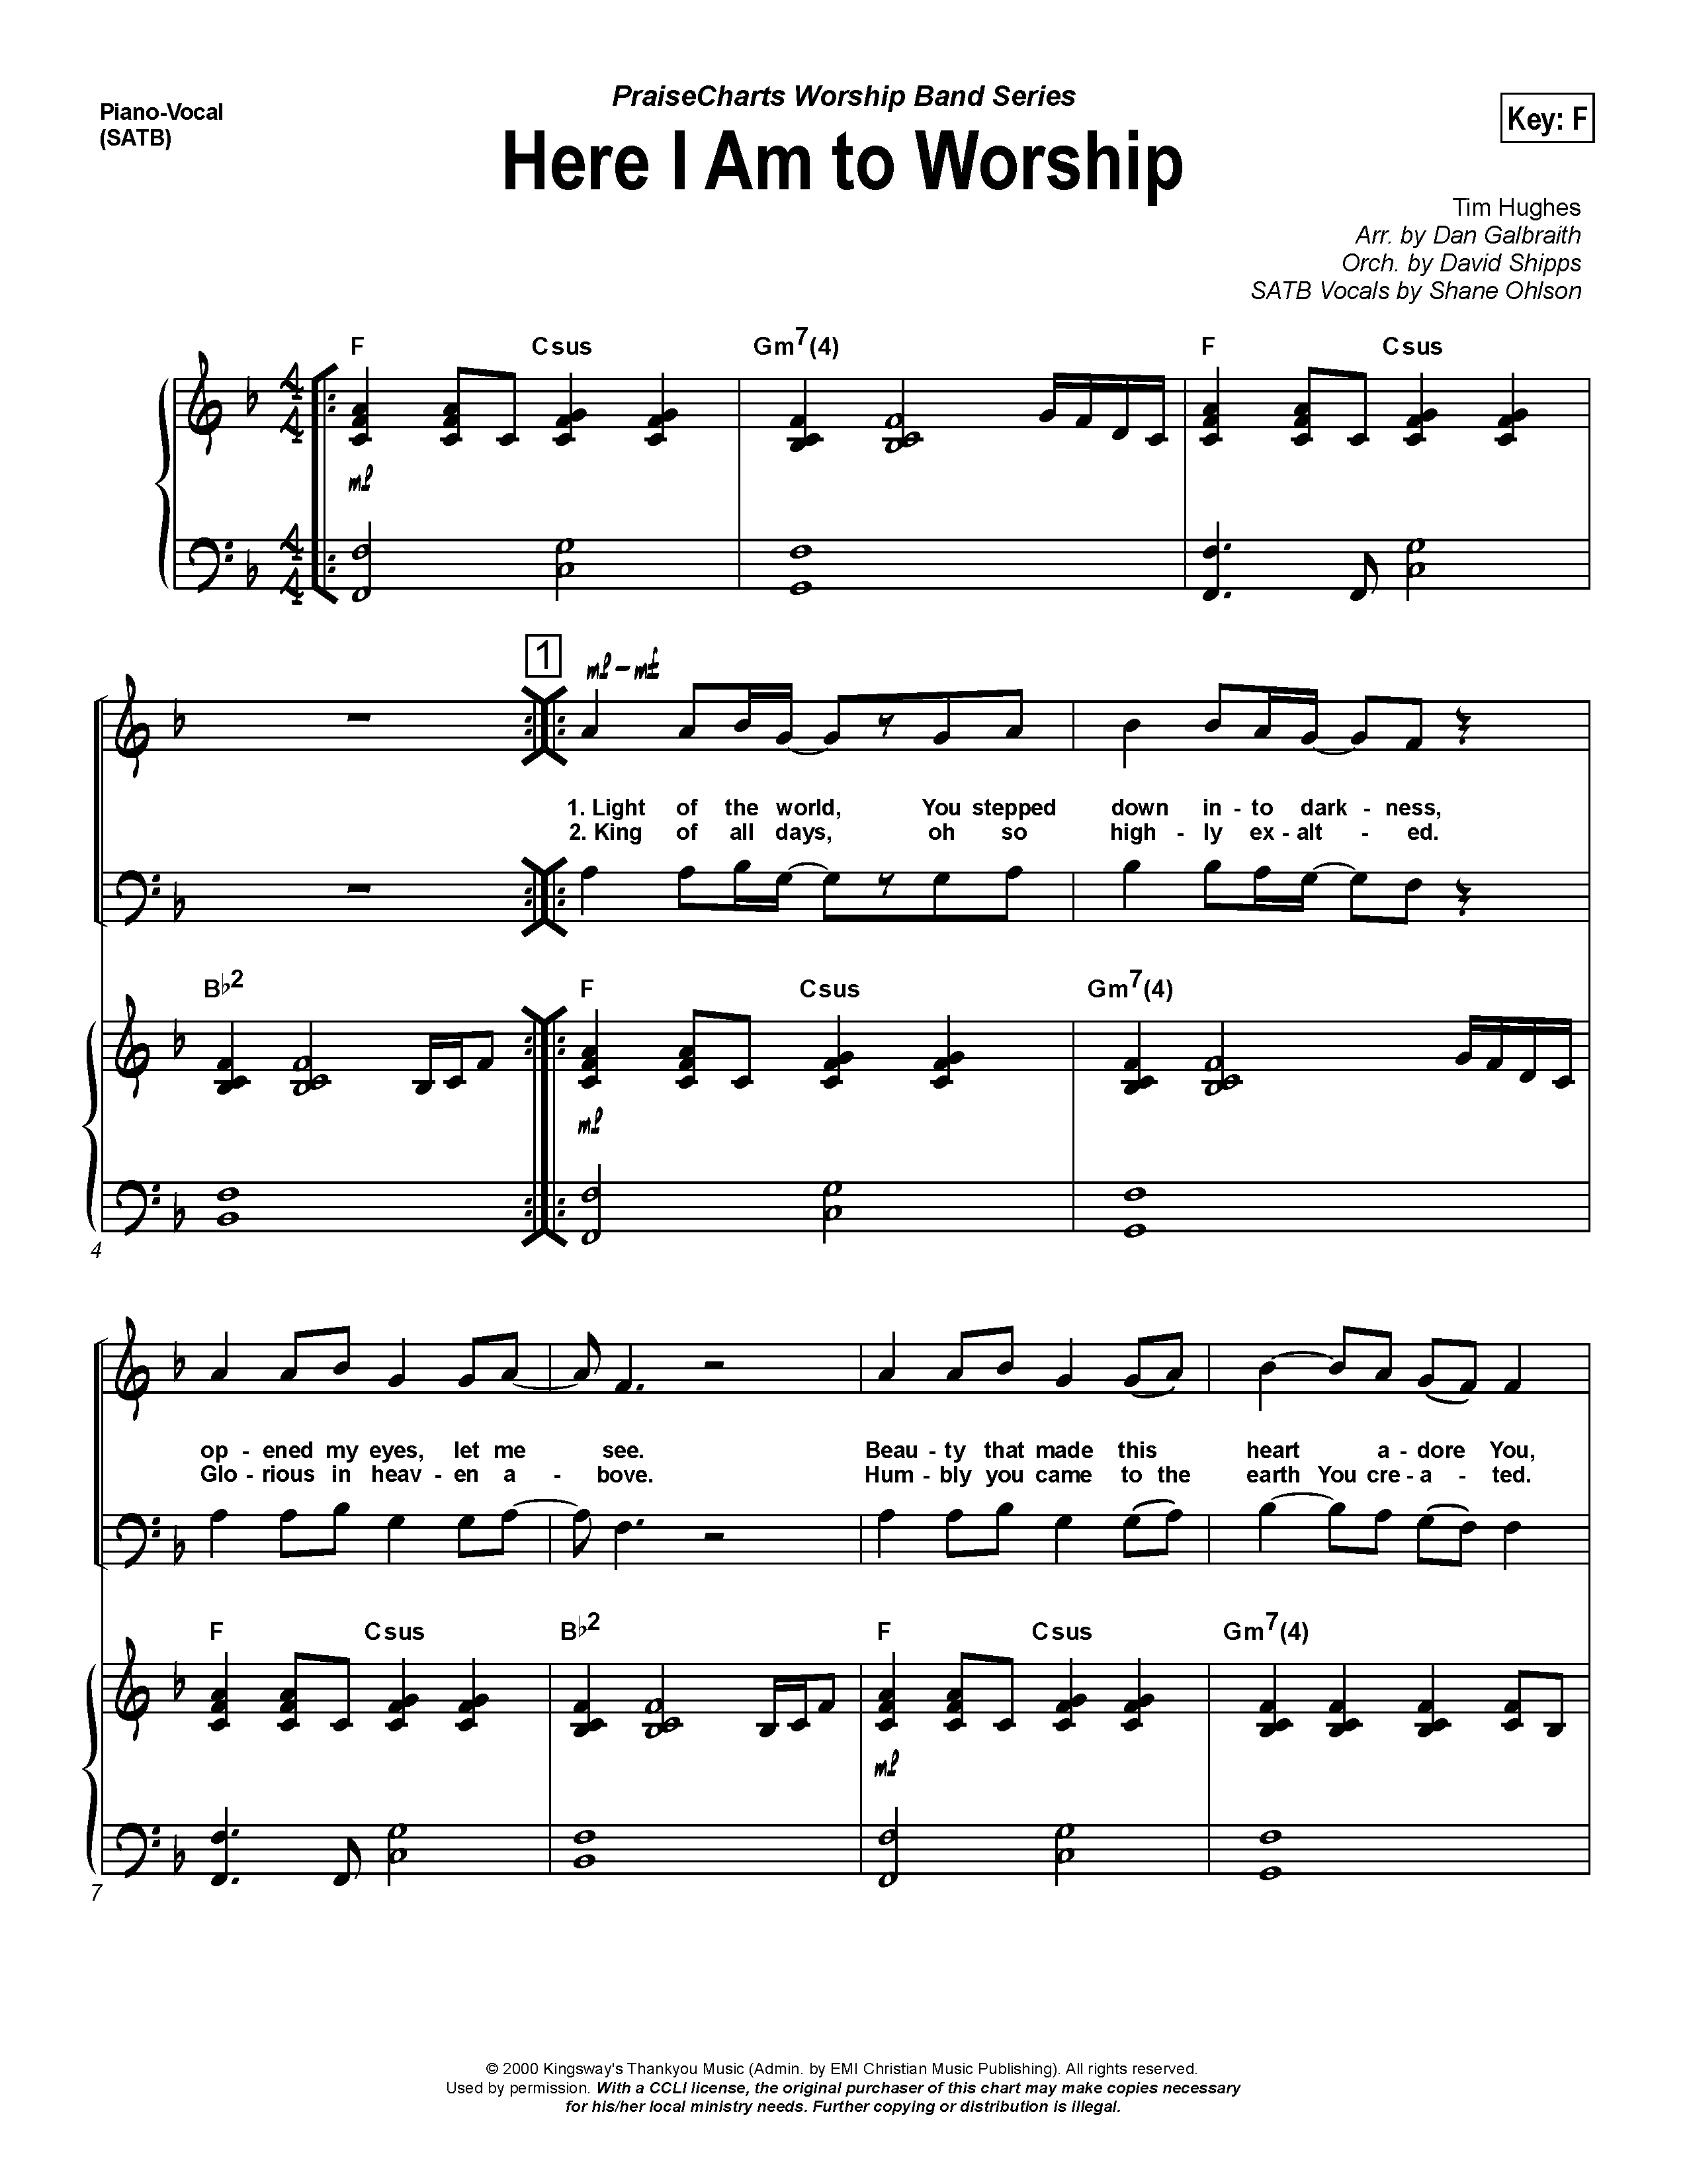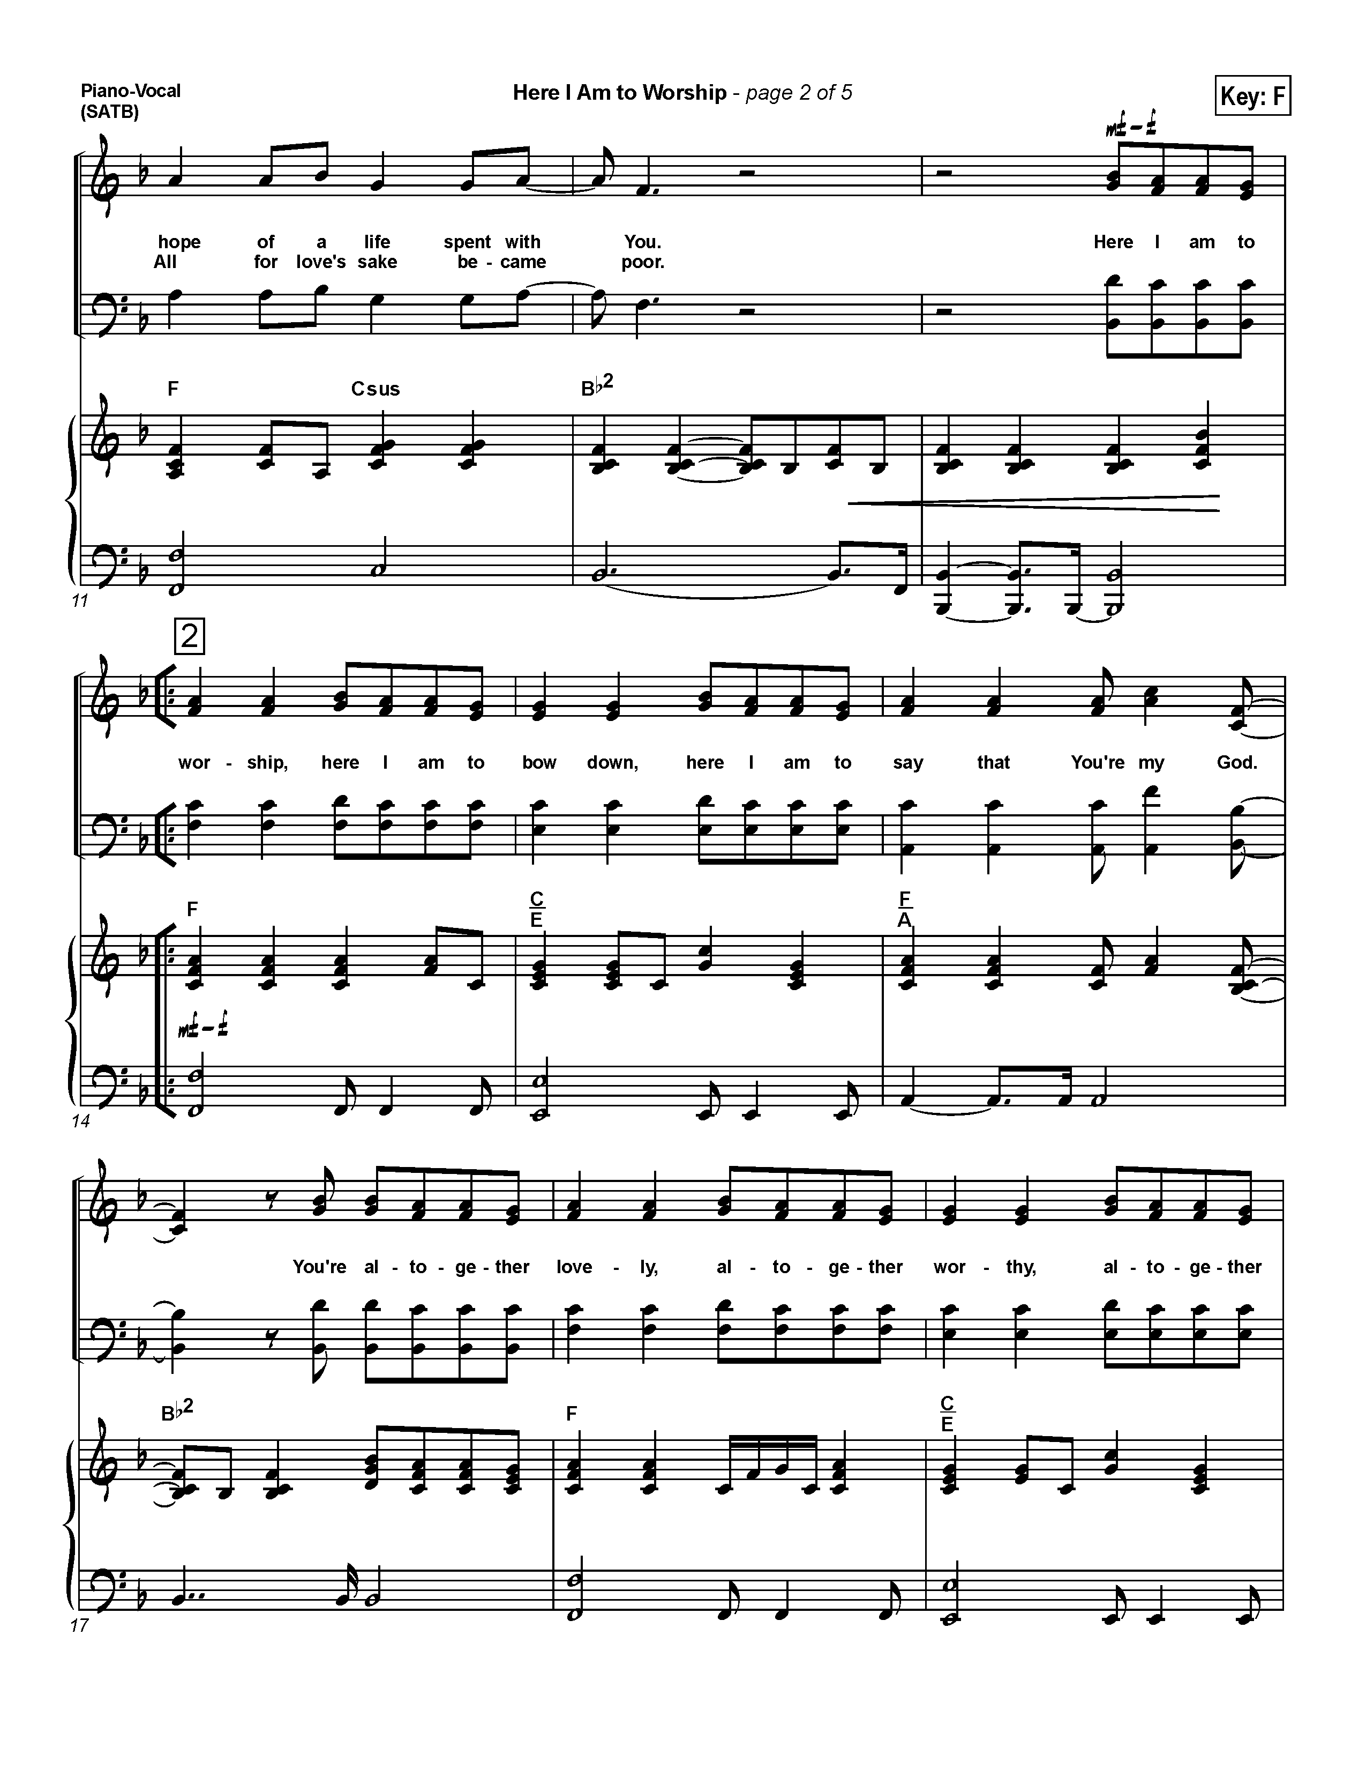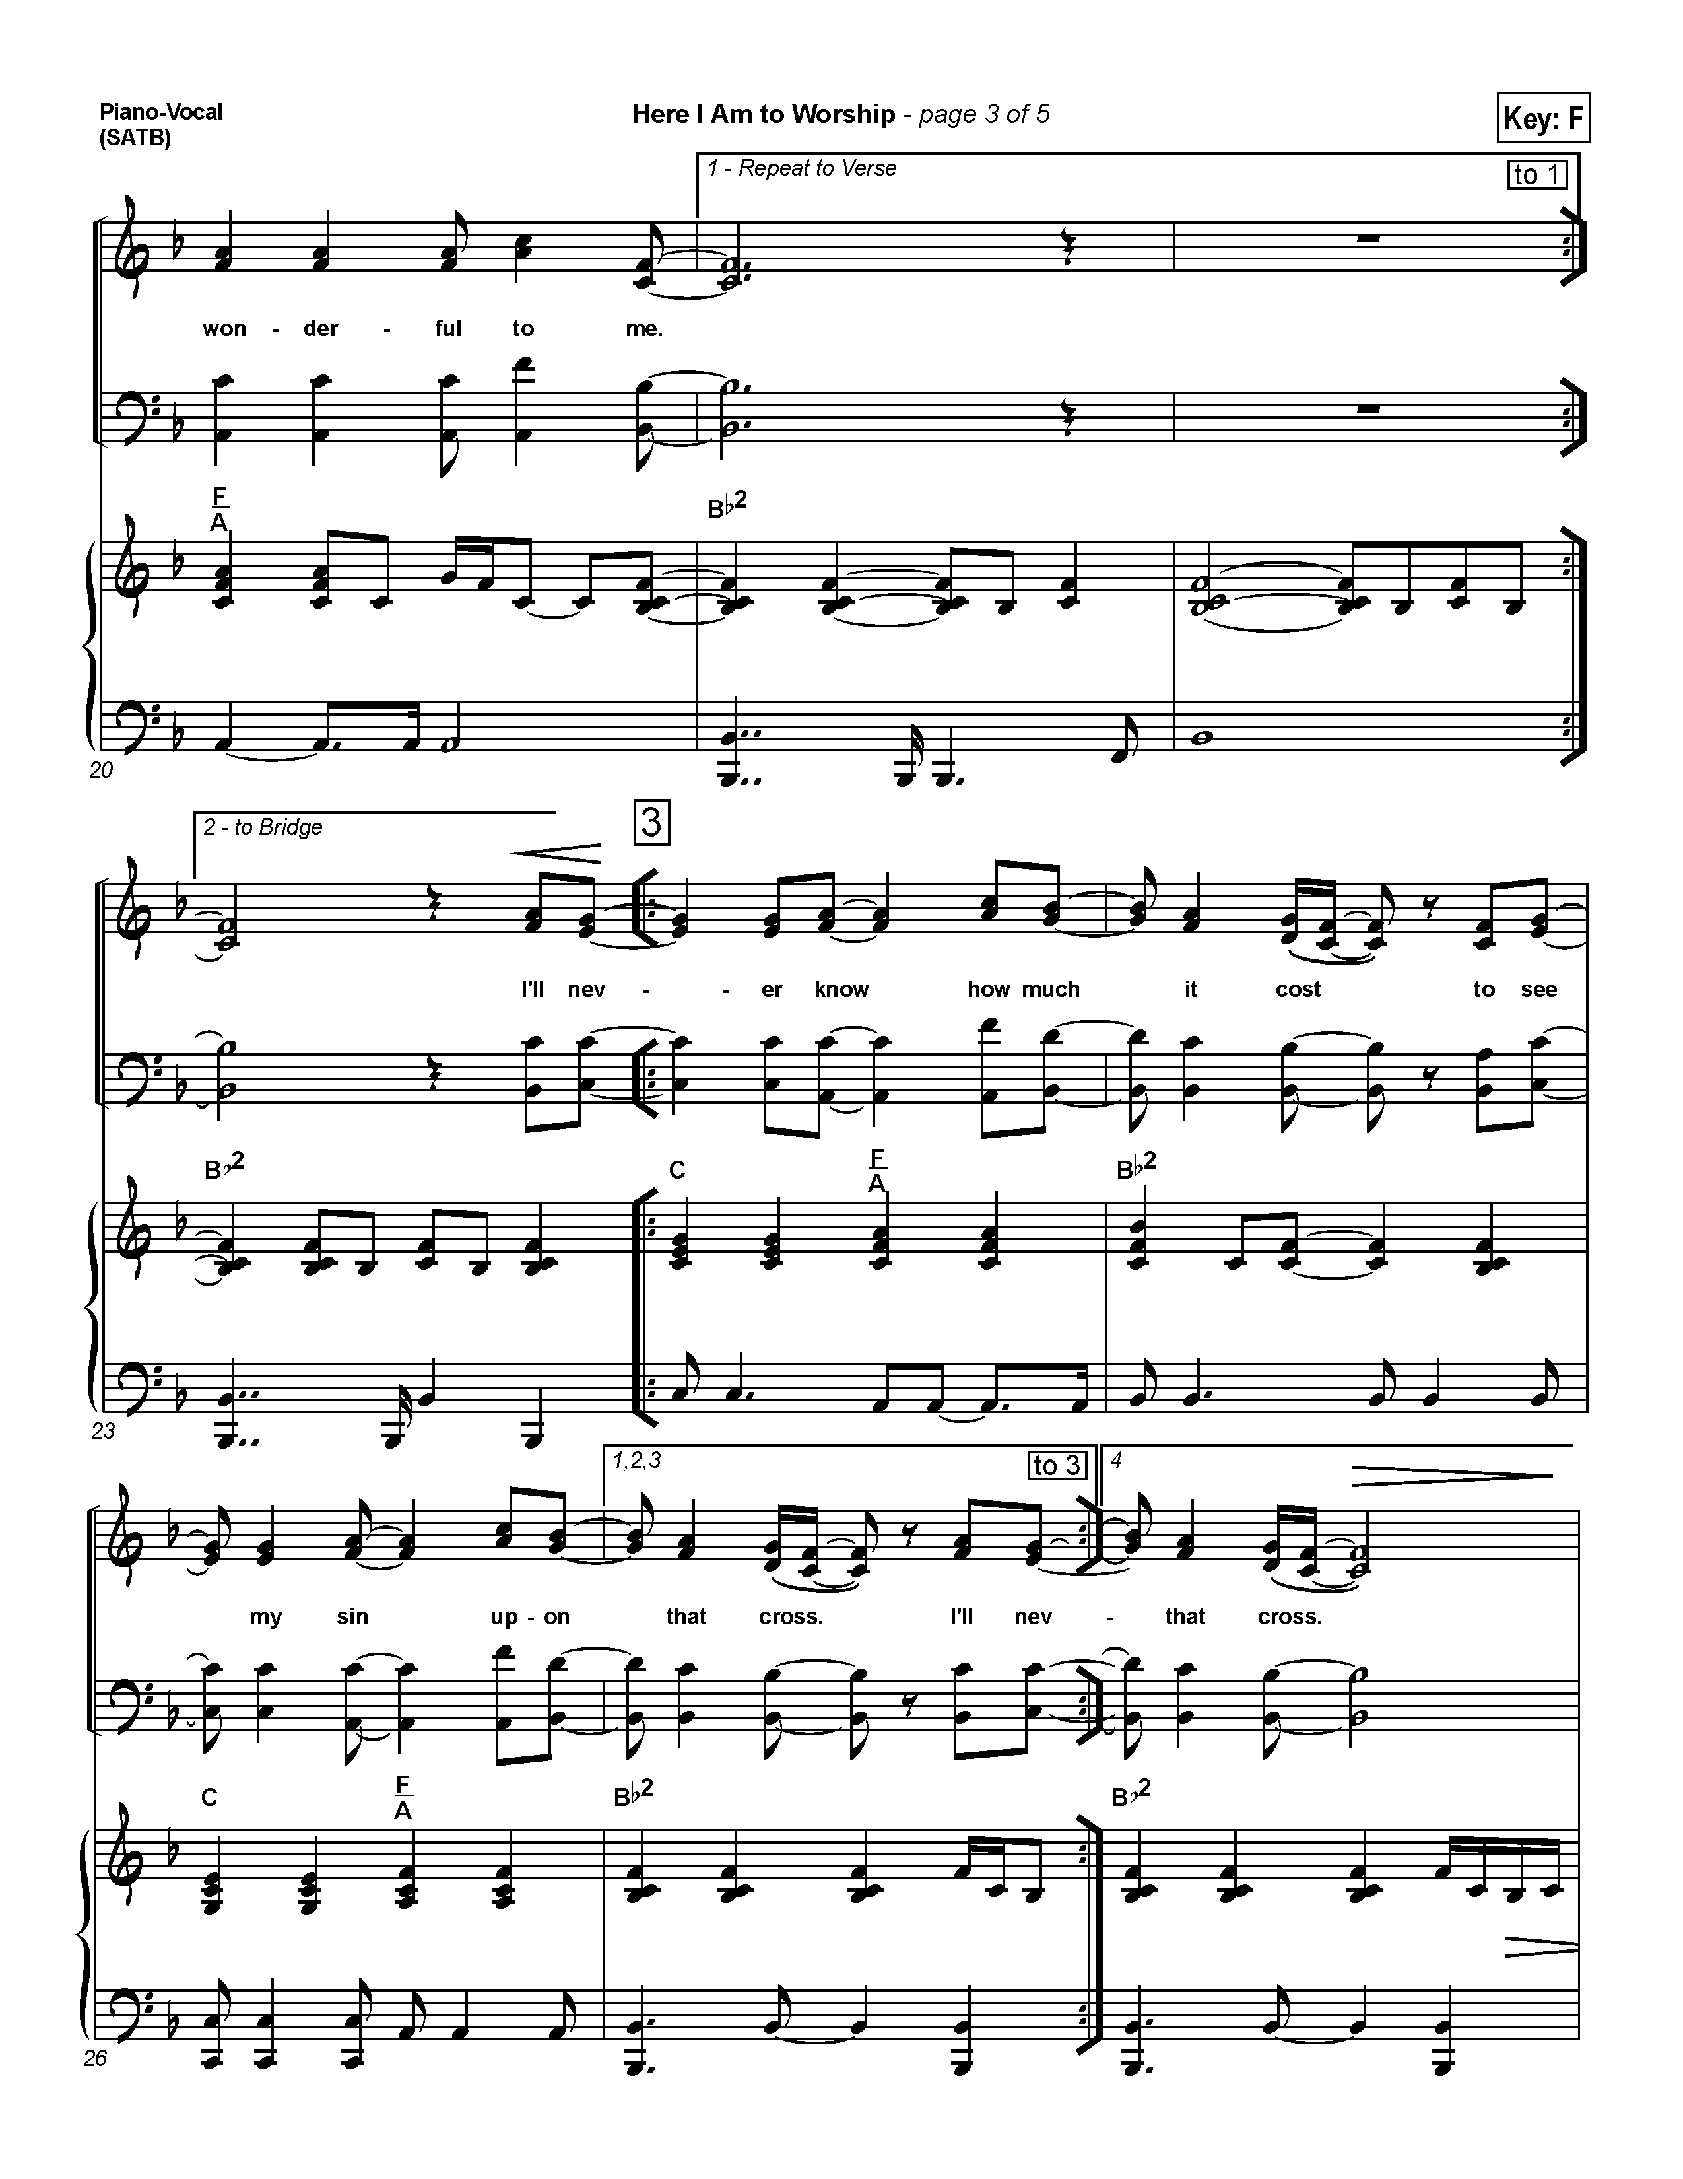
INTROIT: Here I Am to Worship
Hillsong Worship

Light of the world
You stepped down into darkness
Opened my eyes, let me see
Beauty that made this heart adore You
Hope of a life spent with You

(refrain)
Here I am to worship
Here I am to bow down
Here I am to say that You're my God
You're altogether lovely
Altogether worthy
Altogether wonderful to me

King of all days
Oh, so highly exalted
Glorious in heaven above
Humbly You came to the earth You created
All for love's sake became poor. (refrain)

VERSICLES: (Errol Parris ODT)

O Lord, open thou our lips;
And our mouth shall show forth thy praise.

O God, make speed to save us;
O Lord, make haste to help us.

Glory be to the Father, and to the Son, and to the Holy Ghost;
As it was in the beginning, is now, and ever shall be, world without end. Amen.

Praise ye the Lord;
The Lord’s Name be praised.

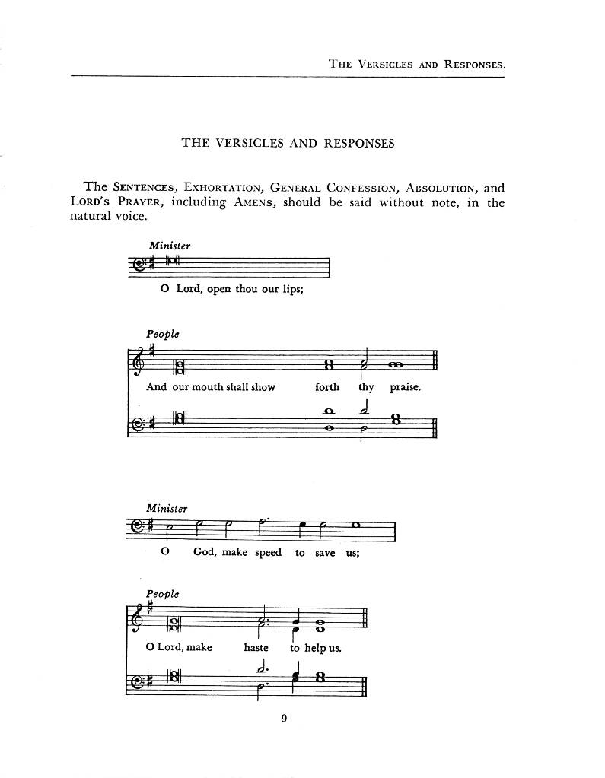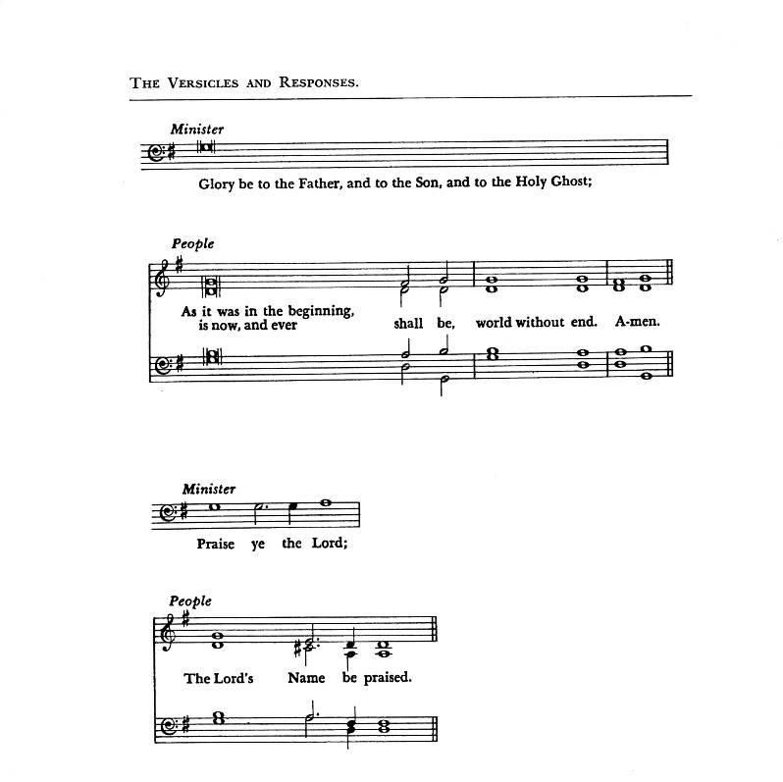
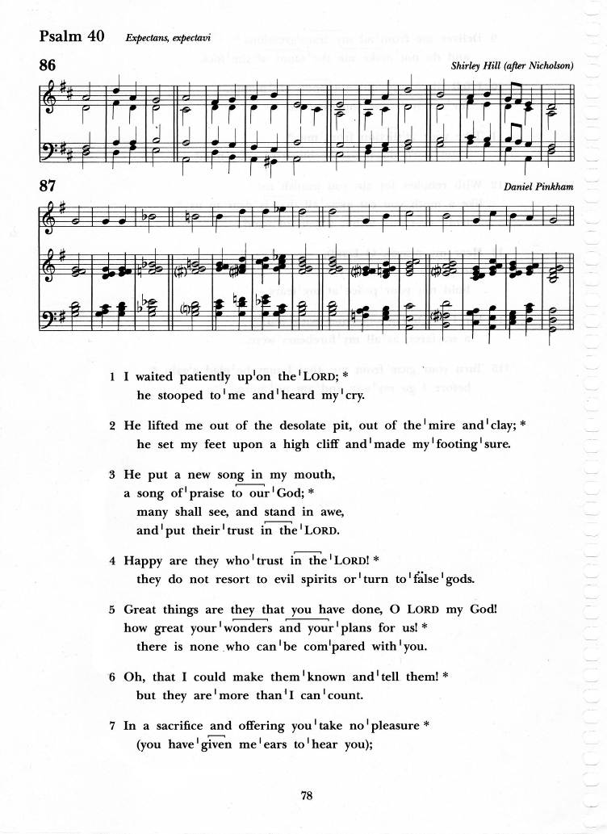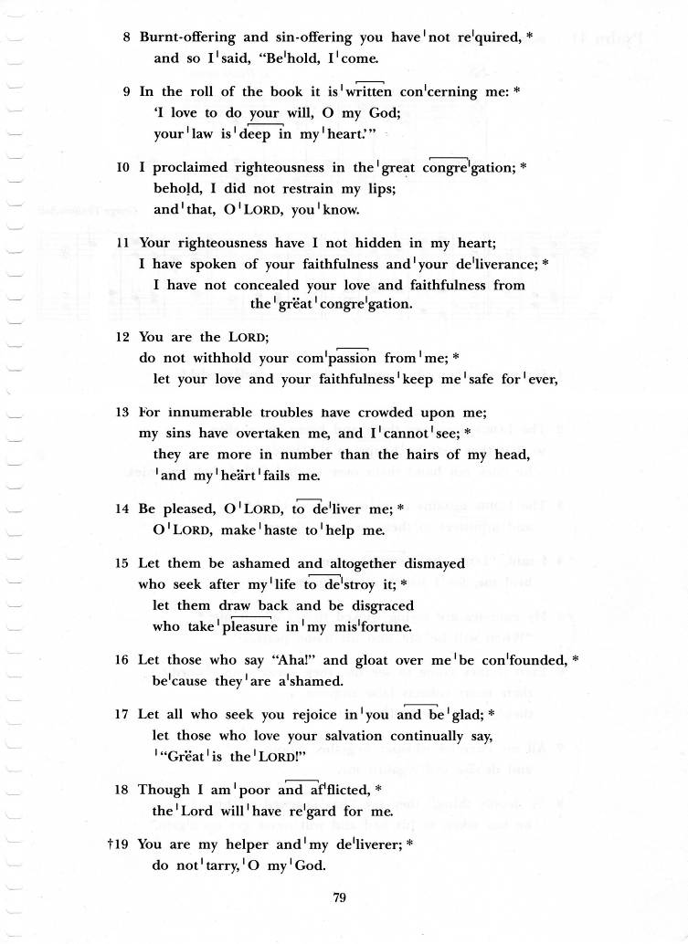
Psalm 40:1-11 (chanted)

I waited patiently upon the Lord; he stooped to me and heard my cry.
He lifted me out of the desolate pit, out of the mire and clay;
he set my feet upon a high cliff and made my footing sure.

He put a new song in my mouth, a song of praise to our God;
many shall see, and stand in awe, and put their trust in the Lord.
Happy are they who trust in the Lord!
they do not resort to evil spirits or turn to false gods.

Great things are they that you have done, O Lord my God! how great your wonders and your plans for us! there is none who can be compared with you.
Oh, that I could make them known and tell them!
but they are more than I can count.

In sacrifice and offering you take no pleasure
you have given me ears to hear you;
Burnt-offering and sin-offering you have not required,
and so I said, “Behold, I come.

In the roll of the book it is written concerning me:
‘I love to do your will, O my God; your law is deep in my heart.’”
I proclaimed righteousness in the great congregation;
behold, I did not restrain my lips; and that, O Lord, you know.

Your righteousness have I not hidden in my heart;
I have spoken of your faithfulness and your deliverance;
I have not concealed your love and faithfulness from the great congregation.
Glory to the Father, and to the Son, and to the Holy Spirit:
As it was in the beginning, is now, and will be for ever. Amen.

THE FIRST READING: Isaiah 49:1-7 (Annette Weekes)

A reading from the Book of the Prophet Isaiah

Listen to me, O coastlands, pay attention, you peoples from far away! The Lord called me before I was born, while I was in my mother’s womb he named me.
He made my mouth like a sharp sword, in the shadow of his hand he hid me;
he made me a polished arrow, in his quiver he hid me away.
And he said to me, “You are my servant, Israel, in whom I will be glorified.”
But I said, “I have labored in vain, I have spent my strength for nothing and vanity; yet surely my cause is with the Lord, and my reward with my God.” And now the Lord says, who formed me in the womb to be his servant, to bring Jacob back to him, and that Israel might be gathered to him, for I am honored in the sight of the Lord, and my God has become my strength— he says, “It is too light a thing that you should be my servant to raise up the tribes of Jacob and to restore the survivors of Israel; I will give you as a light to the nations, that my salvation may reach to the end of the earth.”
Thus says the Lord, the Redeemer of Israel and his Holy One, to one deeply despised, abhorred by the nations, the slave of rulers, “Kings shall see and stand up, princes, and they shall prostrate themselves, because of the Lord,
who is faithful, the Holy One of Israel, who has chosen you.”

The Word of the Lord
Thanks be to God

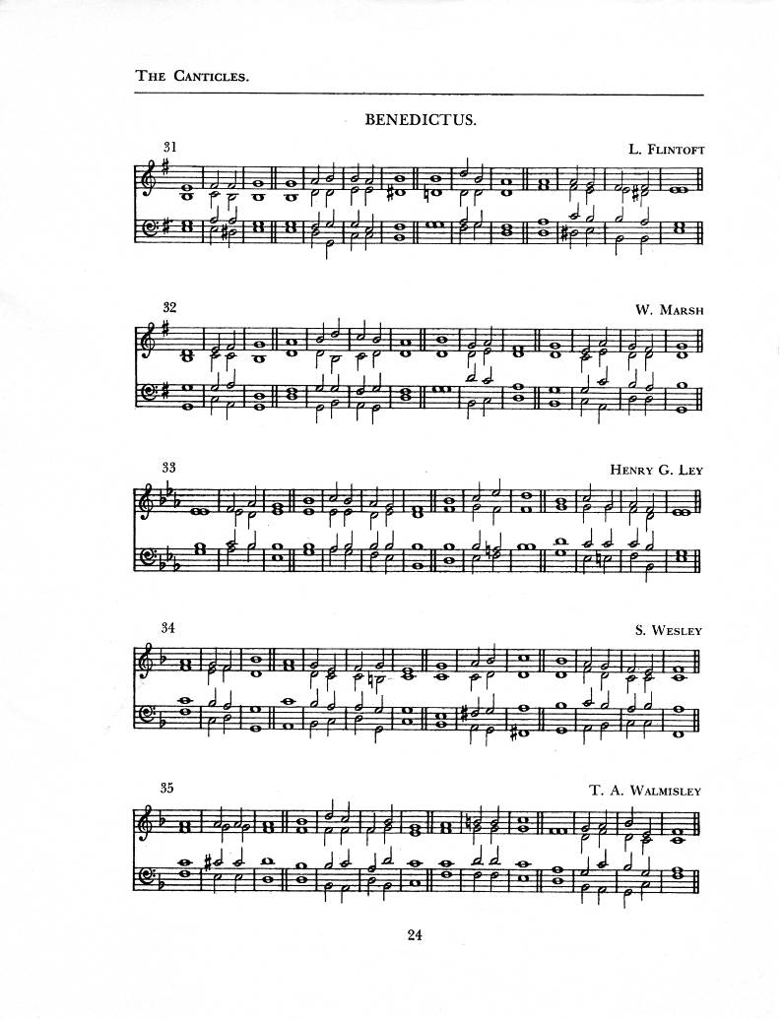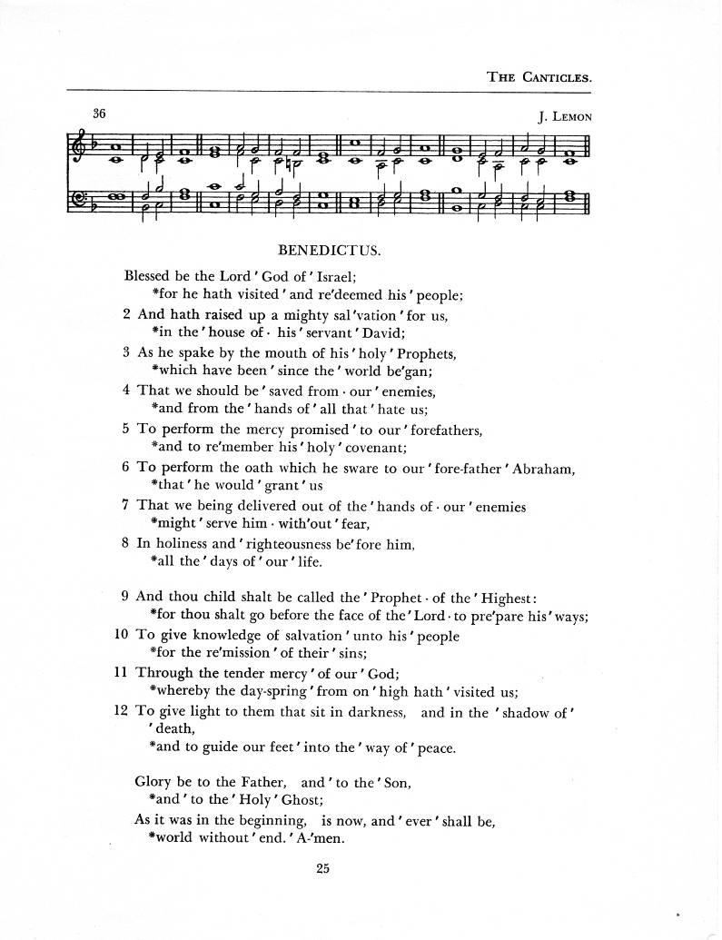
BENEDICTUS (chanted)

BLESSED be the Lord God of Israel; /
For he hath visited, and redeemed his people;
And hath raised up a mighty salvation for us, /
in the house of his servant David;

As he spake by the mouth of his holy Prophets, /
which have been since the world began;
That we should be saved from our enemies, /
and from the hands of all that hate us;

To perform the mercy promised to our forefathers, /
and to remember his holy covenant;
To perform the oath which he sware to our forefather Abraham, /
that he would grant us

That we being delivered out of the hands of our enemies /
might serve him without fear,
In holiness and righteousness before him, /
All, the days of our life.

AND thou, child, shalt be called the Prophet of the Highest: /
for thou shalt go before the face of the Lord to prepare his ways;
To give knowledge of salvation unto his people/
for the remission of their sins;

Through the tender mercy of our God; /
whereby the day-spring from on high hath visited us;
To give light to them that sit in darkness, and in the shadow of death, /
and to guide our feet into the way of peace.

GLORY be to the Father, and to the Son, / and to the Holy Ghost;
As it was in the beginning, is now, and ever shall be, /
world without end. Amen.
THE SECOND READING: 1 Corinthians 1:1-9 (Jerry Watts)

A reading from the First Letter of Paul to the Corinthians

Paul, called to be an apostle of Christ Jesus by the will of God, and our brother Sosthenes, To the church of God that is in Corinth, to those who are sanctified in Christ Jesus, called to be saints, together with all those who in every place call on the name of our Lord Jesus Christ, both their Lord and ours: Grace to you and peace from God our Father and the Lord Jesus Christ. I give thanks to my God always for you because of the grace of God that has been given you in Christ Jesus, for in every way you have been enriched in him, in speech and knowledge of every kind—just as the testimony of Christ has been strengthened among you— so that you are not lacking in any spiritual gift as you wait for the revealing of our Lord Jesus Christ. He will also strengthen you to the end, so that you may be blameless on the day of our Lord Jesus Christ. God is faithful; by him you were called into the fellowship of his Son, Jesus Christ our Lord.

The word of the Lord
Thanks be to God

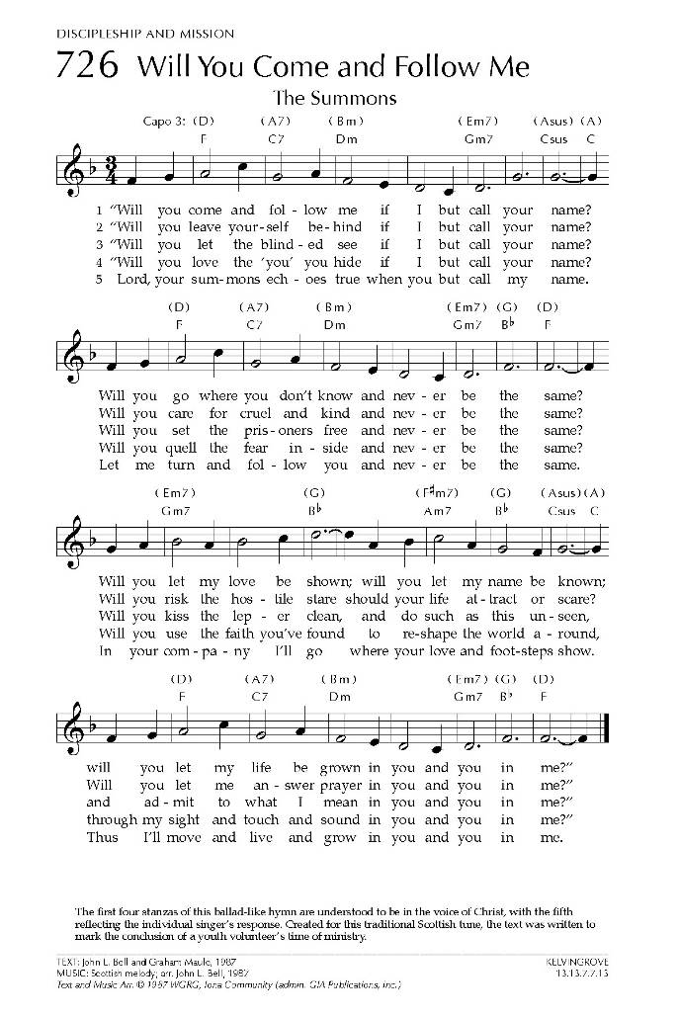
Gradual: The Summons
Text: John Bell; Tune: KELVINGROVE

Will you come and follow me
If I but call your name?
Will you go where you don't know
And never be the same?
Will you let my love be shown?
Will you let my name be known
Will you let my life be grown in you
And you in me?

Will you let the blinded see
If I but call your name?
Will you set the prisoners free
And never be the same?
Will you kiss the leper clean
And do such as this unseen
And admit to what I mean in you
And you in me?

Lord your summons echoes true
When you but call my name
Let me turn and follow you
And never be the same
In Your company I'll go
Where Your love and footsteps show
Thus I'll move and live and grow in you
And you in me

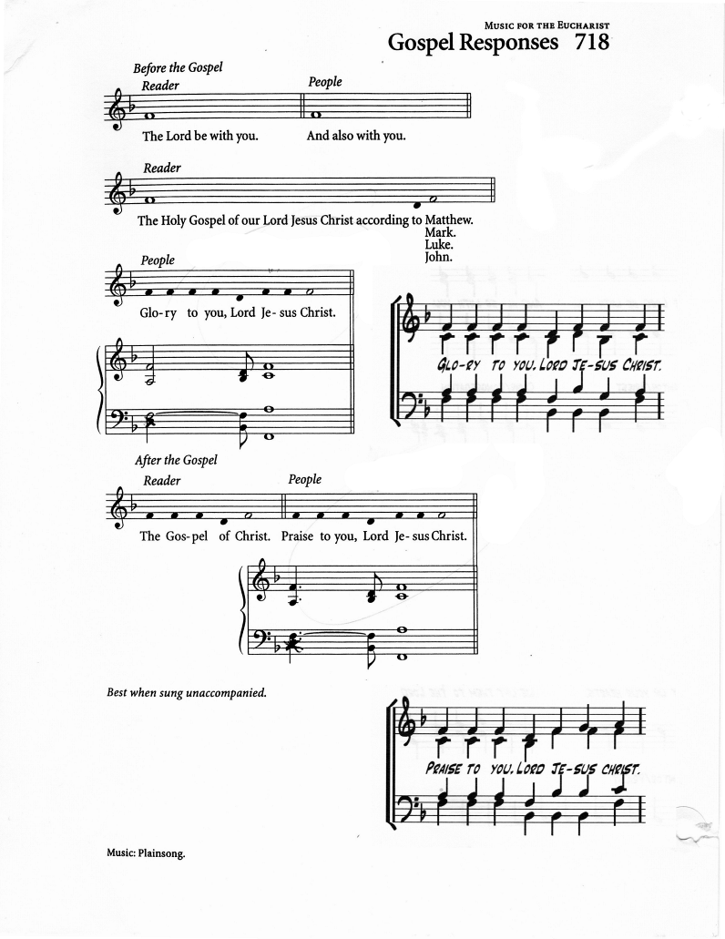
THE HOLY GOSPEL John 1:29-42 Ianthe Alleyne

The Lord be with you
And also with you

The Holy Gospel of our Lord Jesus Christ according to John
Glory to you, Lord Jesus Christ

The next day he saw Jesus coming toward him and declared, “Here is the Lamb
of God who takes away the sin of the world! This is he of whom I said, ‘After me comes a man who ranks ahead of me because he was before me.’ I myself did not know him; but I came baptizing with water for this reason, that he might be revealed to Israel.” And John testified, “I saw the Spirit descending from heaven like a dove, and it remained on him. I myself did not know him, but the one who sent me to baptize with water said to me, ‘He on whom you see the Spirit descend and remain is the one who baptizes with the Holy Spirit.’ And I myself have seen and have testified that this is the Son of God.” The next day John again was standing with two of his disciples, and as he watched Jesus walk by, he exclaimed, “Look, here is the Lamb of God!” The two disciples heard him say this, and they followed Jesus. When Jesus turned and saw them following, he said to them, “What are you looking for?” They said to him, “Rabbi” (which translated means Teacher), “where are you staying?” He said to them, “Come and see.”
They came and saw where he was staying, and they remained with him that day.
It was about four o’clock in the afternoon. One of the two who heard John speak and followed him was Andrew, Simon Peter’s brother. He first found his brother Simon and said to him, “We have found the Messiah” (which is translated Anointed). He brought Simon to Jesus, who looked at him and said,
“You are Simon son of John.
You are to be called Cephas” (which is translated Peter).

The Gospel of Christ
Praise to you, Lord Jesus Christ

Gospel Acclamation: Caribbean Alleluia

THE SERMON:

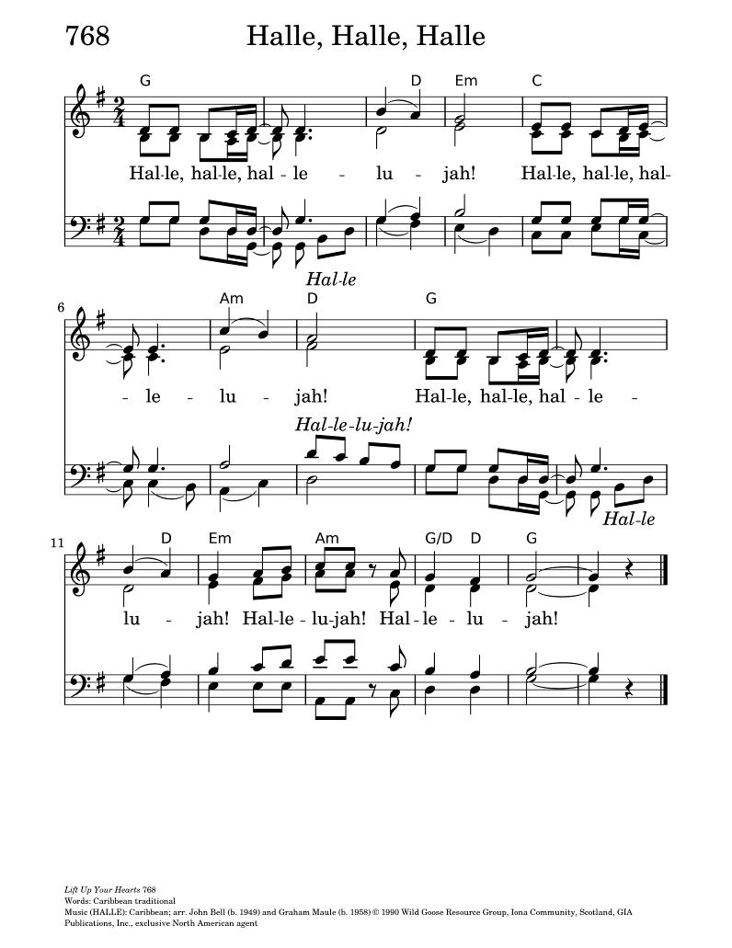
Hear, O Israel: Errol Parris ODT

Let us confess our faith, as we say together, “Hear, O Israel”
Hear, O Israel,
the Lord our God, the Lord is one.
Love the Lord your God with all your heart, with all your soul,
with all your mind, and with all your strength.
This is the first and the great commandment.
The second is like it: Love your neighbour as yourself.
There is no commandment greater than these.

The Lord be with you;
And with thy spirit.
Let us pray.
Lord, have mercy upon us.
Christ, have mercy upon us.
Lord, have mercy upon us.

O Lord, show thy mercy upon us;
And grant us thy salvation.

O Lord, save the King;
And mercifully hear us when we call upon thee.

Endue thy Ministers with righteousness;
And make thy chosen people joyful.

O Lord, save thy people;
And bless thine inheritance.

Give peace in our time, O Lord;
And evermore mightily defend us.

O God, make clean our hearts within us;
And take not thy Holy Spirit from us.

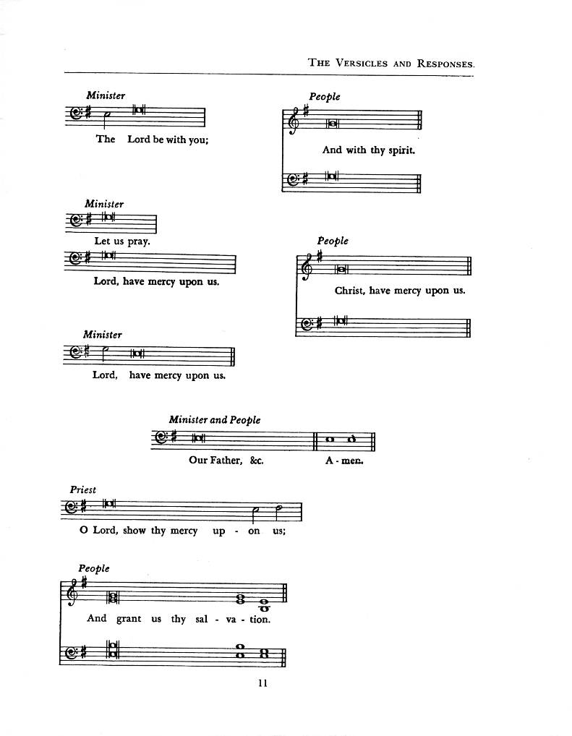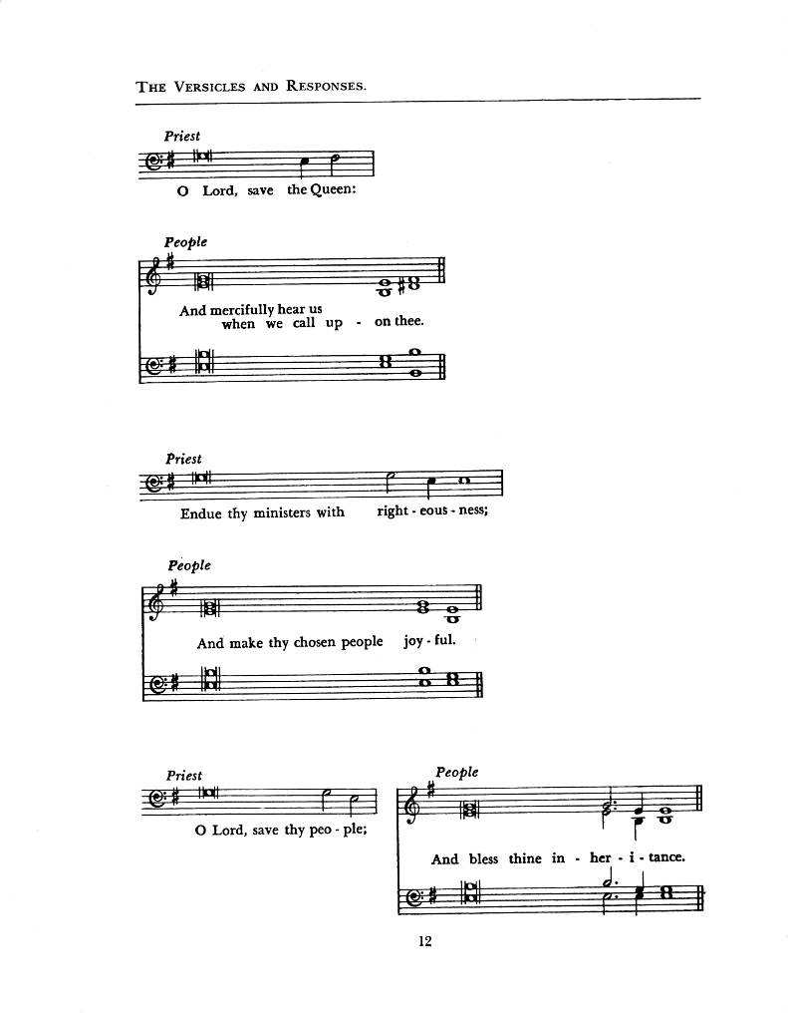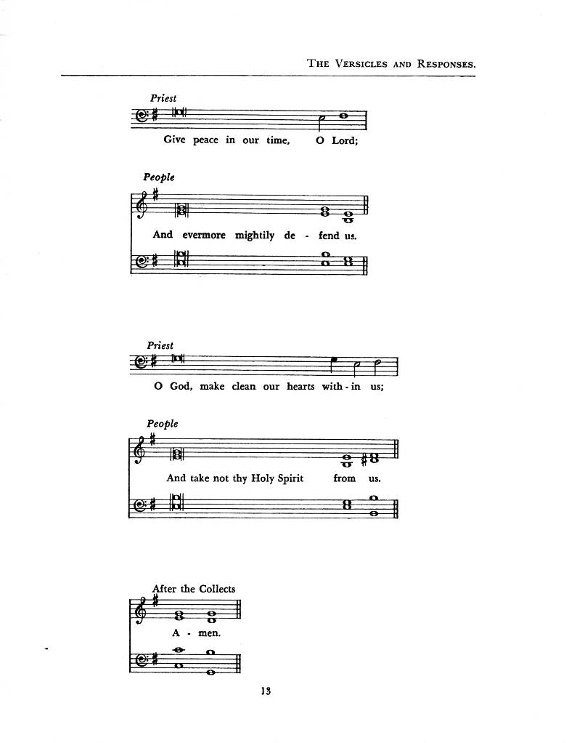
INTERCESSION (Richard Morris)

Trusting in the mercy of Christ,
the Lamb of God who takes away the sin of the world, let us pray.

Lamb of God,
shape your Church to be a faithful witness—not pointing to ourselves,
but always pointing to Christ. Make us a people who invite others to
“come and see.” We pray for the Anglican Church of Congo in the Anglican Cycle and for the Week Of Prayer for Christian Unity in the Diocesan Cycle.
Lord, in your mercy:
Hear our prayer.

Lamb of God,
you carry the weight of the world’s brokenness.
We pray for places of conflict, fear, and injustice,
especially where violence, hunger, or oppression persist.
Bring light where hope feels distant and peace where hearts are weary.
We remember especially the people of Ukraine, Venezuela, Gaza and Sudan.
Lord, in your mercy:
Hear our prayer.

Lamb of God,
We lift up the people of Iran as well. In the midst of widespread unrest, fear, and loss of life — where many have been wounded, detained, or killed and communications are cut off — we pray for Your peace to come into every city
and village. Bring comfort to the grieving, protection to the vulnerable,
and courage to those who feel powerless. Calm hearts filled with anger or despair, and turn them toward hope and healing.
Lord, in your mercy:
Hear our prayer.

Lamb of God,
you ask us, “What are you looking for?”
Be near to all who are searching for meaning, belonging, healing, or direction.
Meet them in their questions and invite them into your life-giving presence.
Lord, in your mercy:
Hear our prayer.

Lamb of God,
call us by name, as you called Simon Peter.
Renew our identity as your beloved people,
and give us courage to follow you into lives of compassion, service, and love.
Lord, in your mercy:
Hear our prayer.

Lamb of God,
take away the pain and sorrow of those who suffer in body, mind, or spirit.
We remember before you those we name now, aloud or in silence.
Hold them in your mercy and grant healing according to your will.
Lord, in your mercy:
Hear our prayer.

Gather these prayers, spoken and unspoken, into your heart of grace,
for we offer them in the name of Jesus Christ, the Lamb of God.
Amen.

THE COLLECT OF THE DAY (Kenute Francis)

Almighty God,
your Son our Saviour Jesus Christ is the light of the world.
May your people, illumined by your word and sacraments,
shine with the radiance of his glory, that he may be known, worshipped,
and obeyed to the ends of the earth;
who lives and reigns with you and the Holy Spirit,
one God, now and for ever.
Amen.

THE COLLECT FOR STRENGTH (Errol Parris ODT)

Into your hands, Lord, we commend ourselves this day.
Let your presence be with us to its close.
Strengthen us to remember that in whatever good work we do
we are serving you. Give us a diligent and watchful spirit,
that we may seek in everything to know your will,
and knowing it, may gladly perform it,
to the honour and glory of your Name;
through Jesus Christ our Lord.
Amen.

The Lord’s Prayer (Tune: Malotte): Errol Parris ODT

And now, as our Saviour Christ has taught us, we are bold to sing

Our Father, which art in heaven,
hallowed be thy Name, Thy kingdom come,
Thy will be done, on earth as it is in heaven.
Give us this day our daily bread and forgive us our debts,
As we forgive our debtors.
And lead us not into temptation, but deliver us from evil.
For thine is the kingdom, and the power, and the glory, forever. Amen.

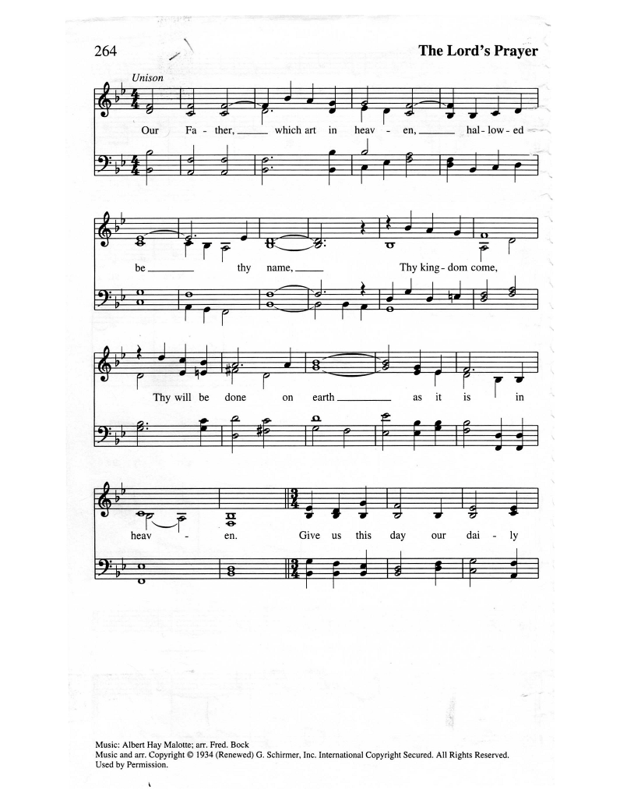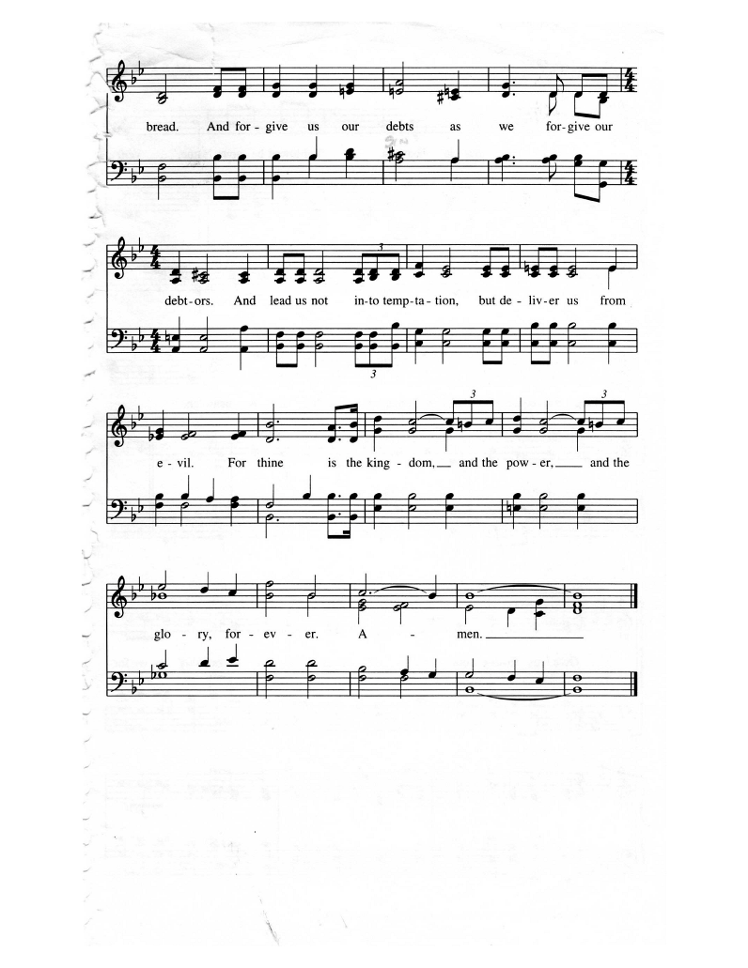
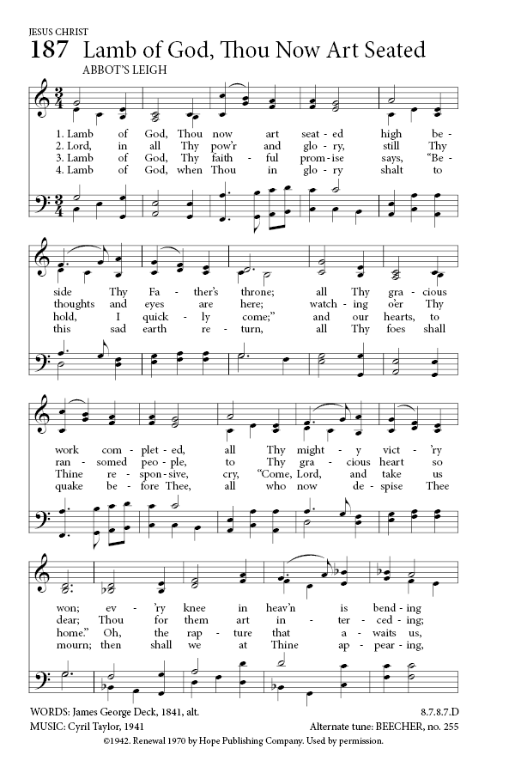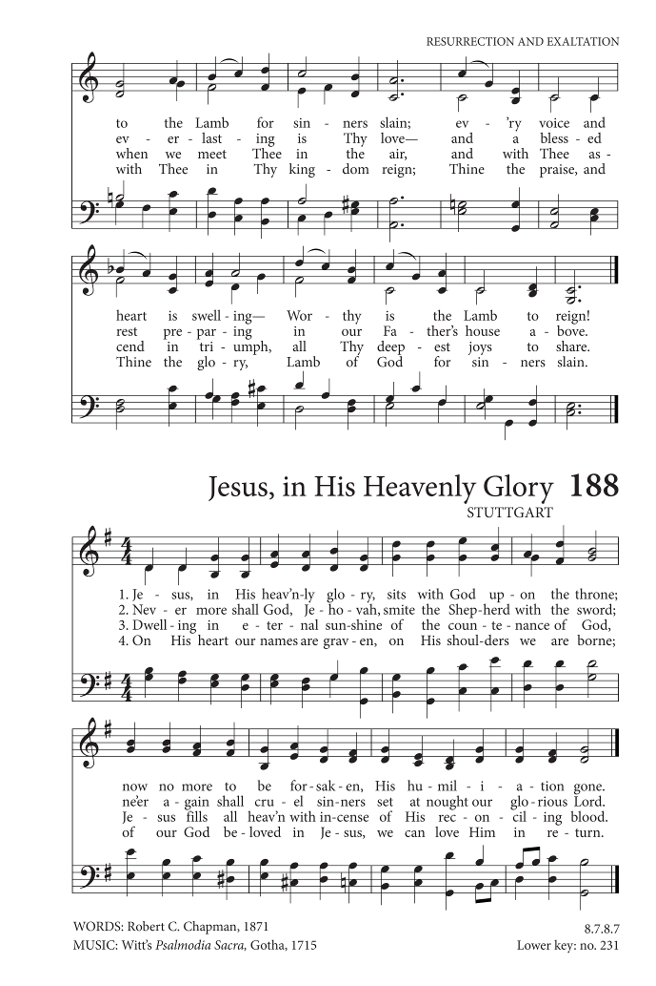
The Peace Errol Parris ODT

The peace of the Lord be always with you.
And also with you.

OFFERTORY: Lord, You Give The Great Commission
Text: Jeffery Howthorn; Tune: ABBOTT LEIGH

Lord, you give the great commission:
"Heal the sick and preach the word."
Lest the church neglect its mission
and the gospel go unheard,
help us witness to your purpose
with renewed integrity:
With the Spirit's gifts empower
us for the work of ministry.

Lord, you call us to your service:
"In my name baptize and teach."
That the world may trust your promise,
life abundant meant for each,
give us all new fervor, draw us
closer in community:
With the Spirit's gifts empower
us for the work of ministry.

Lord, you make the common holy:
"This my body, this my blood."
Let us all, for earth's true glory,
daily lift life heavenward,
asking that the world around us
share your children's liberty:
With the Spirit's gifts empower
us for the work of ministry.

Lord, you bless with words assuring:
"I am with you to the end."
Faith and hope and love restoring,
may we serve as you intend,
and, amid the cares that claim us,
hold in mind eternity:
With the Spirit's gifts empower
us for the work of ministry.
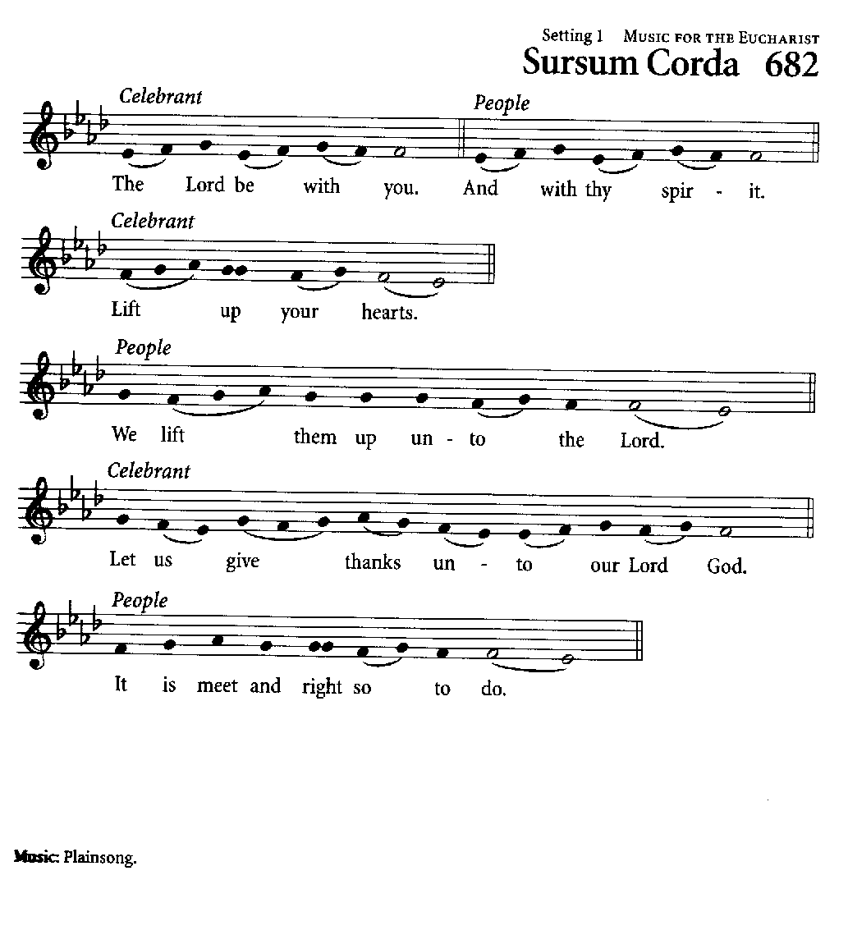
PRAYER OVER THE GIFTS

Living God,
you have revealed your Son as the Messiah.
May we hear his word and follow it,
and live as children of light.
We ask this in the name of Jesus Christ the Lord.
Amen.

EUCHARISTIC PRAYER A

The Lord be with you.
And with thy spirit.
Lift up your hearts.
We lift them up unto the Lord.
Let us give thanks unto our Lord God.
It is meet and right so to do.

It is very meet, right, and our bounden duty, that we should at all times,
and in all places, give thanks unto thee, O Lord, holy Father, almighty,
everlasting God, creator and preserver of all things.
Therefore, with angels and archangels, and with all the company of heaven,
we laud and magnify thy glorious name; evermore praising thee and saying:
Holy, holy, holy, Lord God of Hosts,
heaven and earth are full of thy glory.
Glory be to thee, O Lord most high.
Blessed is he that cometh in the name of the Lord:
Hosanna in the highest.

Blessing and glory and thanksgiving be unto thee, almighty God,
our heavenly Father, who of thy tender mercy didst give thine only Son
Jesus Christ to take our nature upon him,
and to suffer death upon the cross for our redemption;
who made there, by his one oblation of himself once offered, a full, perfect,
and sufficient sacrifice, oblation, and satisfaction, for the sins of the whole world; and did institute, and in his holy Gospel command us to continue,
a perpetual memorial of that his precious death, until his coming again.

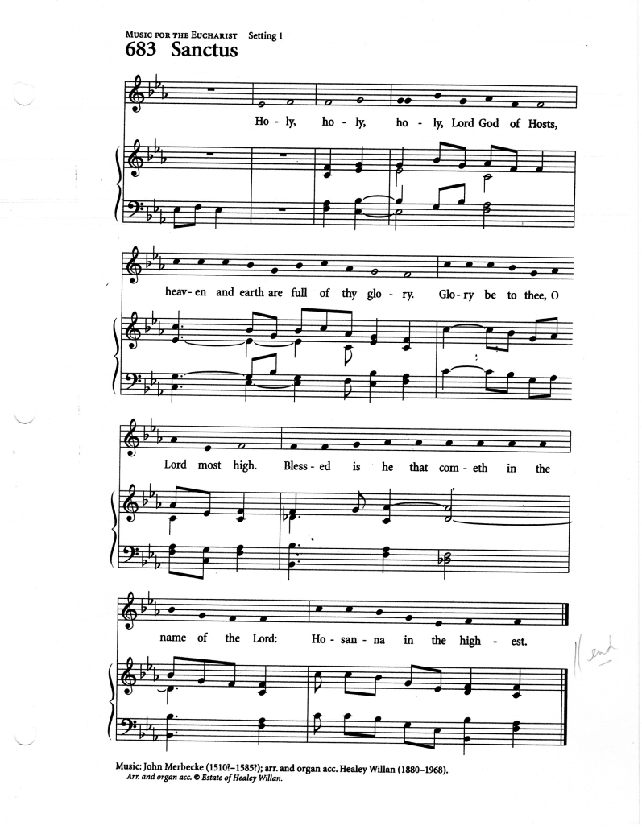
Hear us, O merciful Father, we most humbly beseech thee;
and grant that we receiving these thy creatures of bread and wine,
according to thy Son our Saviour Jesus Christ’s holy institution,
in remembrance of his death and passion,
may be partakers of his most blessed body and blood;
who, in the same night that he was betrayed, took bread;
and, when he had given thanks, he brake it; and gave it to his disciples,
saying, “Take, eat; this is my body which is given for you:
Do this in remembrance of me.”
Likewise, after supper he took the cup; and when he had given thanks,
he gave it to them, saying, “Drink ye all, of this;
for this is my blood of the new covenant, which is shed for you
and for many for the remission of sins:
Do this, as oft as ye shall drink it, in remembrance of me.”

Wherefore, O Father, Lord of heaven and earth, we thy humble servants,
with all thy holy Church, remembering the precious death of thy beloved
Son, his mighty resurrection, and glorious ascension,
and looking for his coming again in glory, do make before thee,
in this sacrament of the holy bread of eternal life
and the cup of everlasting salvation,
the memorial which he hath commanded:
We praise thee, we bless thee, we thank thee,
and we pray to thee, Lord our God.

And we entirely desire thy fatherly goodness mercifully to accept this our sacrifice of praise and thanksgiving, most humbly beseeching thee to grant,
that by the merits and death of thy Son Jesus Christ, and through faith in his blood, we and all thy whole Church may obtain remission of our sins,
and all other benefits of his passion;

And we pray that by the power of thy Holy Spirit, all we who are partakers
of this holy communion may be fulfilled with thy grace and heavenly benediction; through Jesus Christ our Lord, by whom and with whom,
in the unity of the Holy Spirit, all honour and glory be
unto thee, O Father Almighty, world without end.
Amen.

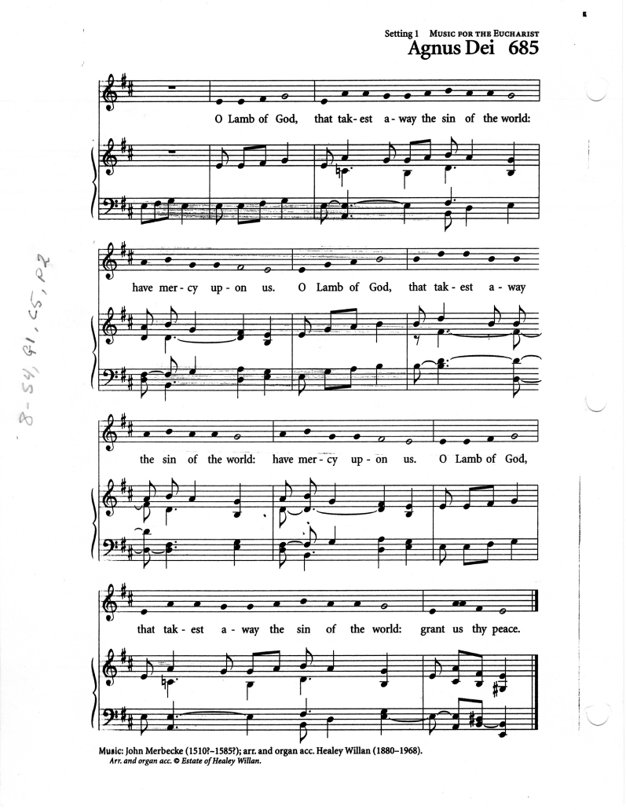
Agnus Dei

Lamb of God you take away the sin of the world, have mercy on us.
Lamb of God you take away the sin of the world, have mercy on us.
Lamb of God you take away the sin of the world, grant us peace.

PRAYER OF HUMBLE ACCESS

We do not presume to come to this thy table, O merciful Lord,
Trusting in our own righteousness, but in thy manifold and great mercies.
We are not worthy So much as to gather up the crumbs under thy table.
But thou art the same Lord, whose property is always to have mercy:
Grant us therefore, gracious Lord, so to eat the flesh
of thy dear Son Jesus Christ, and to drink his blood,
that we may evermore dwell in him, and he in us. Amen.

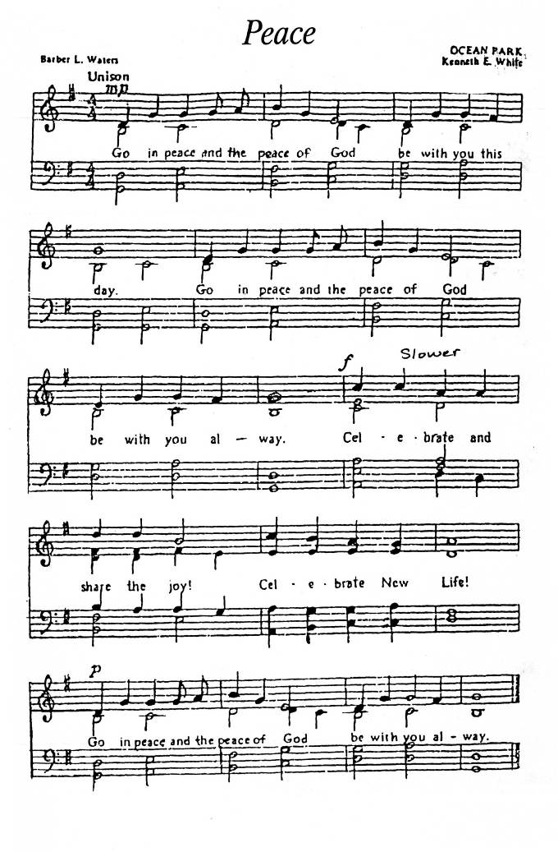
DURING COMMUNION: Just as I am, Without one Plea,
Text: Charlotte Elliott; Tune: Saffron Walden

Just as I am, without one plea,
but that thy blood was shed for me,
and that thou bid'st me come to thee,
O Lamb of God, I come.

Just as I am, though tossed about
with many a conflict, many a doubt,
fightings and fears within, without,
O Lamb of God, I come.

Just as I am, poor, wretched, blind!
Sight, riches, healing of the mind
all that I need, in you to find:
O Lamb of God, I come.

Just as I am! You will receive,
will welcome, pardon, cleanse, relieve:
because your promise I believe,
O Lamb of God, I come.

Just as I am! Of that free love
the breadth, length, depth and height to prove,
here for a time and then above,
O Lamb of God, I come.
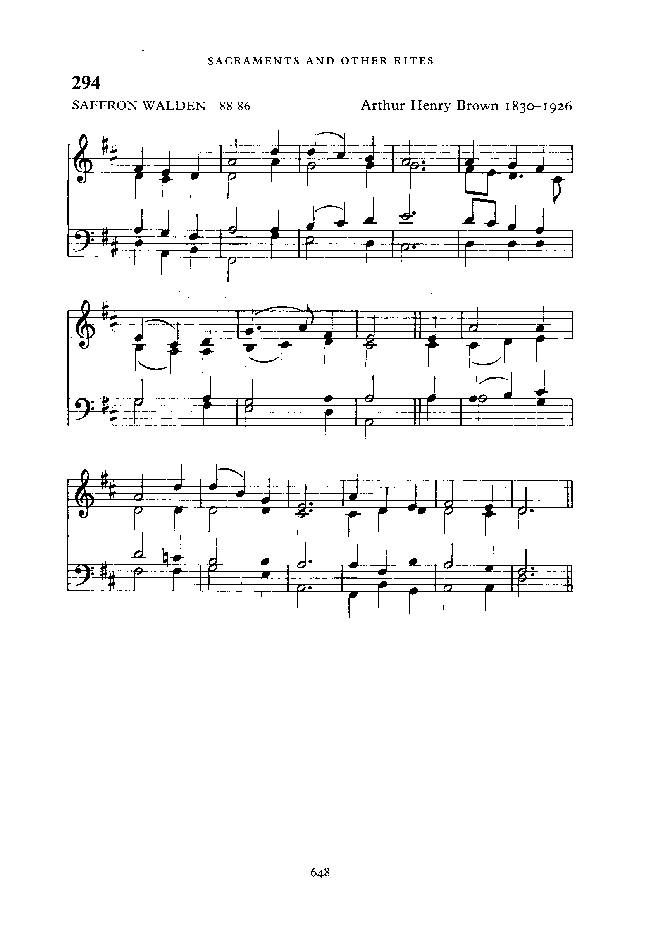
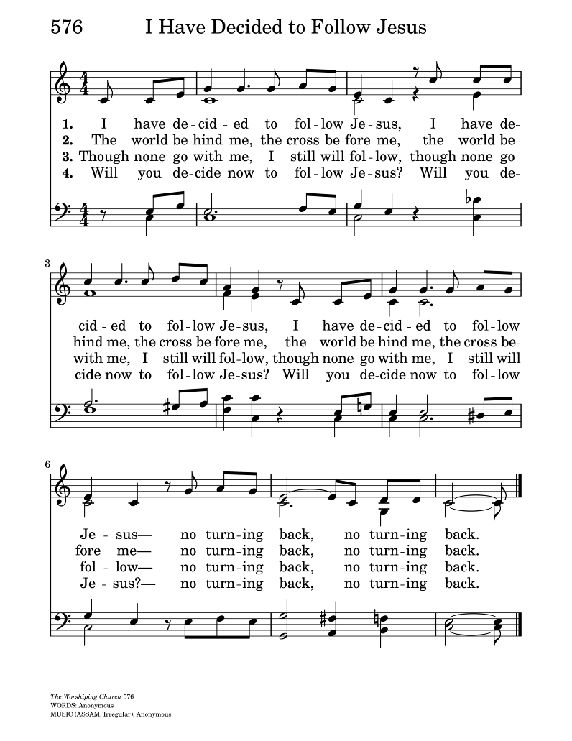
ABLUTIONS: I Have Decided to Follow Jesus
Words: Unknown; Tune: ASSAM

I have decided to follow Jesus;
I have decided to follow Jesus;
I have decided to follow Jesus;

No turning back, no turning back.
The world behind me, the cross before me;
The world behind me, the cross before me;
The world behind me, the cross before me;
No turning back, no turning back.

Though none go with me still I will follow.
Though none go with me still I will follow.
Though none go with me still I will follow.
No turning back, no turning back.

PRAYER AFTER COMMUNION

God of glory, you nourish us with bread from heaven.
Fill us with your Holy Spirit, that through us your light may shine in all the world.
We ask this in the name of Jesus Christ. Amen.

BLESSING (Kenute Francis)

Go now, having seen the Lamb of God and heard his call.
Stay with Christ, walk in his light, and follow where he leads.
And the blessing of God almighty, the Father, Son and Holy Spirit
be with you now and always.
Amen.

ANNOUNCEMENTS

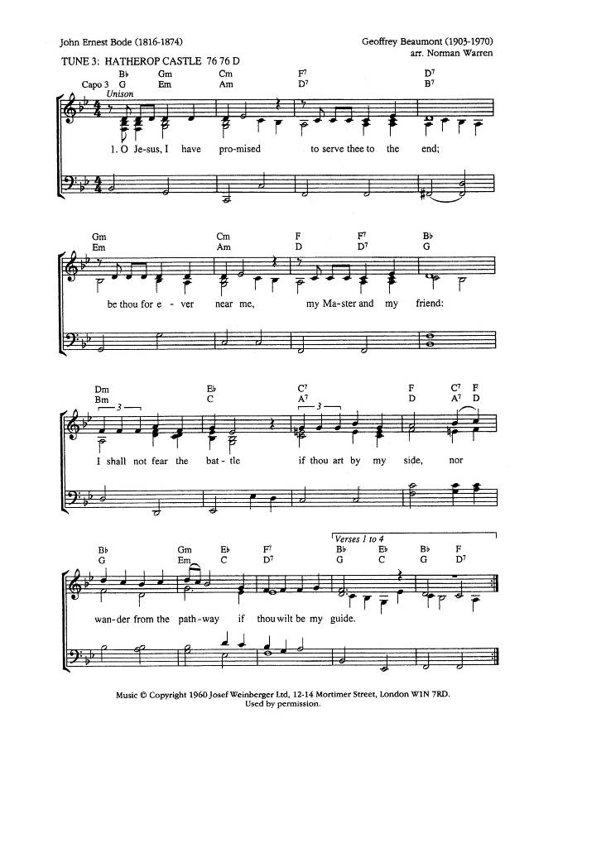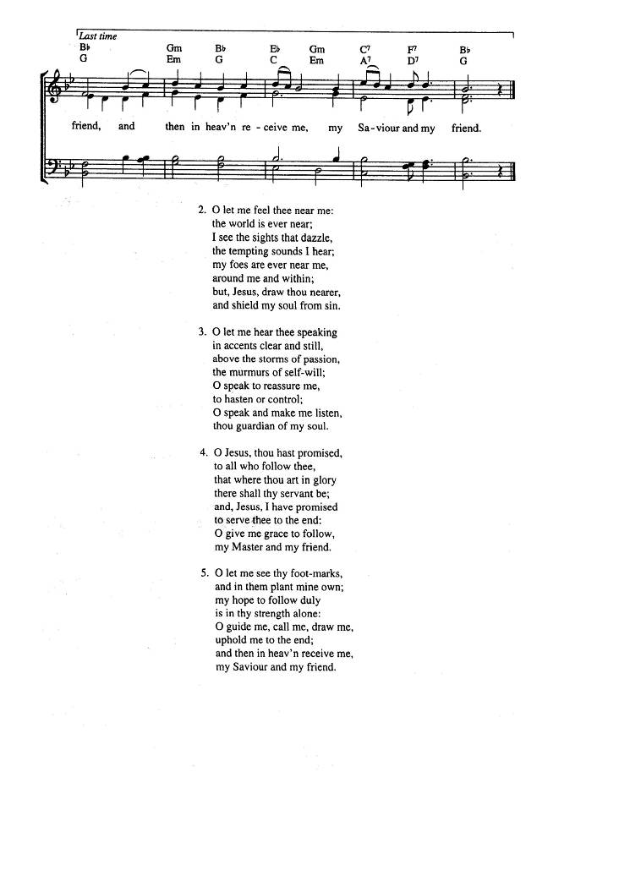
RECESSIONAL: O Jesus I Have Promised
Text: John E. Bode; Tune: HATHEROPE CASTLE

O Jesus, I have promised
to serve Thee to the end;
be Thou forever near me,
my Master and my Friend;
I shall not fear the battle
if Thou art by my side,
nor wander from the pathway
if Thou wilt be my Guide.

O let me feel Thee near me,
the world is ever near;
I see the sights that dazzle,
the tempting sounds I hear;
my foes are ever near me,
around me and within;
but, Jesus, draw Thou nearer,
and shield my soul from sin.

O let me hear Thee speaking
in accents clear and still,
above the storms of passion,
the murmurs of self-will;
O speak to reassure me,
to hasten or control!
O speak, and make me listen,
Thou Guardian of my soul!

O Jesus, Thou hast promised
to all who follow Thee
that where Thou art in glory
there shall Thy servant be;
and, Jesus, I have promised
to serve Thee to the end;
O give me grace to follow,
my Master and my Friend!

Oh, let me see Thy footprints,
and in them plant mine own;
My hope to follow duly
is in Thy strength alone;
Oh, guide me, call me, draw me,
uphold me to the end;
And then in Heav’n receive me,
my Saviour and my Friend.

THE DISMISSAL Errol Parris ODT

Followers of the Christ, Inspired by the Holy Spirit.
Serve the world God loves. Alleluia! Alleluia!
Thanks be to God. Alleluia! Alleluia!

Postlude: Jesu Joy of Man’s Desiring
Johann Sebastian Bach

