The Second Sunday of Easter

April 12, 2026, 10:30am.

Holy Eucharist

Website: www.sthildas.ca
Church Email: info@sthildasanglicanchurch.com
Facebook: St. Hilda’s Fairbank Anglican Church

Incumbent: Fr. Kenute Francis (437-488-9657)

kenute@sthildasanglicanchurch.com

Honorary Assistant: Rev. Canon Leonard Abbah, OHC

Organist: William “Bill” Khan

Eucharistic Ministers: Hardy, Ianthe & William

Crucifer: Kishmar Miller

1st Reading: Margaret Goodridge

2nd Reading: Imelda De Guzman

Gospel: Ianthe Alleyne

Intercession: David Elcock

Tech Team: Temia Maharaj

Ushers Team 1: Jean Caine Christine Fleming

Elfreda Garriques Neville Lowe

Beverley Beckford Dion Robertson

Marcia Lee Hildred Small

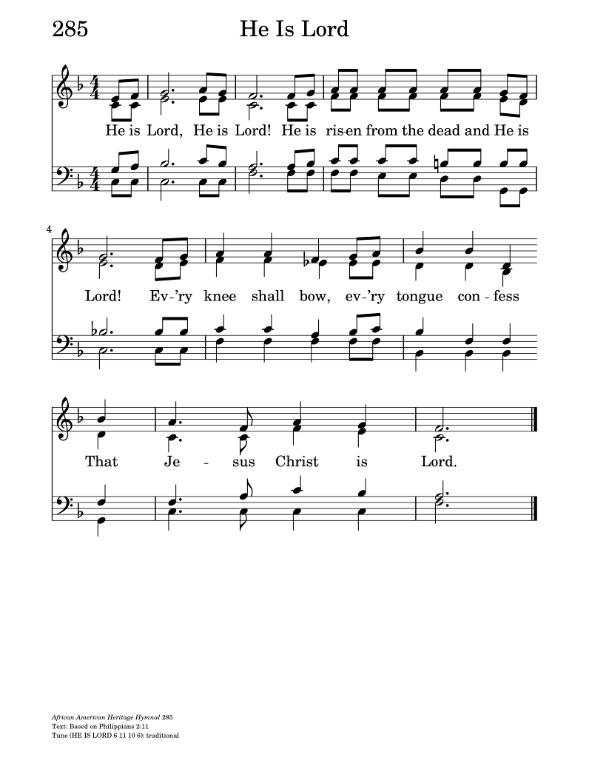

The Order of Service

PRELUDE: He is Lord (HE IS LORD)

OPENING PRAYER:

Risen Lord, You come to us even when doors are locked and hearts are uncertain. Received our thanks and praise and breathe your peace upon us this day.
In your name we pray.
Amen.

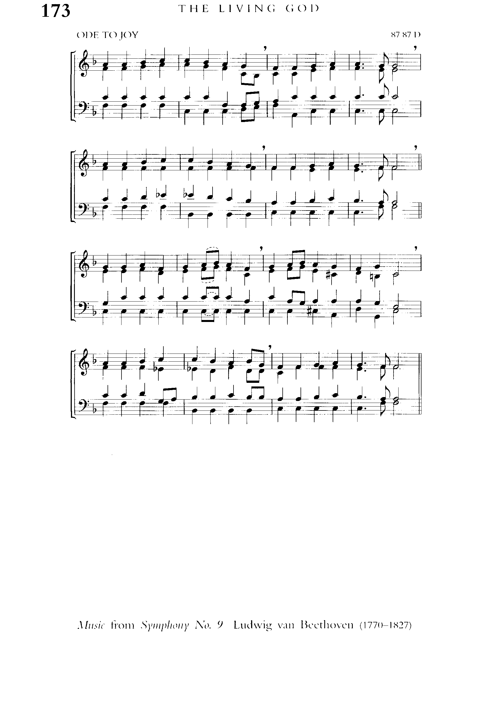
PROCESSIONAL: Alleluia, Alleluia! Hearts to Heav'n
Text: Christopher Wordsworth; Tune: HYMN TO JOY

Alleluia, Alleluia!
Hearts to heav'n and voices raise:
sing to God a hymn of gladness,
sing to God a hymn of praise.
He, who on the cross a victim
for the world's salvation bled,
Jesus Christ, the King of glory,
now is risen from the dead.

Christ is risen, Christ, the first-fruits
of the holy harvest field,
which will all its full abundance
at His second coming yield.
Then the golden ears of harvest
will their heads before Him wave,
ripened by His glorious sunshine
from the furrows of the grave.

Christ is risen, we are risen!
Shed upon us heav'nly grace,
rain and dew and gleams of glory
from the brightness of Thy face,
that we, with our hearts in heaven,
here on earth may fruitful be,
and by angel hands be gathered,
and be ever, Lord, with Thee.
Alleluia, Alleluia!

Glory be to God on high!
Alleluia! to the Saviour
who has gained the victory!
Alleluia! to the Spirit,
fount of love and sanctity!
Alleluia, Alleluia
to the Triune Majesty!

WELCOME:

THE GREETING:

Alleluia! Christ is risen.
The Lord is risen indeed! Alleluia!

May His grace and peace be with you.
May he fill our hearts with joy.

Alleluia! Celebrate God in this sacred space!
Let everything with life and breath praise God! Alleluia!

The Collect for Purity:

Almighty God,
to you all hearts are open, all desires known, and from you no secrets are hidden.
Cleanse the thoughts of our hearts by the inspiration of your Holy Spirit,
that we may perfectly love you, and worthily magnify your holy name;
through Christ our Lord. Amen.

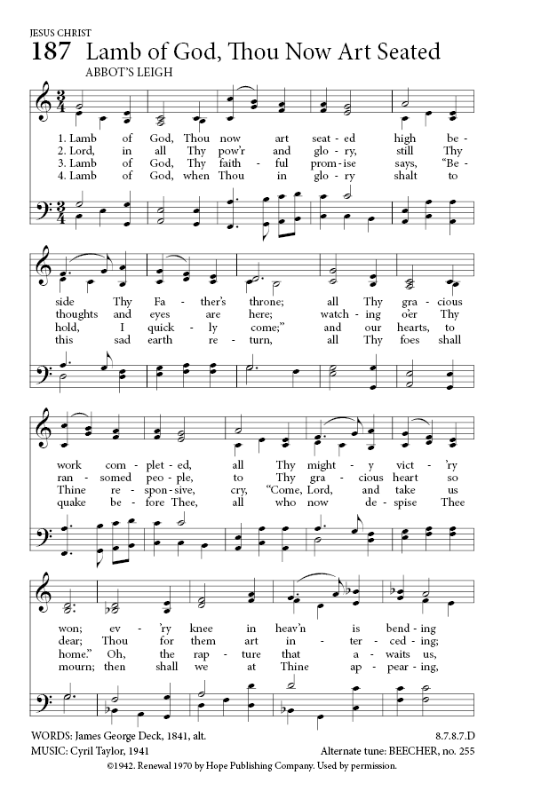
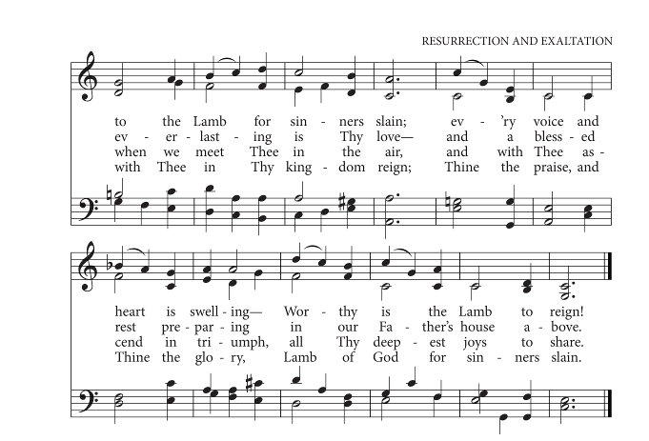
Gloria in Excelsis Deo
Tune: ABBOT'S LEIGH

Glory be to God in heaven,
And to all his people, peace.
Heav’nly King, almighty Father,
May our worship never cease;
May our voices ever thank you,
Songs of blessing ever send,
May we always live to praise you,
For your glory without end.

Jesus, Son of God the Father,
Merciful beyond compare,
All our sin, by you forgiven;
Lamb of God, receive our prayer.
Jesus, you alone are holy,
Jesus, you alone are Lord,
With the Holy Spirit reigning,
And the Father - glorious God!

Children/Youth Talk:

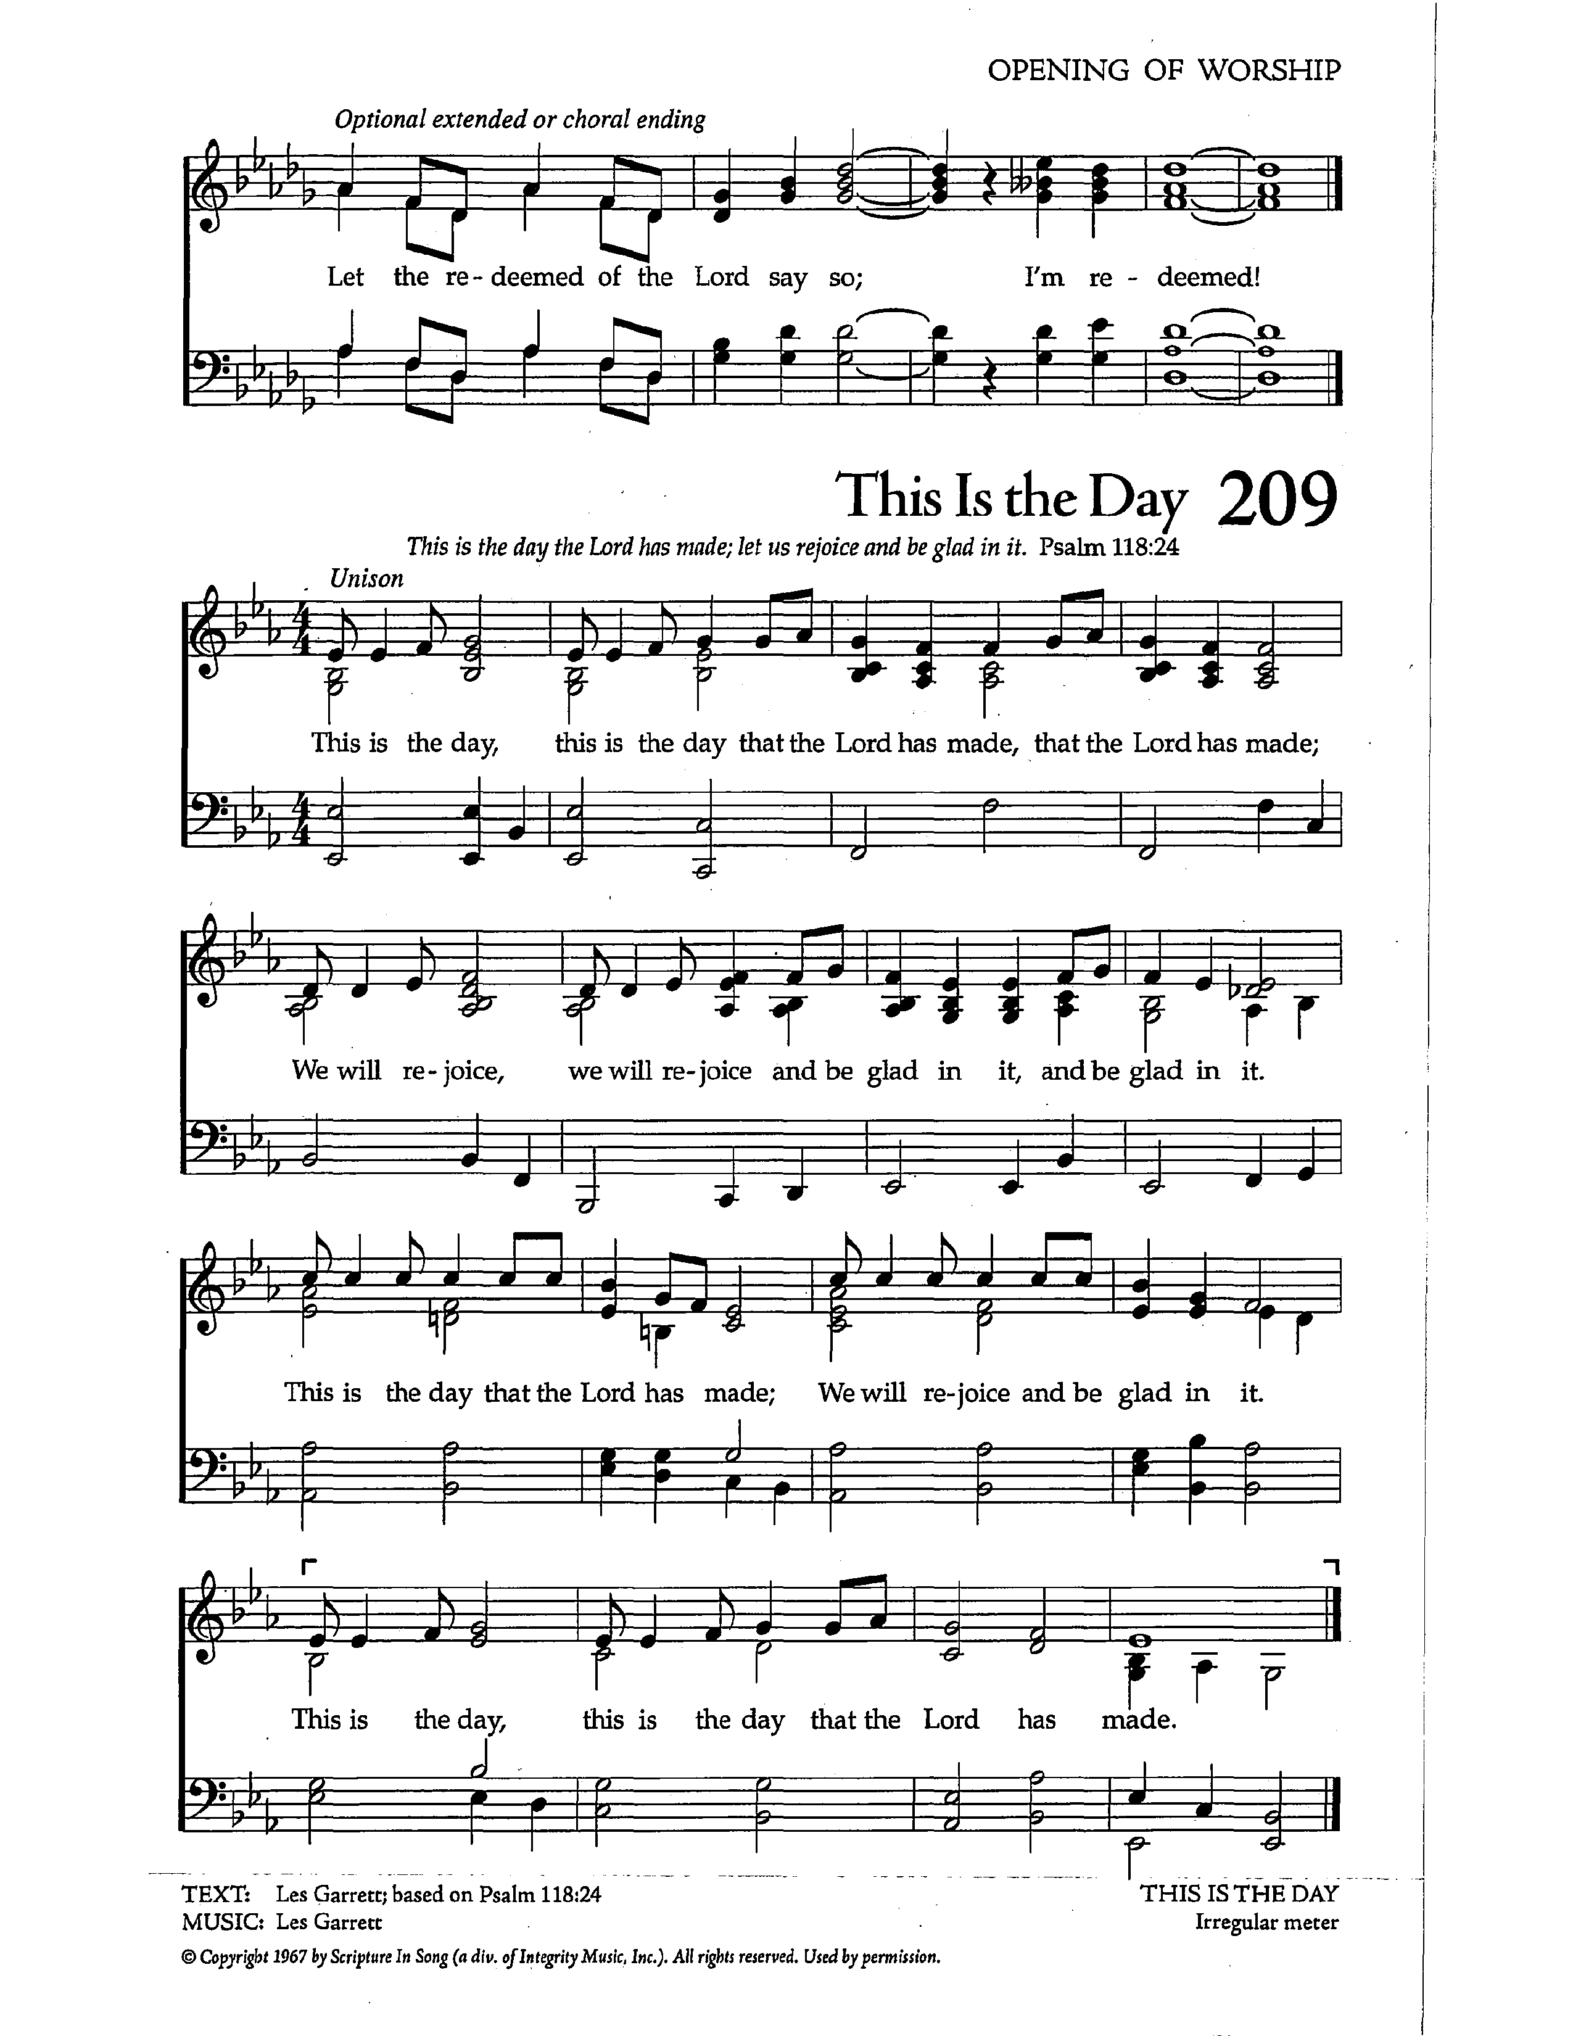
INTROIT: This is the Day (Les Garrett)

This is the day, this is the day
that the Lord has made, that the Lord has made.
We will rejoice, we will rejoice
and be glad in it, and be glad in it.
This is the day that the Lord has made;
we will rejoice and be glad in it.
This is the day, this is the day
that the Lord has made.

This is the day, this is the day
When He rose a-gain, when He rose a-gain
We will rejoice, we will rejoice
And be glad in it, and be glad in it
This is the day when He rose a-gain
We will rejoice and be glad in it
This is the day, this is the day
When He rose again.

THE COLLECT OF THE DAY

Let us pray,

Almighty and eternal God,
the strength of those who believe and the hope of those who doubt,
may we, who have not seen, have faith and receive the fullness of Christ's blessing,
who is alive and reigns with you and the Holy Spirit, one God, now and for ever.
Amen.

THE PROCLAMATION OF THE WORD

FIRST READING: Acts 2:14a, 22-32 (Margaret Goodridge)

A Reading from the Acts of the Apostles

But Peter, standing with the eleven, raised his voice and addressed them,
“You that are Israelites, listen to what I have to say: Jesus of Nazareth,
a man attested to you by God with deeds of power, wonders, and signs that God did through him among you, as you yourselves know— this man,
handed over to you according to the definite plan and foreknowledge of God, you crucified and killed by the hands of those outside the law. But God raised him up, having freed him from death, because it was impossible for him to be held in its power. For David says concerning him, ‘I saw the Lord always before me, for he is at my right hand so that I will not be shaken; therefore my heart was glad,
and my tongue rejoiced; moreover my flesh will live in hope.
For you will not abandon my soul to Hades, or let your Holy One experience corruption. You have made known to me the ways of life; you will make me full of gladness with your presence.’ “Fellow Israelites, I may say to you confidently of our ancestor David that he both died and was buried, and his tomb is with us to this day. Since he was a prophet, he knew that God had sworn with an oath to him that he would put one of his descendants on his throne. Foreseeing this, David spoke of the resurrection of the Messiah, saying, ‘He was not abandoned to Hades, nor did his flesh experience corruption.’ This Jesus God raised up, and of that all of us are witnesses.

The Word of the Lord
Thanks be to God

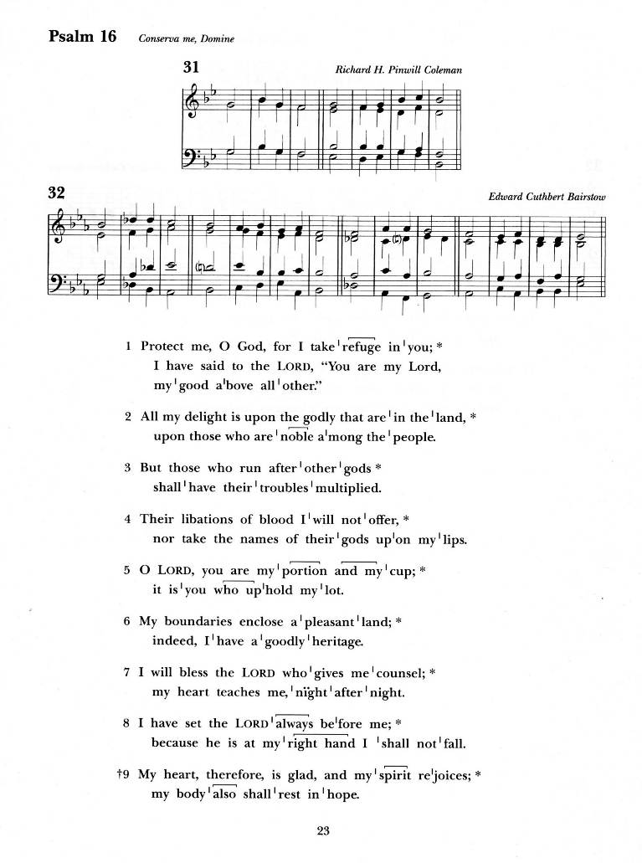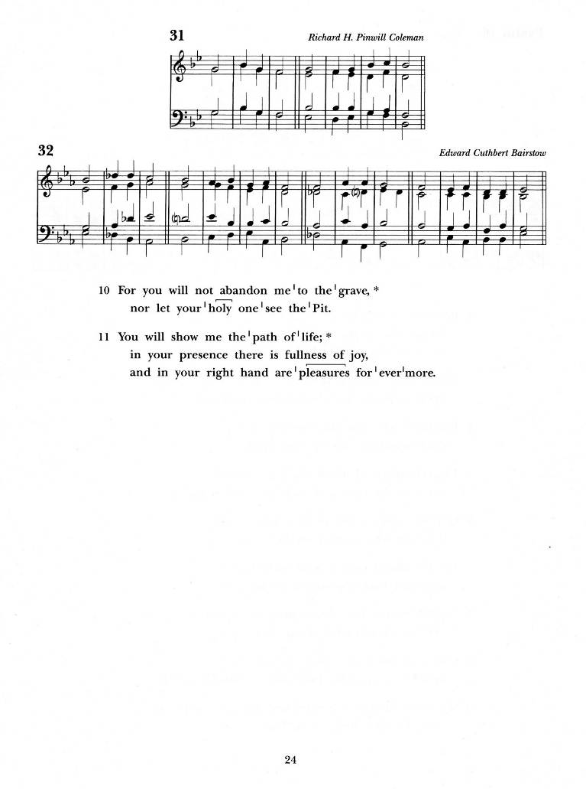
PSALM 16 (chanted)

Protect me, O God, for I take refuge in you;
I have said to the Lord, “You are my Lord, my good above all other.”
All my delight is upon the godly that are in the land,
upon those who are noble among the people.

But those who run after other gods shall have their troubles multiplied.
Their libations of blood I will not offer,
nor take the names of their gods upon my lips.

O Lord, you are my portion and my cup; it is you who uphold my lot.
My boundaries enclose a pleasant land; indeed, I have a goodly heritage.

I will bless the Lord who gives me counsel; my heart teaches me, night after night.
I have set the Lord always before me;
because he is at my right hand I shall not fall.

My heart, therefore, is glad, and my spirit rejoices;
my body also shall rest in hope.
For you will not abandon me to the grave, nor let your holy one see the Pit.

You will show me the path of life; in your presence there is fullness of joy,
and in your right hand are pleasures for evermore.
Glory to the Father and to the Son, and to the Holy Spirit:
As it was in the beginning, is now, and will be for ever. Amen.

SECOND READING: 1 Peter 1:3-9 (Imelda De Guzman)

A reading from the First Letter of Peter

Blessed be the God and Father of our Lord Jesus Christ!
By his great mercy he has given us a new birth into a living hope
through the resurrection of Jesus Christ from the dead,
and into an inheritance that is imperishable, undefiled, and unfading,
kept in heaven for you, who are being protected by the power of God
through faith for a salvation ready to be revealed in the last time.
In this you rejoice, even if now for a little while you have had to suffer various trials, so that the genuineness of your faith—being more precious than gold that, though perishable, is tested by fire—may be found to result in praise and glory
and honor when Jesus Christ is revealed. Although you have not seen him,
you love him; and even though you do not see him now,
you believe in him and rejoice with an indescribable and glorious joy,
for you are receiving the outcome of your faith, the salvation of your souls.

The word of the Lord
Thanks be to God

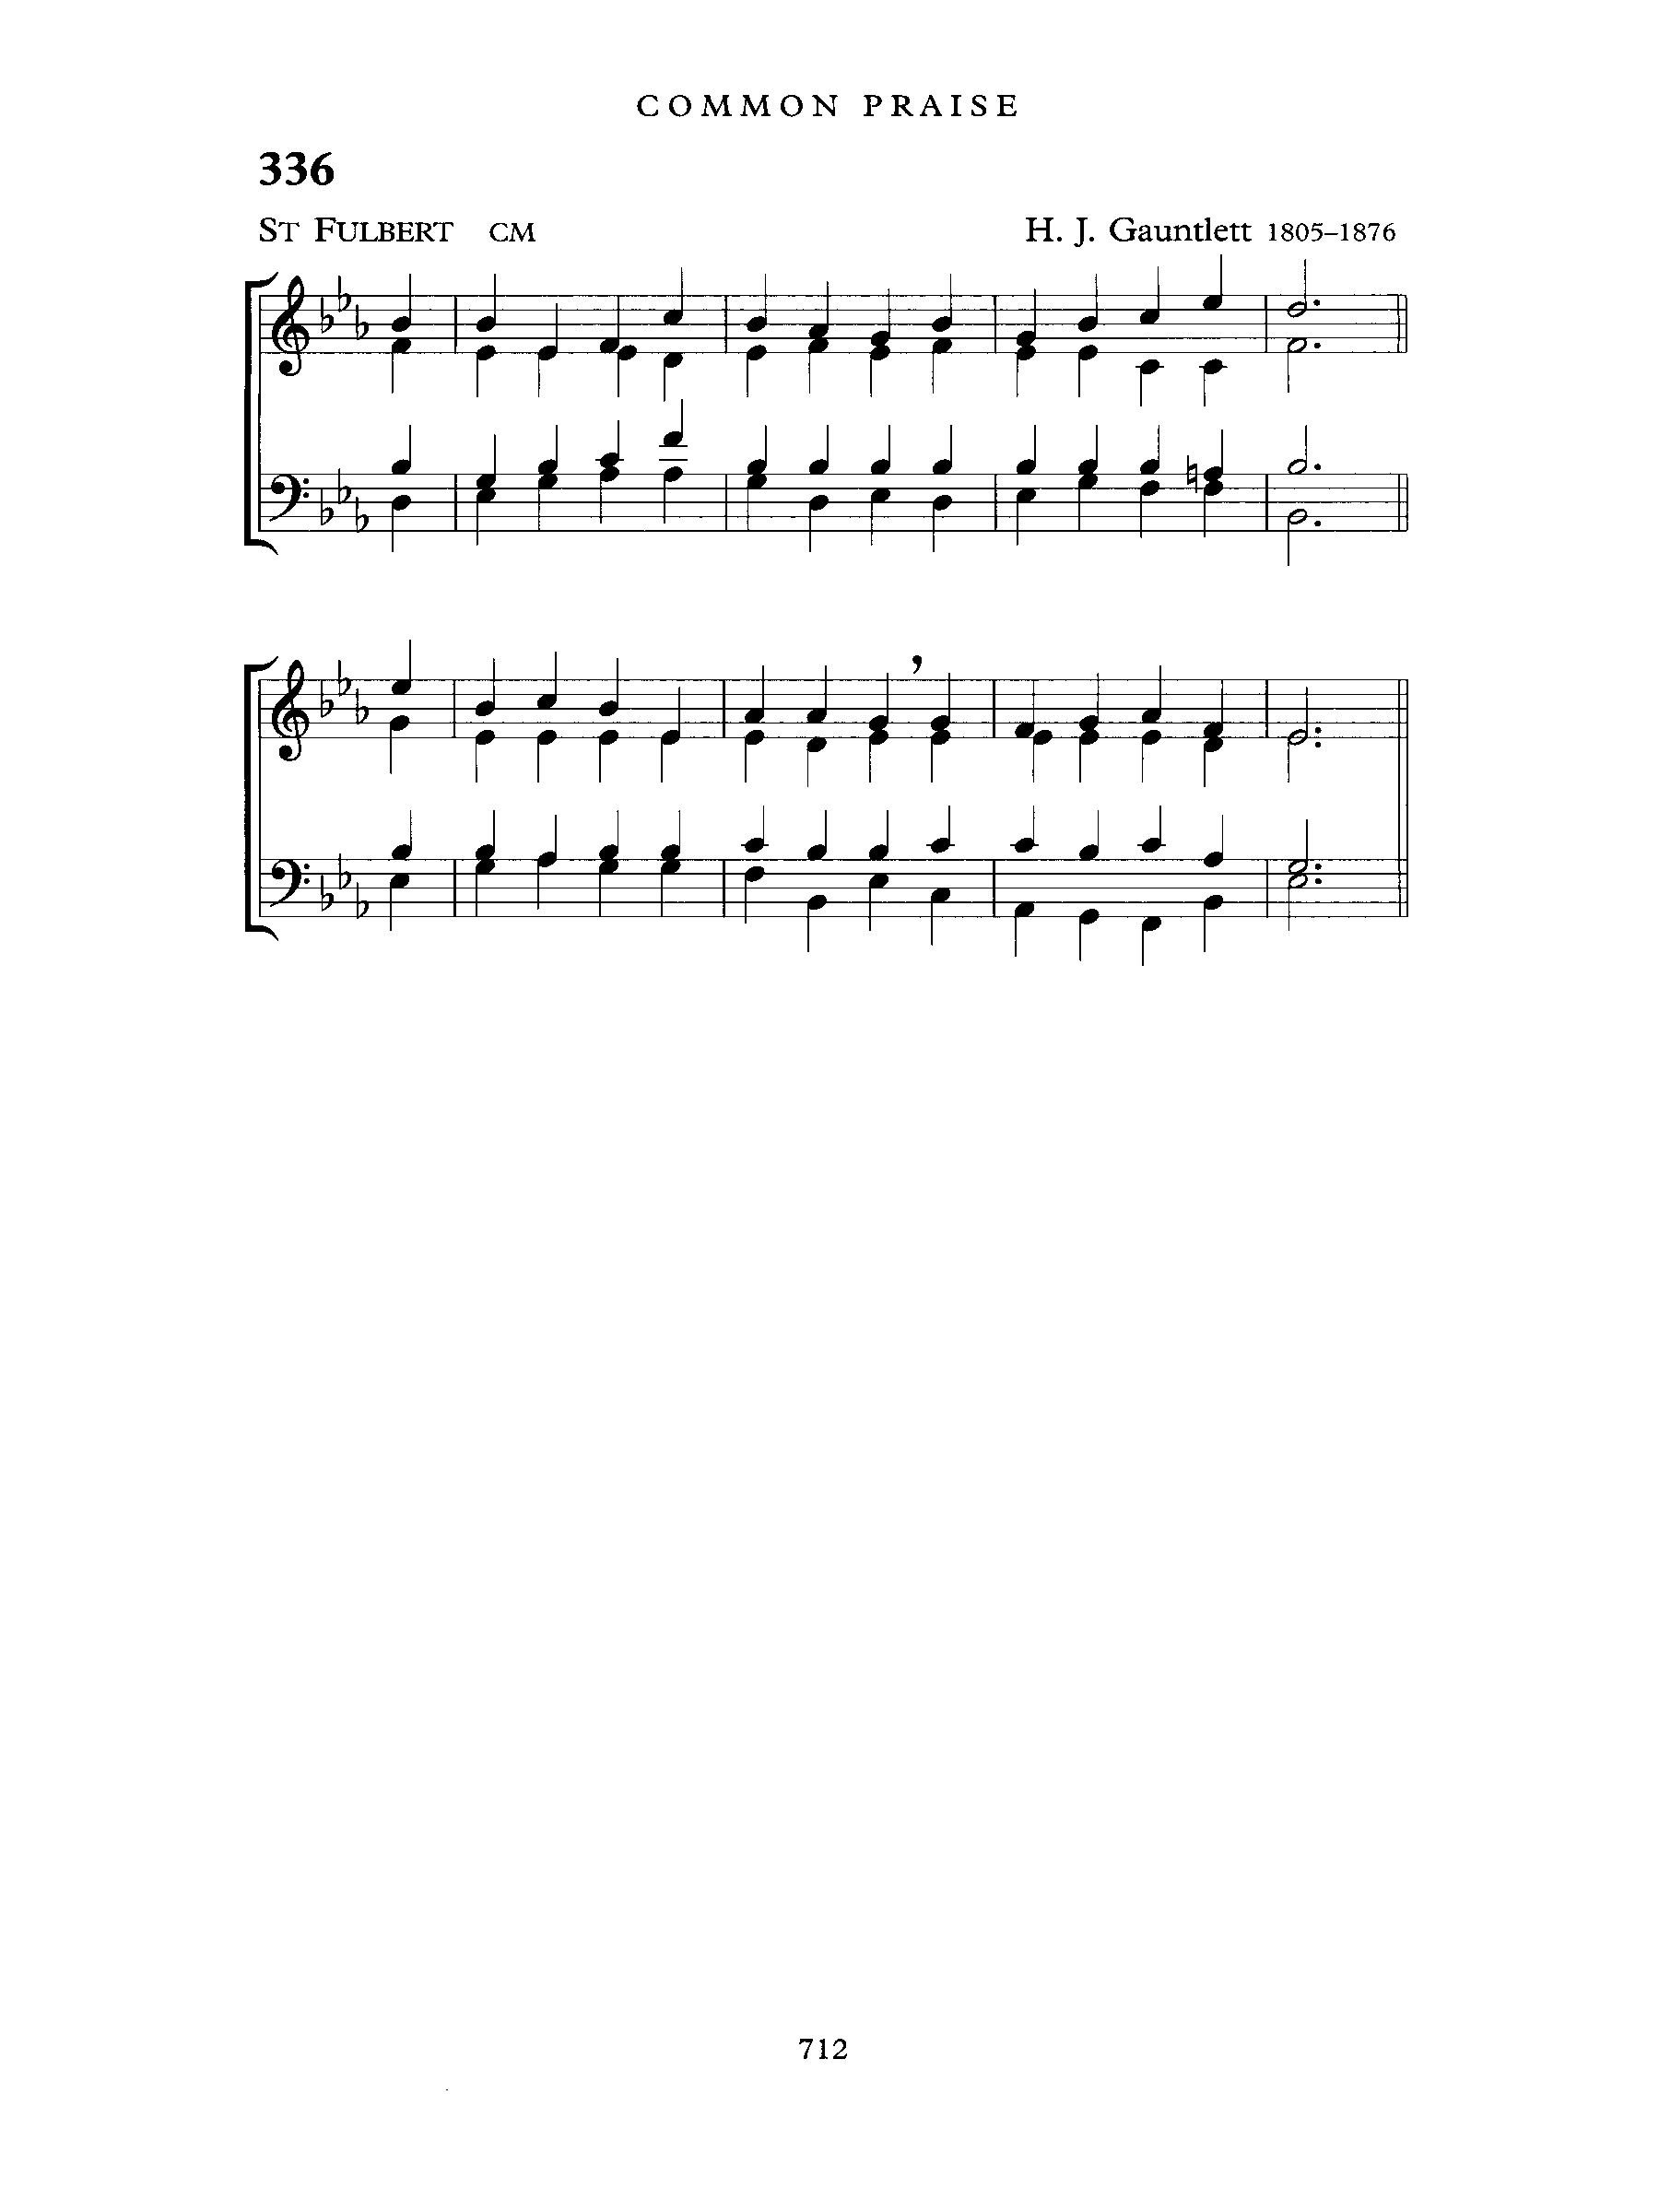
GRADUAL: Ye Choirs of New Jerusalem
Text: Fulbert of Chartres; Tune: ST. FULBERT

Ye choirs of new Jerusalem,
your sweetest notes employ,
the Paschal victory to hymn
in strains of holy joy.

For Judah's Lion bursts his chains,
crushing the serpent's head;
and cries aloud through death's domains
to wake the imprisoned dead.

Triumphant in his glory now
to him all power is given;
to him in one communion bow
all saints in earth and heaven.

While we, his soldiers, praise our King,
his mercy we implore,
within his palace bright to bring
and keep us evermore.

All glory to the Father be,
all glory to the Son,
all glory, Holy Ghost, to thee,
while endless ages run.

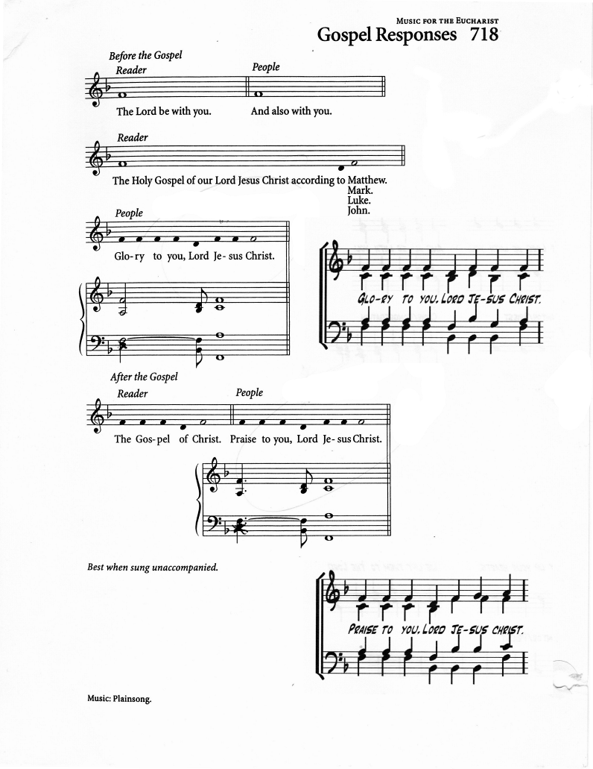
THE GOSPEL: John 20:19-31 (Ianthe Alleyne)

The Lord be with you
And also with you

The Holy Gospel of our Lord Jesus Christ according to John
Glory to you Lord, Jesus Christ

When it was evening on that day, the first day of the week, and the doors of the house where the disciples had met were locked for fear of the Jews, Jesus came and stood among them and said, “Peace be with you.”
After he said this, he showed them his hands and his side. Then the disciples rejoiced when they saw the Lord. Jesus said to them again, “Peace be with you.
As the Father has sent me, so I send you.” When he had said this, he breathed on them and said to them, “Receive the Holy Spirit. If you forgive the sins of any, they are forgiven them; if you retain the sins of any, they are retained.” But Thomas (who was called the Twin), one of the twelve, was not with them when Jesus came. So the other disciples told him, “We have seen the Lord.” But he said to them, “Unless I see the mark of the nails in his hands, and put my finger in the mark of the nails and my hand in his side, I will not believe.”
A week later his disciples were again in the house, and Thomas was with them. Although the doors were shut, Jesus came and stood among them and said,
“Peace be with you.” Then he said to Thomas, “Put your finger here and see my hands. Reach out your hand and put it in my side. Do not doubt but believe.” Thomas answered him, “My Lord and my God!” Jesus said to him, “Have you believed because you have seen me? Blessed are those who have not seen and yet have come to believe.” Now Jesus did many other signs in the presence of his disciples, which are not written in this book. But these are written so that you may come to believe that Jesus is the Messiah, the Son of God, and that through
believing you may have life in his name.

The Gospel of Christ
Praise to you, Lord Jesus Christ

GOSPEL ACCLAMATION: Caribbean Alleluia

THE SERMON:

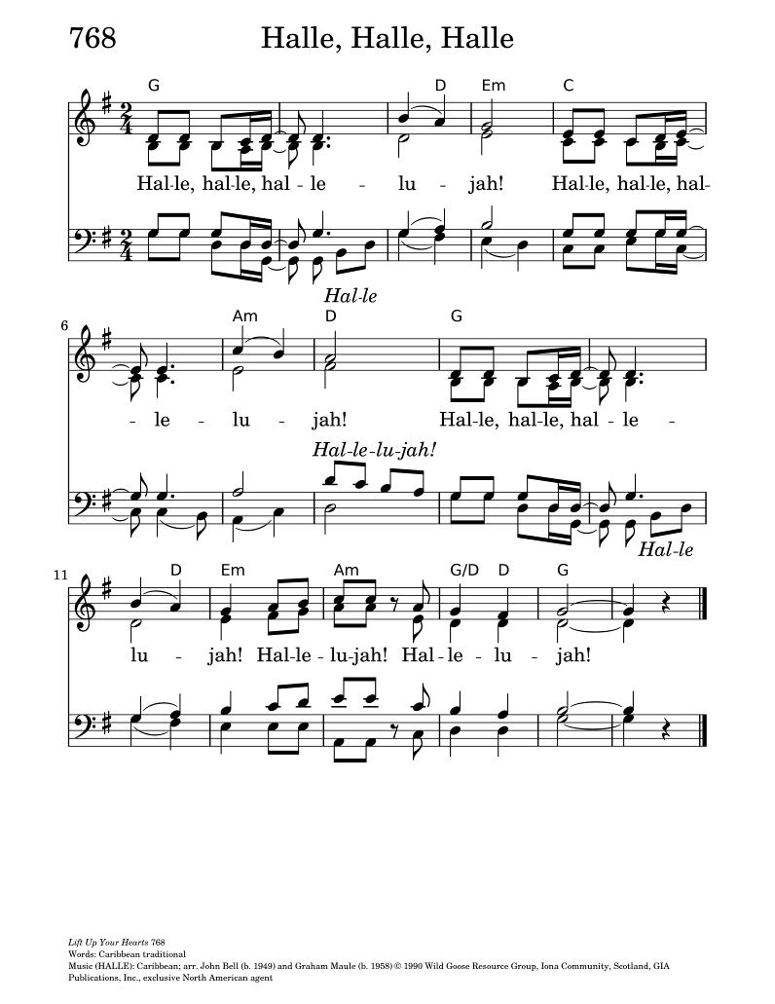
Let us confess our faith, as we sing,

The Creed: We be­lieve in God the Fa­ther
Lyrics: Timothy Dudley-Smith; Tune: HYMN TO JOY

We be­lieve in God the Fa­ther,
God Al­migh­ty, by whose plan
Earth and Heav­en sprang in­to be­ing,
All cre­at­ed things be­gan.

We be­lieve in Christ the Sav­iour,
Son of God in hu­man frame,
Virgin born, the Child of Ma­ry,
Upon whom the Spir­it came.

Christ, who on the cross for­sak­en,
Like a lamb to slaugh­ter led,
Suffered un­der Pon­ti­us Pi­late,
He des­cend­ed to the dead.

We be­lieve in Je­sus ris­en,
Heaven’s King to rule and reign,
To the Fa­ther’s side as­cend­ed
Till as Judge He comes again.

We be­lieve in God the Spir­it:
In one Church, be­low, ab­ove;
Saints of God in one com­mun­ion,
One in ho­li­ness and love.

So by faith, our sins for­giv­en,
Christ our Sav­ior, Lord and friend,
We shall rise with Him in glo­ry
To the life that knows no end.

PRAYERS OF INTERCESSION (David Elcock)

Let us pray,

Risen Christ, you stand among us and say, “Peace be with you.”
In that peace, we bring our prayers before you.

Risen Lord, you breathed your Spirit upon your disciples
and sent them into the world. Renew your Church with that same Spirit.
Strengthen all who proclaim the gospel, and make us bold witnesses of your resurrection. We pray for Andrew, Riscylla and Kevin and all bishops, for Kenute, Elizabeth, Leonard and all priests and deacons, and for all the baptized, that we may live as people of Easter faith.
Lord, in your mercy,
Hear our prayer.

Prince of Peace, you enter places of fear and division.
Bring your peace to the nations of Ukraine, Gaza, Sudan, Haiti, Myanmar and Iran torn by conflict, fractured by injustice, and living behind locked doors of anxiety and uncertainty. Guide leaders in the ways of justice, wisdom, and compassion.
Lord, in your mercy,
Hear our prayer.

Gracious Lord, you did not turn away Thomas the Apostle in his doubt,
but met him with compassion and truth. Draw near to all who struggle to believe,
to those wrestling with questions, grief, or silence.
Reveal yourself in ways they can see and know your love.
Lord, in your mercy,
Hear our prayer.

Healing Christ, you showed your wounded hands and side.
Be present with all who suffer in body, mind, or spirit.
We remember especially Don Krasnovich, Mary Engels, Hyacinth Brooks,
Tony Holder, Gloria & Ancille Parsons, Hazell Coombes, Ann Philips, Sophia Goodman, Doreen Ali, Lucia Mazzone, John Denman, Grace Jordan, Andrea Clarke, Joyce Evans, Johnny McGrath, Cheryl Dean-Harris, Monica Herman, Stella Layne, Earl Williams, Sarah Khan, Esmeralda Taylor, Edith Kwamie, Donna Gero, Erma Greenwich, Vincent Samuels, Hazeldene Clarke, Mehri Norouzi, Margaret Hudson, Diana Henry, Herman Lobban, Winston Barnes, George Dougall, Dwayne Inniss,
Joanne Pitt, Juliet Holness-Lobban, Iloma Brown, Vinnie Jordan, Victoria Attard,
Vinetta Williams, Ester Jones, Roslyn Bartholomew, Stanza Jordan, Dorothy & Shawn Williams, Candace Campbell, Chloe Goring, Sarah Brathwaite, Peninah Nyihorana, Celes Brown, Joyce Noble, Raymond Mason, Elizabeth Carter, Trevor Barrow, Carol Roberts, Raddy Iran, Jojo Ucat Donavon Campbell, Beth Ramage, Coral Hosford, Selwyn Coombes, Desire Mason, Standford Willis, Curtis Jordan,
Elizabeth Mason, Jaleel Levy, Sophie Lindsay & Sybil Robinson.
Bring comfort, healing, and the peace that passes understanding.
Lord, in your mercy,
Hear our prayer.

Living Lord, you call us blessed who have not seen and yet believe.
Deepen our faith, strengthen our fellowship, and make us signs of your resurrection life in this place. Help us to carry your peace into our homes,
our workplaces, and our neighbourhoods.
Lord, in your mercy,
Hear our prayer.

Risen Saviour, you have conquered death. We commend to you those who have died in the hope of the resurrection. Grant them rest in your eternal peace,
and bring us all to share in your risen life.
Lord, in your mercy,
Hear our prayer.
Lord Jesus Christ, you are our risen Lord and our living hope.
Receive these prayers and those we hold in the silence of our hearts,
for you live and reign forever and ever.
Amen.

CONFESSION & ABSOLUTION:

Dear friends in Christ, God is steadfast in love and infinite in mercy and welcomes sinners. Let us confess our sins, confident in God's forgiveness.

Most merciful God,
we confess that we have sinned against you in thought, word and deed,
by what we have done and by what we have left undone.
We have not loved you with our whole heart;
we have not loved our neighbours as ourselves.
We are truly sorry and we humbly repent.
For the sake of your Son Jesus Christ, have mercy on us and forgive us,
that we may delight in your will, and walk in your ways,
to the glory of your name. Amen.

Almighty God have mercy upon you, pardon and deliver you
from all your sins, confirm and strengthen you in all goodness,
and keep you in eternal life; through Jesus Christ our Lord.
Amen.

The Peace

The peace of the Lord be always with you.
And also with you.

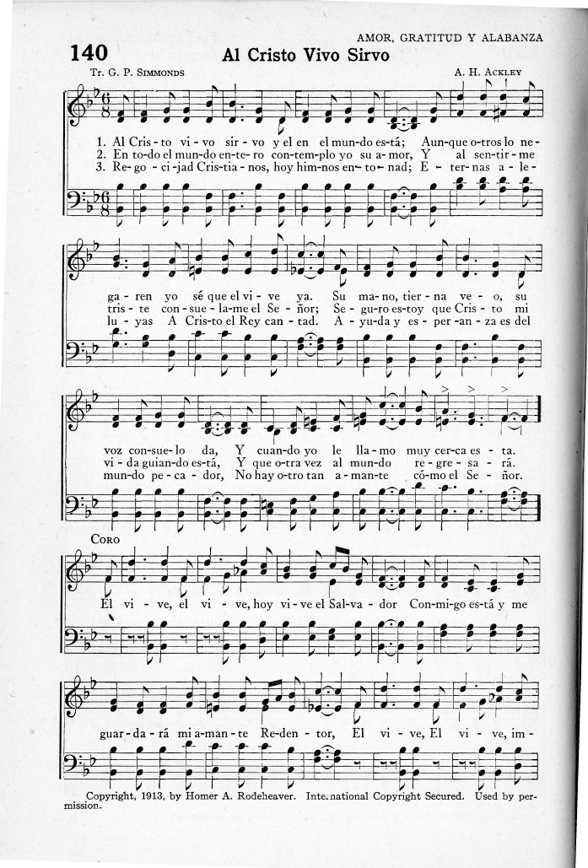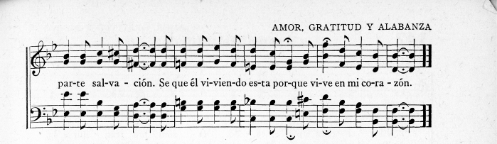
OFFERTORY HYMN: I Serve a Risen Saviour
Text: A. H. Ackley; Tune: ACKLEY

I serve a risen Saviour, He’s in the world today.
I know that He is living, whatever men may say.
I see His hand of mercy; I hear His voice of cheer;
And just the time I need Him, He’s always near.

(refrain)
He lives, He lives, Christ Jesus lives today!
He walks with me and talks with me along life’s narrow way.
He lives, He lives, salvation to impart!
You ask me how I know He lives?
He lives within my heart.

In all the world around me - I see His loving care,
And though my heart grows weary, I never will despair;
I know that He is leading, through all the stormy blast;
The day of His appearing will come at last. (refrain)

Rejoice, rejoice, O Christian, lift up your voice and sing
Eternal hallelujahs to Jesus Christ the King!
The Hope of all who seek Him, the Help of all who find,
None other is so loving, so good and kind. (refrain)

PRAYER OVER THE GIFTS

God of grace,
you have freed us from our sins and made us a kingdom
in your Son Jesus Christ our Lord.
Accept all we offer you this day,
and strengthen us in the new life you have given us,
through Jesus Christ our Lord.
Amen.
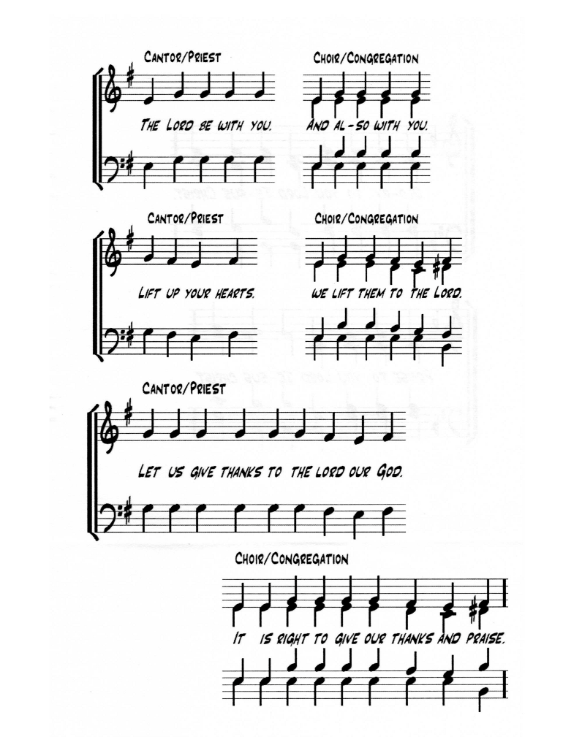
THE GREAT THANKSGIVING

EUCHARISTIC PRAYER (Church of England)

The Lord be with you.
And also with you.

Lift up your hearts.
We Lift them to the Lord.

Let us give thanks to the Lord our God.
It is right to give our thanks and praise.

It is truly right and just, our duty and our salvation,
always and everywhere to give you thanks,
holy Father, almighty and eternal God.
For though the human race is divided by dissention and discord,
Christ calls us in his death and resurrection
to embody hearts of change and his work of reconciliation.

By your Spirit you give courage to overcome fears and to seek the unity of all.
By the working of your power, hatred is overcome by love,
revenge gives way to forgiveness,
and division is transformed by mutual respect and humility.
Therefore, we give you ceaseless thanks,
and join with choirs of angels and with all the heavenly host,
to proclaim your glory in their unending song of praise:

SANCTUS:
Holy, holy, holy, Lord, God of power and might,
Heaven and earth are full of your glory.
Hosanna in the highest.
Blessed is he who comes in the name of the Lord.
Hosanna in the highest.

We praise and bless you, loving Father,
through Jesus Christ, our Lord;
and as we obey his command, send your Holy Spirit,
that broken bread and wine outpoured
may be for us the body and blood of your dear Son.

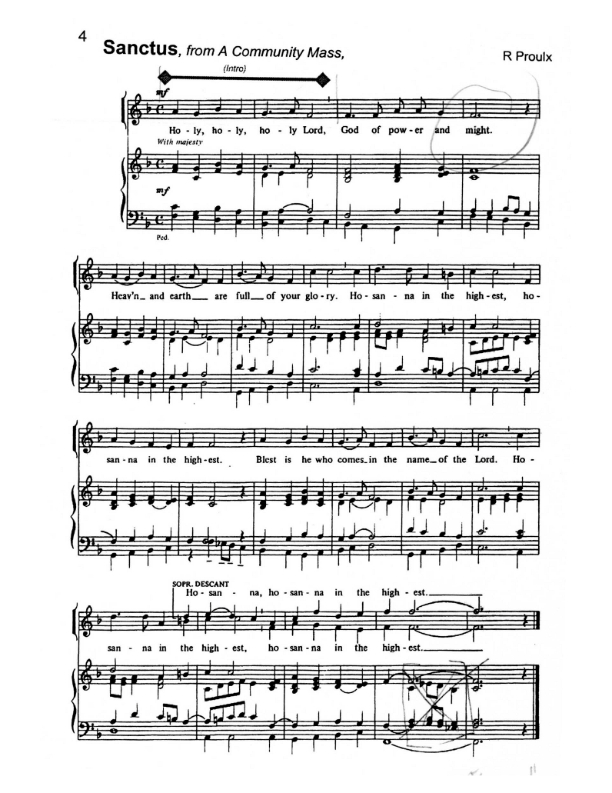
On the night before he died he had supper with his friends
and, taking bread, he praised you.
He broke the bread, gave it to them and said:
Take, eat; this is my body which is given for you;
do this in remembrance of me.

When supper was ended he took the cup of wine.
Again he praised you, gave it to them and said:
Drink this, all of you; this is my blood of the new covenant,
which is shed for you and for many for the forgiveness of sins.
Do this, as often as you drink it, in remembrance of me.
So, Father, we remember all that Jesus did,
in him we plead with confidence for his sacrifice
made once for all upon the cross.
Bringing before you the bread of life and cup of salvation,
we proclaim his death and resurrection until he comes in glory.

Let us proclaim the mystery of our faith

ACCLAMATION: (Tune: WE SHALL OVERCOME)

(sung) Jesus Christ has died
Jesus Christ is risen
Jesus Christ will come again
Deep in my heart I do believe
Jesus Christ will come again

Lord of all life,
help us to work together for that day when your kingdom comes
and justice and mercy will be seen in all the earth.
Look with favour on your people, gather us in your loving arms
and bring us with all the saints to feast at your table in heaven.
Through Christ, with Christ, and in Christ in the unity of the Holy Spirit,
we worship you, Father Almighty, now and forever.
Amen.

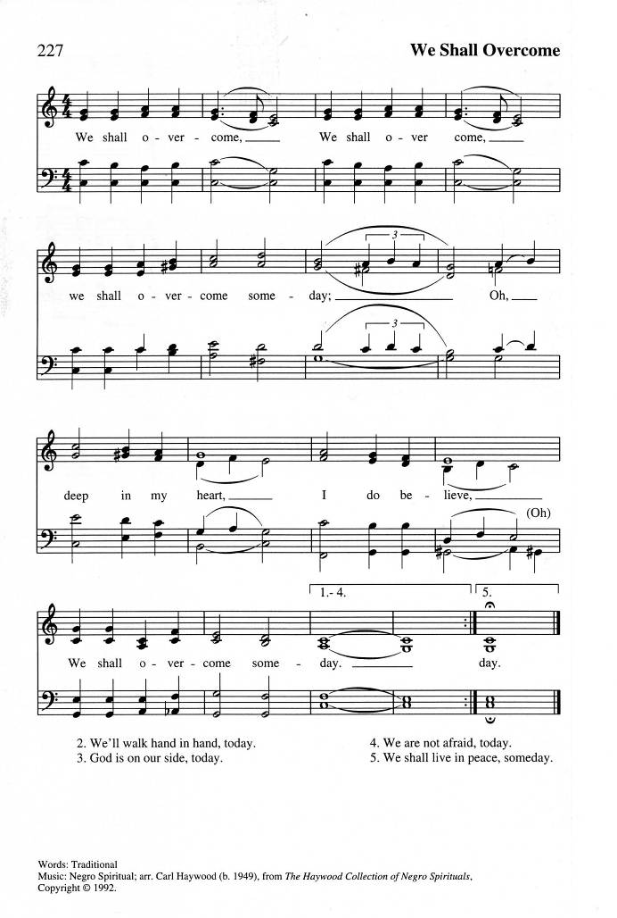
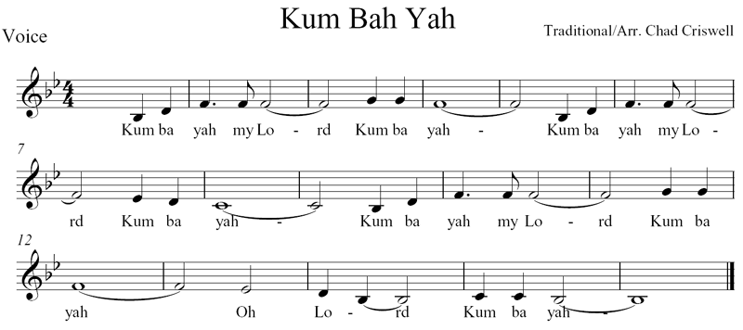
The Lord’s Prayer
And now, as our Saviour Christ has taught us, we are bold to sing.

Father God in Heaven
Text: J.E. Seddon; Tune: KUM BA YAH

Father God in heaven, Lord most high:
hear your children's prayer, Lord most high:
hallowed be your name, Lord most high
O Lord, hear our prayer.

May your kingdom come, here on earth;
may your will be done, here on earth,
as it is in heaven, so on earth
O Lord, hear our prayer.

Give us daily bread, day by day,
and forgive our sins, day by day,
as we too forgive, day by day
O Lord, hear our prayer.

Lead us in your way, make us strong;
when temptations come, make us strong;
save us from all sin, keep us strong
O Lord, hear our prayer.

All things come from you, all are yours
kingdom, glory, power, all are yours;
take our lives and gifts, all are yours
O Lord, hear our prayer. Amen.
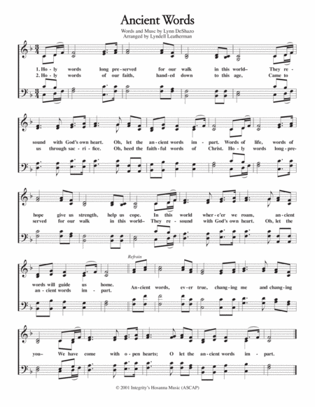
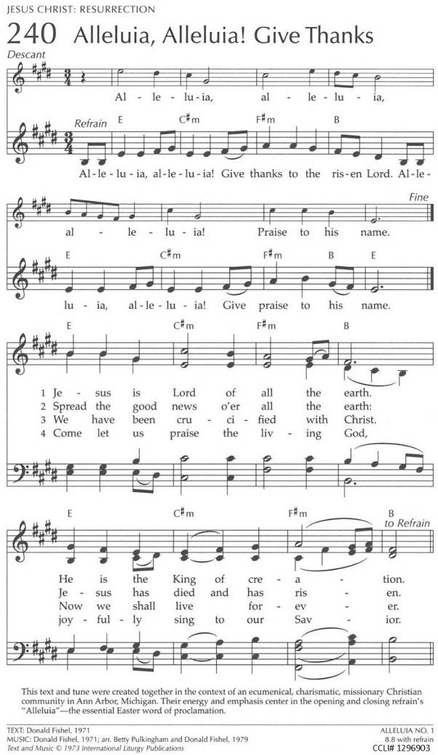
THE BREAKING OF THE BREAD

Lord, we died with you on the cross,
Now we are raised to new life

We were buried in your tomb
Now we share in your resurrection.

Live in us, that we nay live in you.

THE INVITATION

The gifts of God for the People of God
Thanks be to God.

COMNMUNION: Alleluia, Alleluia, Give Thanks To the Risen Lord
Text & Music: Donald Fishel; Tune: ALLELUIA NO. 1

Alleluia, Alleluia, give thanks to the risen Lord
Alleluia, Alleluia, give praise to his name.

Jesus is Lord of all the earth
He Is the King of creation. (refrain)

Spread the Good News all the earth
Jesus has died and has risen. (refrain)

We have been crucified with Christ
now we shall live forever. (refrain)

come let us praise the living God
joyfully sing to our Saviour. (refrain)

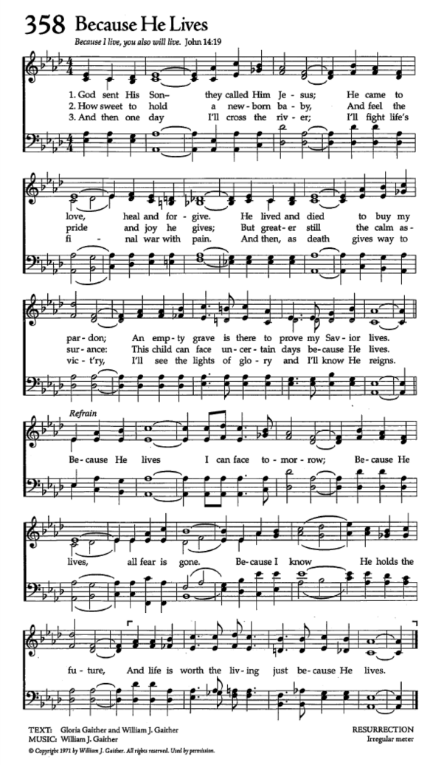
ABLUTIONS:` Because He Lives
Text: Gloria & William Gaither Tune: RESURRECTION

God sent His son, they called Him Jesus;
He came to love, heal and forgive;
He lived and died to buy my pardon,
An empty grave is there to prove my Saviour lives!

(refrain)
Because He lives, I can face tomorrow,
Because He lives, all fear is gone;
Because I know He holds the future,
And life is worth a living just because He lives.

And then one day, I'll cross the river
And I'll fight life's final war with pain
And then ss death gives way to victory
I'll see the lights of glory and I'll know He reigns. (refrain)

PRAYER AFTER COMMUNION:

Father, we have seen with our eyes
and touched with our hands the bread of life.
Strengthen our faith that we may grow in love for you and for each other;
through Jesus Christ the risen Lord. Amen.

THE BLESSING:

Alleluia! Christ is risen!
Christ is risen indeed! Alleluia!

There is now no negative force that can finally defeat us,
Leave this house of prayer confidently, travel joyfully, love generously, serve gladly,
And the blessing of God almighty, the Father, the Son and the Holy Spirit
be with you now and always.
Amen.

Announcements:

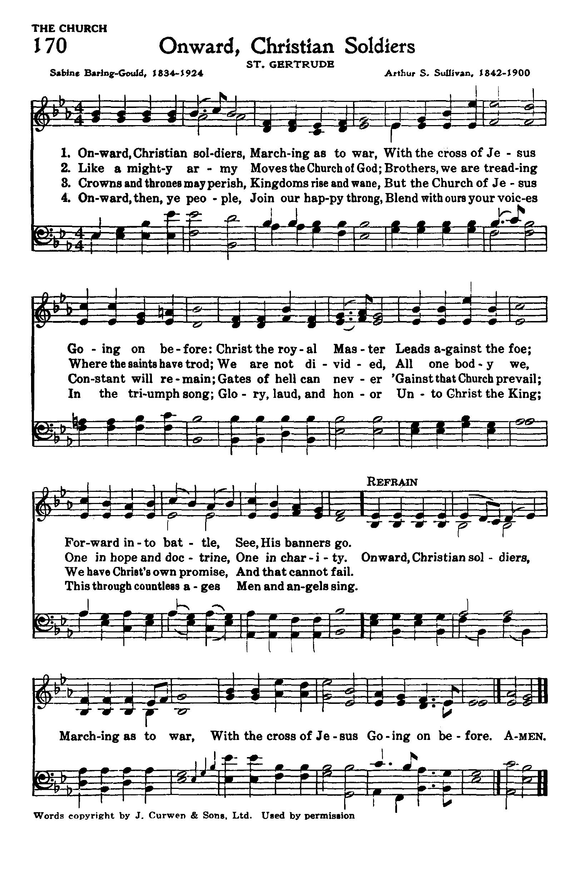
Recessional Hymn: Jesus, Prince and Saviour
Text: Timothy Dudley-Smith; Tune: GERTRUDE

Jesus, prince and saviour, Lord of life who died,
Christ, the friend of sinners, mocked and crucified;
for a world’s salvation - he his body gave,
lay at last death’s victim, lifeless in the grave.

(refrain)
Lord of life triumphant, risen now to reign!
King of endless ages, Jesus lives again!

In his power and Godhead- every victory won,
pain and passion ended, all his purpose done:
Christ the Lord is risen: sighs and sorrows past,
death’s dark night is over, morning comes at last! (refrain)

Resurrection morning, sinners’ bondage freed!
Christ the Lord is risen, he is risen indeed!
Jesus, Prince and Saviour, Lord of life who died,
Christ the King of glory now is glorified! (refrain)

THE DISMISSAL:

Followers of Christ, Inspired by the Holy Spirit.
Serve the world God loves. Alleluia! Alleluia!
Thanks be to God. Alleluia! Alleluia!

POSTLUDE: Celebrate Jesus, Celebrate
