The Fourth Sunday after the Epiphany

Celebrating the Presentation of Jesus & Black History

February 1, 2026, 10:30am

Black History Theme: “30 Years of Black History Month: Honouring Black Brilliance Across Generations — From Nation Builders to Tomorrow’s Visionaries.”

Website: www.sthildasanglicanchurch.com
Church Email: info@sthildasanglicanchurch.com
Facebook: St. Hilda’s Fairbank Anglican Church

Incumbent: Fr. Kenute Francis (437-488-9657)

kenute@sthildasanglicanchurch.com

Honorary Assistant: Canon Leonard Abbah

Organist: William “Bill” Khan
Crucifer: Kishmar Miller

Eucharistic Ministers: William, Ianthe & Errol

Moderator: Akada Olive

Welcome: Tessanni Philip-Brown

1st Reading: Sherlian Grant

2nd Reading: Annika Pereira

Gospel: Angelica McPherson

Sermon: Ms. Constance Kendall

Intercession: Joacquim & Mikhail Getfield-Francis
Nation Builders & Visionaries: Kai Nedd & Kishmar Miller

Tech Team:

Ushers Team 3: Sonia Wickham Andrea Clarke

Richard Goddard Richard Morris Denise Sawney-Mark Jenita Hutchison

Pauline Waldron Patricia Roachford

The Order of Service

Prelude: (band) Blessed be the Name of the Lord

Clinton Utterbach

Blessed be the name of the Lord
Blessed be the name of the Lord
Blessed be the name of the Lord Most High
Blessed be the name of the Lord
Blessed be the name of the Lord
Blessed be the name of the Lord Most High

(refrain)
The name of the Lord is a strong tower
The righteous run into it and they are saved
The name of the Lord is a strong tower
The righteous run into it and they are saved.

Glory to the name of the Lord
Glory to the name of the Lord
Glory to the name of the Lord Most High
Glory to the name of the Lord
Glory to the name of the Lord
Glory to the name of the Lord Most High. (refrain)

Opening Prayer: (Akada Olive)

God of light, you fulfilled your promise in Jesus and revealed your salvation to all people. Open our eyes to see your glory and our hearts to receive your peace;
through Jesus Christ our Lord.
Amen.

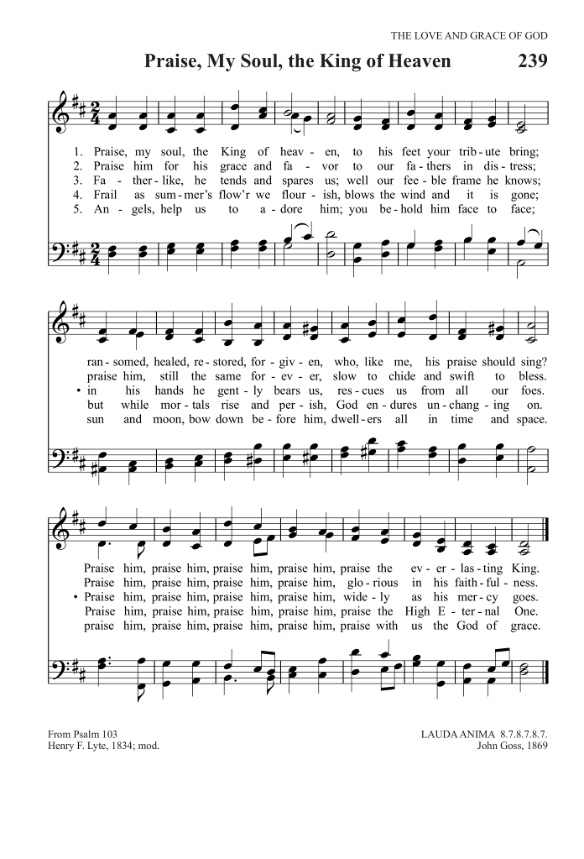
Processional: (organ) In His Temple Now Behold Him
Text: Henry J. Pye; Tune: PRAISE MY SOUL

In His temple now behold Him;
See the long-expected Lord!
Ancient prophets had foretold him;
God hath now fulfilled His word.
Now to praise Him, His redeemed
Shall break forth with one accord.

In the arms of her who bore Him,
Virgin pure, behold Him lie,
While His aged saints adore Him,
Ere in perfect faith they die:
Alleluia! Alleluia!
Lo, the incarnate God most high!

Jesus, by Thy Presentation,
Thou, Who didst for us endure,
Make us see Thy great salvation,
Seal us with Thy promise sure;
And present us in Thy glory
To Thy Father cleansed and pure.

Prince and author of salvation,
Be Thy boundless love our theme!
Jesus, praise to Thee be given
By the world Thou didst redeem,
With the Father and the Spirit,
Lord of majesty supreme!

Welcome: (Tessanni Philip-Brown)

The Greeting: (Akada Olive)

The love of the Creator, the grace of the Redeemer,
and the fellowship of the Counsellor, be with you all.
And also with you.

Rejoice! The Light of God has come into the world.

We come to see the Light revealed.

The promise long awaited is now placed among us.

Our eyes have seen God’s salvation!

We’ve come this far by faith leaning on the Lord.

To Christ our Lord, be glory, honour and blessing, forever and ever.

Amen.

The Collect for Purity (Akada Olive)

Almighty God,
to you all hearts are open, all desires known,
and from you no secrets are hidden. Cleanse the thoughts of our hearts by the inspiration of your Holy Spirit,
that we may perfectly love you, and worthily magnify your holy name;
through Christ our Lord. Amen.

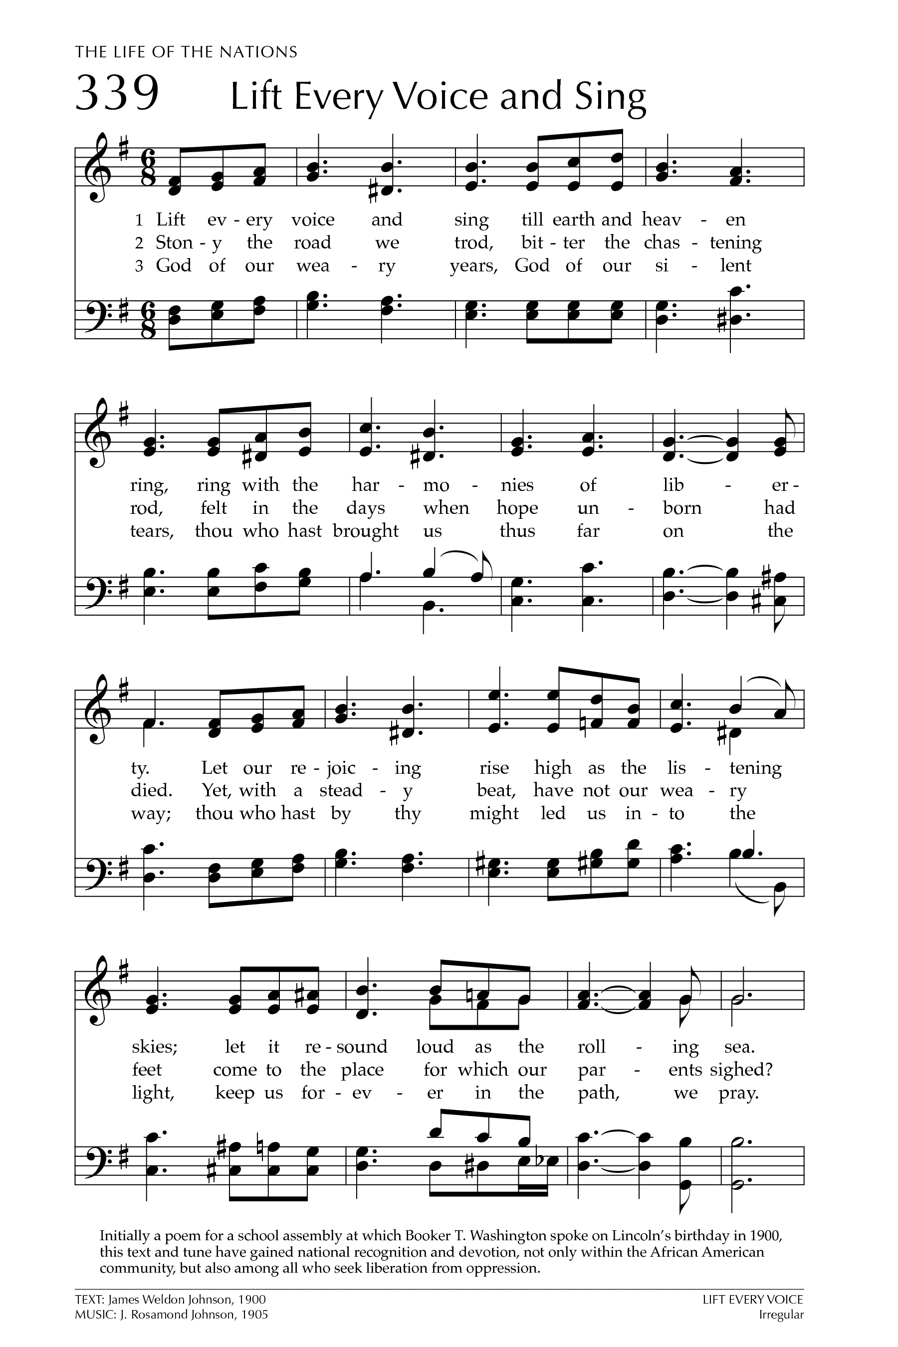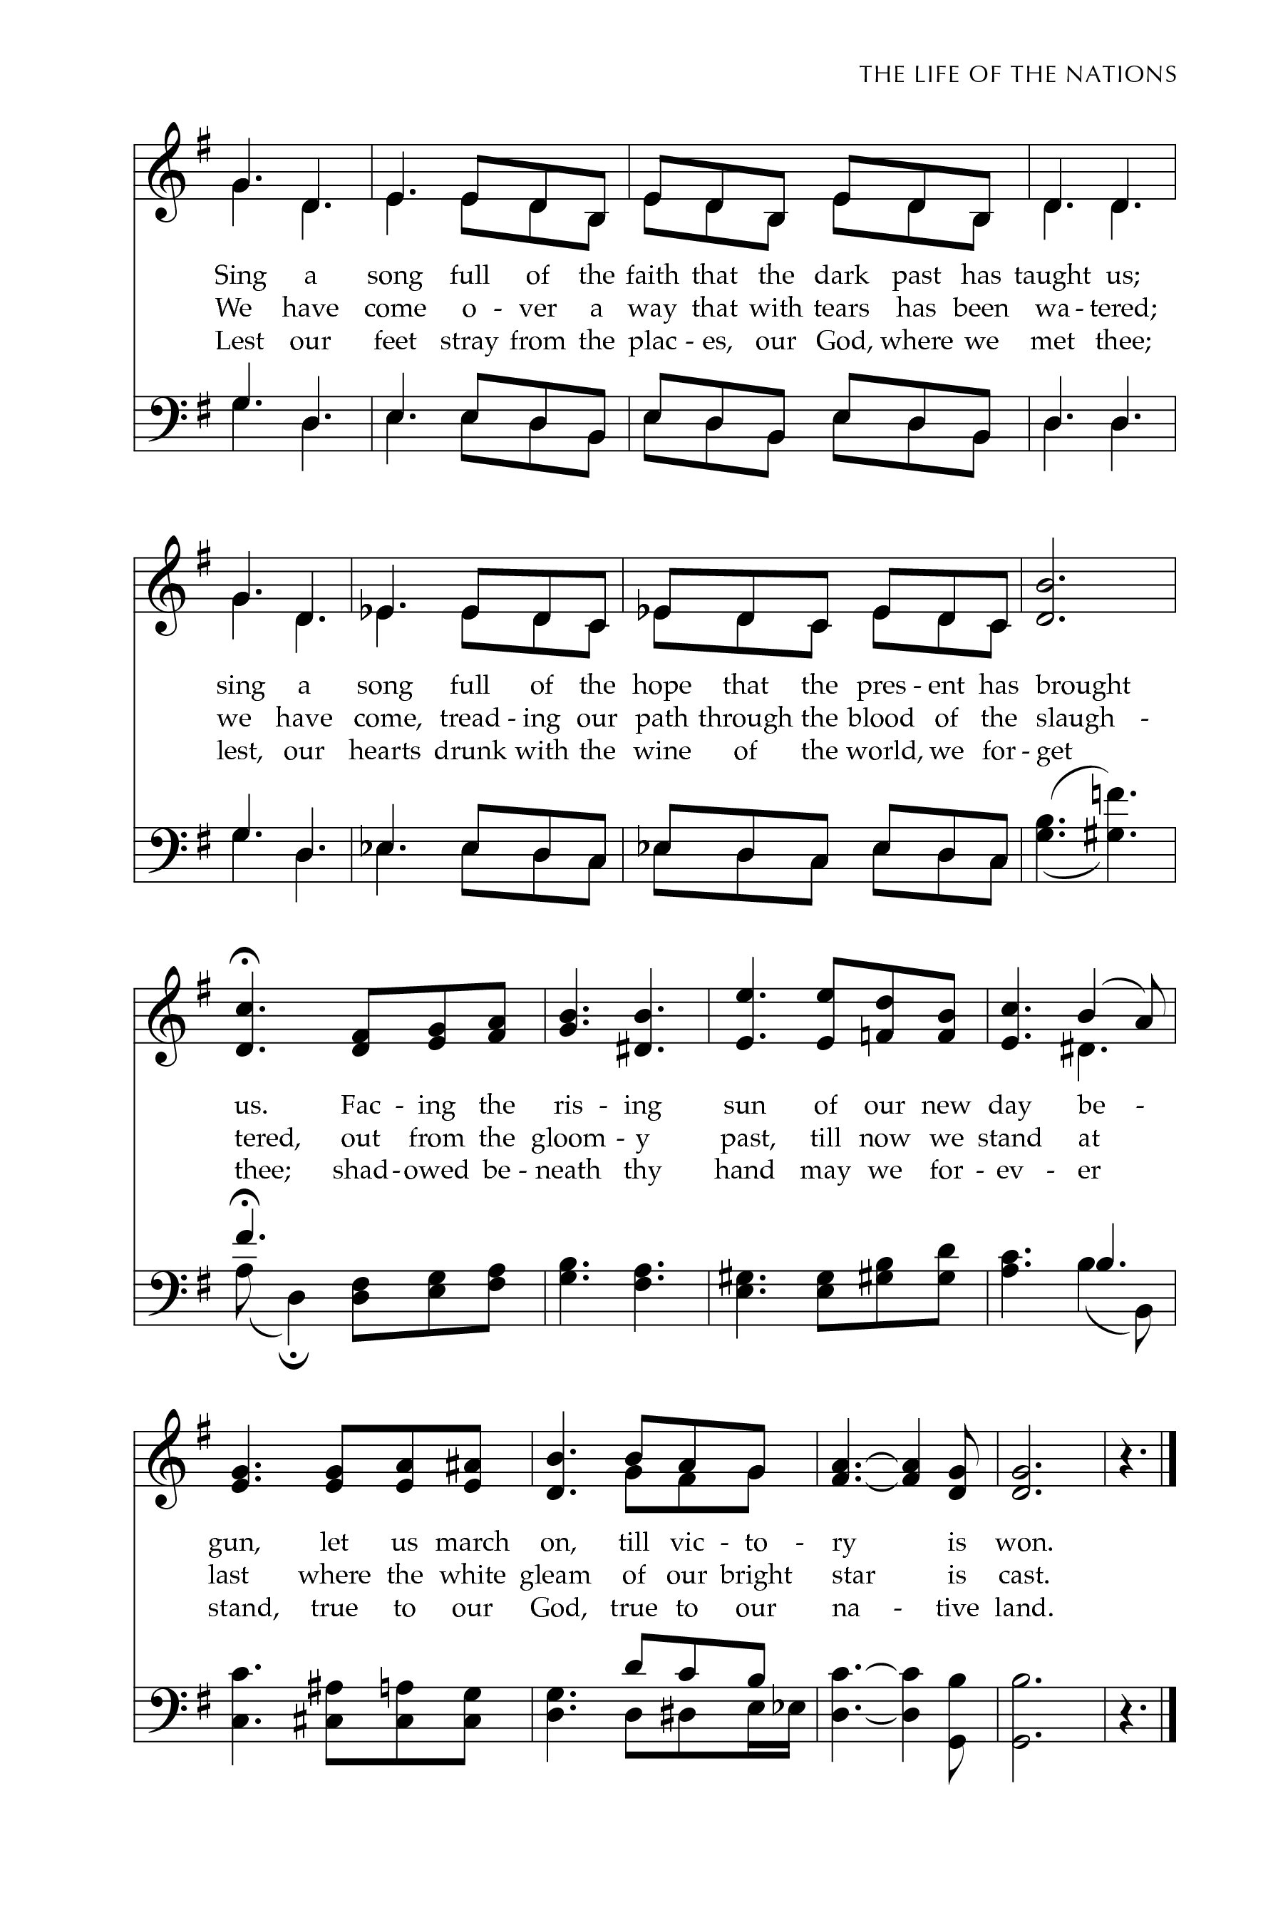
Introit: (organ) Lift Ev’ry Voice and Sing,
Text: James Weldon Johnson; Tune: LIFT EVERY VOICE

Lift ev’ry voice and sing, till earth and heaven ring,
ring with the harmonies of liberty.
Let our rejoicing rise - high as the list’ning skies,
let it resound loud as the rolling sea.
Sing a song full of the faith that the dark past has taught us.
Sing a song full of the hope that the present has brought us.
Facing the rising sun of our new day begun,
let us march on till victory is won.

Stony the road we trod, bitter the chast’ning rod,
felt in the days when hope unborn had died;
yet with a steady beat, have not our weary feet
come to the place for which our people sighed?
We have come over a way that with tears has been watered.
We have come, treading our path thro’ the blood of the slaughtered,
out from the gloomy past, till now we stand at last
where the bright gleam of our bright star is cast.

God of our weary years, God of our silent tears,
thou who hast brought us thus far on the way,
thou who hast by thy might - led us into the light,
keep us forever in the path, we pray.
Lest our feet stray from the places, our God, where we met thee;
lest our hearts, drunk with the wine of the world, we forget thee;
shadowed beneath thy hand, may we forever stand,
true to our God, true to our native land.

The Collect for the Presentation of Jesus Fr. Kenute

Let us pray,

Blessed are you, O Lord our God, for you have sent us your salvation.
Inspire us by your Holy Spirit to recognize him who is the glory of Israel
and the light for all nations, your Son Jesus Christ our Lord.
Amen.

THE PROCLAMATION OF THE WORD

First Reading: Malachi 3:1-4 (Sherlian Grant)

A Reading from the Book of Malachi

See, I am sending my messenger to prepare the way before me,
and the Lord whom you seek will suddenly come to his temple.
The messenger of the covenant in whom you delight—
indeed, he is coming, says the Lord of hosts.
But who can endure the day of his coming, and who can stand when he appears? For he is like a refiner’s fire and like fullers’ soap;
he will sit as a refiner and purifier of silver,
and he will purify the descendants of Levi and refine them like gold and silver,
until they present offerings to the Lord in righteousness.
Then the offering of Judah and Jerusalem will be pleasing to the Lord
as in the days of old and as in former years.

The Word of the Lord
Thanks be to God

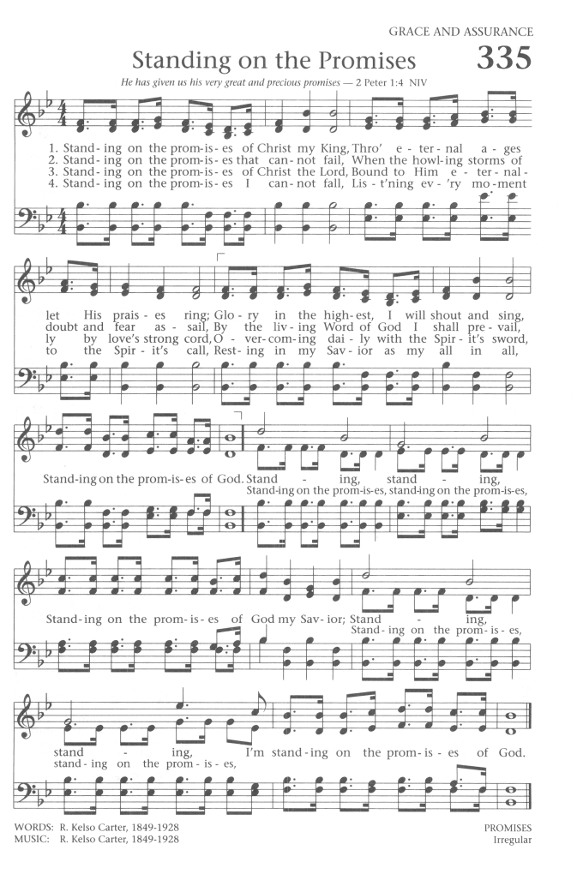
Hymn: Standing on the Promises
Text: Russell K. Carter; Tune: PROMISES

Standing on the promises of Christ my King,
Through eternal ages let His praises ring,
Glory in the highest, I will shout and sing,
Standing on the promises of God.

(refrain)
Standing, standing, Standing on the promises of God my Saviour;
Standing, standing, I’m standing on the promises of God.

Standing on the promises that cannot fail,
When the howling storms of doubt and fear assail,
By the living Word of God I shall prevail,
Standing on the promises of God. (refrain)

Standing on the promises I now can see
Perfect, present cleansing in the blood for me;
Standing in the liberty where Christ makes free,
Standing on the promises of God. (refrain)

Standing on the promises of Christ the Lord,
Bound to Him eternally by love’s strong cord,
Overcoming daily with the Spirit’s sword,
Standing on the promises of God. (refrain)

Second Reading: Hebrews 2:10-18 (Annika Pereira)

A reading from the Letter of Paul to the Hebrews

It was fitting that God, for whom and through whom all things exist,
in bringing many children to glory, should make the pioneer of their salvation perfect through sufferings. For the one who sanctifies and those who are sanctified all have one Father. For this reason Jesus is not ashamed to call them brothers and sisters, saying, “I will proclaim your name to my brothers and sisters,
in the midst of the congregation I will praise you.”
And again, “I will put my trust in him.”
And again, “Here am I and the children whom God has given me.”
Since, therefore, the children share flesh and blood, he himself likewise shared the same things, so that through death he might destroy the one who has the power of death, that is, the devil, and free those who all their lives were held in slavery by the fear of death. For it is clear that he did not come to help angels,
but the descendants of Abraham. Therefore, he had to become like his brothers and sisters in every respect, so that he might be a merciful and faithful high priest in the service of God, to make a sacrifice of atonement for the sins of the people.
Because he himself was tested by what he suffered, he is able to help those who are being tested.

The word of the Lord
Thanks be to God

Gradual: (band) Caribbean Alleluia

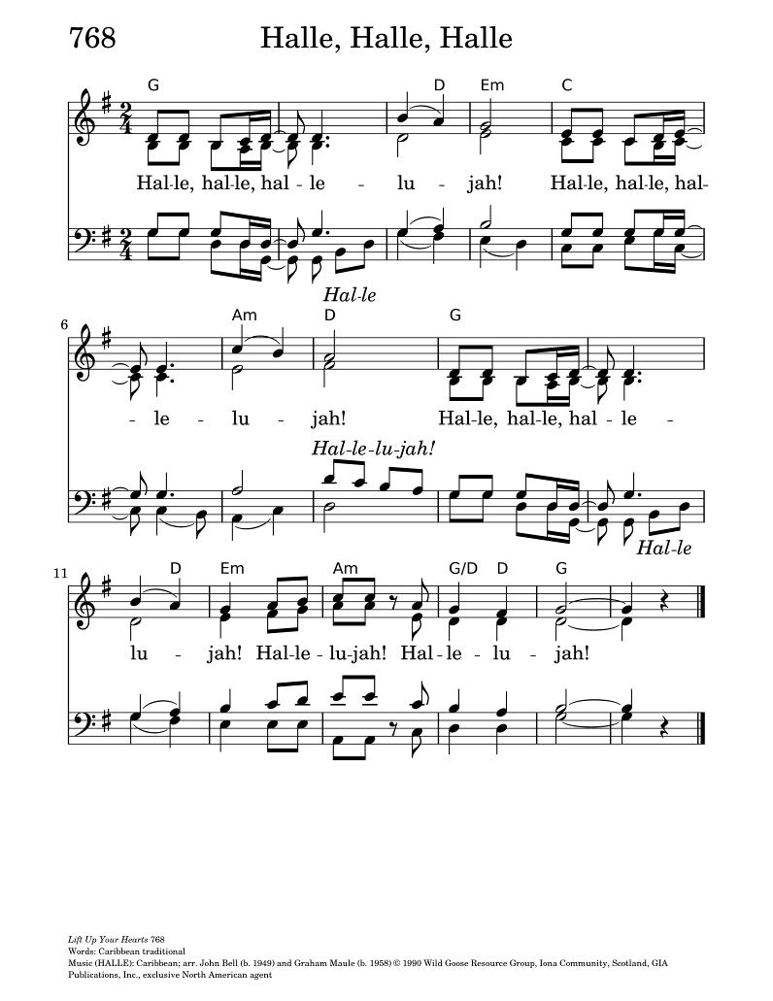
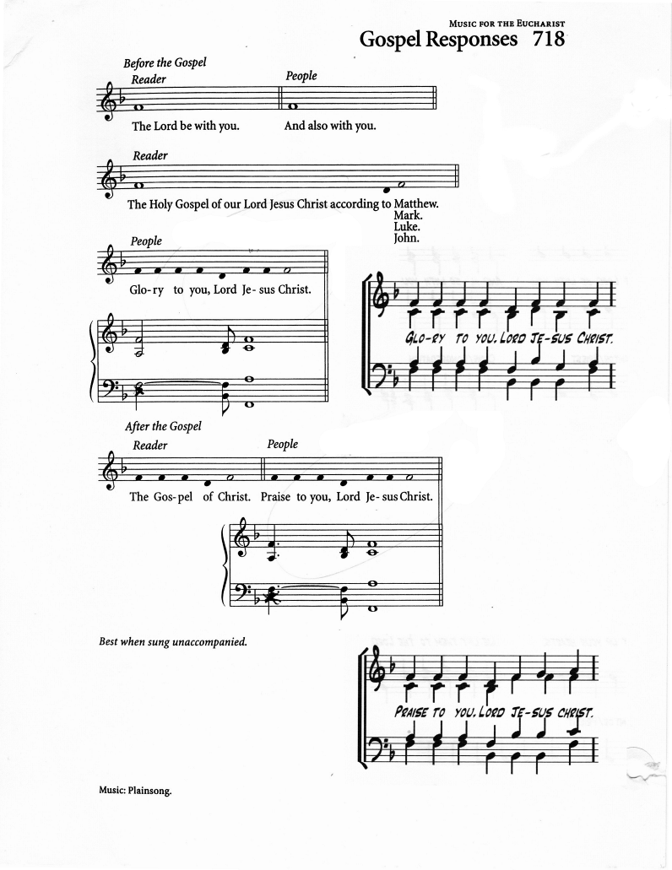
The Gospel: Luke 2:22-40 (Angelica McPherson)

The Lord be with you
And also with you

The Holy Gospel of our Lord Jesus Christ according to Luke
Glory to you Lord, Jesus Christ

When the time came for their purification according to the law of Moses,
they brought him up to Jerusalem to present him to the Lord (as it is written
in the law of the Lord, “Every firstborn male shall be designated as holy to the Lord”), and they offered a sacrifice according to what is stated in the law of the Lord, “a pair of turtledoves or two young pigeons.”
Now there was a man in Jerusalem whose name was Simeon; this man was righteous and devout, looking forward to the consolation of Israel, and the Holy Spirit rested on him. It had been revealed to him by the Holy Spirit that he would not see death before he had seen the Lord’s Messiah. Guided by the Spirit,
Simeon came into the temple; and when the parents brought in the child Jesus,
to do for him what was customary under the law, Simeon took him in his arms and praised God, saying, “Master, now you are dismissing your servant in peace, according to your word; for my eyes have seen your salvation, which you have prepared in the presence of all peoples, a light for revelation to the Gentiles and for glory to your people Israel.” And the child’s father and mother were amazed at what was being said about him. Then Simeon blessed them and said to his mother Mary, “This child is destined for the falling and the rising of many in Israel, and to be a sign that will be opposed so that the inner thoughts of many will be revealed—and a sword will pierce your own soul too.” There was also a prophet, Anna the daughter of Phanuel, of the tribe of Asher. She was of a great age, having lived with her husband seven years after her marriage, then as a widow to the age of eighty-four. She never left the temple but worshiped there with fasting and prayer night and day. At that moment she came, and began to praise God and to speak about the child to all who were looking for the redemption of Jerusalem.
When they had finished everything required by the law of the Lord, they returned to Galilee, to their own town of Nazareth. The child grew and became strong,
filled with wisdom; and the favor of God was upon him.

The Gospel of Christ
Praise to you, Lord Jesus Christ

Gospel Acclamation: (band) Caribbean Alleluia

The Sermon: Ms. Constance Kendal
Diocesan Youth Ministry Coordinator for the West Archdeaconry

Hymn: (band) We’ve Come This Far by Faith
Text & Music: Albert Goodson

(refrain)
We’ve Come This Far By Faith,
Leaning On The Lord.
Trusting In His Holy Word.
He’s Never Failed Us Yet.
Oh, Oh- Oh- Can’t Turn Around,
We’ve Come This Far By Faith.

Don’t Be Discouraged With Troubles In Your Life.
He’ll Bear Your Burdens
And Move All misery And Strife.
That’s why (refrain)

Just The Other Day I Heard someone Say,
He Didn’t Believe In God Word.
But I Can Truly Say The Lord Will Make A Way.
Because He Never Failed Me Yet.
That’s why we’ve (refrain)

Oh, Oh- Oh- Can’t Turn Around,
We’ve Come This Far By, This Far By Faith!

Thinking of Nation Builders
to Tomorrow’s Visionaries. Kai Ned & Kishmar Miller

Profession of Faith: (Akada Olive)

Let us confess our faith, as we say,

I believe in God, the Father almighty, creator of heaven and earth.
I believe in Jesus Christ, his only Son, our Lord.
He was conceived by the power of the Holy Spirit and born of the Virgin Mary.
He suffered under Pontius Pilate, was crucified, died, and was buried.
He descended to the dead. On the third day he rose again.
He ascended into heaven, and is seated at the right hand of the Father.
He will come again to judge the living and the dead.
I believe in the Holy Spirit, the holy catholic Church,
the communion of saints, the forgiveness of sins,
the resurrection of the body, and the life everlasting.
Amen.

The Intercession: (Joacquim & Mikhail Getfield-Francis)

Joacquim: Let us bring our prayers before God, who fulfils the hope of all generations.

Mikhail: For the Church universal, and for all who lead, teach,
and serve in Christ’s name, that we may be faithful witnesses,
living out the hope and justice we proclaim.
We pray to you, O Lord,
All: Lord, hear our prayer.

Joacquim: For our world, we pray for peace, and for our nation, our leaders, lawmakers, and citizens, we pray for justice, compassion, and equity.
We give thanks for the contributions of all who have helped shape this land, and remember those whose voices were silenced by oppression, slavery, or injustice,
We pray to you, O Lord,
All: Lord, hear our prayer.

Mikhail: For our cities, towns, and communities, that they may be places of welcome and inclusion, where neighbours help neighbours, and strangers—especially migrants and newcomers— are embraced and protected.
We pray to you, O Lord,
All Lord, hear our prayer.

Joacquim: For the relief of suffering in every form - for the hungry, the homeless, the lonely, the unemployed, and the oppressed, for all who face racism, discrimination, or marginalization, that God’s light may shine through acts of justice and mercy.
We pray to you, O Lord,
All: Lord, hear our prayer.

Mikhail: For the sick, the suffering, and the anxious, for those struggling with mental or physical illness, and for caregivers and health workers who share God’s compassion.
We pray to you, O Lord,
All: Lord, hear our prayer.

Joacquim: For our youth, growing up in a complex and confusing world,
that they may be guided by the Spirit, find faithful mentors,
and see God’s light in the midst of challenge and change.
We pray to you, O Lord,
All: Lord, hear our prayer.

Mikhail: For Black Canadians, past and present, whose courage, wisdom,
and vision have shaped communities, culture, and the life of the Church, and for all whose lives have been touched by injustice and discrimination.
We pray to you, O Lord,
All: Lord, hear our prayer.

Joacquim: For all people of faith, of every race, language, and nation,
that together we may shine the Light of Christ into the world,
being faithful to God’s call to justice, mercy, and peace.
We pray to you, O Lord,
All: Lord, hear our prayer.

Mikhail: Heavenly Father, we bring these prayers, spoken and unspoken,
trusting that your light pierces darkness, your love heals wounds,
and your Spirit strengthens us to walk in faithfulness across generations.
All: Amen.

Confession: (Akada Olive)

Let us confess our sins, confident in God's forgiveness.

Most merciful God,
we confess that we have sinned against you in thought, word and deed,
by what we have done and by what we have left undone.
We have not loved you with our whole heart;
we have not loved our neighbours as ourselves.
We are truly sorry and we humbly repent.
For the sake of your Son Jesus Christ,
have mercy on us and forgive us,
that we may delight in your will, and walk in your ways,
to the glory of your name. Amen.

Absolution: Fr. Kenute

Almighty God have mercy upon you,
pardon and deliver you from all your sins,
confirm and strengthen you in all goodness,
and keep you in eternal life; through Jesus Christ our Lord.
Amen.

The Peace (Akada Olive)

“When the power of love overcomes the love of power, the world will know peace.” The peace of the Lord be always with you.
And also with you.

Offertory (band) I am the Way, the King of the Victory
Text: Richard Ho Lung

I am the Way, the King of the Victory
I am the Truth, the Lord of the Harmony
I am the Light, the Light of the world to be

(refrain)
Hosanna! I hold your hand my friend,
Hosanna! I give you strength my friend,
Hosanna! You walk the sea my friend;
We gonna sail to victory!
Sailing (sailing), sailing (sailing)
Sailing cross the river, sailing!
Sailing (Jesus), sailing (sailing)
Sailing cross the river, sailing!
Freedom (brother), freedom (sister)
Freedom in the life of Jesus

Hosanna! I hold your hand my friend,
Hosanna! I give you strength my friend,
Hosanna! You walk the sea my friend;
We gonna sail to victory!

I am the Vine, you shall abide in Me,
I am the River, you shall be cleansed in Me,
I am the Rock, you shall have life in Me. (refrain)

I am your brother, living in flesh with thee
I am your Saviour, dying on Calvary.
I am your God, rising in victory. (refrain)

The Prayer over the Gifts

Almighty God, accept the joyful offering of your Church,
and grant that your Son may shine in us as the light that lightens every nation.
We ask this in the name of the same Jesus Christ our Lord.
Amen.

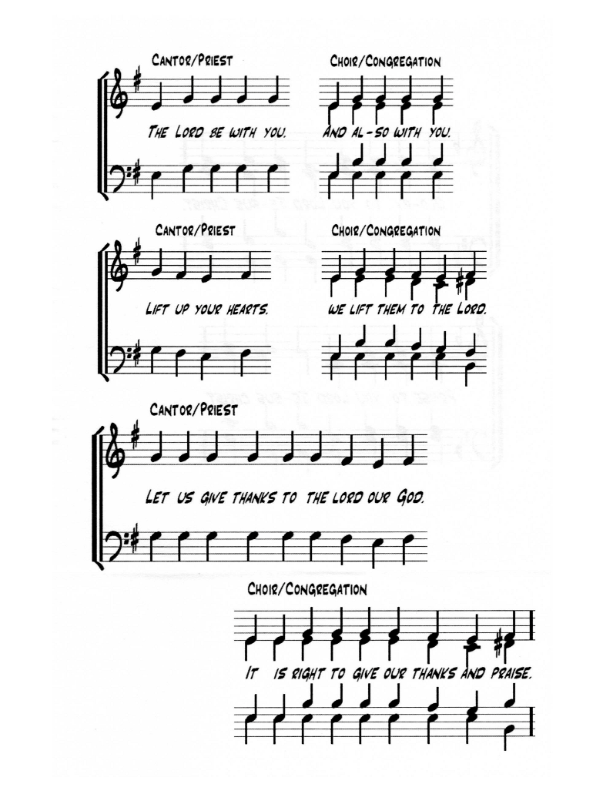
EUCHARISTIC PRAYER (Church of England)

The Lord be with you.
And also with you.

Lift up your hearts.
We Lift them to the Lord.

Let us give thanks to the Lord our God.
It is right to give our thanks and praise.

It is truly right and just, our duty and our salvation,
always and everywhere to give you thanks, holy Father, almighty and eternal God.
For though the human race is divided by dissention and discord,
Christ calls us in his death and resurrection to embody hearts of change
and his work of reconciliation.
By your Spirit you give courage to overcome fears and to seek the unity of all.
By the working of your power, hatred is overcome by love,
revenge gives way to forgiveness,
and division is transformed by mutual respect and humility.
Therefore, we give you ceaseless thanks,
and join with choirs of angels and with all the heavenly host,
to proclaim your glory in their unending song of praise:

Sanctus: (band) Daren Evans & Everton Clarke

Holy, holy, holy, holy, Lord.
Lord, God of power and might,
heaven and earth are full, O- of your glory. X2
Holy, holy, holy, holy, Lord.

Blessed is he who comes
In the precious name of the Lord.
Hosanna upon high. Hosanna upon high
Blessed is he who comes.

We praise and bless you, loving Father, through Jesus Christ, our Lord;
and as we obey his command, send your Holy Spirit,
that broken bread and wine outpoured
may be for us the body and blood of your dear Son.
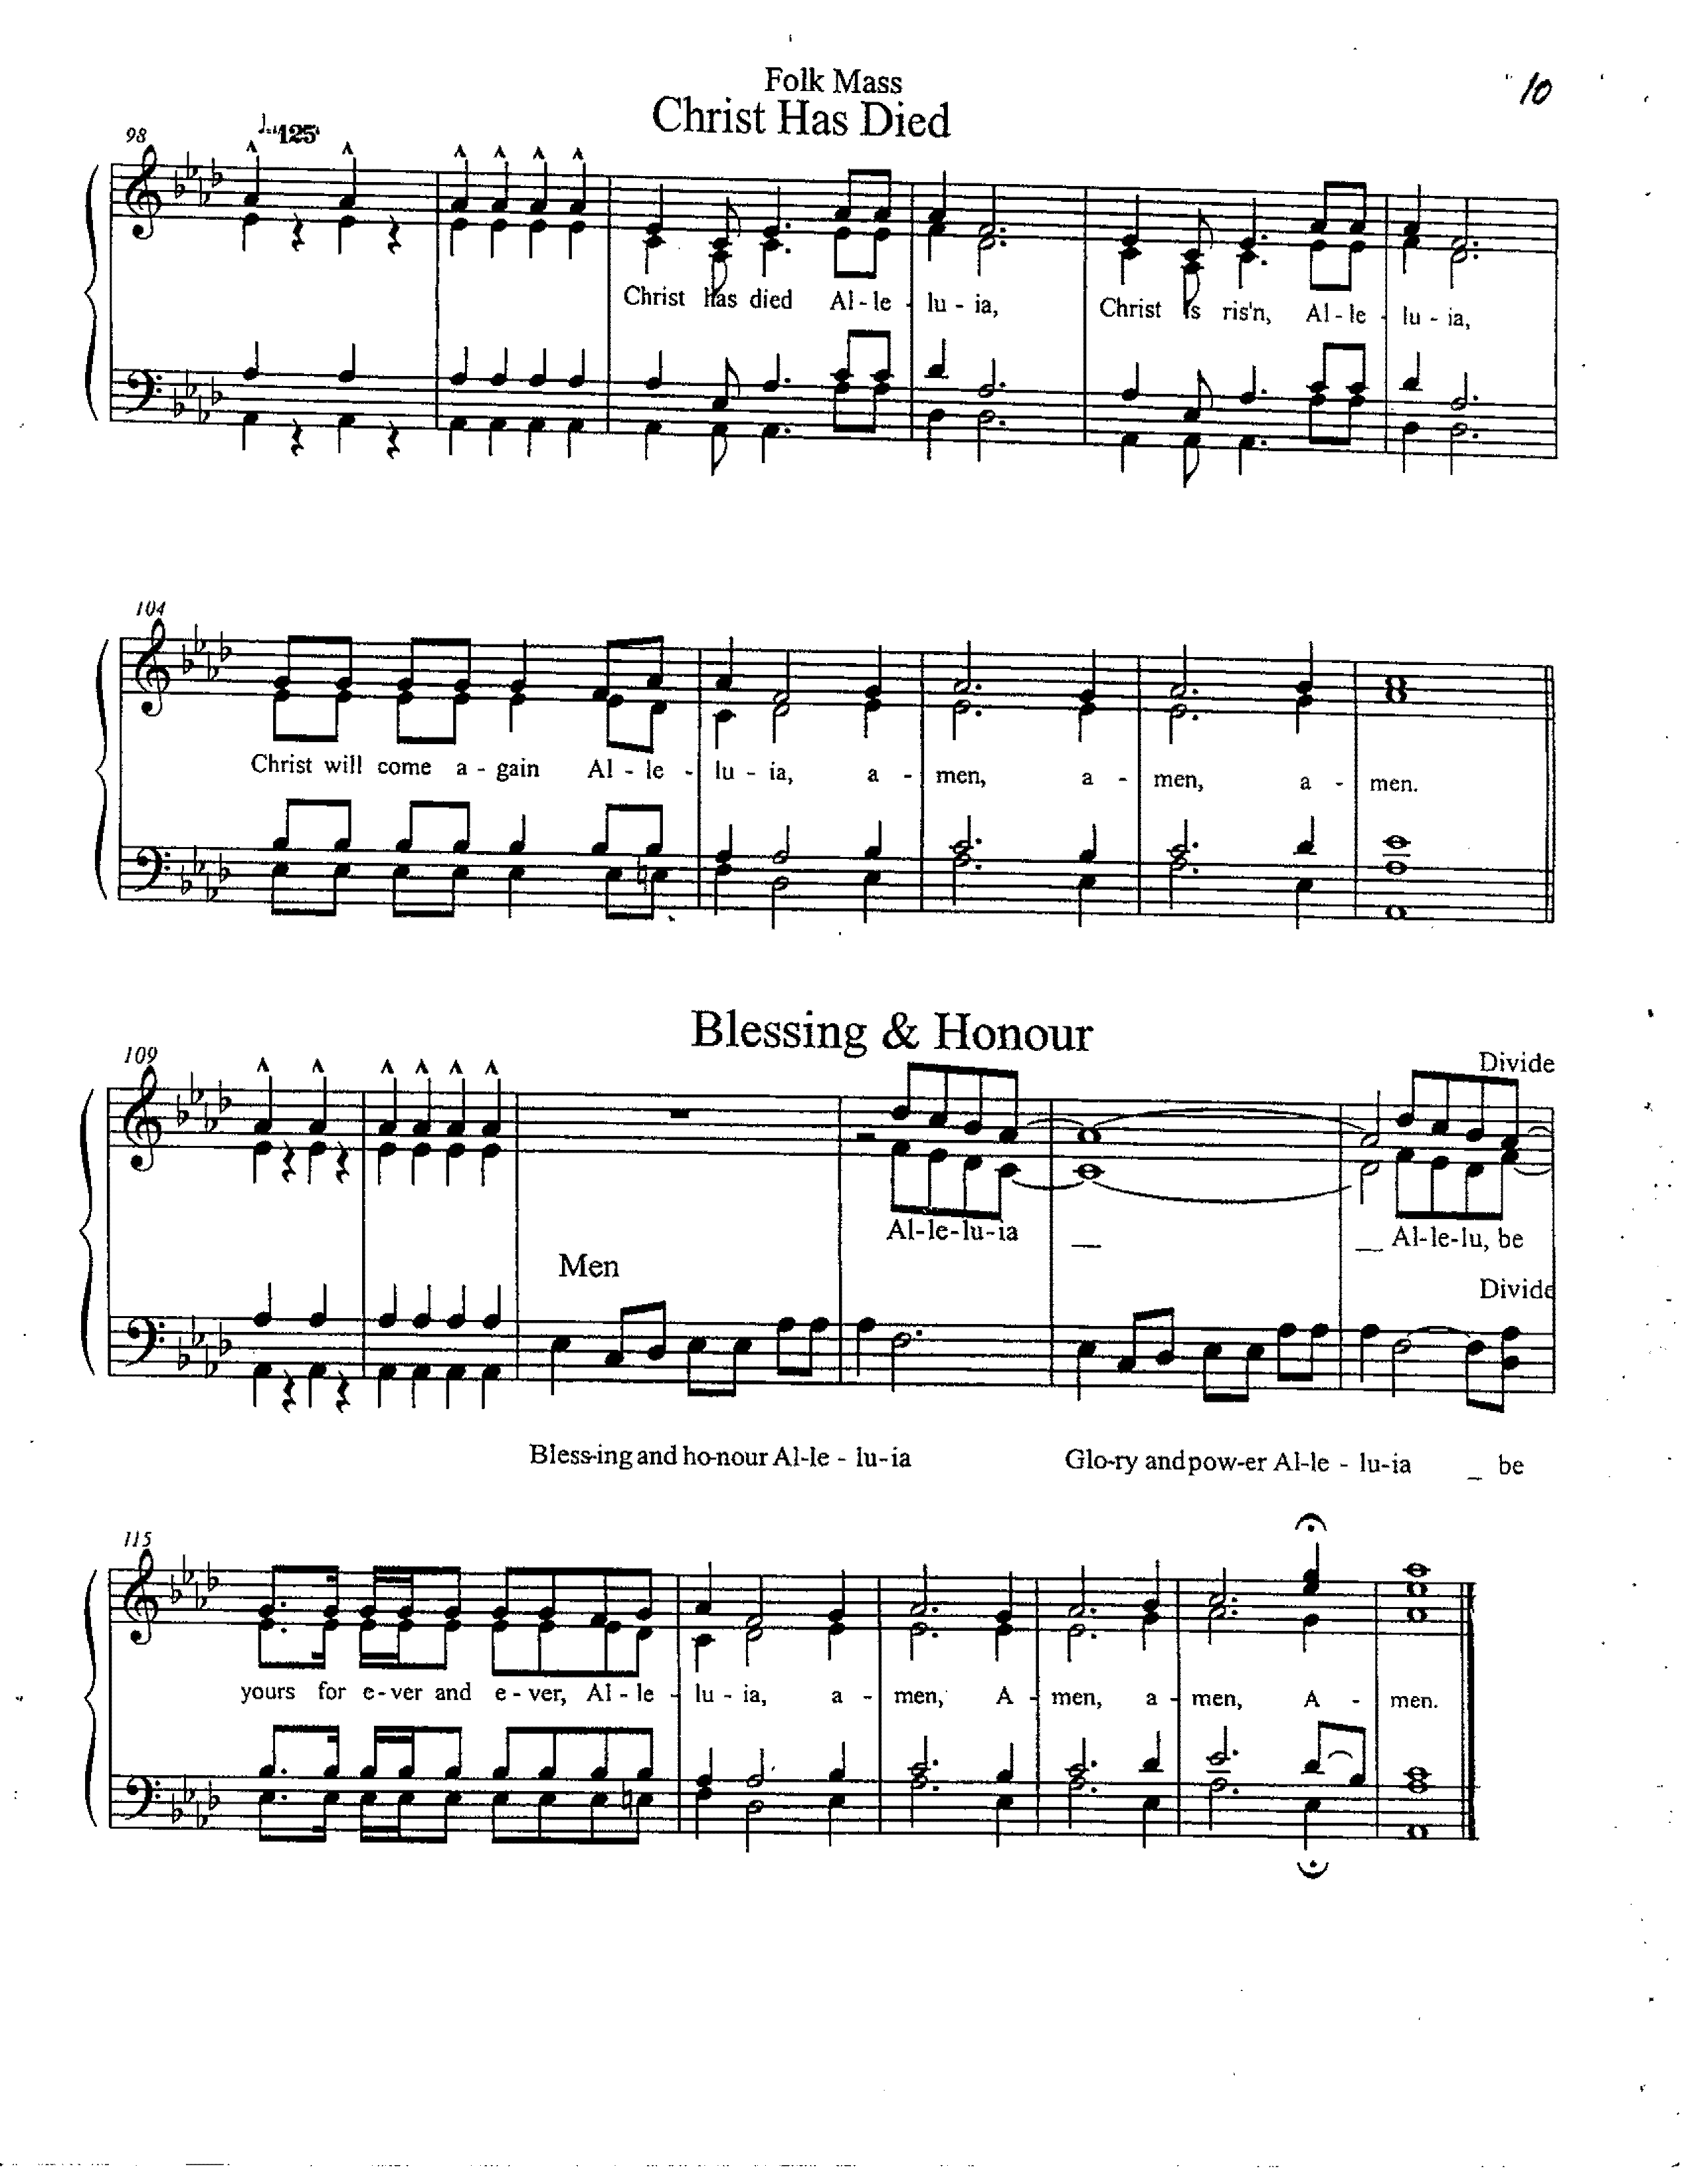
On the night before he died he had supper with his friends
and, taking bread, he praised you.
He broke the bread, gave it to them and said:
Take, eat; this is my body which is given for you;
do this in remembrance of me.

When supper was ended he took the cup of wine.
Again he praised you, gave it to them and said:
Drink this, all of you; this is my blood of the new covenant,
which is shed for you and for many for the forgiveness of sins.
Do this, as often as you drink it, in remembrance of me.

So, Father, we remember all that Jesus did,
in him we plead with confidence for his sacrifice
made once for all upon the cross.
Bringing before you the bread of life and cup of salvation,
we proclaim his death and resurrection until he comes in glory.

Let us proclaim the mystery of our faith

Acclamation (band) Lisa Narcisse

(sung) Christ has died! Alleluia!
Christ is risen! Alleluia!
Christ will come again! Alleluia!
Amen. Amen. Amen.

Lord of all life, help us to work together for that day,
when your kingdom comes and justice and mercy will be seen in all the earth.
Look with favour on your people, gather us in your loving arms
and bring us with all the saints to feast at your table in heaven.
Through Christ, with Christ, and in Christ in the unity of the Holy Spirit,
we worship you, Father Almighty, in songs of everlasting praise.

Eucharistic Doxology (band) Lisa Narcisse

(sung) Blessing and honour! Alleluia!
Glory and power! Alleluia!
Be yours forever and ever! Alleluia!
Amen. Amen. Amen. Amen.

The Lord’s Prayer (band) Matt Mayer

And now, as our Saviour Christ has taught us, we are bold to sing

Father, let Your Kingdom come
Father, let Your will be done x2
On Earth as in Heaven
Right here in my heart

(refrain)
Give us this day, our daily bread
Forgive us, forgive us
As we forgive the ones who sin against us, forgive them
And lead us not into temptation, but deliver us
From the еvil one
Let Your Kingdom come

It's Yours, it's Yours
All Yours, all Yours
The Kingdom, the power
The glory are Yours
It's Yours, it's Yours X2
All Yours, all Yours
Forever and ever.
The Kingdom is Yours

Father, let Your Kingdom come
Father, let Your will be done
On Earth as in Heaven
Right here in my heart

On Earth as in Heaven
Right here in my heart.

THE BREAKING OF THE BREAD

We break the bread of life, and that life is the light of the world.
God here among us, light in the midst of us, bring us to light and life.

THE INVITATION

These are God’s holy gifts for you God’s holy people
Thanks be to God.
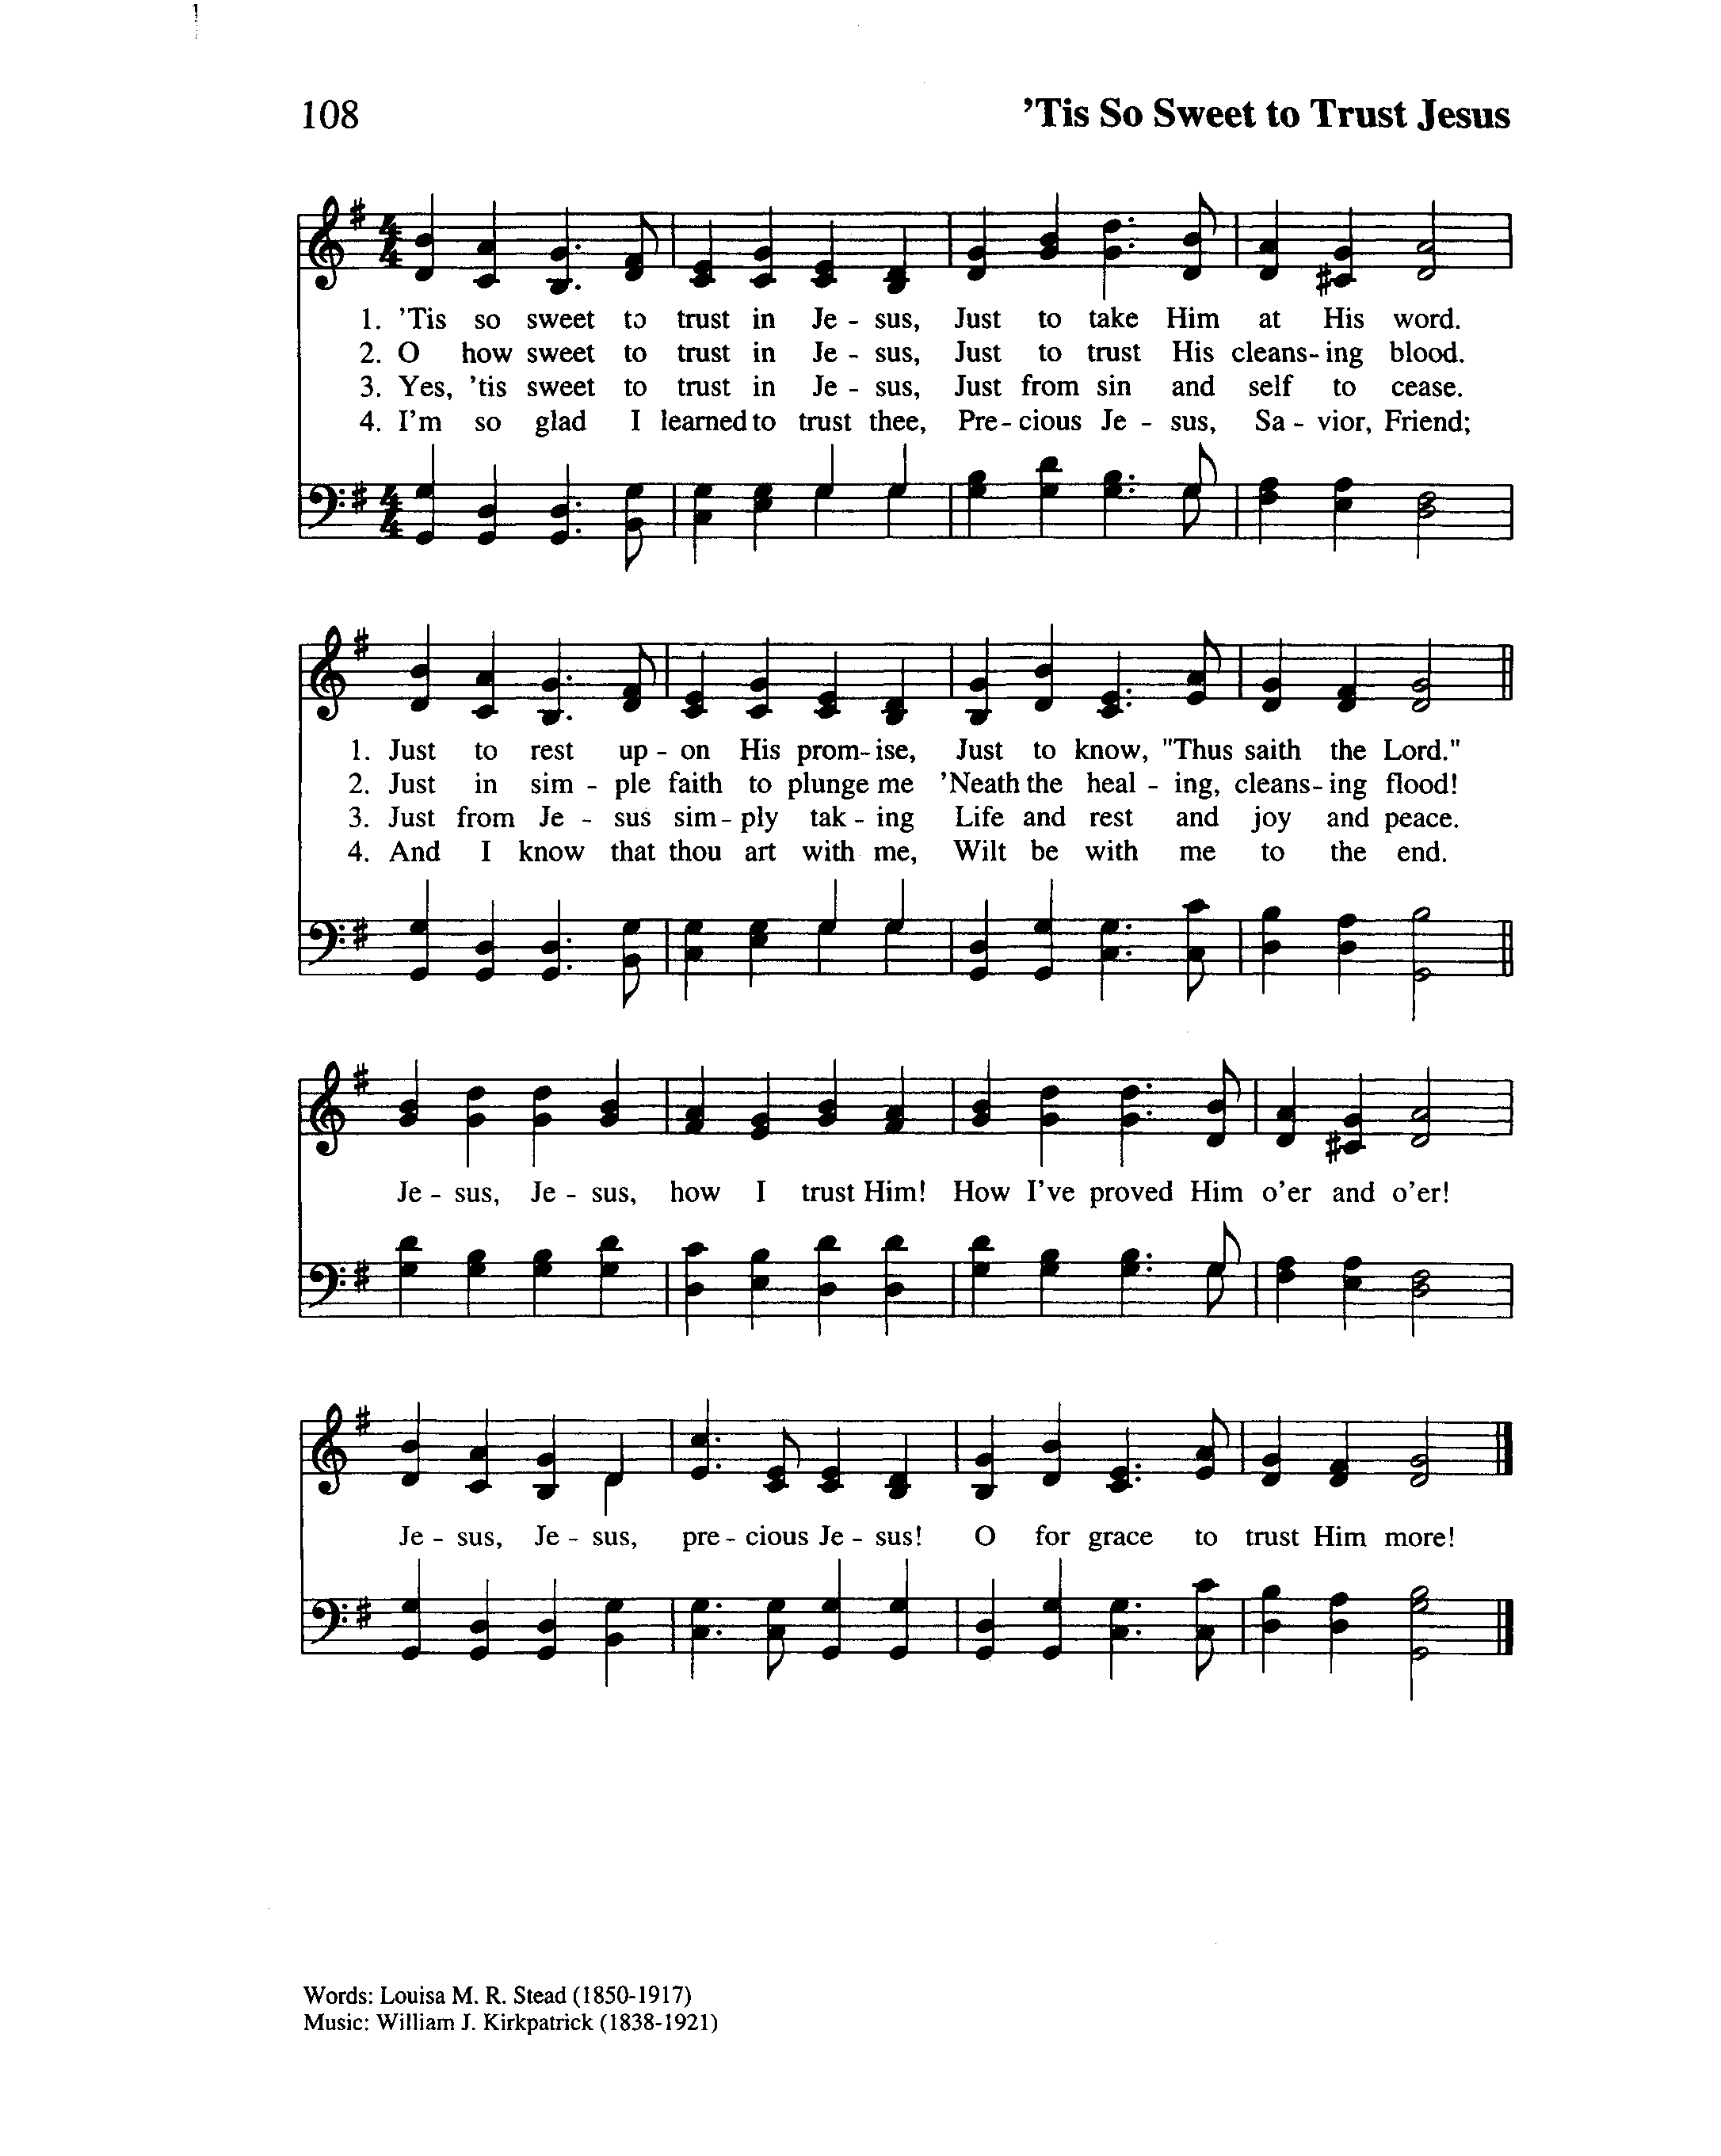
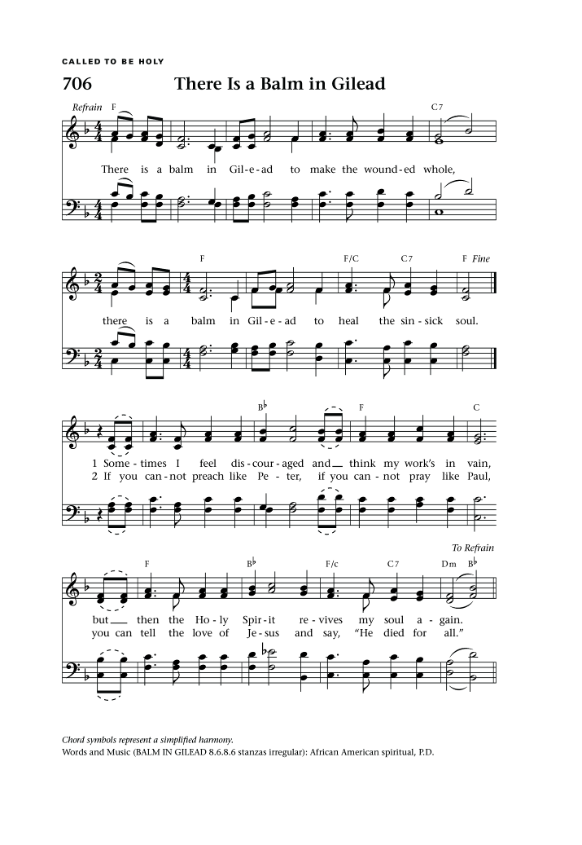
Hymn During Communion:

(organ) There is a Balm in Gilead
Text: African American Spiritual

There is a balm in Gilead
to make the wounded whole,
there is a balm in Gilead
to heal the sin-sick soul.
Sometimes I feel discouraged
and think my work's in vain,
but then the Holy Spirit
revives my soul again. (refrain)

If you cannot preach like Peter,
if you cannot pray like Paul,
you can tell the love of Jesus
and say, "He died for all." (refrain)

(organ) We Shall Overcome
African American Spiritual

We shall overcome,
We shall overcome,
We shall overcome, some day.

(refrain)
Oh, deep in my heart, I do believe
We shall overcome, some day.

We'll walk hand in hand,
We'll walk hand in hand,
We'll walk hand in hand, some day. (refrain)

We shall live in peace,
We shall live in peace,
We shall live in peace, some day. (refrain)

We shall all be free,
We shall all be free,
We shall all be free, some day. (refrain)

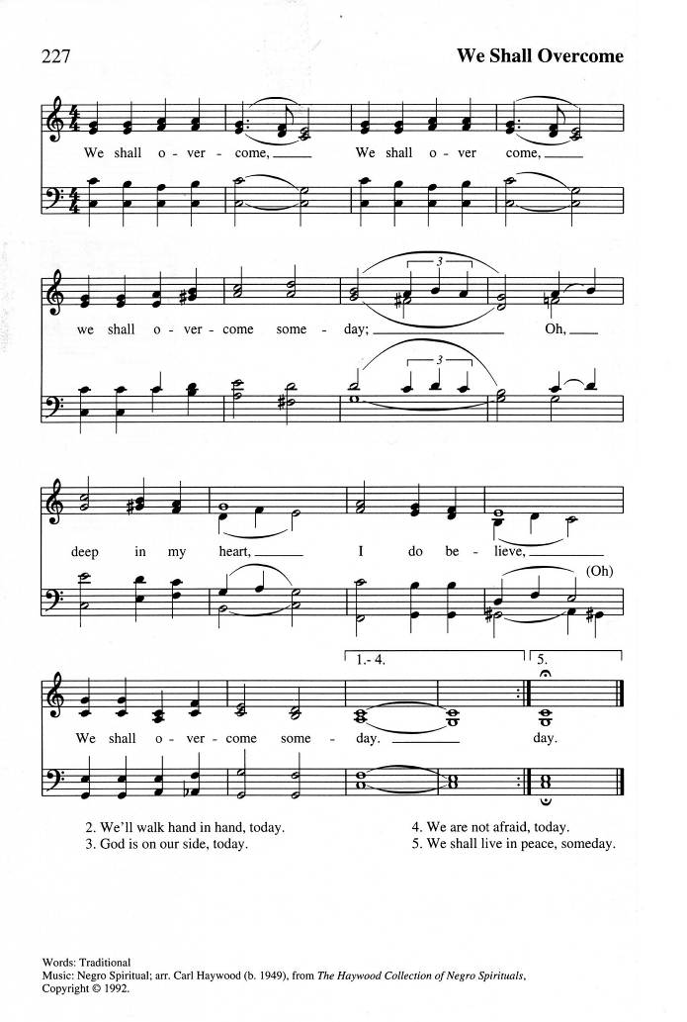
Ablutions: (band) Medley

I'm trading my sorrows
I'm trading my shame
I'm laying them down for the joy of the Lord
I'm trading my sickness
I'm trading my pain
I'm laying them down for the joy of the Lord
Yes Lord, yes Lord, yes, yes Lord
Yes Lord, yes Lord, yes, yes Lord
Yes Lord, yes Lord, yes, yes Lord, Amen.
-------------------------
I'll say yes, Lord, yes
To your will and to your way
I'll say yes, Lord, yes
I will trust you and obey
When your Spirit speaks to me
With my whole heart I'll agree
And my answer will be yes, Lord, yes.

---------------------------

This little light of mine, I'm gonna let it shine.
This little light of mine, I'm gonna let it shine.
This little light of mine, I'm gonna let it shine,
let it shine, let it shine, let it shine.

Prayer after Communion:

God for whom we wait, you fulfilled the hope of Simeon,
who did not die till he had welcomed the Messiah.
Complete in us your perfect will,
that we in Christ may share in your eternal kingdom;
for he is Lord for ever and ever. Amen

The Sending Out: (Akada Olive)

“Having seen the Light of Christ, go now to carry that Light forward—
honouring those who came before you and making room for those yet to come.”

The Blessing: (Fr Kenute)

As you go, do so in peace;
be of good courage; hold fast that which is good;
render to no one evil for evil; strengthen the fainthearted;
support the weak; help the afflicted;
honour everyone; love and serve the Lord,
rejoicing in the power of the Holy Spirit;
And the blessing of God almighty, the Father, the Son and the Holy Spirit
be with you now and always.
Amen.

Announcements:

Recessional: (band) Mine Eyes Have Seen the Glory
Text: Julia Ward Howe; Tune: BATTLE HYMN

Mine eyes have seen the glory of the coming of the Lord;
He is trampling out the vintage where the grapes of wrath are stored;
He hath loosed the fateful lightning of his terrible swift sword:
His truth is marching on.

(refrain)
Glory! Glory! Hallelujah!
Glory! Glory! Hallelujah!
Glory! Glory! Hallelujah!
His truth is marching on.

I have seen him in the watch-fires of a hundred circling camps;
They have builded him an altar in the evening dews and damps;
I can read the righteous sentence by the dim and flaring lamps;
His day is marching on. (refrain)

He has sounded forth the trumpet that shall never call retreat;
He is sifting out the hearts of all before his judgment seat;
O be swift, my soul, to answer him; be jubilant, my feet!
Our God is marching on. (refrain)

In the beauty of the lilies Christ was born across the sea,
With a glory in his bosom that transfigures you and me;
As he died to make us holy, let us die that all be free!
While God is marching on. (refrain)

The Dismissal: (Akada Olive)

Followers of the Christ, Inspired by the Holy Spirit.
Serve the world God loves. Alleluia! Alleluia!
Thanks be to God. Alleluia! Alleluia!
Postlude: (band) We are Marching in the Light of God
Translator: Anders Nyberg; Tune: SIYAHAMBA

We are marching in the light of God.
We are marching in the light of God.
We are marching in the light of God.
we are marching, marching,
we are marching, oh ohhh,
We are marching in the light of God.
we are marching, marching,
we are marching, oh ohhh,
We are marching in the light of God.

We are living in the love of God.
We are living in the love of God.
We are living in the love of God.
We are living in the love of God.
we are living, living,
we are living, oh ohhh,
We are living in the love of God.
we are living, living,
we are living, oh ohhh,
We are living in the love of God.

We are moving in the power of God.
We are moving in the power of God.
We are moving in the power of God.
We are moving in the power of God.
we are moving, moving,
we are moving, oh ohhh,
We are moving in the power of God.
we are moving, moving,
we are moving, oh ohhh,
We are moving in the power of God.

