The Ninth Sunday after Pentecost (Proper 17)

Sung Eucharist & Anointing

July 26, 2026, 10:30am

Website: www.sthildasanglicanchurch.com
Church Email: info@sthildasanglicanchurch.com
Facebook: St. Hilda’s Fairbank Anglican Church

Incumbent: Kenute Francis (437-488-9657)

kenute@sthildasanglicanchurch.com

Assistants: The Venerable Elizabeth Hardy
The Rev. Canon Leonard Abbah, OHC

Lay Reader: Ianthe Alleyne
Organist: William “Bill” Khan
Crucifer: Annika Pereira
Eucharistic Ministers: Francis, Greenidge, Alleyne, De Guzman

1st Reading: Margaret Goodridge
2nd Reading: Richard Morris
Gospel: Imelda De Guzman
Intercession: William Greenidge

Tech Team: Gail Evans & Richard Morris

Ushers Team 4: Ian Rocheford Edith Kwamie

Ernest Clarke Neville Lowe Maxine Shan Pearson Morgan

Michael Goodridge

MISSION STATEMENT
The purpose of St. Hilda’s Church is to be Christ-centered in our life and worship,
to serve lovingly those within our family and others within our reach

that the spirit of God might empower us for worship. service, education,

stewardship, evangelism and pastoral care.

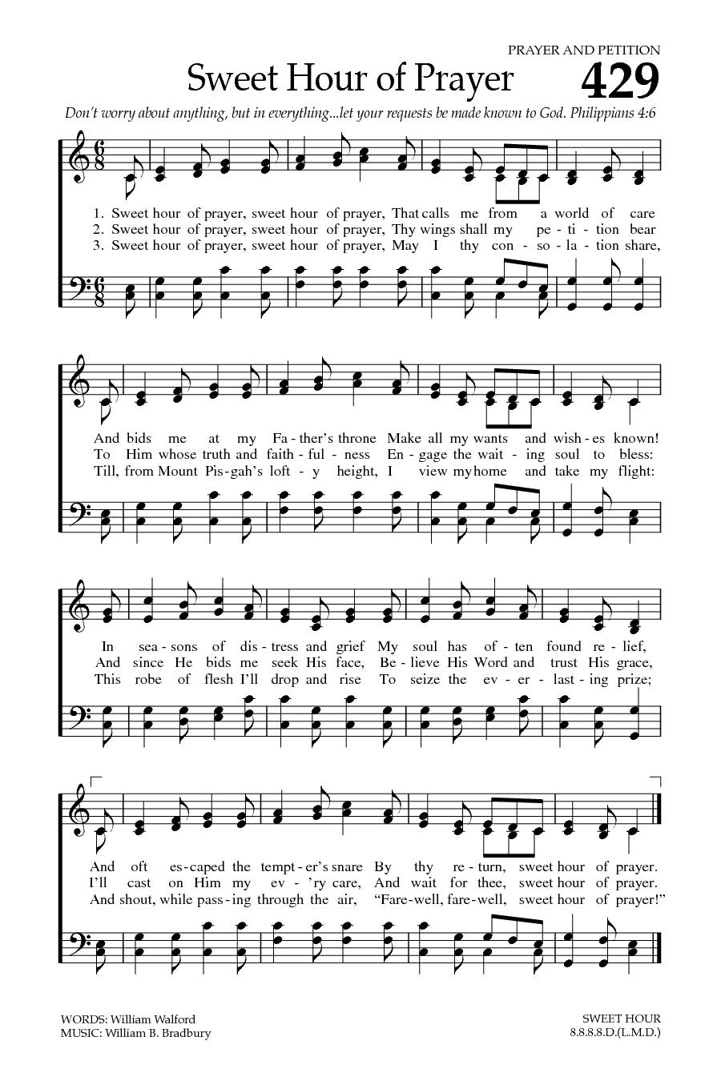

The Order of Service

PRELUDE: Sweet Hour of Prayer

OPENING PRAYER:

Into your presence we come, God of Grace and Peace.
Bind us together in the love that died and rose again for us,
our Saviour Jesus Christ.
Amen.

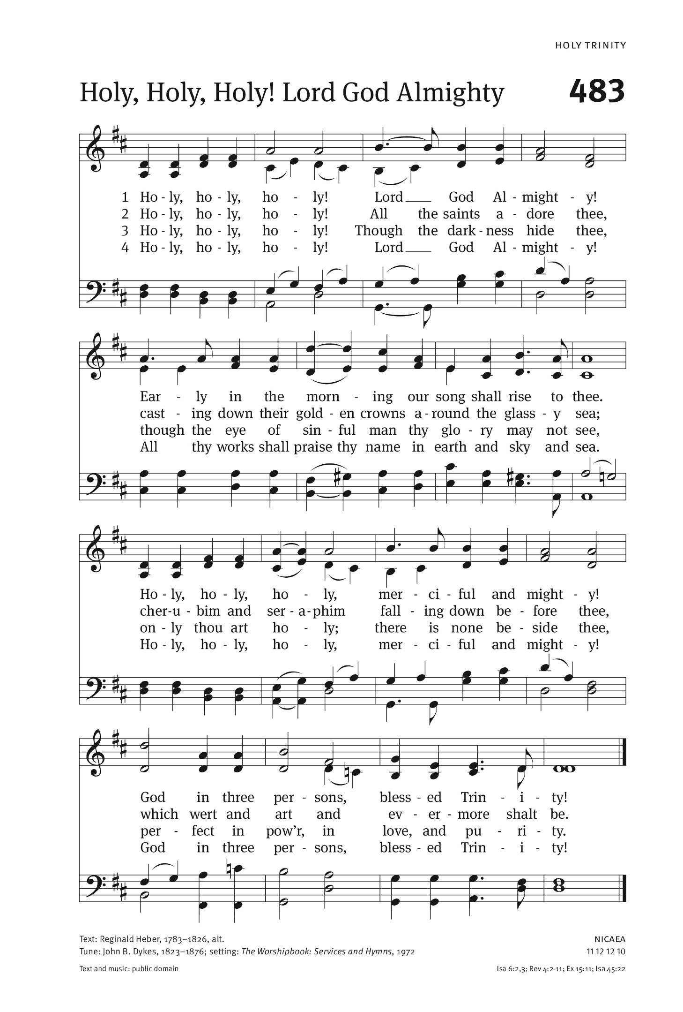
PROCESSIONAL: Holy, Holy, Holy Lord God Almighty
Text: Reginald Heber; Tune: NICAEA

Holy, holy, holy! Lord God Almighty!
Early in the morning our song shall rise to Thee;
Holy, holy, holy, merciful and mighty!
God in three Persons, blessed Trinity!

Holy, holy, holy! all the saints adore Thee,
casting down their golden crowns around the glassy sea;
cherubim and seraphim, falling down before Thee,
which wert and art and evermore shalt be.

Holy, holy, holy! though the darkness hide Thee,
though the eye of sinful man Thy glory may not see;
only Thou art holy, there is none beside Thee,
perfect in pow'r, in love, and purity.

Holy, holy, holy! Lord God Almighty!
All Thy works shall praise Thy name, in earth and sky and sea;
Holy, holy, holy! merciful and mighty!
God in three Persons, blessed Trinity!

WELCOME:

GREETINGS:

The grace of our Lord Jesus Christ, the love of God
and the fellowship of the Holy spirit be with you all.
And also with you.
This day is God’s gift to us
To give thanks and bask in the divine presence.

This time is also our gift to God –
A gift of song and prayer, of celebration and silence

This moment is our gift to God –
A gift of offering our lives anew.

Surrounded by all these gifts
Let us worship God.

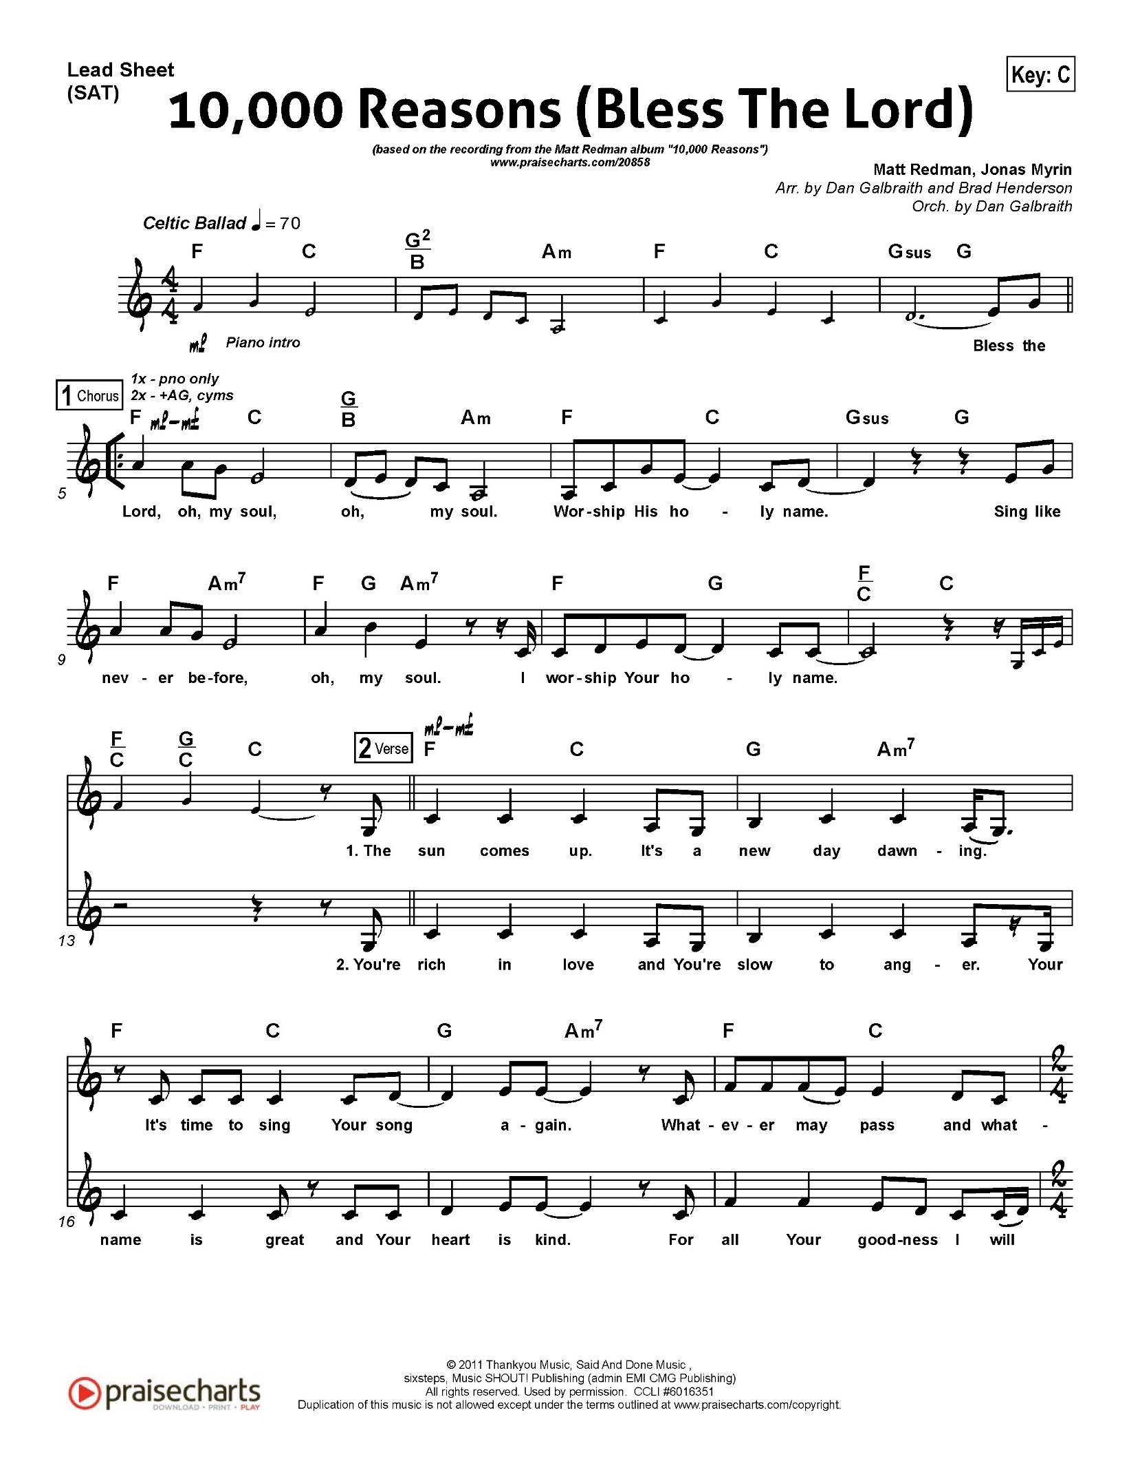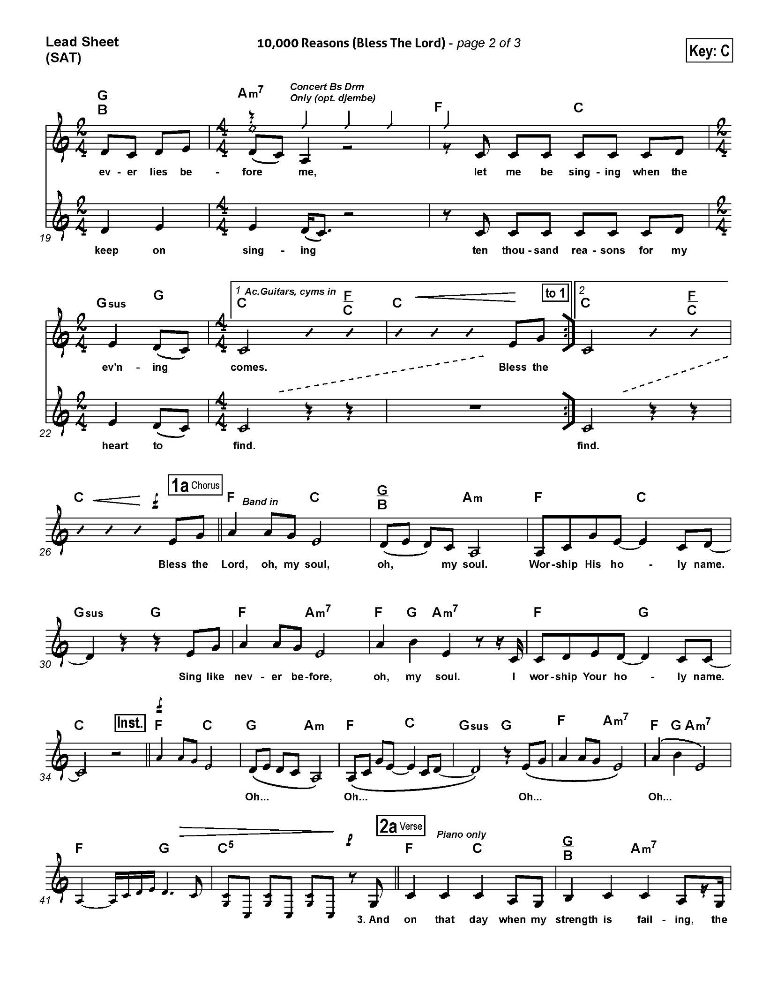
THE COLLECT FOR PURITY

Almighty God,
to you all hearts are open, all desires known, and from you no secrets are hidden.
Cleanse the thoughts of our hearts by the inspiration of your Holy Spirit,
that we may perfectly love you, and worthily magnify your holy name;
through Christ our Lord.
Amen.

INTROIT: 10,000 Reasons
Matt Redman

(refrain)
Bless the Lord O my soul, O my soul
Worship his holy name
Sing like never before, O my soul
I'll worship your holy name

The sun comes up, it's a new day dawning
It's time to sing your song again
Whatever may pass and whatever lies before me
Let me be singing when the evening comes. (refrain)

You're rich in love and you're slow to anger
Your name is great and your heart is kind
For all your goodness I will keep on singing
Ten thousand reasons for my heart to find. (refrain)

THE COLLECT OF THE DAY (Fr. Kenute)

Let us pray.

O God, the protector of all who trust in you,
without whom nothing is strong, nothing is holy,
increase and multiply upon us your mercy, that with you as our ruler and guide,
we may so pass through things temporal, that we lose not the things eternal;
through Jesus Christ our Lord, who lives and reigns with you and the Holy Spirit,
one God, for ever and ever.
Amen.
THE MINISTRY OF THE WORD

THE FIRST READING: Genesis 29:15-28 (Margaret Goodridge)

A reading from the book of Genesis
Then Laban said to Jacob, "Because you are my kinsman, should you therefore serve me for nothing? Tell me, what shall your wages be?"
Now Laban had two daughters; the name of the elder was Leah,
and the name of the younger was Rachel.
Leah's eyes were lovely, and Rachel was graceful and beautiful.
Jacob loved Rachel; so he said, "I will serve you seven years for your younger daughter Rachel." Laban said, "It is better that I give her to you than that I should give her to any other man; stay with me." So Jacob served seven years for Rachel, and they seemed to him but a few days because of the love he had for her.
Then Jacob said to Laban, "Give me my wife that I may go in to her, for my time is completed." So Laban gathered together all the people of the place, and made a feast. But in the evening he took his daughter Leah and brought her to Jacob; and he went in to her. (Laban gave his maid Zilpah to his daughter Leah to be her maid.)
When morning came, it was Leah! And Jacob said to Laban, "What is this you have done to me? Did I not serve with you for Rachel? Why then have you deceived me?" Laban said, "This is not done in our country--giving the younger before the firstborn. Complete the week of this one, and we will give you the other also in return for serving me another seven years." Jacob did so, and completed her week; then Laban gave him his daughter Rachel as a wife.

The Word of the Lord
Thanks be to God
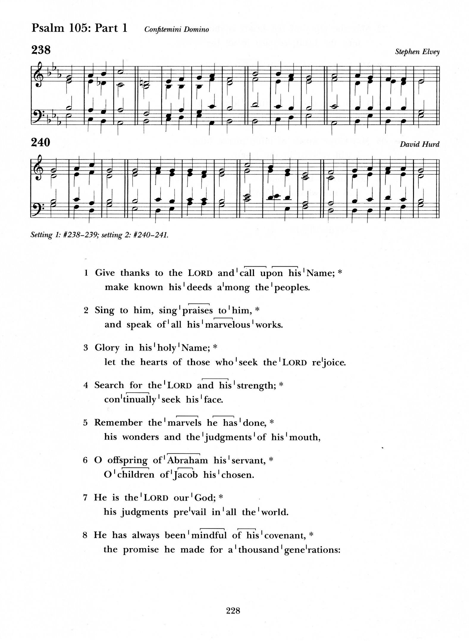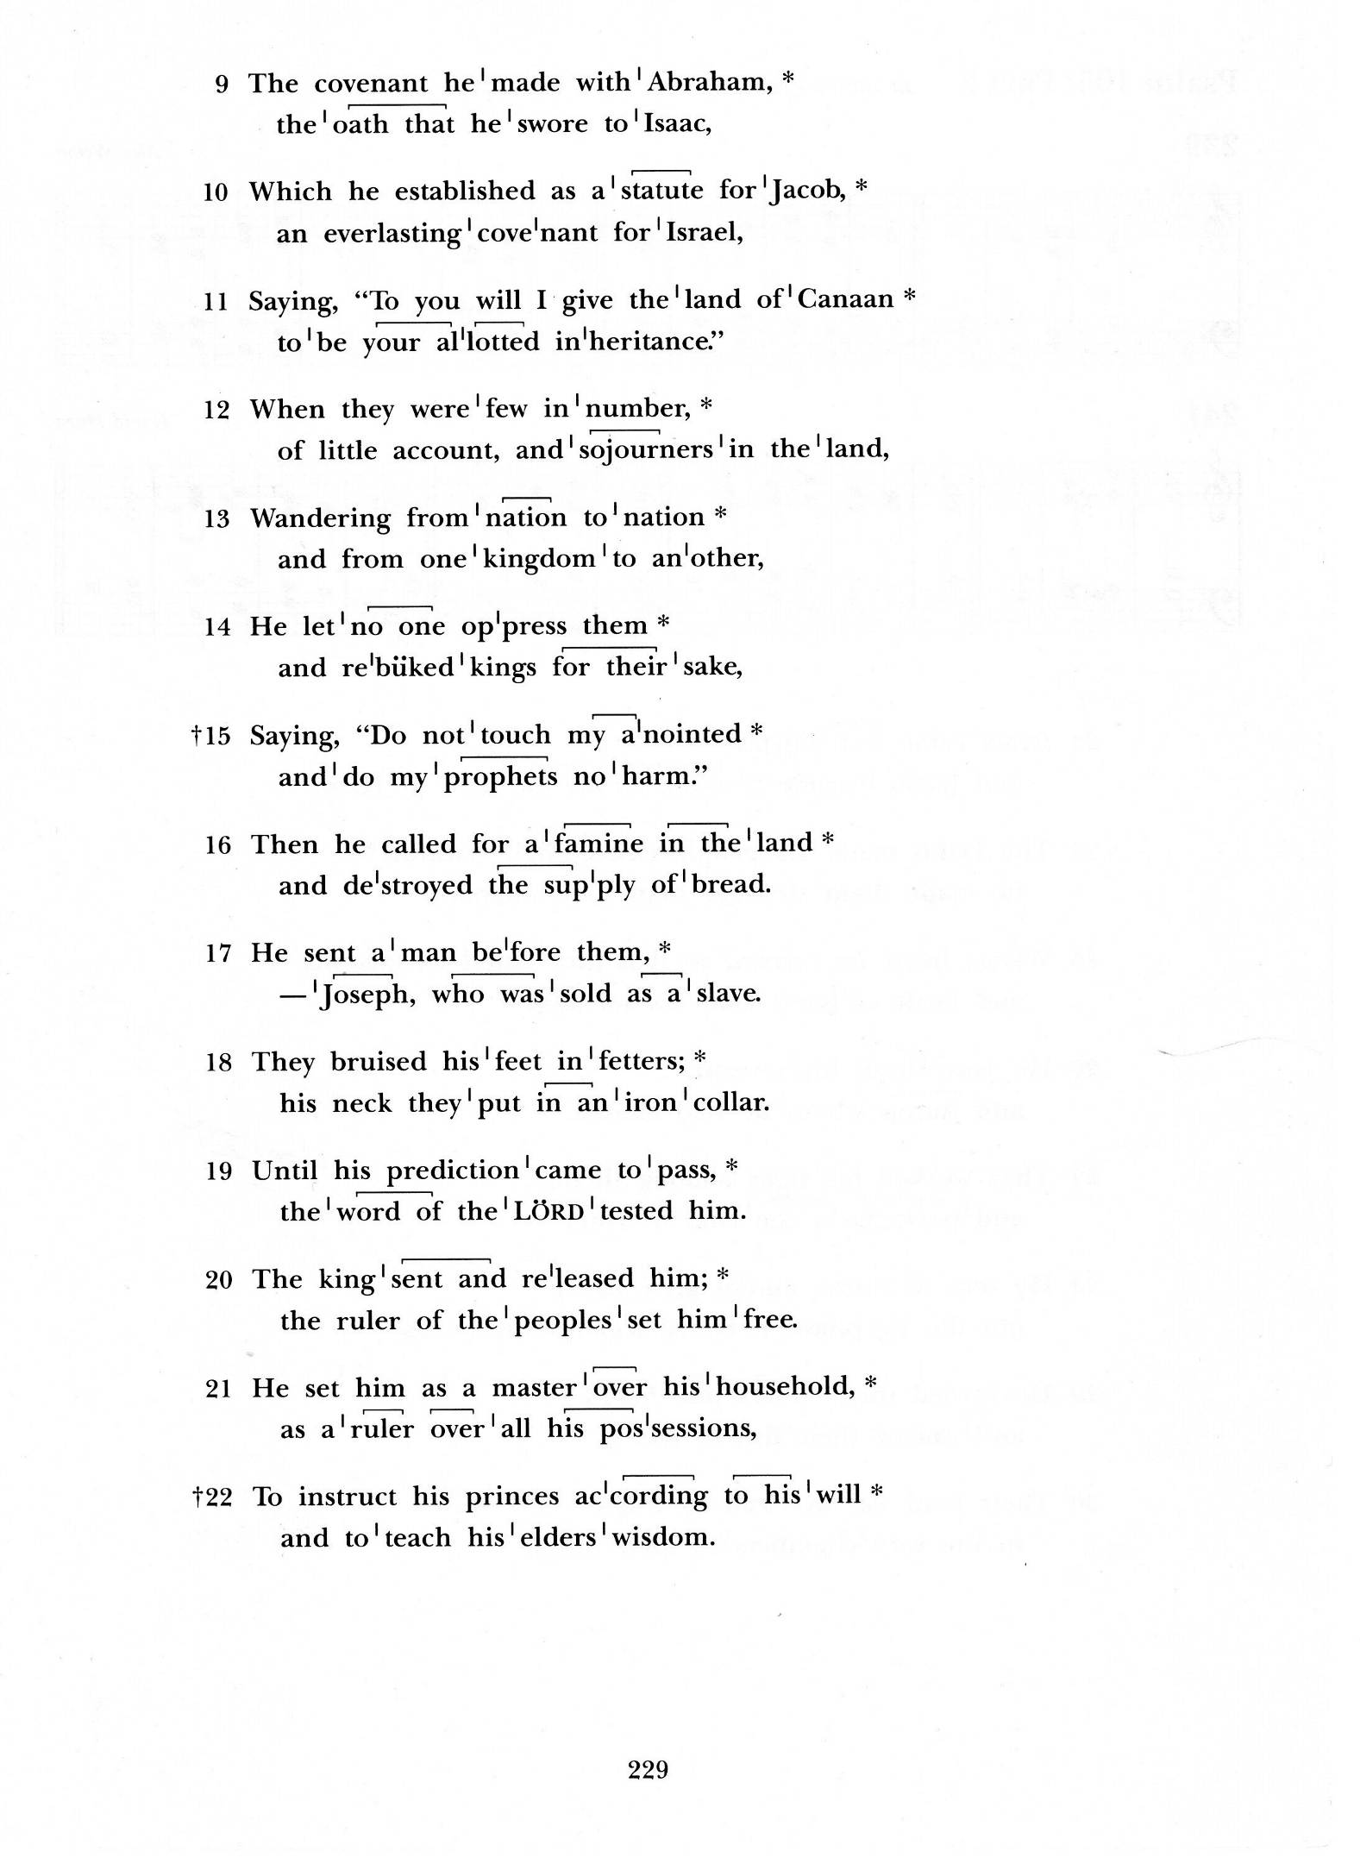
PSALM 105:1-11, 45c (chanted)

Give thanks to the Lord and call upon his name;
make known his deeds among the peoples.
Sing to him, sing praises to him, and speak of all his marvellous works.

Glory in his holy name; let the hearts of those who seek the Lord rejoice.
Search for the Lord and his strength; continually seek his face.

Remember the marvels he has done,
his wonders and the judgements of his mouth,
O offspring of Abraham his servant, O children of Jacob his chosen.

He is the Lord our God; his judgements prevail in all the world.
He has always been mindful of his covenant,
the promise he made for a thousand generations:

The covenant he made with Abraham, the oath that he swore to Isaac,
Which he established as a statute for Jacob,
an everlasting covenant for Israel,

Saying, ”To you will I give the land of Canaan to be your allotted inheritance.”
Hallelujah!

Glory to the Father and to the Son, and to the Holy Spirit:
As it was in the beginning is now, and will be for ever. Amen

SECOND READING Romans 8:26-39 (Richard Morris)

A reading from Paul’s letter to the Romans
Likewise the Spirit helps us in our weakness; for we do not know how to pray
as we ought, but that very Spirit intercedes with sighs too deep for words.
And God, who searches the heart, knows what is the mind of the Spirit,
because the Spirit intercedes for the saints according to the will of God.
We know that all things work together for good for those who love God,
who are called according to his purpose. For those whom he foreknew he also predestined to be conformed to the image of his Son, in order that he might
be the firstborn within a large family.
And those whom he predestined he also called; and those whom he called he also justified; and those whom he justified he also glorified. What then are we to say about these things? If God is for us, who is against us? He who did not withhold his own Son, but gave him up for all of us, will he not with him also give us everything else? Who will bring any charge against God's elect? It is God who justifies.
Who is to condemn? It is Christ Jesus, who died, yes, who was raised,
who is at the right hand of God, who indeed intercedes for us.
Who will separate us from the love of Christ? Will hardship, or distress,
or persecution, or famine, or nakedness, or peril, or sword?
As it is written, "For your sake we are being killed all day long;
we are accounted as sheep to be slaughtered." No, in all these things
we are more than conquerors through him who loved us.
For I am convinced that neither death, nor life, nor angels, nor rulers,
nor things present, nor things to come, nor powers, nor height,
nor depth, nor anything else in all creation, will be able to separate us
from the love of God in Christ Jesus our Lord.

The word of the Lord
Thanks be to God

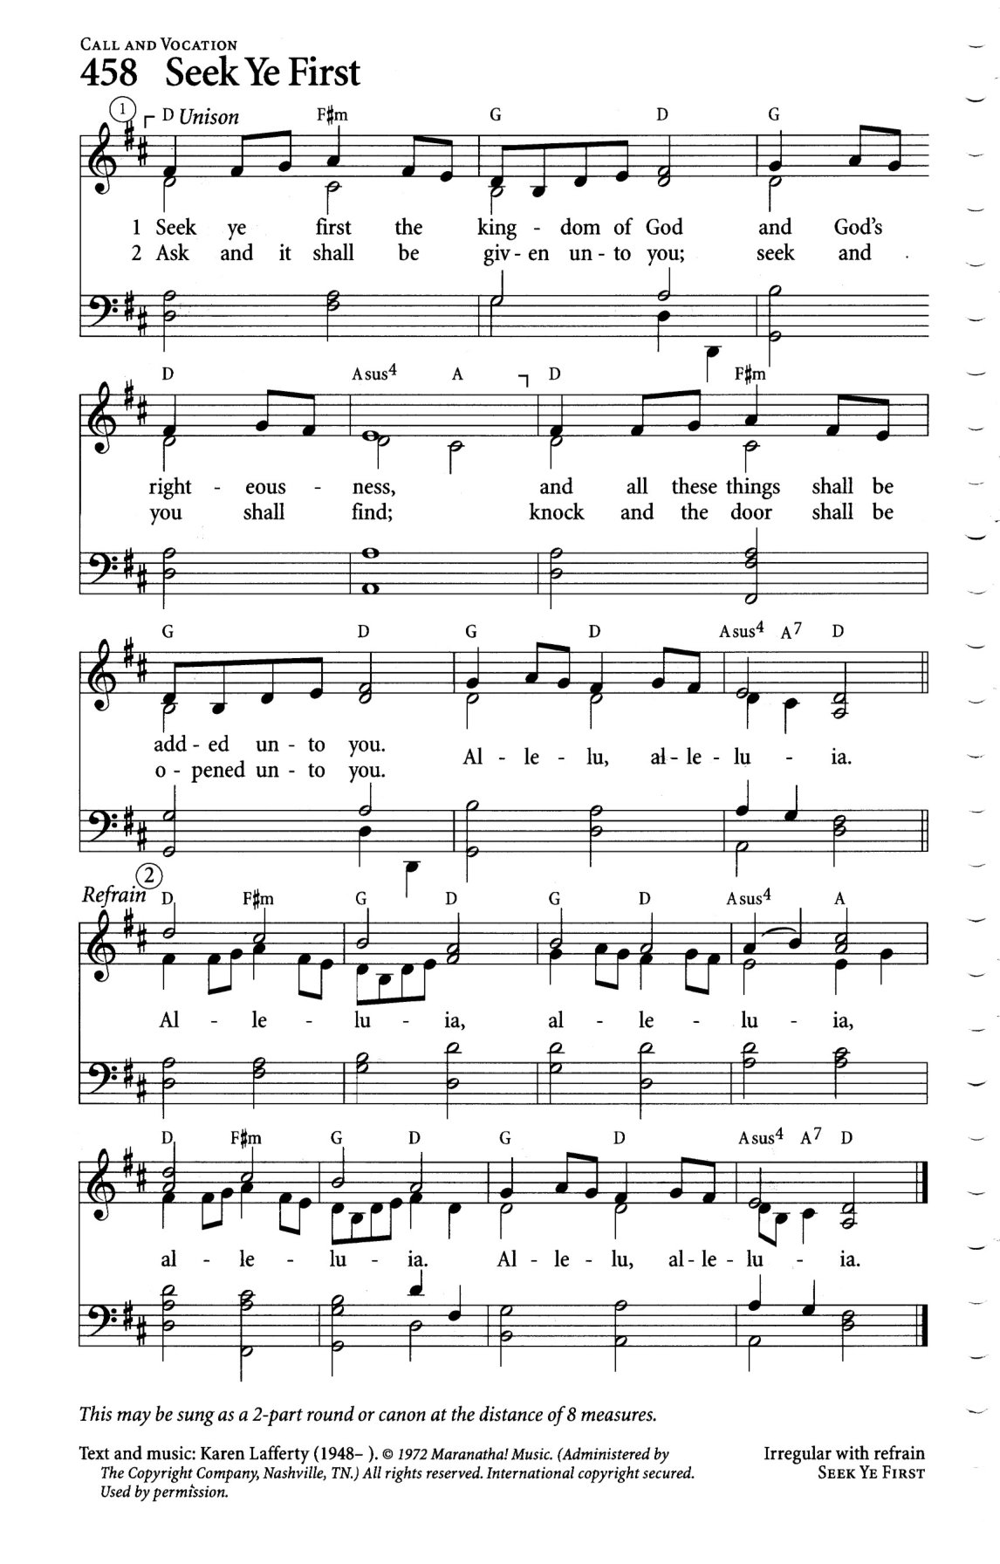
THE GRADUAL: Seek Ye First the Kingdom of God
Text: Karen Lafferty; Tune: SEEK YE FIRST

Seek ye first the kingdom of God
And His righteousness;
And all these things shall be added unto you.
Hallelu, Hallelujah!

(refrain)
Al-le-lu-ia. Al-le-lu-ia. Al-le-lu-ia. Al-le-lu- Al-le-lu-ia.

Ask, and it shall be given unto you;
Seek, and you shall find.
Knock, and it shall be opened unto you.
Hallelu, Hallelujah! (refrain)

Man shall not live by bread alone,
But by every word
That proceeds out from the mouth of God.
Hallelu, Hallelujah! (refrain)
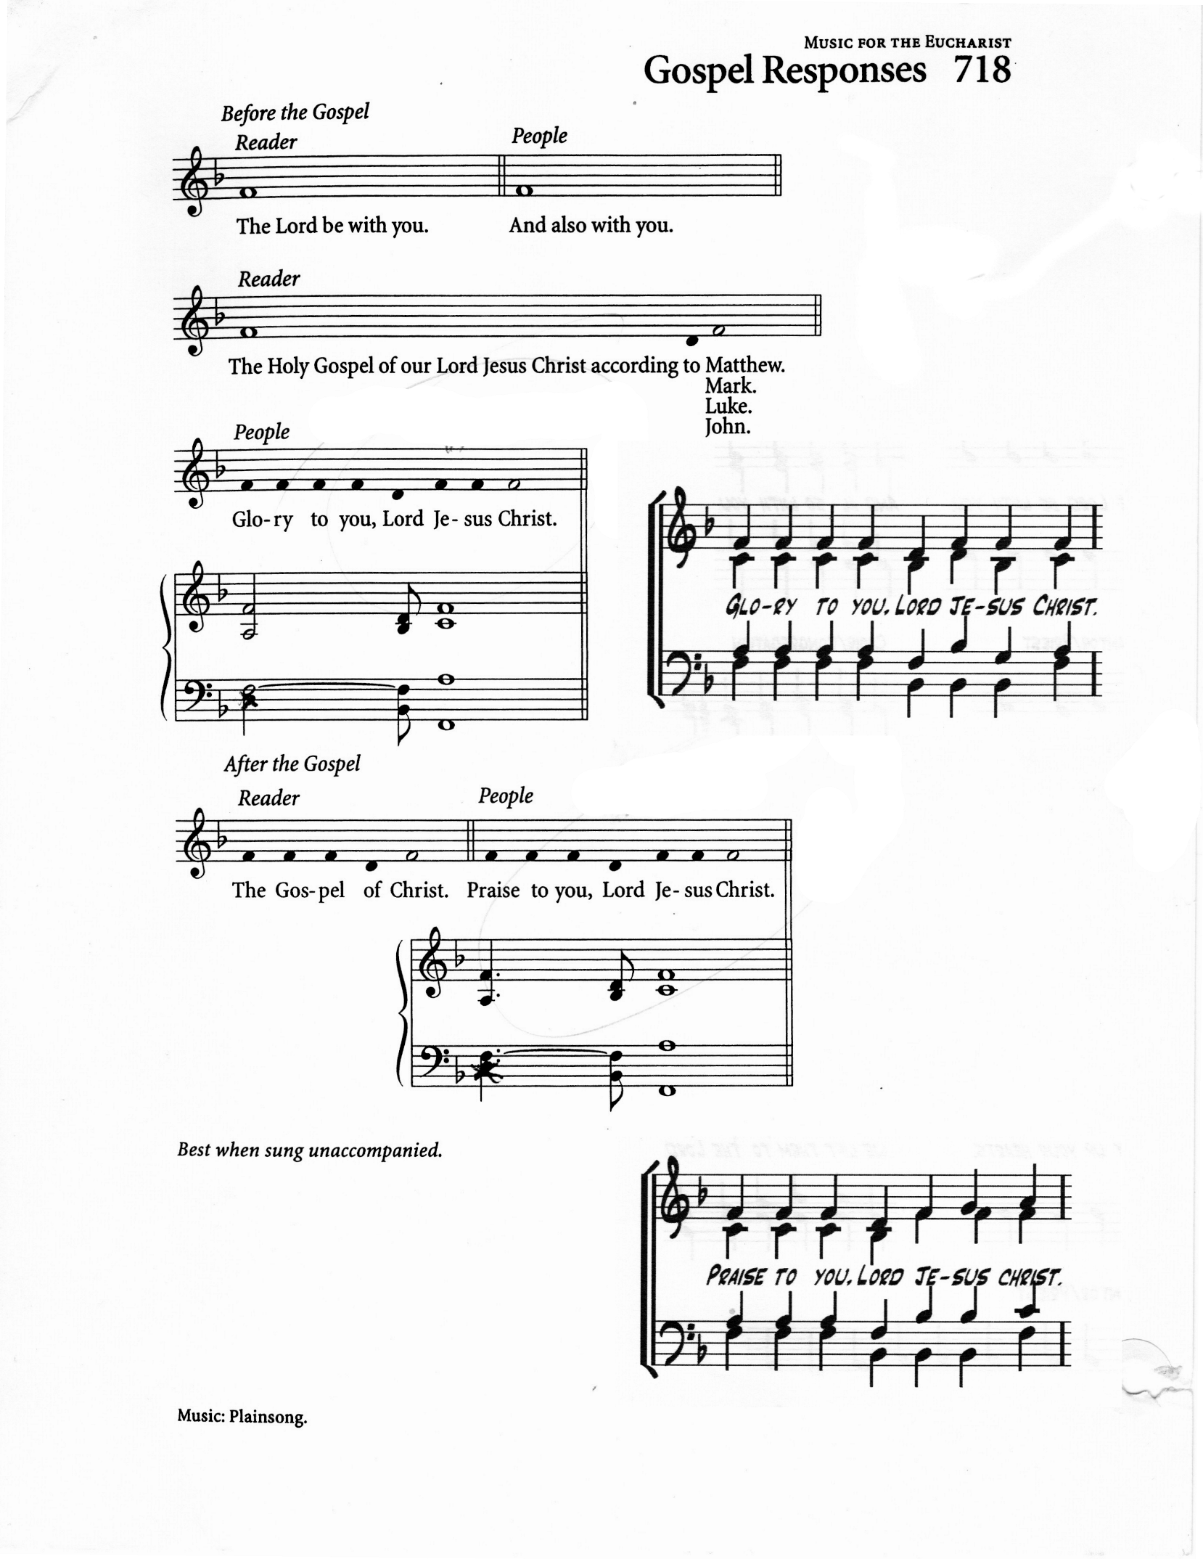
THE HOLY GOSPEL Matthew 13:31-33, 44-52 (Imelda De Guzman)

The Lord be with you
And also with you

The Holy Gospel of our Lord Jesus Christ according to Matthew
Glory to you, Lord Jesus Christ.

He put before them another parable: "The kingdom of heaven is like a mustard seed that someone took and sowed in his field; it is the smallest of all the seeds, but when it has grown it is the greatest of shrubs and becomes a tree, so that the birds of the air come and make nests in its branches."
He told them another parable: "The kingdom of heaven is like yeast that a woman took and mixed in with three measures of flour until all of it was leavened."
"The kingdom of heaven is like treasure hidden in a field, which someone found and hid; then in his joy he goes and sells all that he has and buys that field.
"Again, the kingdom of heaven is like a merchant in search of fine pearls;
on finding one pearl of great value, he went and sold all that he had and bought it.
"Again, the kingdom of heaven is like a net that was thrown into the sea and caught fish of every kind; when it was full, they drew it ashore, sat down, and put the good into baskets but threw out the bad. So it will be at the end of the age.
The angels will come out and separate the evil from the righteous and throw them into the furnace of fire, where there will be weeping and gnashing of teeth.
"Have you understood all this?" They answered, "Yes." And he said to them,
"Therefore every scribe who has been trained for the kingdom of heaven is like the
master of a household who brings out of his treasure what is new and what is old."

The Gospel of Christ
Praise to you, Lord Jesus Christ

GOSPEL ACCLAMATION: Alleluia (Caribbean)

THE SERMON:

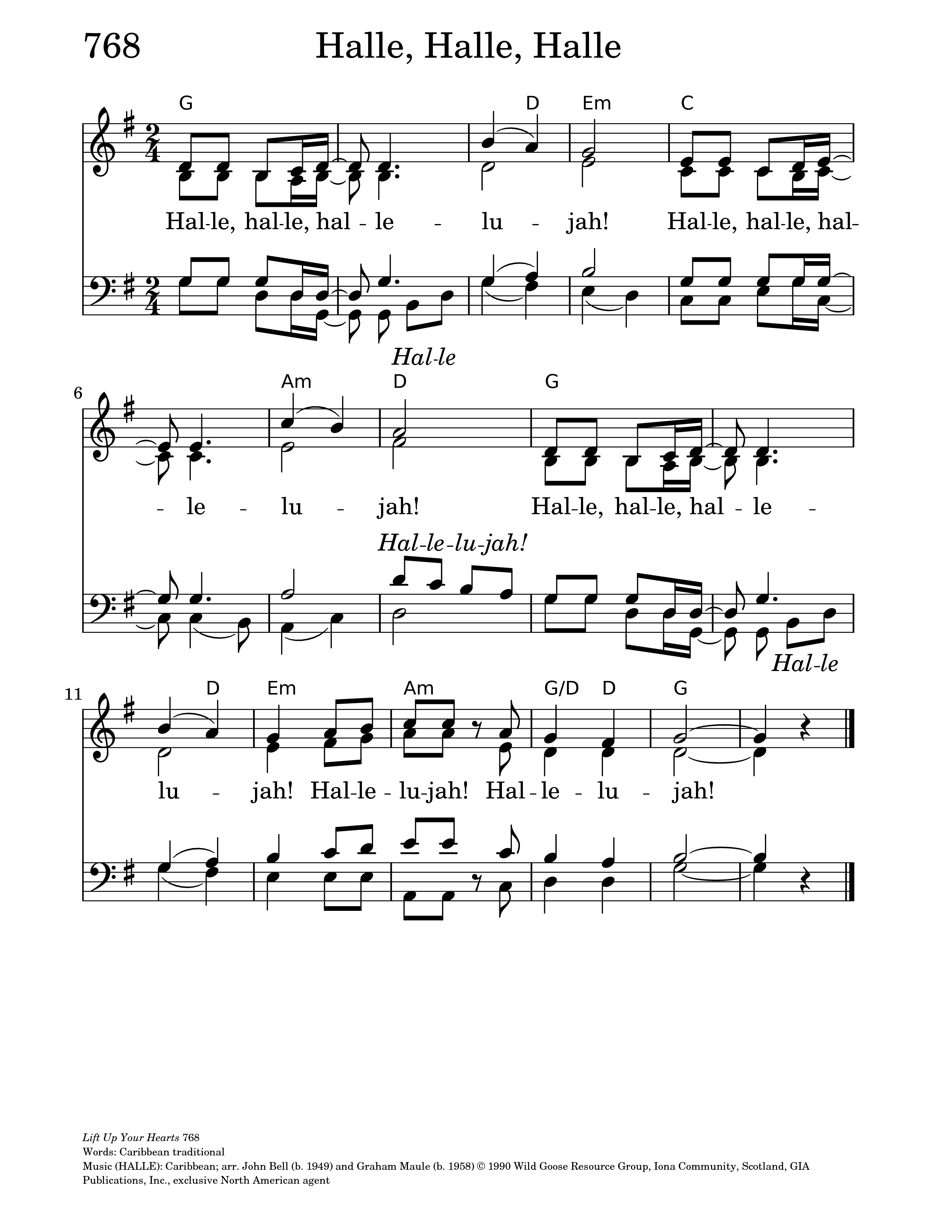
THE APOSTLES’ CREED

Let us confess the faith of our baptism, as we say,

I believe in God, the Father almighty, creator of heaven and earth.
I believe in Jesus Christ, his only Son, our Lord.
He was conceived by the power of the Holy Spirit and born of the Virgin Mary.
He suffered under Pontius Pilate, was crucified, died, and was buried.
He descended to the dead. On the third day he rose again.
He ascended into heaven, and is seated at the right hand of the Father.
He will come again to judge the living and the dead.
I believe in the Holy Spirit, the holy catholic Church,
the communion of saints, the forgiveness of sins,
the resurrection of the body, and the life everlasting.
Amen.

PRAYERS OF INTERCESSION (William Greenidge)

Let us pray,

Holy God, thank you for giving to your Chosen People the pearl of your holy Word and for perfectly enfleshing your Word in the Pearl of great price, your son Jesus. Thank you for making us, through him, into your pearl, your hidden treasure,
and your beloved people!
Lord, let your will be done
And your kingdom come

Make the Church lovely with Jesus’ goodness.
May it always treat your Word and Sacraments as precious, living treasures.
By the gracious power of your Spirit, draw many to faith in Jesus.
Lord, let your will be done
And your kingdom come

Keep us in your care, knowing that nothing can separate us from your love
for us in Christ Jesus. Use our words and deeds to share that love with
those around us who need it most.
Lord, let your will be done
And your kingdom come

We lift up this year's graduates to you, herein we remember Tyreke, Annika,
Lily, Sherlian, Nathaniel and Rasheeda. We bring their hopes, fears, and futures.
Direct their lives, and guide their steps as they navigate the unknown,
whether they are entering the workforce or pursuing further education.
We trust that You who began a good work in them will bring it to completion.
Lord, let your will be done
And your kingdom come
Establish your justice among the nations, and do not let the scepter of evil hold sway over us. Turn our hearts from evildoing and crooked ways;
and fix them firmly upon faith toward you and fervent love toward one another.
Lord, let your will be done
And your kingdom come

We pray for the sick, injured, dying and bereaved; for the troubled, confused, lonely, or despairing; Grant them your healing properties.
Lord, let your will be done
And your kingdom come

We remember before you the beloved dead.
Lord, let your will be done
And your kingdom come

O Lord, send us help from above.
And evermore mightily defend us.

As we abide in Christ we are supplied with all the spiritual resources
required for our needs.
As we abide in Christ we are free from fear and have quietness
and confidence within.

As we abide in Christ we are at one with God and know the peace of God
which passes understanding.
We can do all things through Christ who strengthens us.

Who shall separate us from the love of Christ? Shall tribulation or
distress or persecution or famine or nakedness or peril or sword?
No, in all these things we are more than conquerors through him that
loved us. For we are persuaded, that neither death nor life, nor angels,
nor principalities, nor powers, nor things present, nor things to come,
nor height, nor depth, nor any other creatures, shall be able to separate us
from the love of God, which is in Christ Jesus, our Lord.

Hear our prayers, dear Father, as they touch your heart through the Spirit
who searches our hearts. For the sake of your beloved Son,
answer them as may be best for us and give you glory.
Amen.

CONFESSION AND ABSOLUTION

Dear friends in Christ, God is steadfast in love and infinite in mercy;
he welcomes sinners and invites them to his table.
Let us confess our sins, confident in God’s forgiveness.
Most merciful God,
we confess that we have sinned against you in thought, word, and deed,
by what we have done, and by what we have left undone.
We have not loved you with our whole heart;
we have not loved our neighbours as ourselves.
We are truly sorry and we humbly repent.
For the sake of your Son Jesus Christ, have mercy on us and forgive us,
that we may delight in your will, and walk in your ways,
to the glory of your name. Amen.

Almighty God have mercy upon you,
pardon and deliver you from all your sins,
confirm and strengthen you in all goodness,
and keep you in eternal life; through Jesus Christ our Lord.
Amen.

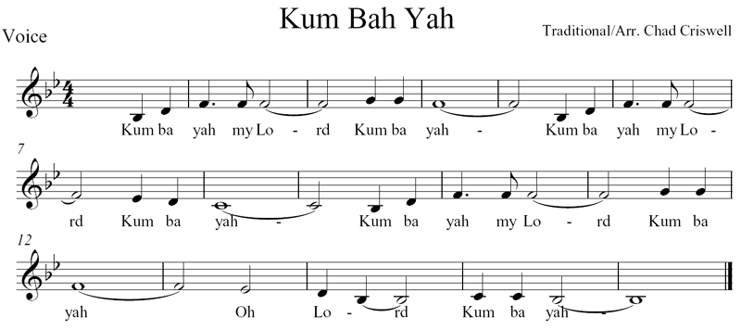

THE ANOINTING

Kum Ba Yah My Lord
Text: African-American spiritual: Tune: Kum Ba Yah

(refrain)
Kumbaya my Lord, kumbaya
Kumbaya my Lord, kumbaya
Kumbaya my Lord, kumbaya
Oh Lord, kumbaya

Someone's singing Lord, kumbaya
Someone's singing Lord, kumbaya
Someone's singing Lord, kumbaya
Oh Lord, kumbayah. (refrain)

Someone's crying Lord, kumbaya
Someone's crying Lord, kumbaya
Someone's crying Lord, kumbaya
Oh Lord, kumbaya. (refrain)

Someone's praying Lord, kumbaya
Someone's praying Lord, kumbaya
Someone's praying Lord, kumbaya
Oh Lord, kumbaya. (refrain)

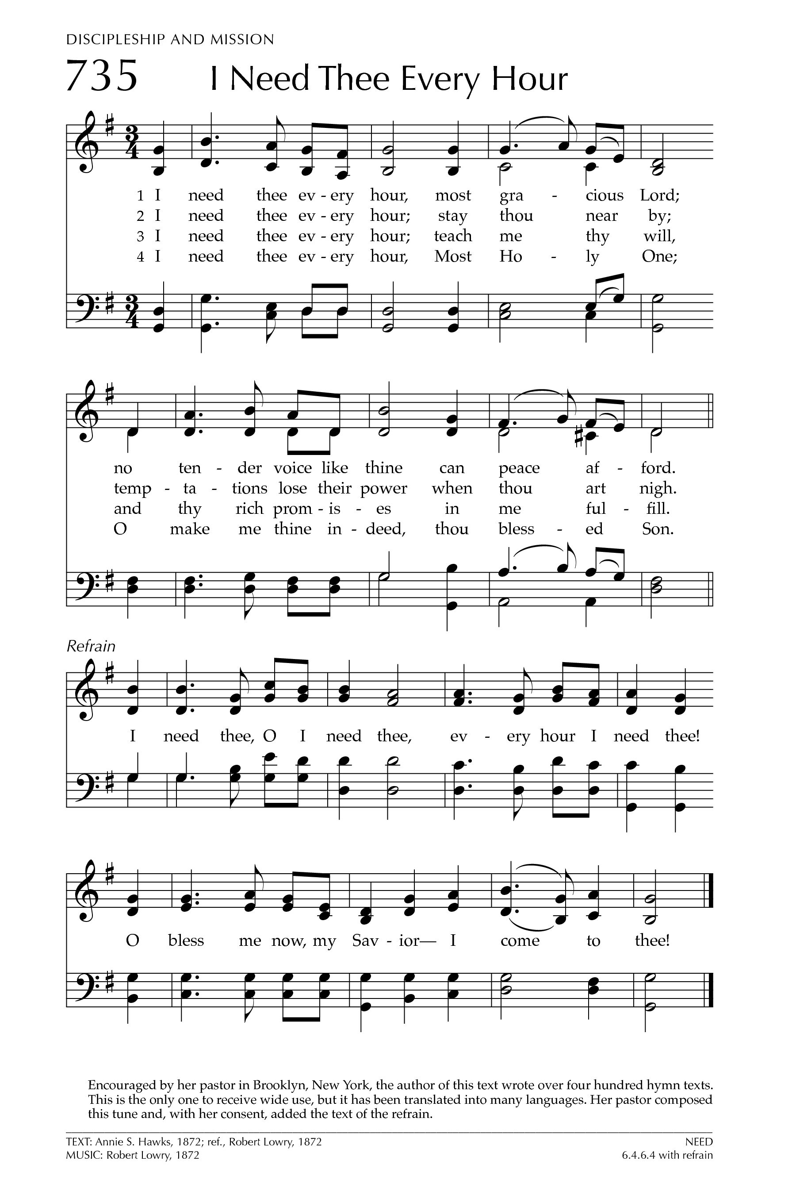
I Need Thee Every Hour
Text: Robert Lowry: Tune: NEED

I need Thee every hour
Most gracious Lord
No tender voice like Thine
Can peace afford

(refrain)
I need Thee, O I need Thee
Every hour I need Thee
O bless me now, my Savior
I come to Thee

I need Thee every hour
Stay Thou nearby
Temptations lose their power
When Thou art nigh. (refrain)

I need Thee every hour
In joy or pain
Come quickly and abide
Or life is vain. (refrain)

I need Thee every hour;
teach me Thy will;
And Thy rich promises
in me fulfill. (refrain)

I need Thee every hour,
most Holy One;
Oh, make me Thine indeed,
Thou blessed Son. (refrain)

THE PEACE

The peace of the Lord be always with you.
And also with you.

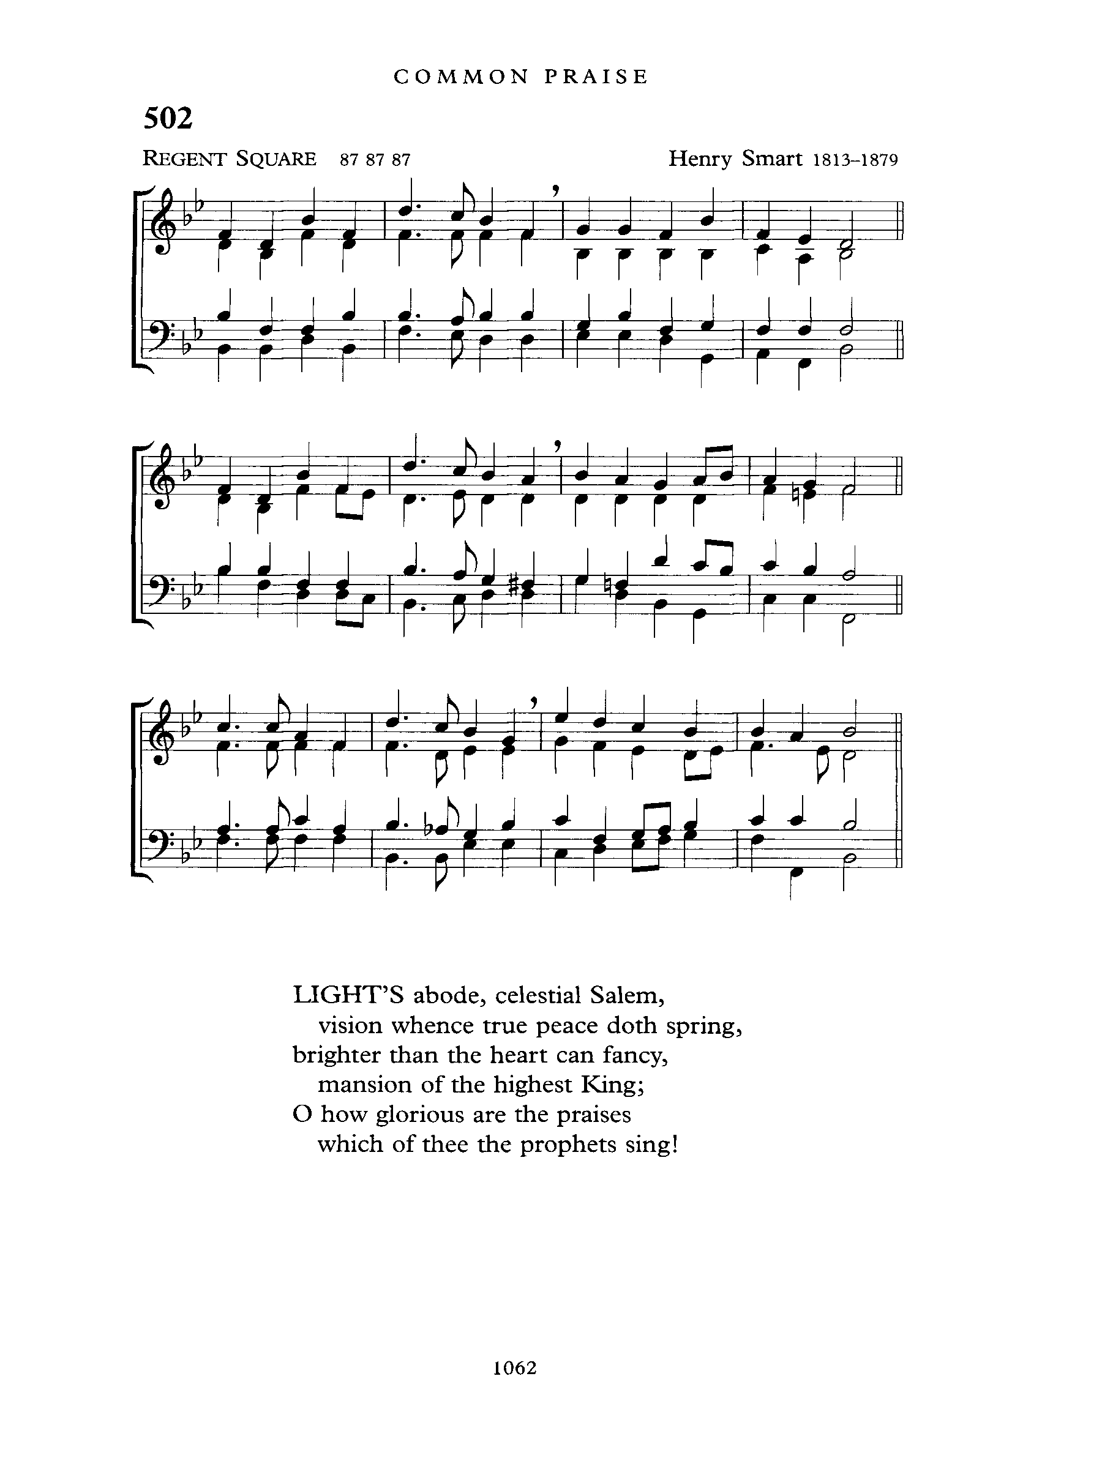
OFFERTORY: God of Grace and God of Glory
Text: Harry Emerson Fosdick; Tune: REGEANT SQUARE

God of grace and God of glory,
on your people pour your pow’r;
crown your ancient Church’s story,
bring its bud to glorious flow’r.
Grant us wisdom, grant us courage
for the facing of this hour.

Lo, the hosts of evil round us
scorn the Christ, assail his ways.
From the fears that long have bound us
free our hearts to faith and praise.
Grant us wisdom, grant us courage
for the living of these days.

Cure your children’s warring madness;
bend our pride to your control;
shame our wanton, selfish gladness,
rich in things and poor in soul.
Grant us wisdom, grant us courage
lest we miss your kingdom’s goal.

Set our feet on lofty places;
gird our lives that they may be
armoured with all Christlike graces,
pledged to set all captives free.
Grant us wisdom, grant us courage,
that we fail not them nor thee!

PRAYER OVER THE GIFTS

God of grace, accept all we offer you this day,
as we look toward the glory you have promised.
This we ask in the name of Jesus Christ our Lord. Amen.
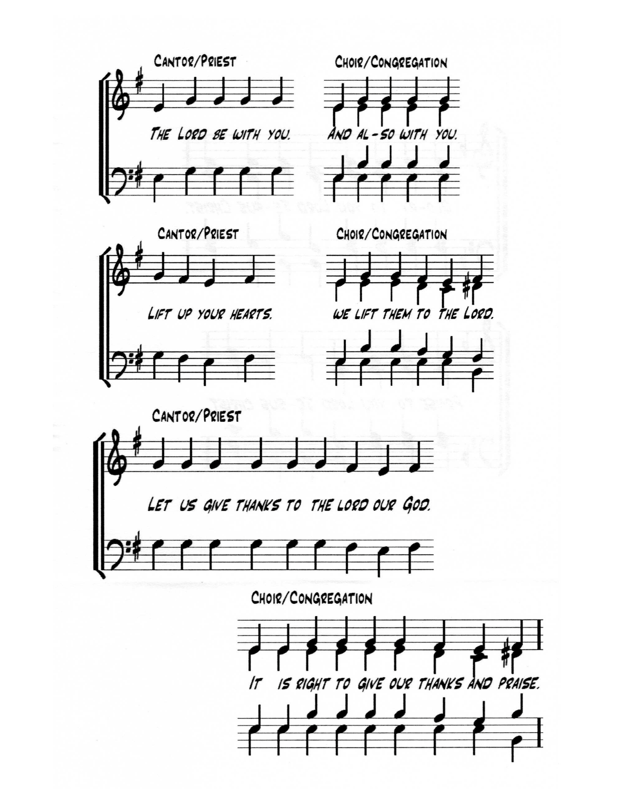
EUCHARISTIC PRAYER 2

The Lord be with you.
And also with you.

Lift up your hearts.
We lift them to the Lord.

Let us give thanks to the Lord our God.
It is right to give our thanks and praise.

We give you thanks and praise, almighty God,
through your beloved Son, Jesus Christ, our Saviour and Redeemer.
He is your living Word, through whom you have created all things.
By the power of the Holy Spirit he took flesh of the Virgin Mary
and shared our human nature.
He lived and died as one of us, to reconcile us to you, the God and Father of all.

In fulfilment of your will he stretched out his hands in suffering,
to bring release to those who place their hope in you;
and so he won for you a holy people.
He chose to bear our griefs and sorrows, and to give up his life on the cross,
that he might shatter the chains of evil and death,
and banish the darkness of sin and despair.
By his resurrection he brings us into the light of your presence.

Now with all creation we raise our voices to proclaim the glory of your name.
Holy, holy, holy Lord,
God of power and might,
heaven and earth are full of your glory.
Hosanna in the highest.
Blessed is he who comes in the name of the Lord.
Hosanna in the highest.

Holy and gracious God, accept our praise,
through your Son our Saviour Jesus Christ;
who on the night he was handed over to suffering and death,
took bread and gave you thanks, saying, “Take, and eat:
this is my body which is broken for you.”

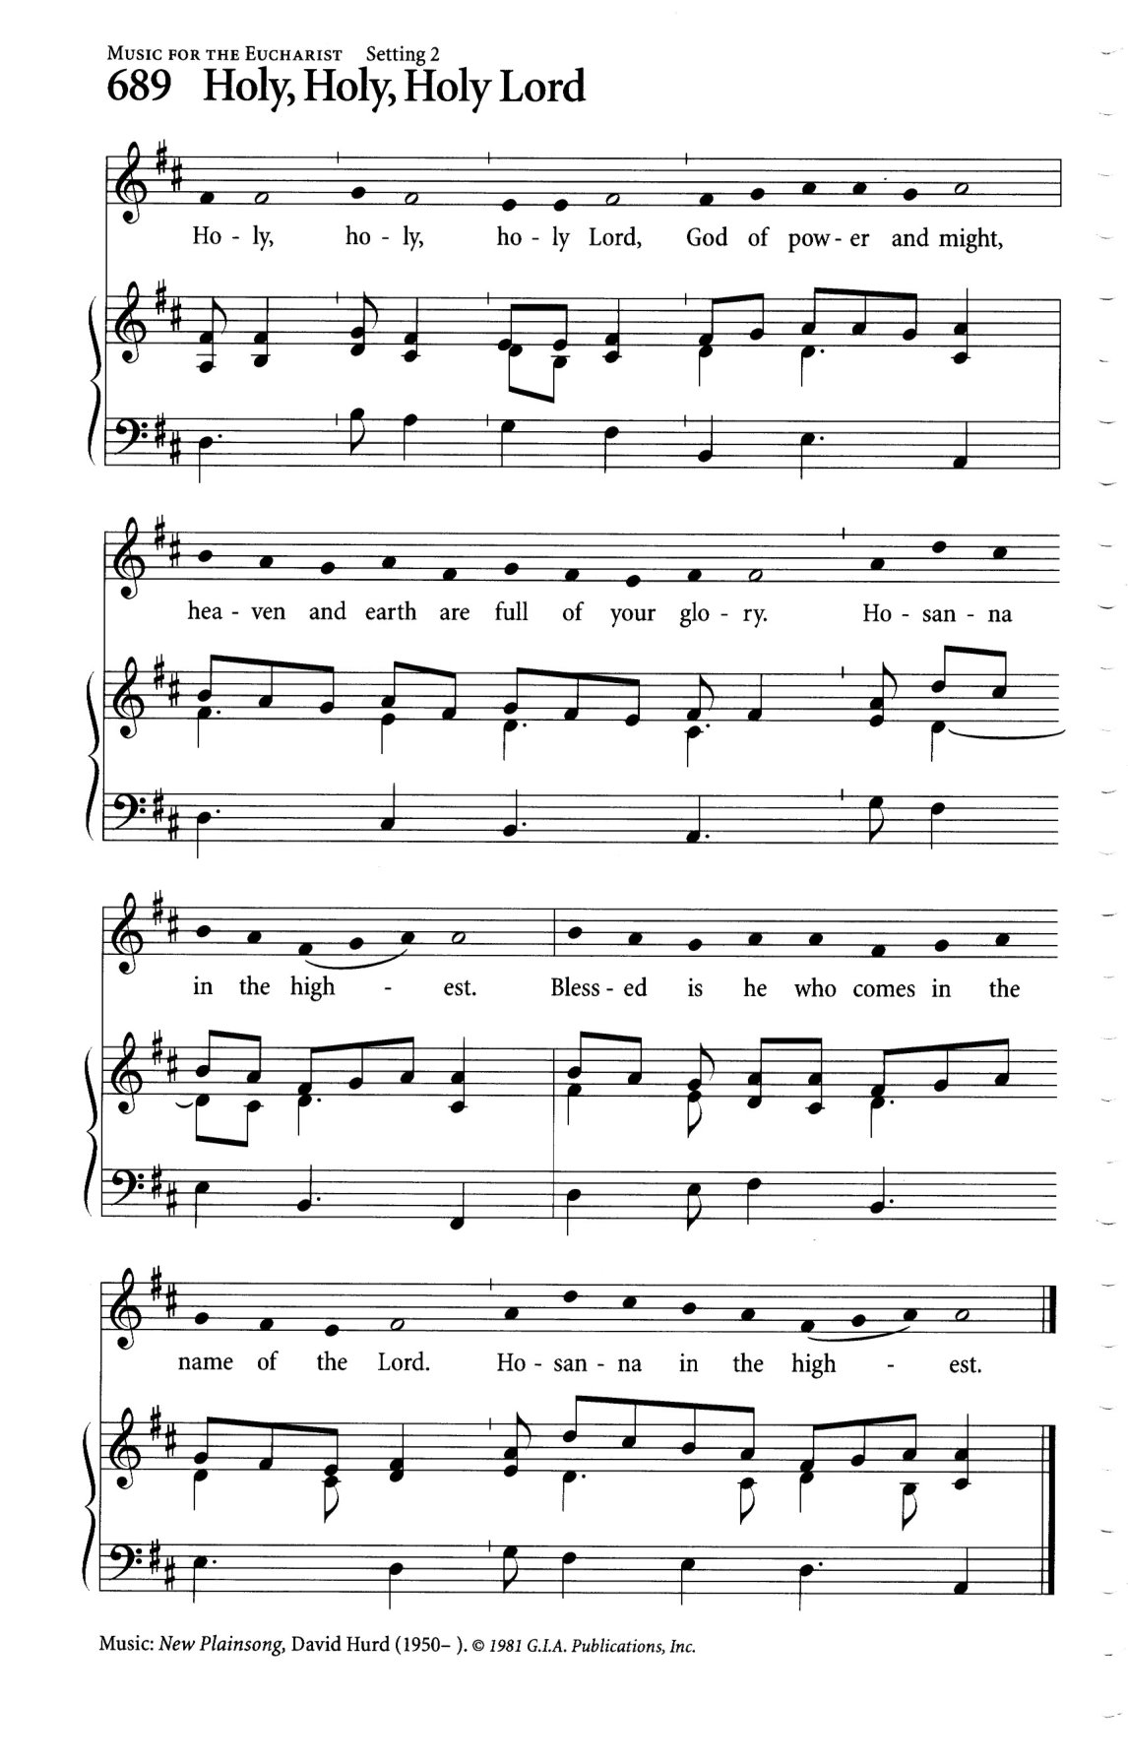
In the same way he took the cup,
saying, “This is my blood which is shed for you.
When you do this, you do it in memory of me.”

Remembering, therefore, his death and resurrection,
we offer you this bread and this cup,
giving thanks that you have made us worthy
to stand in your presence and serve you.
We ask you to send your Holy Spirit
upon the offering of your holy Church.

Gather into one all who share in these sacred mysteries,
filling them with the Holy Spirit and confirming their faith in the truth,
that together we may praise you and give you glory
through your Servant, Jesus Christ.
All glory and honour are yours, Father and Son, with the Holy Spirit
in the holy Church, now and for ever.
Amen.

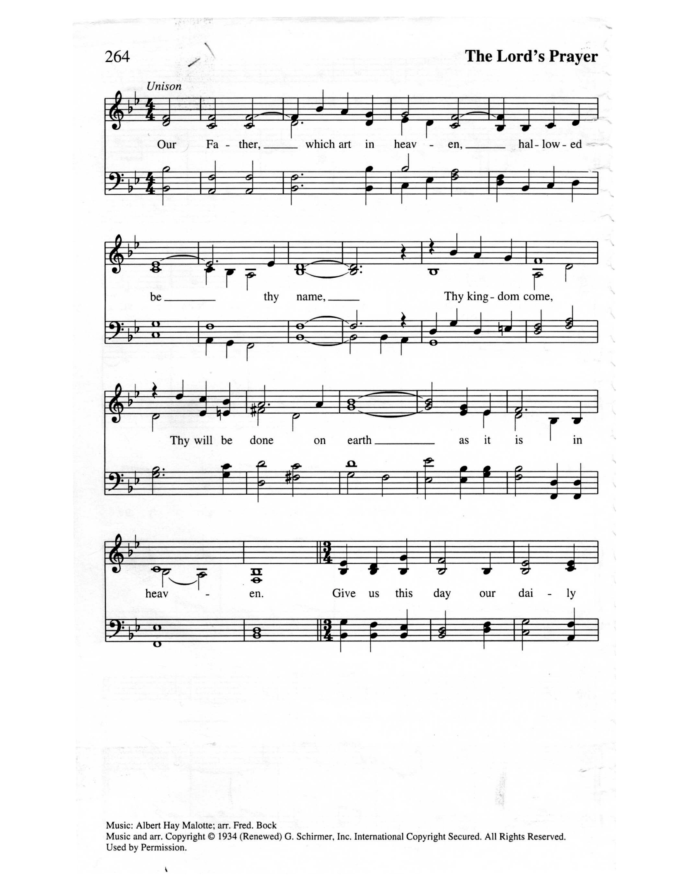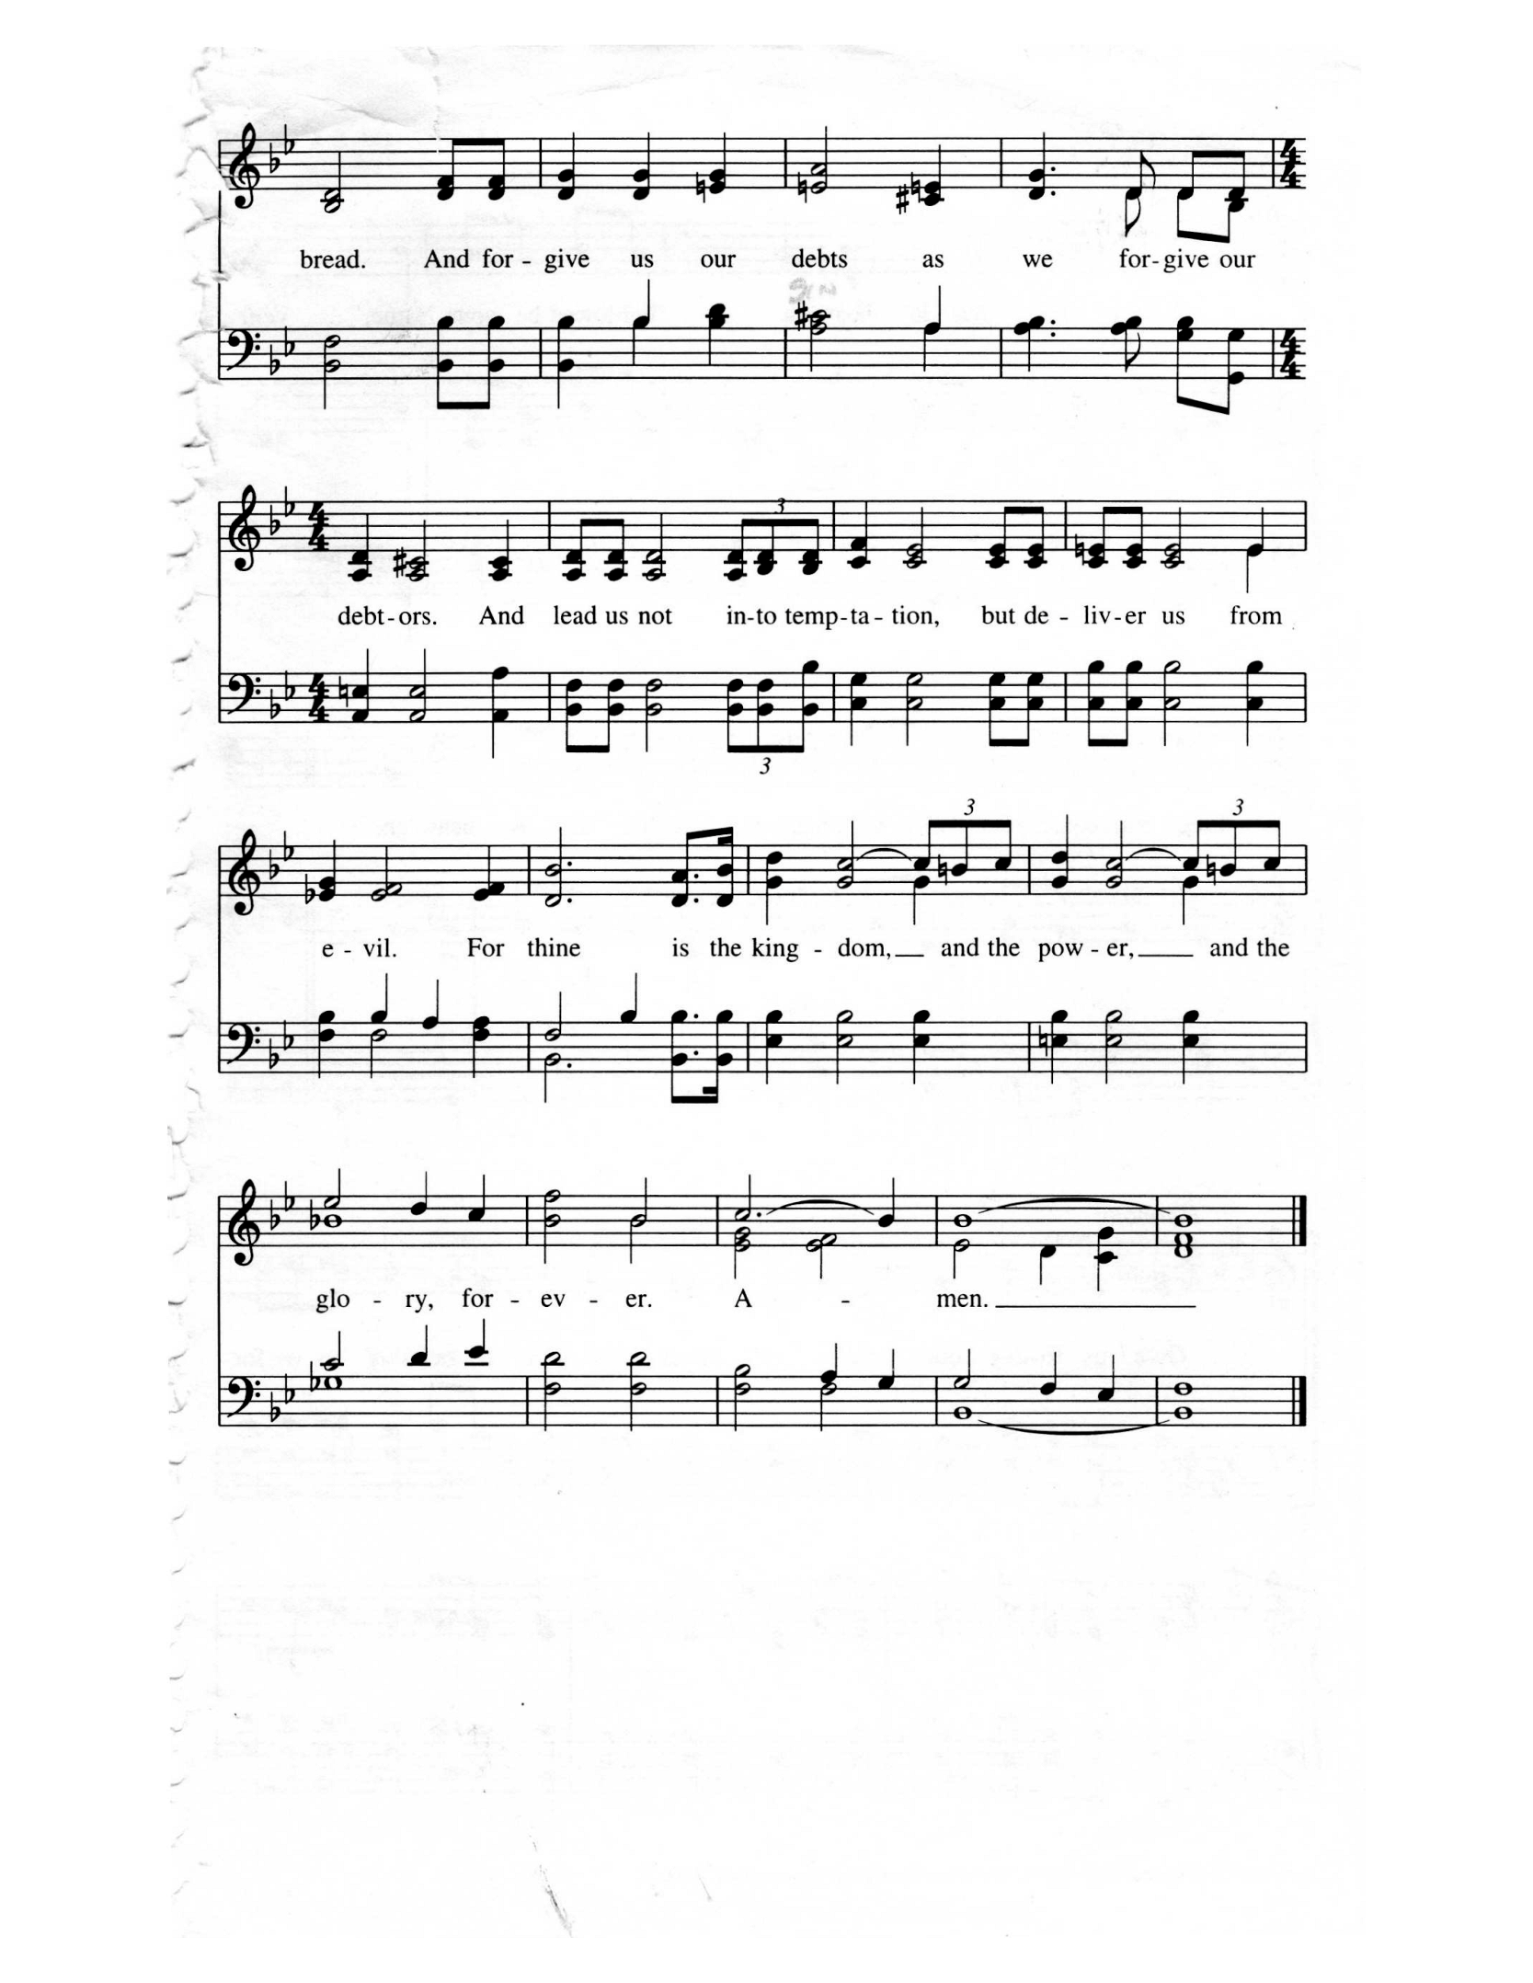
THE LORD’S PRAYER (Malotte)

And now, as our Saviour Christ has taught us, we are bold to sing,

Our Father
Which art in Heaven
Hallowed be thy name
Thy Kingdom come, Thy will be done
On earth as it is in heaven
Give us this day, Our daily bread
And forgive us our debts
As we forgive our debtors
And lead us not into temptation
But deliver us from evil
For Thine is the kingdom
And the power, and the glory, forever. Amen.

THE BREAKING OF THE BREAD

We break this bread to share in the body of Christ.
We, being many, are one body, for we all share in the one bread.

THE INVITATION

The gifts of God for the People of God
Thanks be to God.

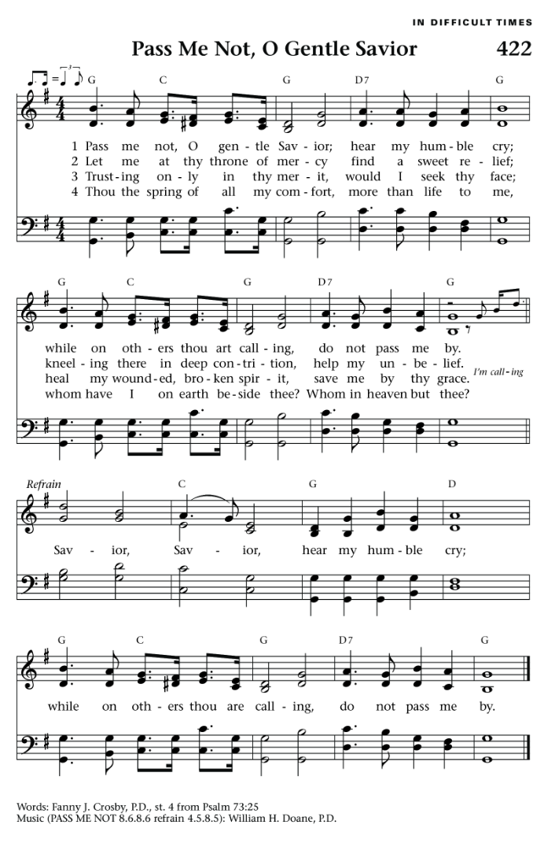
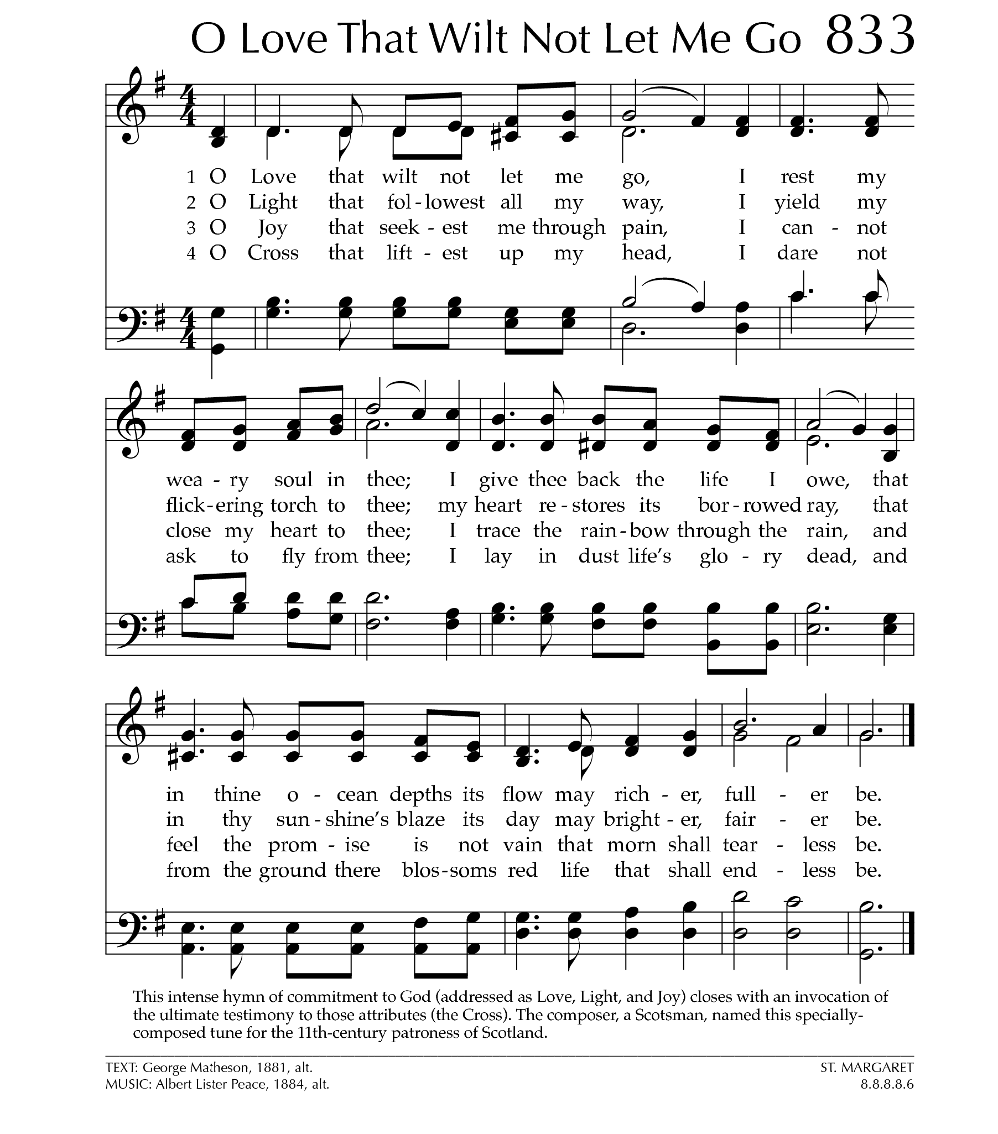
DURING COMNMUNION: O Love That Will Not Let me God
Text: George Matheson; Tune: ST. MARGARET

O Love that will not let me go,
I rest my weary soul in thee;
I give thee back the life I owe,
That in thine ocean depths its flow
May richer, fuller be.

O Light that foll’west all my way,
I yield my flick’ring torch to thee;
My heart restores its borrowed ray,
That in thy sunshine’s blaze its day
May brighter, fairer be.

O Joy that seekest me through pain,
I cannot close my heart to thee;
I trace the rainbow through the rain,
And feel the promise is not vain,
That morn shall tearless be.

O Cross that liftest up my head,
I dare not ask to fly from thee;
I lay in dust life’s glory dead,
And from the ground there blossoms red
Life that shall endless be.

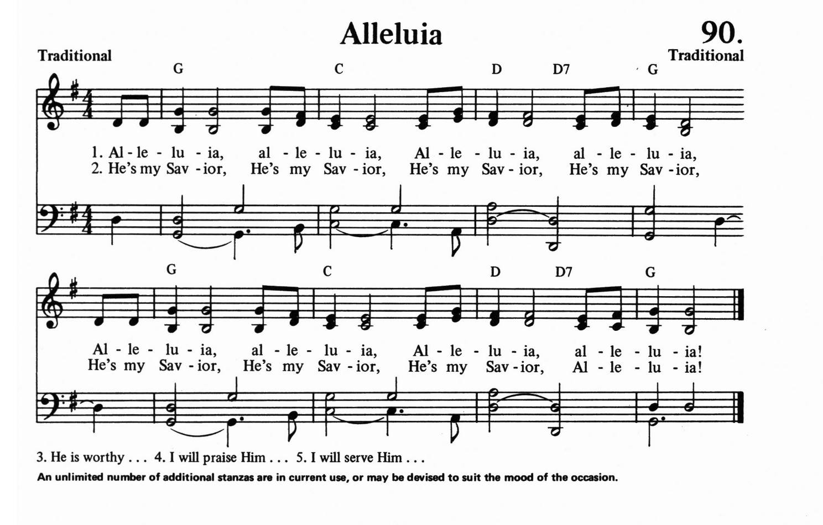
ABLUTIONS: Alleluia
Text: Jerry Sinclair; Tune: ALLELUIA

Alleluia, Alleluia, Alleluia, Alleluia,
Alleluia, Alleluia, Alleluia, Alleluia,

Thank you, Jesus. Thank you, Jesus. Thank you, Jesus. Thank you, Jesus.
Thank you, Jesus. Thank you, Jesus. Thank you, Jesus. Thank you, Jesus.

Lord, we praise you. Lord, we praise you. Lord, we praise you. Lord, we praise you.
Lord, we praise you. Lord, we praise you. Lord, we praise you. Lord, we praise you.

Alleluia, Alleluia, Alleluia, Alleluia,
Alleluia, Alleluia, Alleluia, Alleluia,

PRAYER AFTER COMMUNION

God of grace, we have received the memorial
of the death and resurrection of your Son.
May your love, poured into us, bring us to your promises.
We ask this in the name of our Redeemer Jesus Christ. Amen.

THE BLESSING

As you go hold to these reminders in Scripture,
that If God is for us, there is nothing to be afraid of.
And also that nothing can separate us from the love of Christ.
In all trouble we are better than winners because God loves us unconditionally.
The blessing of God Almighty, the Father,
the Son and the Holy Spirit, be with you, now and forever.
Amen.

ANNOUNCEMENTS

CELEBRATING OUR GRADUATES:

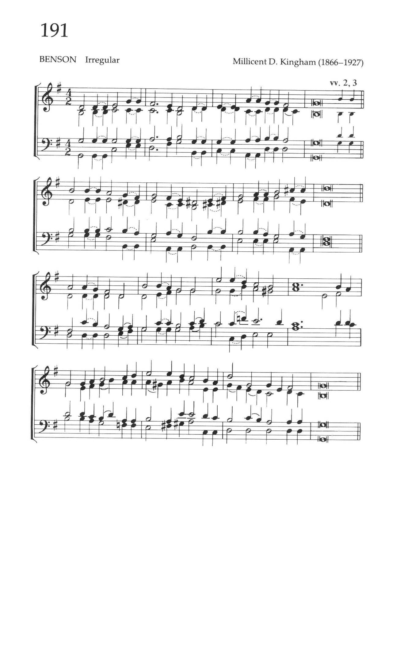
RECESSIONAL: God is Working His Purpose Out
Text: Arthur Campbell Ainger; Tune: BENSON

God is working this purpose out,
as year succeeds to year;
God is working this purpose out,
and the time is drawing near;
nearer and nearer draws the time,
the time that shall surely be:
when the earth shall be filled with the glory of God
as the waters cover the sea.

From utmost east to utmost west,
where human feet have trod,
by the mouth of many messengers
goes forth the voice of God:
“Give ear to me, ye continents,
ye isles, give ear to me,
that the earth may be filled with the glory of God
as the waters cover the sea.”

Let us go forth in the strength of God,
with the banner of Christ unfurled,
that the light of the glorious gospel of truth
may shine throughout the world.
Let us all fight with sorrow and sin
to set the captives free,
that the earth may be filled with the glory of God
as the waters cover the sea.

All we can do is nothing worth
unless God blesses the deed.
Vainly we hope for the harvest-tide
till God gives life to the seed.
Yet nearer and nearer draws the time,
the time that shall surely be,
when the earth shall be filled with the glory of God
as the waters cover the sea.

THE DISMISSAL:

Followers of the Christ, Inspired by the Holy Spirit.
Serve the world God loves. Alleluia! Alleluia!
Thanks be to God. Alleluia! Alleluia!

Postlude: Praise Him! Praise Him!
Joyful Song
