The Second Sunday of Advent

December 7, 2025, 10:30am

Theme: God Breaks In

Subtheme: Give Peace a Chance (Peace)

Website: www.sthildasanglicanchurch.com
Church Email: info@sthildasanglicanchurch.com
Facebook: St. Hilda’s Fairbank Anglican Church

Incumbent: The Rev. Canon Kenute Francis

(437-488-9657)

kenute@sthildasanglicanchurch.com

Honorary Assistant: The Rev. Canon Leonard Abbah

Eucharistic Ministers: Ianthe, William & Errol

Organist: William “Bill” Khan

Crucifer: Kishmar Miller

1st Reading: Donna Scantlebury

2nd Reading: Tanika Moore

The Gospel: Errol Parris

Intercession: Jerry Watts

Tech Team: Jonathan Small

Ushers Team 3: Richard Goddard Andrea Clarke

Sonia Wickham Richard Morris

Denise Sawney-Mark Jenita Hutchinson

Patricia Roachford-Skeete

MISSION STATEMENT
The purpose of St. Hilda’s Church is to be Christ-centered in our life and worship,
to serve lovingly those within our family and others within our reach

that the spirit of God might empower us for worship and pastoral care.

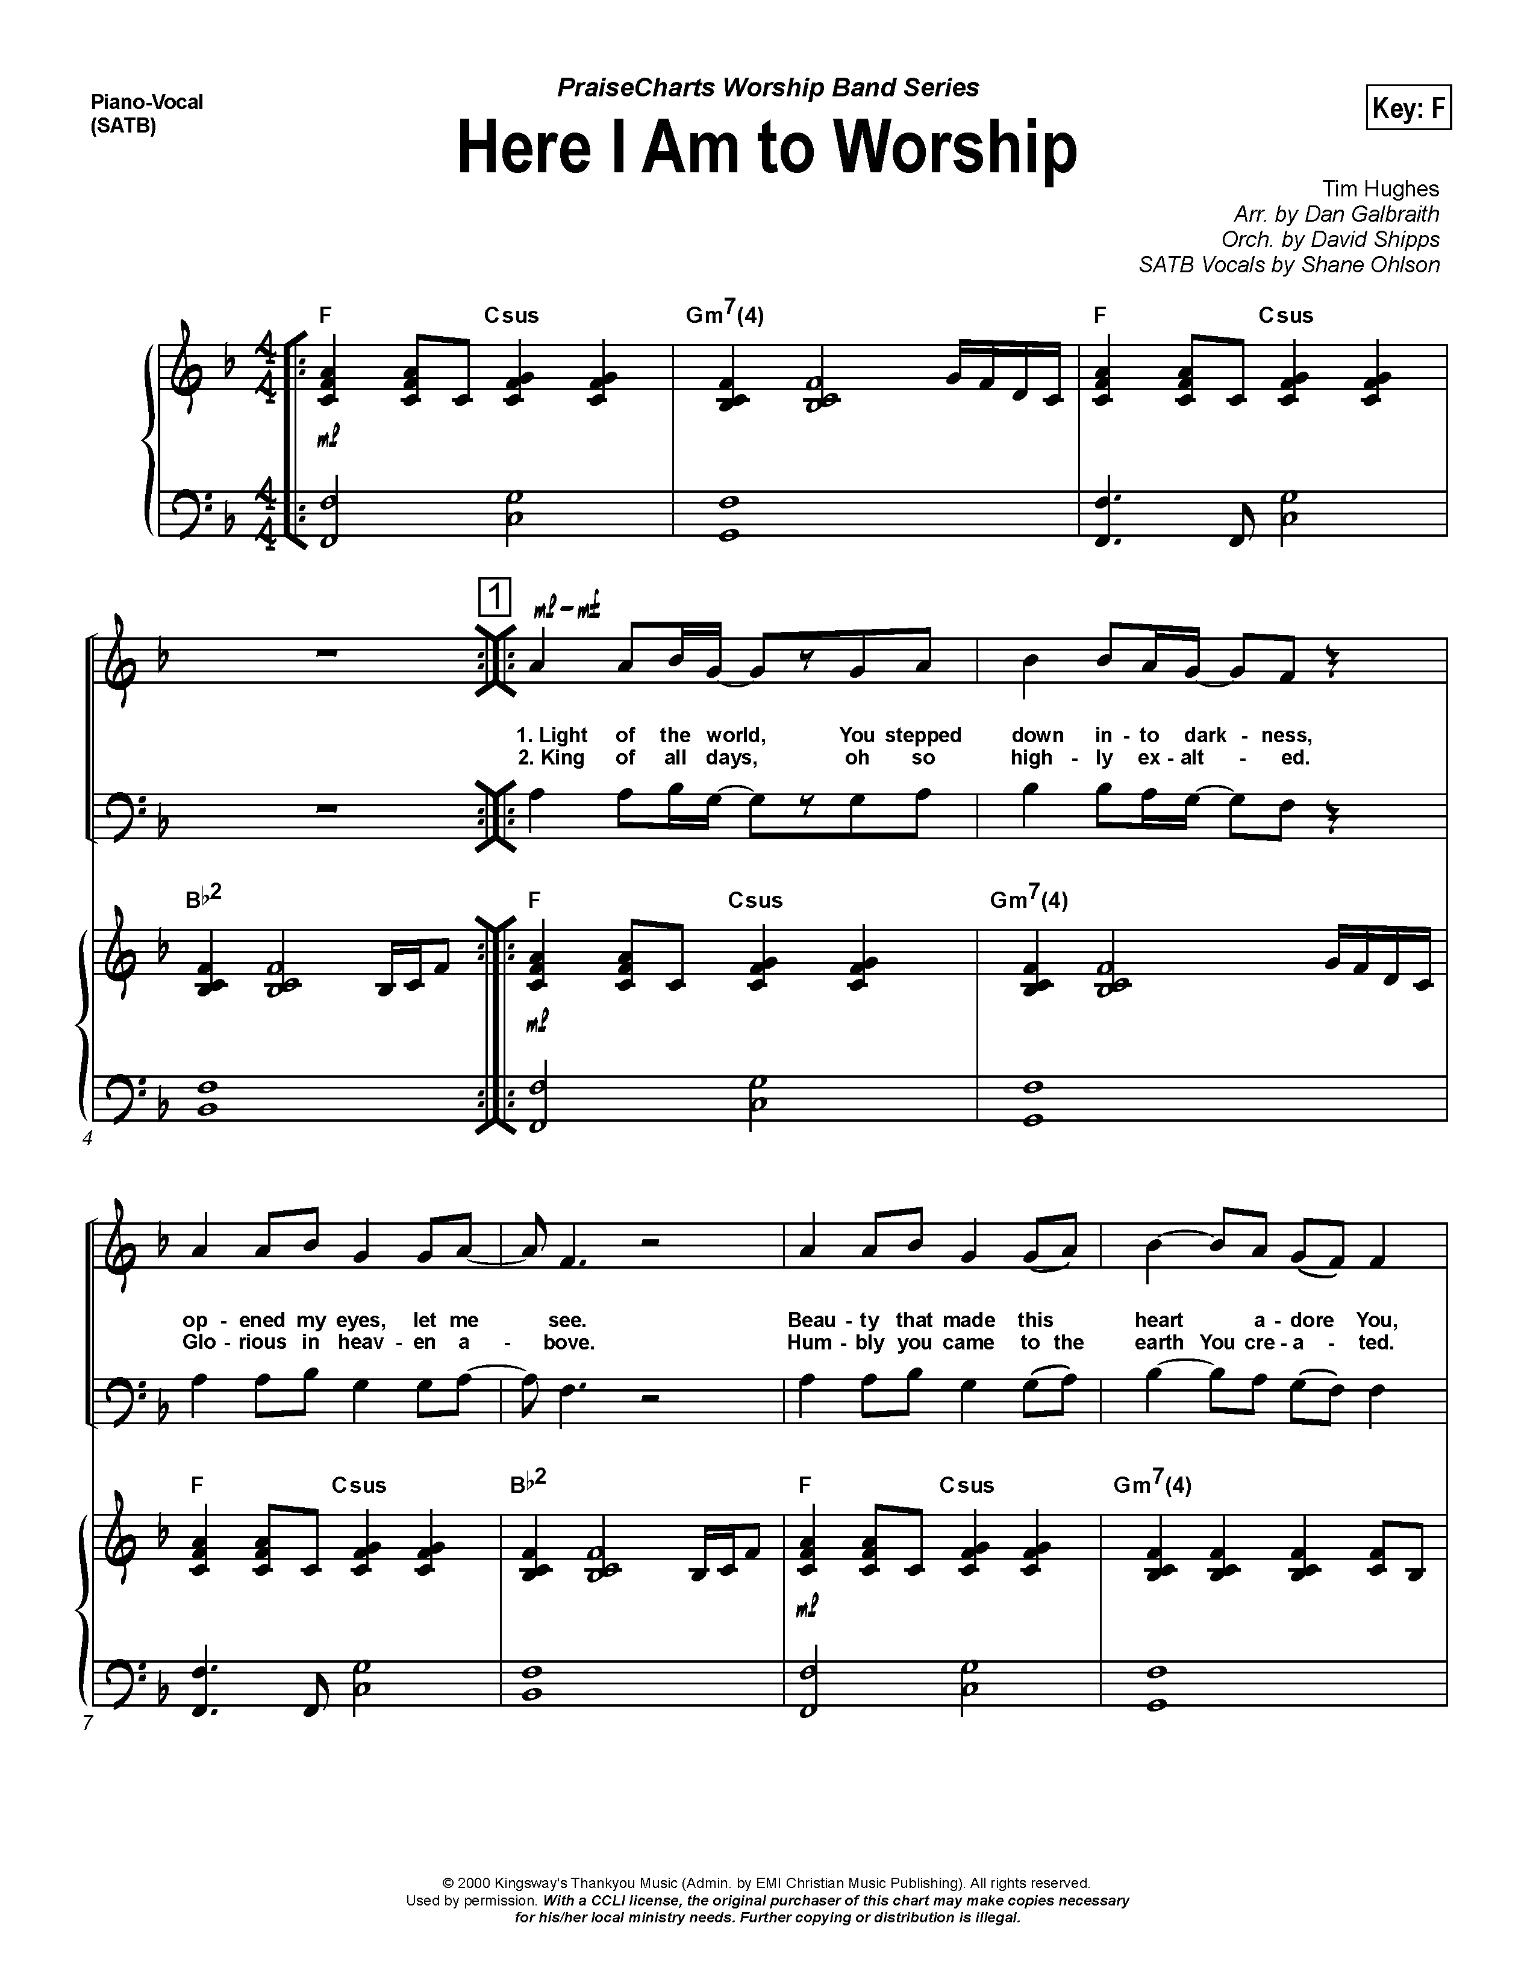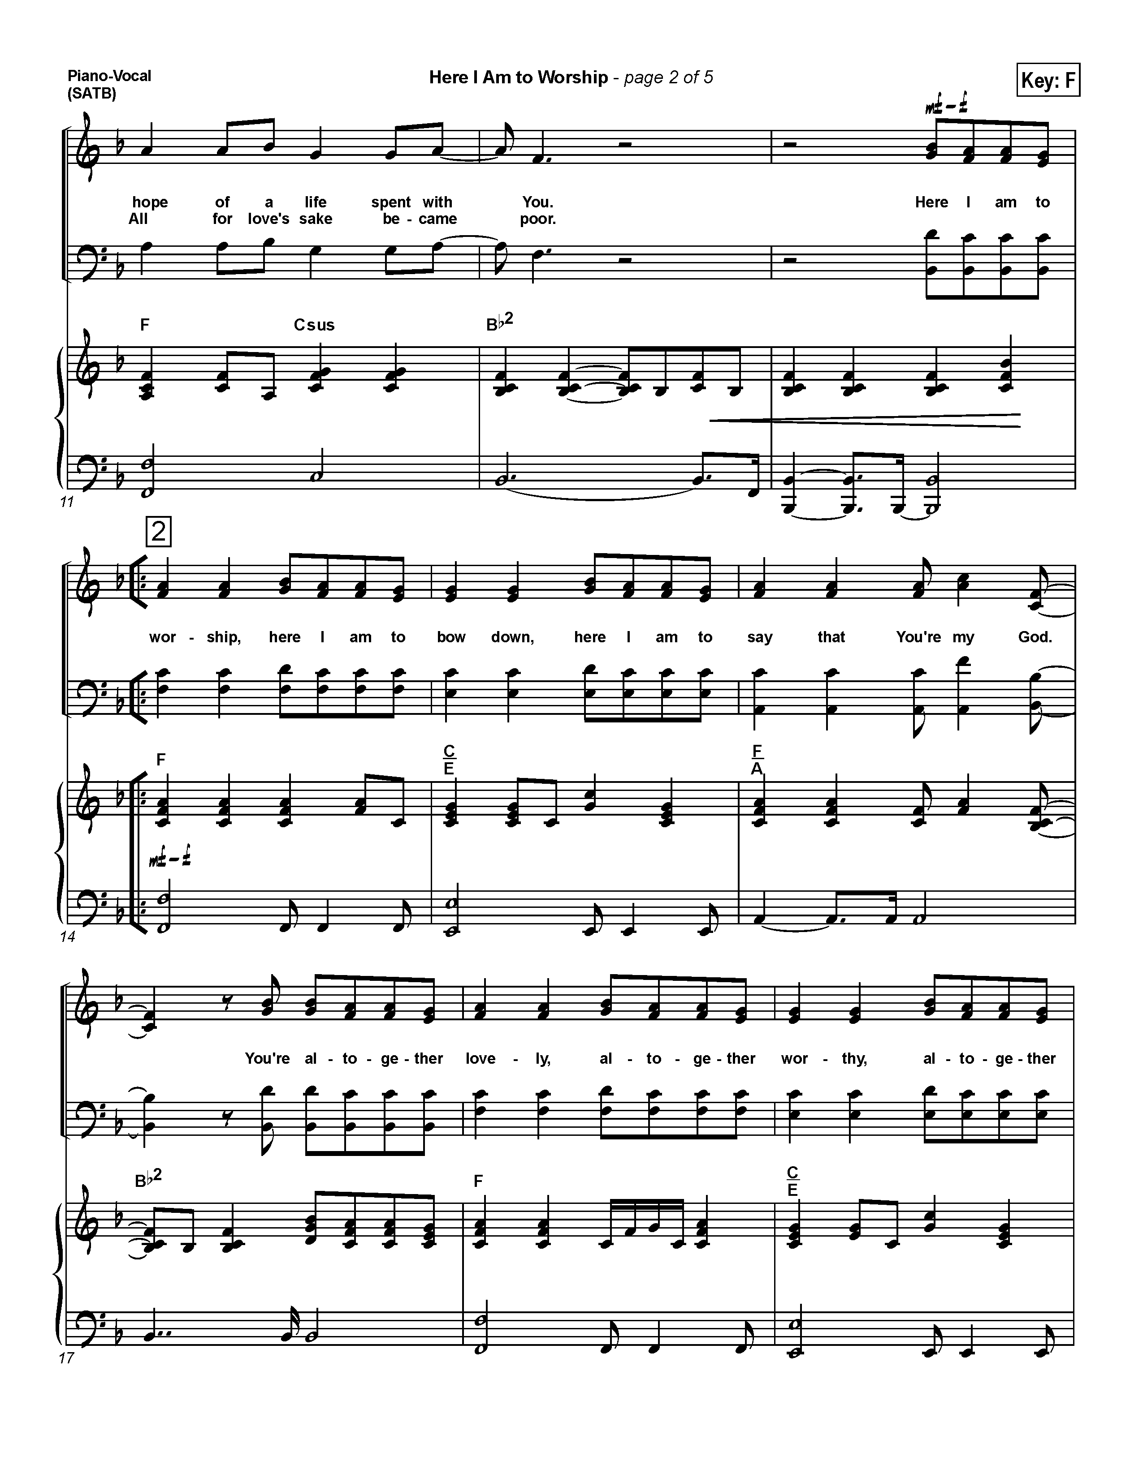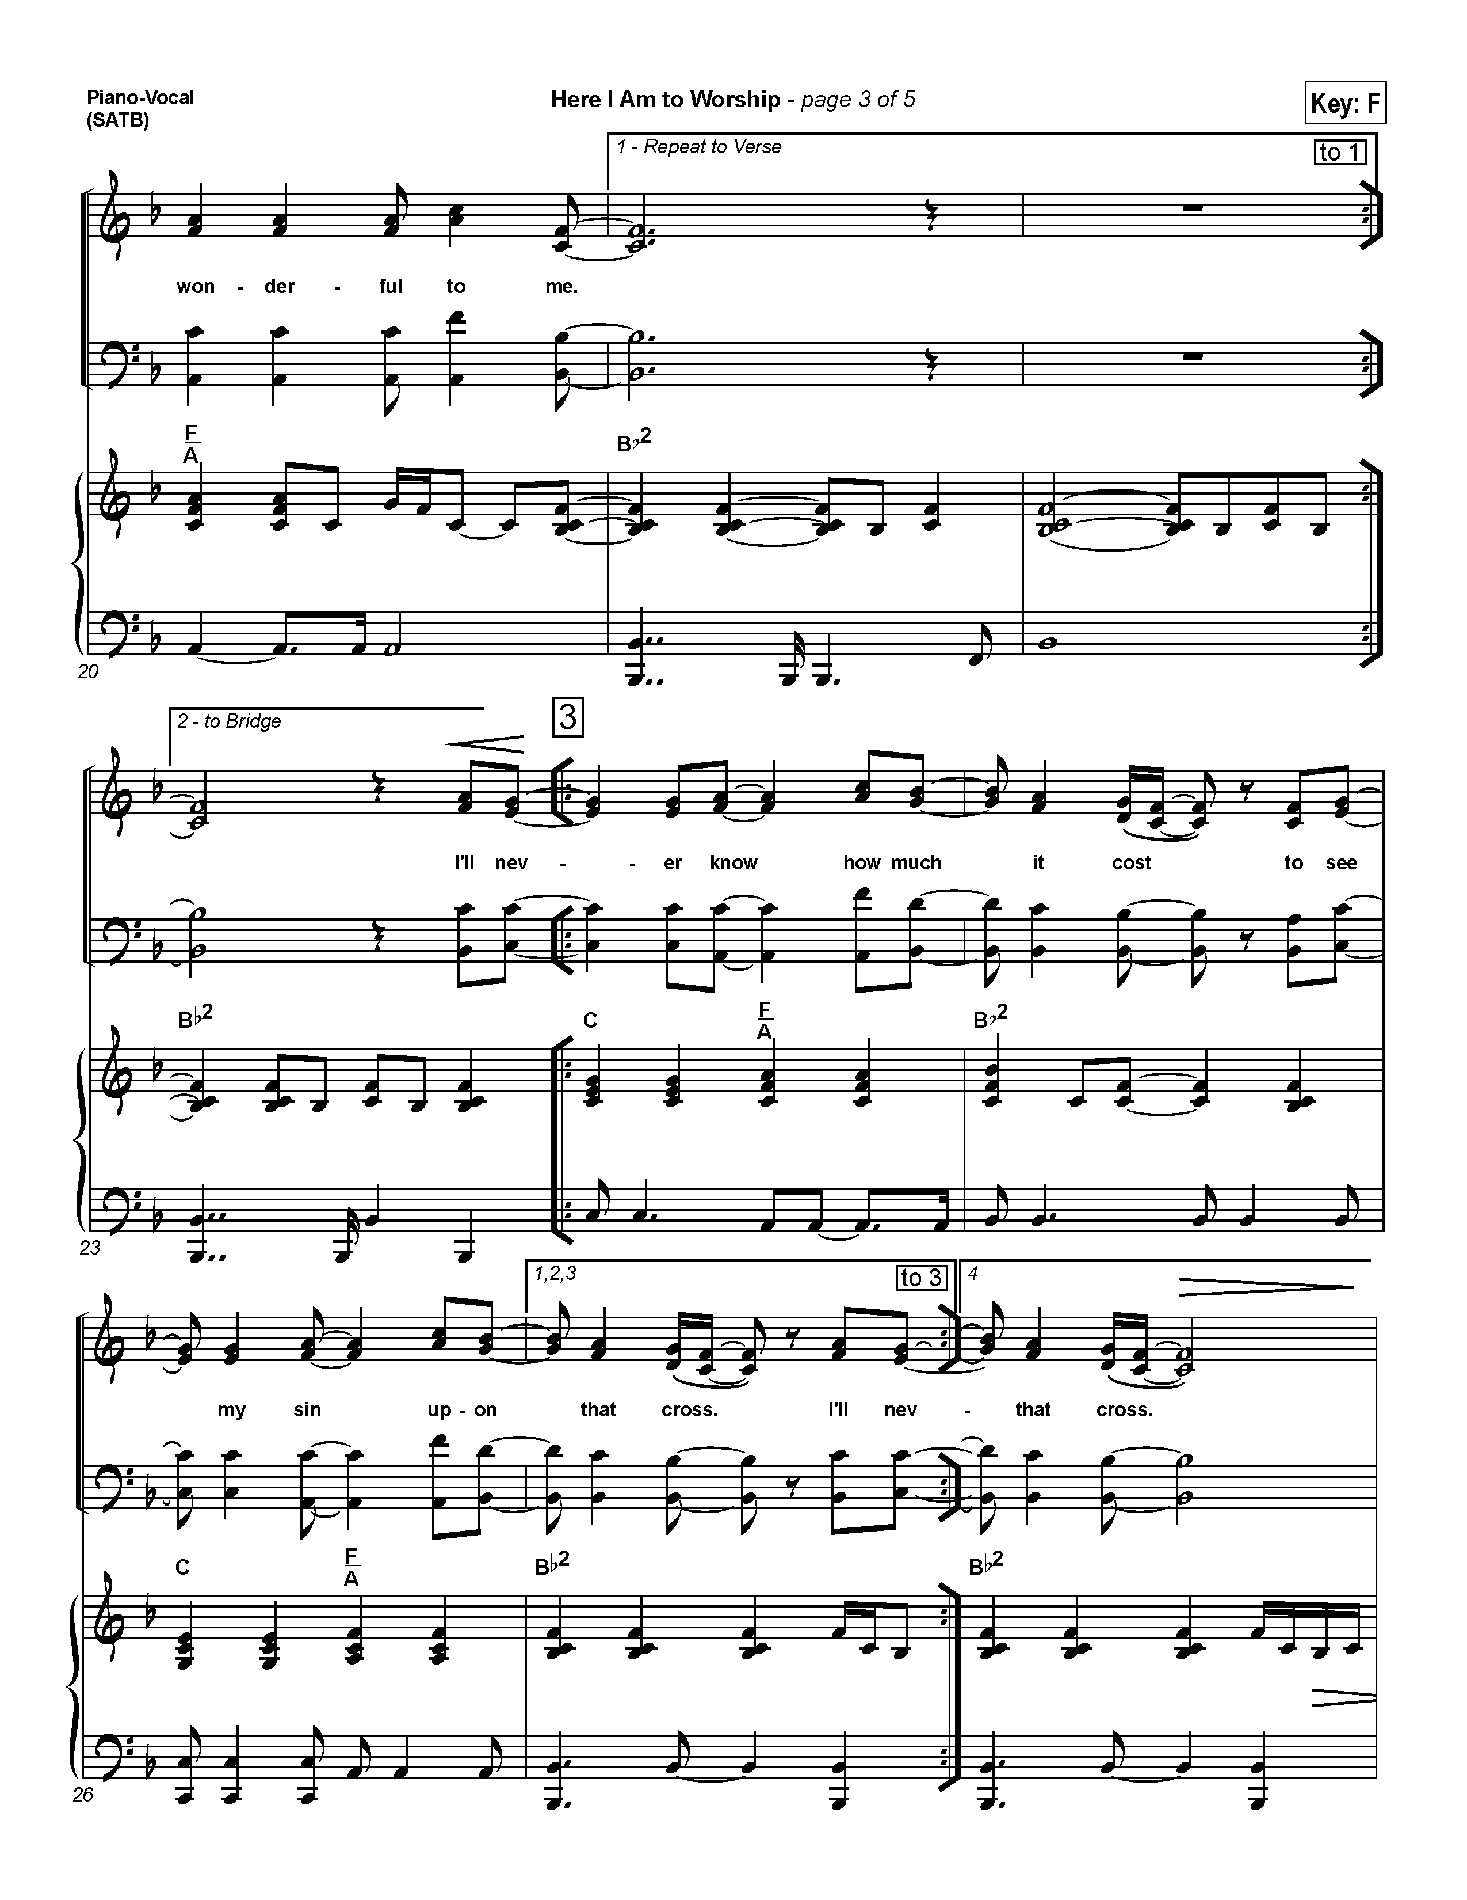

The Gathering of the Community

PRELUDE: “Here I Am to Worship”
Tim Hughes

OPENNG PRAYER:

God of Peace, calm our hearts and fill us with Your gentle light.
Let Christ’s peace rest upon us and guide us.
Amen.

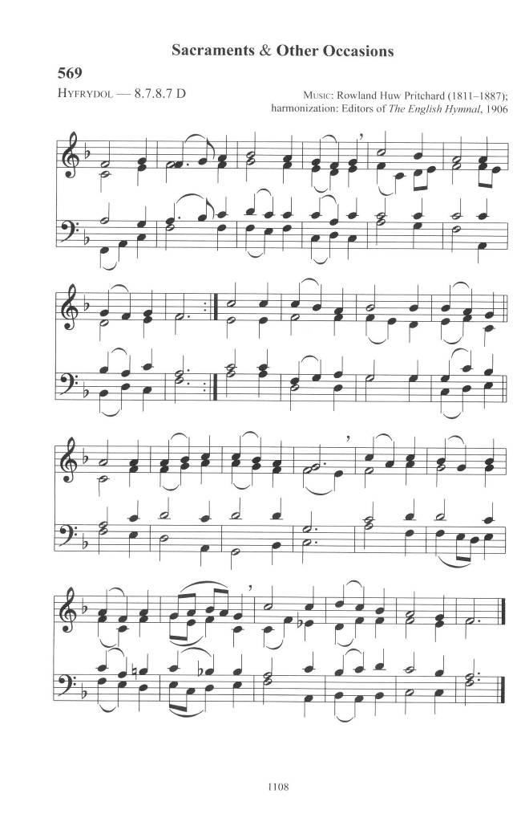
PROCESSIONAL: Come, Thou Long Expected Jesus
Words: Charles Wesley; Tune: HYFRODOL

Come, thou long expected Jesus
Born to set Thy people free;
From our fears and sins release us;
Let us find our rest in Thee
Israel's Strength and Consolation
Hope of all the earth Thou art;
Dear Desire of every nation
Joy of every longing heart

Joy to those who long to see thee
Day-spring from on high appear
Come thou promised Rod of Jesse
Of Thy birth we long to hear
O'er the hills the angels singing
News glad tidings of a birth
Go to him your praises bringing
Christ the Lord has come to earth

Born Thy people to deliver
Born a child and yet a King
Born to reign in us forever
Now Thy gracious kingdom bring
By Thine own eternal Spirit
Rule in all our hearts alone;
By Thine all sufficient merit
Raise us to Thy glorious throne
WELCOME:

THE GREETING:

The grace of our Lord Jesus Christ, the love of God
and the fellowship of the Holy Spirit be with you all.
And also with you

THE COLLECT FOR PURITY

Almighty God,
to you all hearts are open, all desires known, and from you no secrets are hidden.
Cleanse the thoughts of our hearts by the inspiration of your Holy Spirit,
that we may perfectly love you, and worthily magnify your holy name;
through Christ our Lord. Amen.

The Lighting of the Advent Candle - (Sobena Walton & Maxine Shan)
Give Peace a Chance (Peace)

The prophet Isaiah shared a word with the fearful world, a vision of gentleness and peace. “The wolf shall live with the lamb," he said, and "the leopard shall lie down with the kid, the calf and the lion and the fatling together, and a little child shall lead them." Peace often feels impossible, yet Advent declares that God breaks in with a different kind of peace—one rooted not in power but in righteousness, justice, and healing.

(the first Candle is lit)

Last week, we lit the first candle—the Candle of Hope.
In a weary world, God speaks a new promise.

(the second Candle is lit)

Today we light the Candle of Peace.
Because God breaks so that peace can be given a chance.

From Jesse’s stump, a new branch will grow.
And He will lead us into God’s peace.

Let us pray

Prince of Peace, enter our restless hearts and anxious world.
Teach us to walk in Your ways and make us instruments of reconciliation.
Break in again with peace. Amen.
(During the Introit Hymn the Children will go to the Lounge for Sunday School
& the Young People will go to the Board Room for Advent Study)

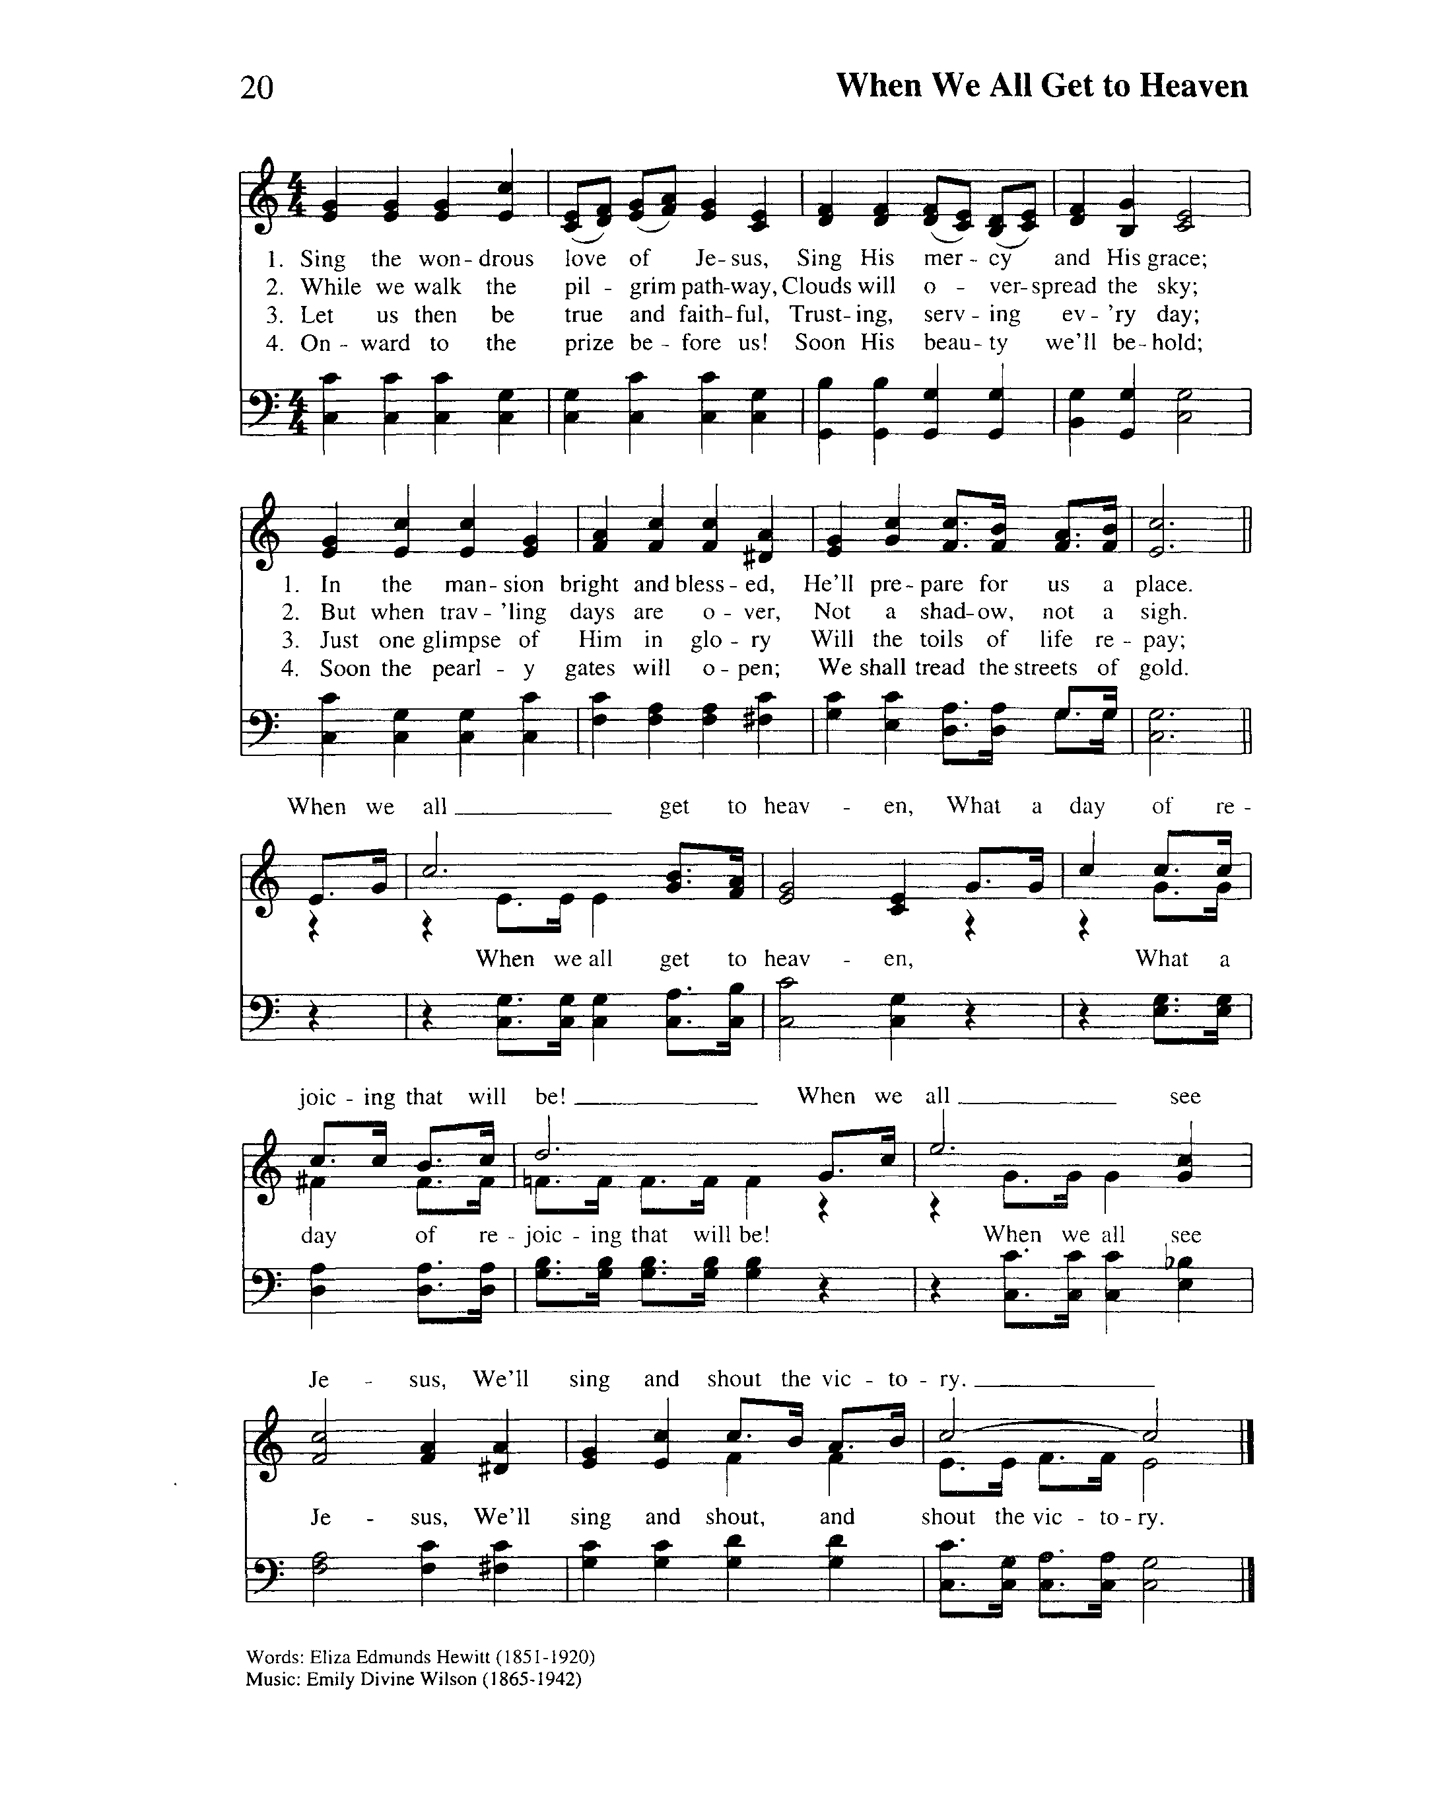
THE INTROIT: When our Lord Breaks In
Tune: WHEN WE ALL GET TO HEAVEN

In our chaos God is breaking,
Speaking peace to storm-tossed souls;
John the Baptist cries, “Prepare ye!”
For the One who makes us whole.

(refrain)
When our Lord breaks in with glory,
Every heart will rise and sing;
Praise the gift of our salvation
In the coming of our King.

THE COLLECT OF THE DAY

Almighty God,
who sent your servant John the Baptist
to prepare your people to welcome the Messiah, inspire us,
the ministers and stewards of your truth, to turn our disobedient hearts to you, that when the Christ shall come again to be our judge,
we may stand with confidence before his glory;
who is alive and reigns with you and the Holy Spirit,
one God, now and forever.
Amen.

THE PROCLAMATION OF THE WORD

THE FIRST READING: Isaiah 11:1-10 (Donna Scantlebury)

A Reading from the Book of the Prophet Isaiah

A shoot shall come out from the stump of Jesse, and a branch shall grow out of his roots. The spirit of the LORD shall rest on him, the spirit of wisdom and understanding, the spirit of counsel and might, the spirit of knowledge and the fear of the LORD. His delight shall be in the fear of the LORD.
He shall not judge by what his eyes see, or decide by what his ears hear;
but with righteousness he shall judge the poor, and decide with equity
for the meek of the earth; he shall strike the earth with the rod of his mouth, and with the breath of his lips he shall kill the wicked.
Righteousness shall be the belt around his waist, and faithfulness the belt around his loins. The wolf shall live with the lamb, the leopard shall lie down with the kid, the calf and the lion and the fatling together, and a little child shall lead them.
The cow and the bear shall graze, their young shall lie down together; and the lion shall eat straw like the ox. The nursing child shall play over the hole of the asp,
and the weaned child shall put its hand on the adder's den.
They will not hurt or destroy on all my holy mountain; for the earth
will be full of the knowledge of the LORD as the waters cover the sea.
On that day the root of Jesse shall stand as a signal to the peoples;
the nations shall inquire of him, and his dwelling shall be glorious.

The word of the Lord.
Thanks be to God

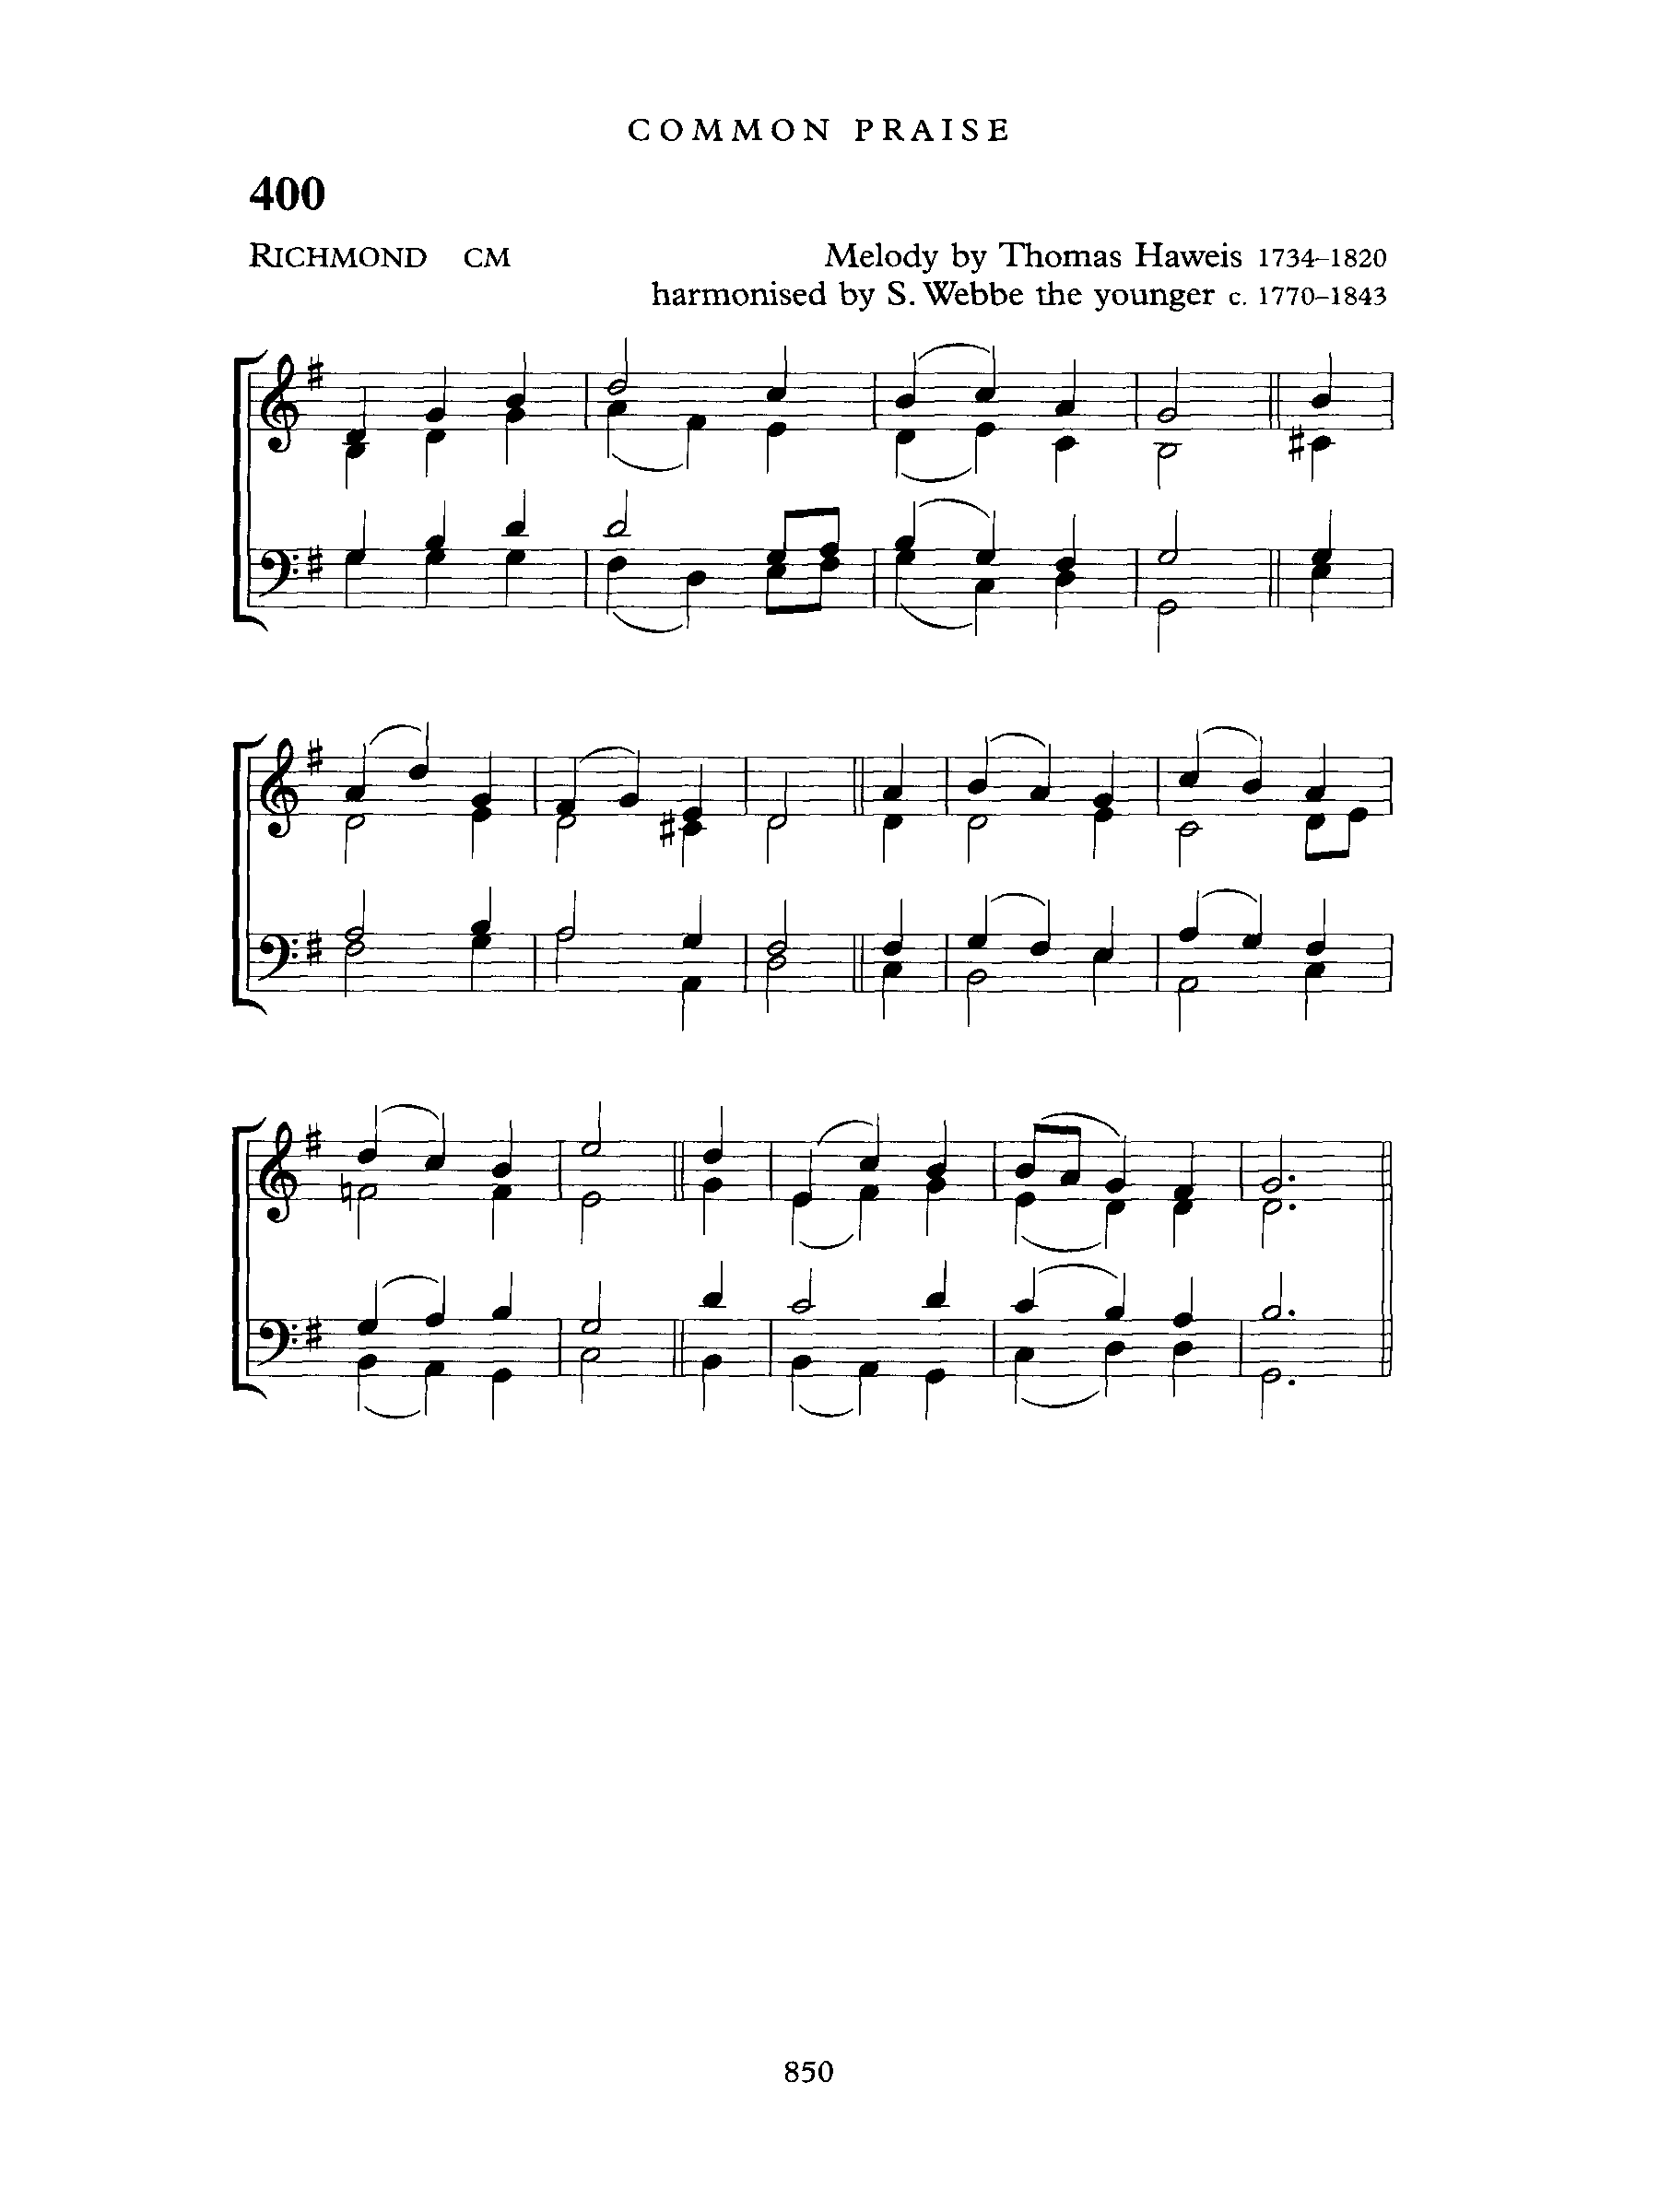
Psalm 72:1-7 - Tune: RICHMOND

Send us, O God, the King whose reign;
will make your justice known
Let him deal fairly with your land,
the poor and all your own.

Let every mountain, every hill,
Bring righteousness and peace;
Let him defend the needy poor
Make all oppression cease.

So long as sun and moon endure
Let him, O Lord, remain
Let him come down as showers, Lord.
And as refreshing rain.

Let peace and righteousness increase
Till moons shall be no more
And let him have dominion, Lord.
And reign from shore to shore.
Give glory to the Father, Son,
and Spirit equally,
As from the first it was, is now,
and evermore shall be.
Amen.

THE SECOND READING: ROMANS 15: 4-13 (Tanika Moore)

A READING FROM THE LETTER OF PAUL TO THE ROMANS

For whatever was written in former days was written for our instruction, so that by steadfastness and by the encouragement of the scriptures we might have hope. May the God of steadfastness and encouragement grant you to live in harmony with one another, in accordance with Christ Jesus, that together you may with one voice glorify the God and Father of our Lord Jesus Christ. Welcome one another, therefore, just as Christ has welcomed you, for the glory of God. For I tell you that Christ has become a servant of the circumcised on behalf of the truth of God in order that he might confirm the promises given to the patriarchs, and in order that the Gentiles might glorify God for his mercy. As it is written, "Therefore I will confess you among the Gentiles, and sing praises to your name"; and again he says, "Rejoice, O Gentiles, with his people"; and again, "Praise the Lord, all you Gentiles, and let all the peoples praise him"; and again Isaiah says, "The root of Jesse shall come, the one who rises to rule the Gentiles; in him the Gentiles shall hope."
May the God of hope fill you with all joy and peace in believing, so that you may abound in hope by the power of the Holy Spirit.

The word of the Lord
Thanks be to God

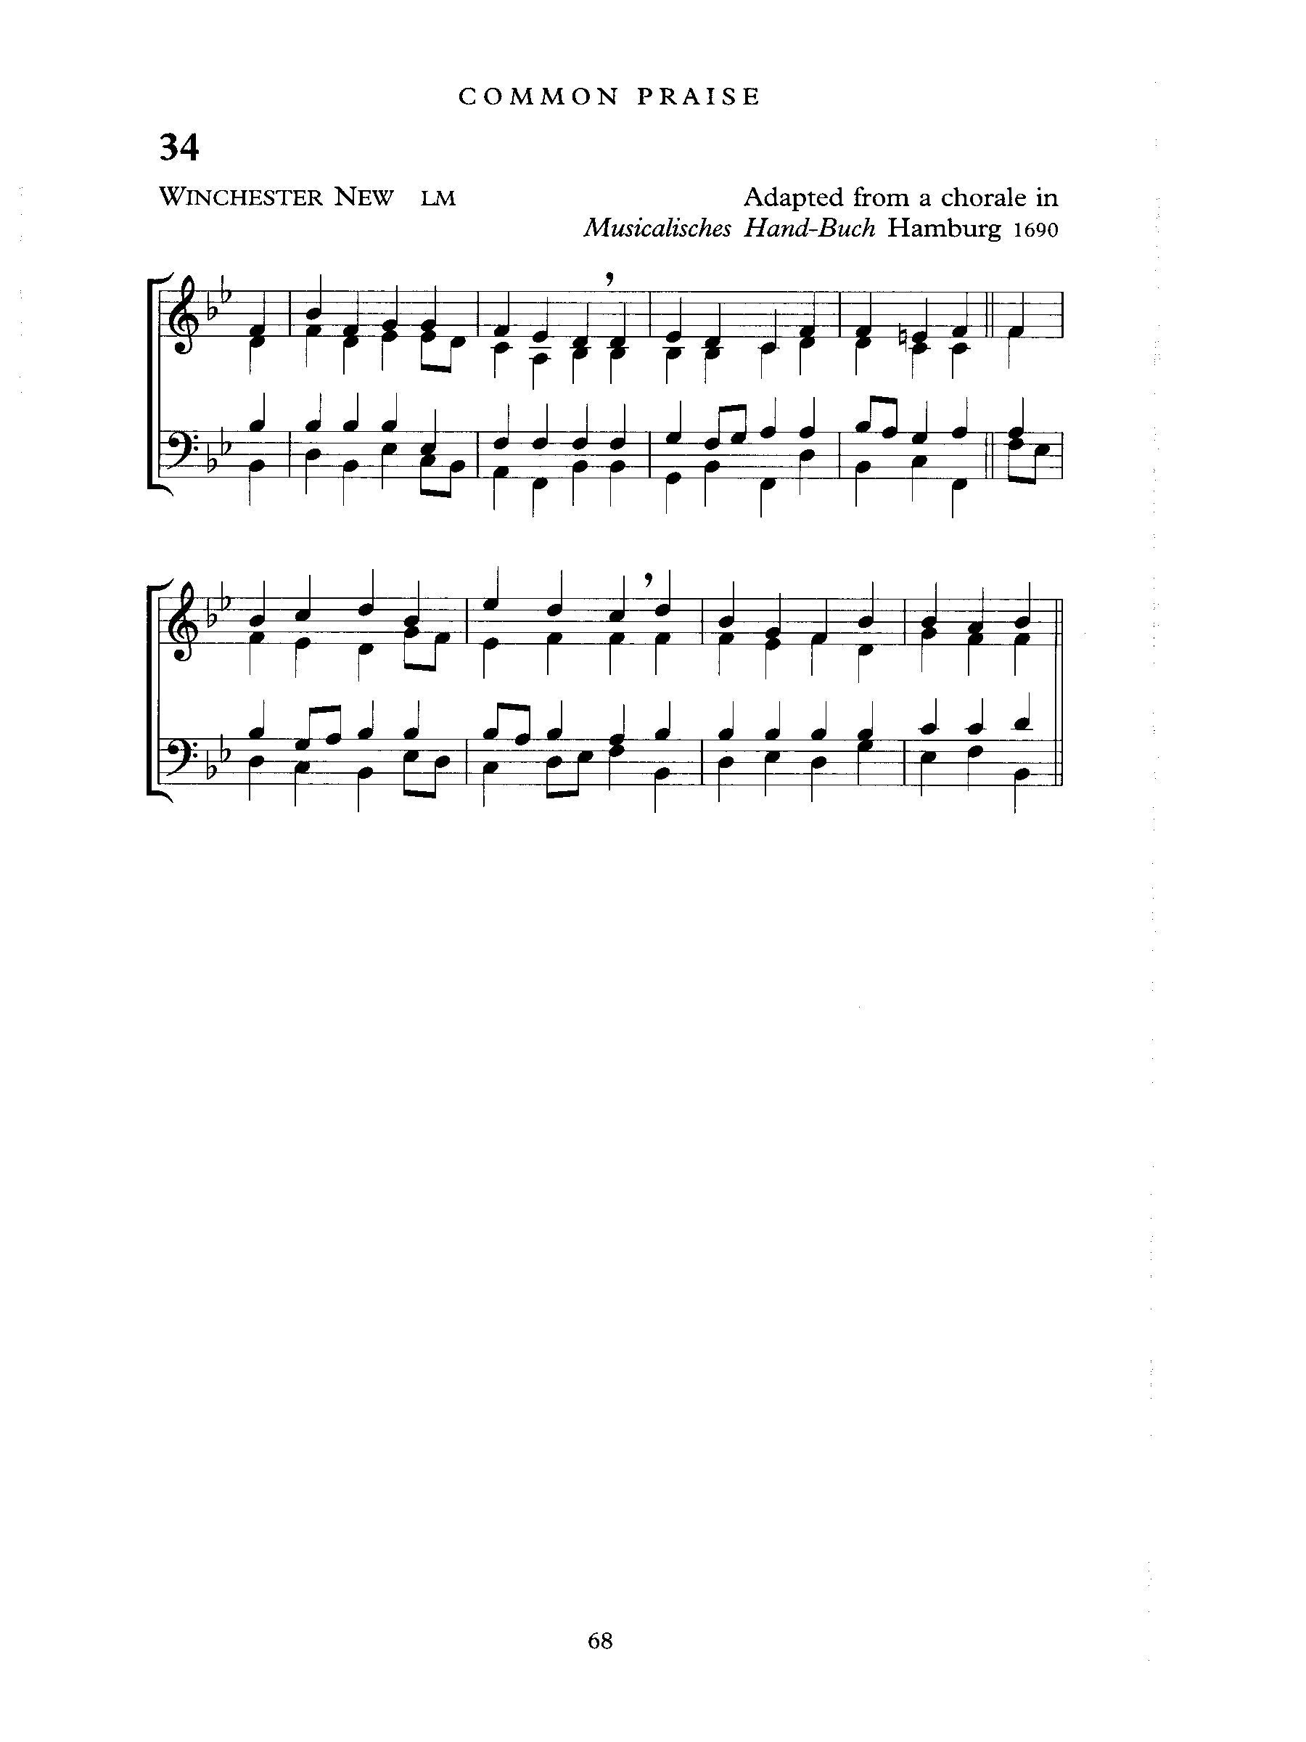
THE GRADUAL: On Jordan’s Bank the Baptist Cry
Words: Charles Coffin; Tune: WINCHESTER NEW

On Jordan's bank, the Baptist's cry
Announces that the Lord is nigh;
Awake, and hearken, for he brings
Glad tidings of the King of kings!

Then cleansed be every breast from sin;
Make straight the way for God within;
Prepare we in our hearts a home
Where such a mighty Guest may come.

For Thou art our Salvation, Lord,
Our Refuge, and our great Reward.
Without Thy grace we waste away,
Like flowers that wither and decay.

To heal the sick stretch out Thine hand,
And bid the fallen sinner stand;
Shine forth, and let Thy light restore
Earth's own true loveliness once more.

All praise, eternal Son, to Thee
Whose advent sets Thy people free,
Whom, with the Father, we adore,
And Holy Ghost, forevermore.

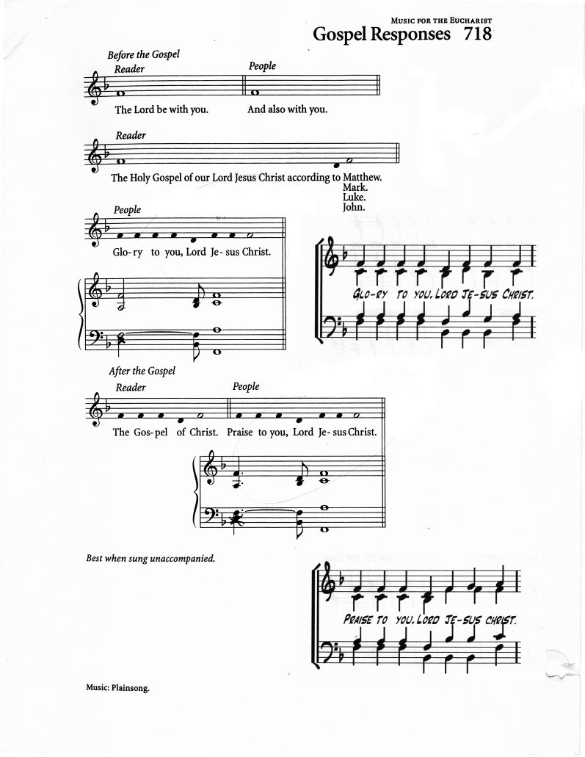
THE HOLY GOSPEL: MATTHEW 3:1-12 (Errol Parris)

The Lord be with you
And also with you

The Holy Gospel of our Lord Jesus Christ according to Matthew
Glory to you, Lord Jesus Christ

In those days John the Baptist appeared in the wilderness of Judea, proclaiming, "Repent, for the kingdom of heaven has come near."
This is the one of whom the prophet Isaiah spoke when he said,
"The voice of one crying out in the wilderness: 'Prepare the way of the Lord, make his paths straight.'"
Now John wore clothing of camel's hair with a leather belt around his waist,
and his food was locusts and wild honey.
Then the people of Jerusalem and all Judea were going out to him, and all the region along the Jordan, and they were baptized by him in the river Jordan, confessing their sins. But when he saw many Pharisees and Sadducees coming for baptism, he said to them, "You brood of vipers!
Who warned you to flee from the wrath to come?
Bear fruit worthy of repentance. Do not presume to say to yourselves, 'We have Abraham as our ancestor'; for I tell you, God is able from these stones to raise up children to Abraham. Even now the ax is lying at the root of the trees; every tree therefore that does not bear good fruit is cut down and thrown into the fire.
"I baptize you with water for repentance, but one who is more powerful than I is coming after me; I am not worthy to carry his sandals. He will baptize you with the Holy Spirit and fire. His winnowing fork is in his hand, and he will clear his threshing floor and will gather his wheat into the granary; but the chaff he will burn with unquenchable fire."

The Gospel of Christ
Praise to you, Lord Jesus Christ

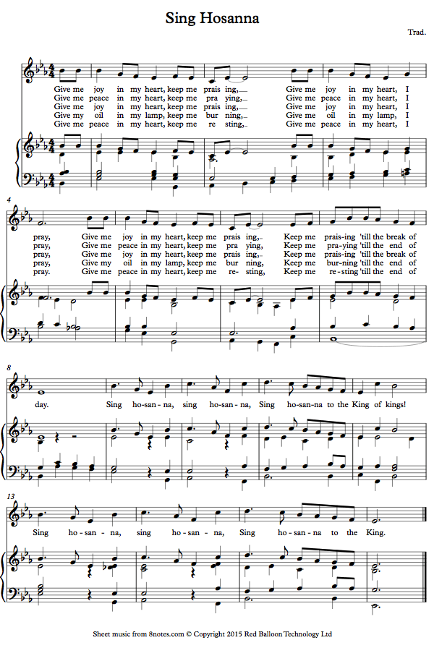
Gospel Acclamation: Give me Oil in my Lamp (X2)
Text: Traditional; Tune: SING HOSANNA

Give me peace in my heart, keep me trusting.
Give me peace in my heart, I pray.
Give me peace in my heart, keep me praying.
Keep me praying till the break of day.

(refrain)
Sing hosanna, sing hosanna,
sing hosanna to the King of kings!
Sing hosanna, sing hosanna,
sing hosanna to the King!

THE SERMON: Kenute Francis

THE APOSTLES CREED:

Let us confess our faith, as we say,

I believe in God, the Father almighty, creator of heaven and earth.
I believe in Jesus Christ, his only Son, our Lord.
He was conceived by the power of the Holy Spirit and born of the Virgin Mary.
He suffered under Pontius Pilate, was crucified, died, and was buried.
He descended to the dead. On the third day he rose again.
He ascended into heaven, and is seated at the right hand of the Father.
He will come again to judge the living and the dead.
I believe in the Holy Spirit, the holy catholic Church,
the communion of saints, the forgiveness of sins,
the resurrection of the body, and the life everlasting.
Amen.

PRAYERS OF INTERCESSION (Jerry Watts)

Let us pray,

God of peace who breaks into our noise, breathe Your calm into us now.
Hear, our cry, O God
and attend unto our prayer.

For pray our world aching for peace –
for every place where fear has a louder voice than hope,
where conflict steals childhoods and shatters communities,
where justice feels like a distant dream.
We lift before You every region living with unrest, displacement, or oppression.
Break in, O God, and teach the nations to give peace a chance.
Hear, our cry, O God
and attend unto our prayer.

We pray for peace in our communities, especially
where neighbours live behind locked doors,
where loneliness sits like a heavy winter coat,
where division has become normal—
break in with reconciliation, mercy, and belonging.
Make us peacemakers, not peace-avoiders.
Hear, our cry, O God
and attend unto our prayer.

We pray for peace in our homes
Especially where tension, grief, or silence have taken root;
for families facing financial strain, exhaustion, or misunderstanding—
break in with gentleness, healing, and patience.
Hear, our cry, O God
and attend unto our prayer.

We pray for peace within ourselves.
When our minds race, when our hearts are tired,
when we feel stretched thin - break in with Your stillness.
Calm our inner storm. Speak again the words You spoke over the waters:
“Peace. Be still.”
Hear, our cry, O God
and attend unto our prayer.

We pray for all who are ill in body or weary in spirit, for those carrying diagnoses, waiting for results, or living one difficult day at a time.
We commend especially those of our parish, family and friendship
to your healing grace.
Hear, our cry, O God
and attend unto our prayer.

We lift up the lonely, those who feel unseen or unvalued,
and those who fear that this season will bring
more disappointment than delight,
more embarrassment than celebration,
more shattered dreams than answered hopes.
Break in, O God, with the tenderness of Christ—
comforting the hurting, holding the hopeless,
and whispering that no one is forgotten by You.
Hear, our cry, O God
and attend unto our prayer.

We pray for the church, called to be a sign of peace
Turn us into a community that listens with compassion,
serves with courage, and loves without conditions.
May our worship rehearse the peace You desire,
and may our lives proclaim that when God breaks in, peace becomes possible.
Hear, our cry, O God
and attend unto our prayer.

God of Advent peace, we place these prayers into Your healing hands.
Let peace start in us, grow through us, and reach far beyond us –
to the wounded, the weary, and the waiting.
Through Jesus Christ, the One who is our Peace.
Amen.
THE CONFESSION AND ABSOLUTION

Dear friends in Christ, God is steadfast in love and infinite in mercy;
he welcomes sinners and invites them to his table.
Let us confess our sins, confident in God's forgiveness.

Most merciful God,
we confess that we have sinned against you in thought, word and deed,
by what we have done and by what we have left undone. We have not loved
you with our whole heart; we have not loved our neighbours as ourselves.
We are truly sorry and we humbly repent. For the sake of your Son Jesus Christ, have mercy on us and forgive us, that we may delight in your will,
and walk in your ways, to the glory of your name. Amen.

Almighty God have mercy upon you, pardon and deliver you from all your sins, confirm and strengthen you in all goodness, and keep you in eternal life;
through Jesus Christ our Lord.
Amen.

The Peace
The peace of the Lord be always with you.
And also with you.
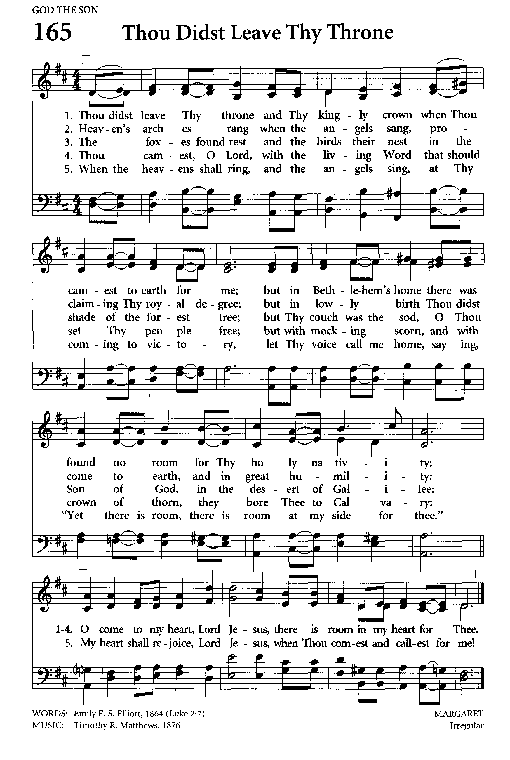
THE CELEBRATION OF THE EUCHARIST

OFFERTORY: Thou Didst Leave Thy Throne and Thy Kingly Crown
Words: Emily E. Steele Elliot; Tune: MARGARET

Thou didst leave Thy throne and Thy kingly crown,
When Thou camest to earth for me;
But in Bethlehem's home was there found no room
For Thy holy nativity.
O come to my heart, Lord Jesus,
There is room in my heart for Thee.

Heaven's arches rang when the angels sang,
Proclaiming Thy royal degree;
But of lowly birth didst Thou come to earth,
And in great humility.
O come to my heart, Lord Jesus,
There is room in my heart for Thee.
Thou camest, O Lord, with the living word
That should set Thy people free;
But with mocking scorn, and with crown of thorn,
They bore Thee to Calvary.
O come to my heart, Lord Jesus,
There is room in my heart for Thee.

When the heavens shall ring, and the angels sing,
At Thy coming to victory,
Let Thy voice call me home, saying "Yet there is room,
There is room at My side for thee."
O come to my heart, Lord Jesus,
There is room in my heart for Thee.

PRAYER OVER THE GIFTS

God our strength, we are nothing without you.
Receive all we offer you this day as you sustain us with your mercy;
in the name of Jesus Christ our Lord.
Amen.

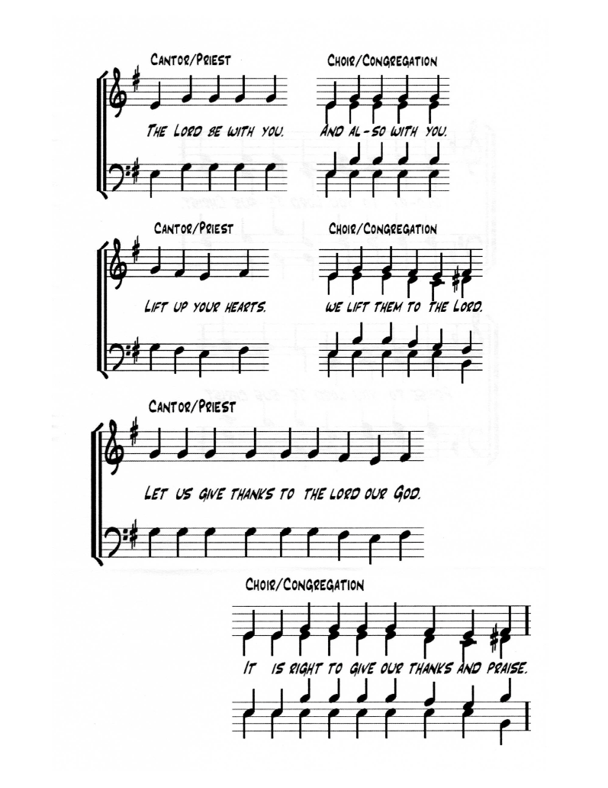
THE GREAT THANKSGIVING

EUCHARISTIC PRAYER 1

The Lord be with you.
And also with you.

Lift up your hearts.
We lift them to the Lord.

Let us give thanks to the Lord our God.
It is right to give our thanks and praise.

It is indeed right that we should praise you,
gracious God, for you created all things.
You formed us in your own image: male and female you created us.
When we turned away from you in sin, you did not cease to care for us,
but opened a path of salvation for all people.

You made a covenant with Israel,
and through your servants Abraham and Sarah
gave the promise of a blessing to all nations.
Through Moses you led your people from bondage into freedom;
through the prophets you renewed your promise of salvation.

Therefore, with them, and with all your saints who have served you in every age,
we give thanks and raise our voices to proclaim the glory of your name.

Holy, holy, holy Lord,
God of power and might,
heaven and earth are full of your glory.
Hosanna in the highest.
Blessed is he who comes in the name of the Lord.
Hosanna in the highest.

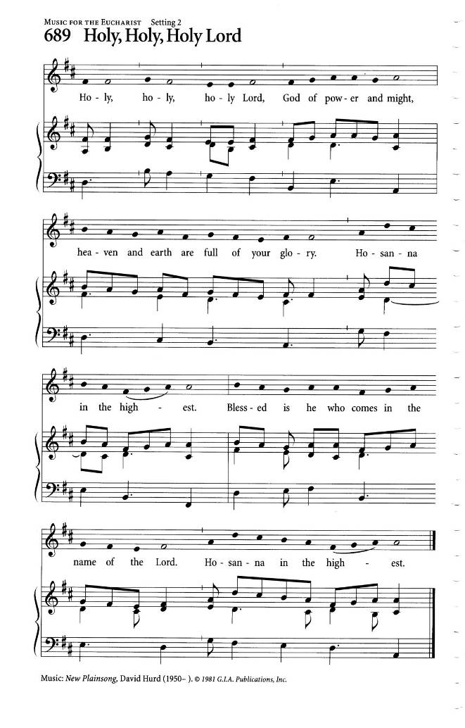
Holy God, source of life and goodness,
all creation rightly gives you praise.
In the fullness of time, you sent your Son Jesus Christ,
to share our human nature, to live and die as one of us,
to reconcile us to you, the God and Father of all.
He healed the sick and ate and drank with outcasts and sinners;
he opened the eyes of the blind
and proclaimed the good news of your kingdom to the poor and to those in need.
In all things he fulfilled your gracious will.

On the night he freely gave himself to death,
our Lord Jesus Christ took bread,
and when he had given thanks to you,
he broke it, and gave it to his disciples, and said,
“Take, eat: this is my body which is given for you.
Do this for the remembrance of me.”

After supper he took the cup of wine;
and when he had given thanks, he gave it to them, and said,
“Drink this, all of you: this is my blood of the new covenant,
which is shed for you and for many for the forgiveness of sins.
Whenever you drink it, do this for the remembrance of me.”

Gracious God, his perfect sacrifice destroys the power of sin and death;
by raising him to life you give us life for evermore.

Therefore, we proclaim the mystery of faith.
Christ has died.
Christ is risen.
Christ will come again.

Recalling his death, proclaiming his resurrection,
and looking for his coming again in glory,
we offer you, Father, this bread and this cup.
Send your Holy Spirit upon us and upon these gifts,
that all who eat and drink at this table may be one body and one holy people,
a living sacrifice in Jesus Christ, our Lord.
Through Christ, with Christ, and in Christ,
in the unity of the Holy Spirit, all glory is yours, almighty Father, now and for ever
Amen.

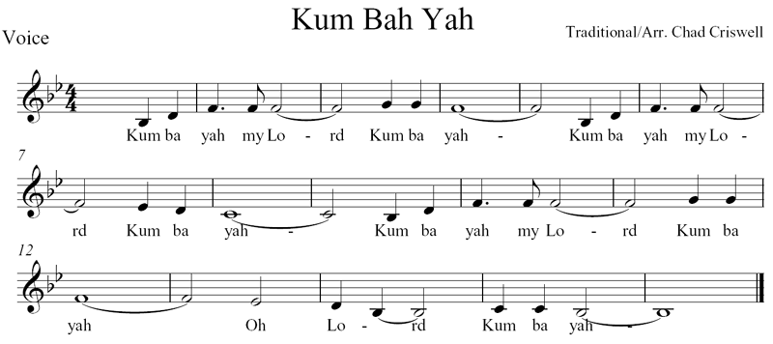
THE LORD’S PRAYER: Father God in Heaven
Text: J.E. Seddon; Tune: KUM BA YAH

And now, as our Saviour Christ has taught us, we are bold to sing.

Father God in heaven, Lord most high:
hear your children's prayer, Lord most high:
hallowed be your name, Lord most high
O Lord, hear our prayer.

May your kingdom come, here on earth;
may your will be done, here on earth,
as it is in heaven, so on earth
O Lord, hear our prayer.

Give us daily bread, day by day,
and forgive our sins, day by day,
as we too forgive, day by day
O Lord, hear our prayer.

Lead us in your way, make us strong;
when temptations come, make us strong;
save us from all sin, keep us strong
O Lord, hear our prayer.

All things come from you, all are yours
kingdom, glory, power, all are yours;
take our lives and gifts, all are yours
O Lord, hear our prayer. Amen.
THE BREAKING OF THE BREAD

God of promise, you prepare a banquet for us in your kingdom.
Happy are those who are called to the supper of the Lamb.

THE INVITATION

The gifts of God for the People of God
Thanks be to God.

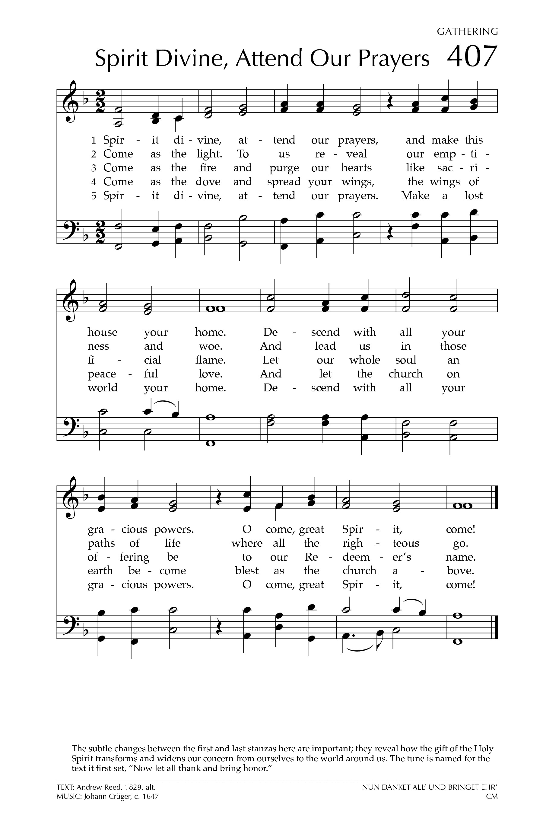
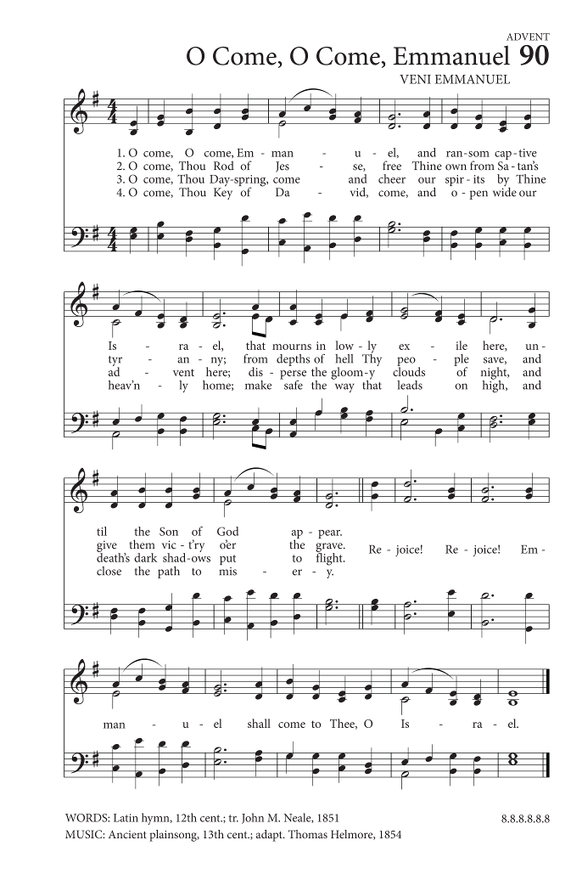
DURING COMMUNION: O Come, O Come, Emmanuel
Words: Anonymous; Tune: VENI EMMANUEL

O come, O come, Emmanuel
And ransom captive Israel
That mourns in lonely exile here
Until the Son of God appear
Rejoice! Rejoice! Emmanuel
Shall come to thee, O Israel.

O come, Thou Rod of Jesse, free
Thine own from Satan's tyranny
From depths of Hell Thy people save
And give them victory o'er the grave
Rejoice! Rejoice! Emmanuel
Shall come to thee, O Israel.

O come, Thou Day-Spring, come and cheer
Our spirits by Thine advent here
Disperse the gloomy clouds of night
And death's dark shadows put to flight.
Rejoice! Rejoice! Emmanuel
Shall come to thee, O Israel.

O come, Thou Key of David, come,
And open wide our heavenly home;
Make safe the way that leads on high,
And close the path to misery.
Rejoice! Rejoice! Emmanuel
Shall come to thee, O Israel.

O come, O come, Thou Lord of might,
Who to Thy tribes, on Sinai's height,
In ancient times did'st give the Law,
In cloud, and majesty and awe.
Rejoice! Rejoice! Emmanuel
Shall come to thee, O Israel.

Ablutions: Make Me a Channel of Your Peace
Attributed to St Francs of Assissi

Make me a channel of your peace:
Where there is hatred, let me bring your love;
where there is injury, your healing power,
and where there’s doubt, true faith in you.

Make me a channel of your peace:
where there’s despair in life let me bring hope;
Where there is darkness, only light,
and where there’s sadness, ever joy.

O, Spirit, grant that I may never seek
so much to be consoled as to console,
to be understood as to understand,
to be loved as to love with all my soul.

Make me a channel of your peace:
it is in pardoning that we are pardoned,
in giving to all that we receive,
and in dying that we’re born to eternal life.

PRAYER AFTER COMMUNION

Faithful God,
we thank you for feeding us with this heavenly banquet.
Help us always to hear the prophet`s call to turn our hearts to you;
in the name of Christ the Lord.
Amen.

THE BLESSING

May the peace of God rest upon you,
may the peace of Christ rise within you,
and may the peace of the Spirit flow through you.
And the blessing of the God almighty,
The Father, the Son, and the Holy Spirit,
be upon you and remain with you this Adventide and always.
Amen.

ANNOUNCEMENTS:

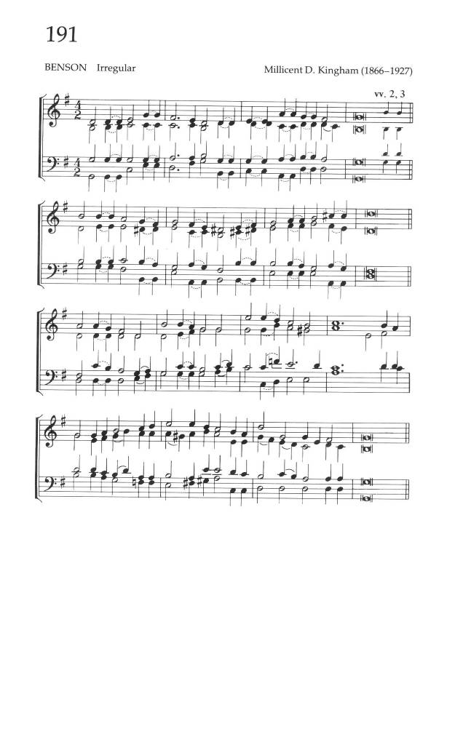
RECESSIONAL: God is Working His Purpose Out
Words: Arthur C. Ainger; Tune: BENSON

God is working his purpose out,
as year succeeds to year;
God is working his purpose out,
and the time is drawing near;
nearer and nearer draws the time,
the time that shall surely be:
when the earth shall be filled with the glory of God
as the waters cover the sea.

From utmost east to utmost west,
where human feet have trod,
by the mouth of many messengers
goes forth the voice of God:
“Give ear to me, ye continents,
ye isles, give ear to me,
that the earth may be filled with the glory of God
as the waters cover the sea.”

March we forth in the strength of God,
with the banner of Christ unfurled,
that the light of the glorious gospel of truth
may shine throughout the world.
Fight we the fight with sorrow and sin
to set the captives free,
that the earth may be filled with the glory of God
as the waters cover the sea.

All we can do is nothing worth
unless God blesses the deed.
Vainly we hope for the harvest-tide
till God gives life to the seed.
Yet nearer and nearer draws the time,
the time that shall surely be,
when the earth shall be filled with the glory of God
as the waters cover the sea.

THE DISMISSAL (Diocese Vision Statement)

Followers of Christ, Inspired by the Holy Spirit.
Serve the world God loves. Alleluia! Alleluia!
Thanks be to God. Alleluia! Alleluia!

POSTLUDE: Let There be Peace on Earth

