The Seventh Sunday after Pentecost (Proper 15)

July 12, 2026, 10:30am

Sung Eucharist

Website: www.sthildasanglicanchurch.com
Church Email: info@sthildasanglicanchurch.com
Facebook: St. Hilda’s Fairbank Anglican Church

Incumbent: Fr. Kenute Francis (437-488-9657)

kenute@sthildasanglicanchurch.com

Assistants: The Venerable Elizabeth Hardy
The Rev. Canon Leonard Abbah, OHC

Organist: William “Bill” Khan
Crucifer: Kishmar Miller
Eucharistic Ministers: Francis, Hardy, Greenidge, De Guzman

1st Reading: David Elcock
2nd Reading: Doreen Britton
Gospel: Archdeacon Elizabeth Hardy
Intercession: Jean Caine

Tech Team:

Ushers Team 2: Oscar Lewis Isla Barnes
Merlene Eastmond John Goddard
Brenda Ferary Percy Lorde

MISSION STATEMENT
The purpose of St. Hilda’s Church is to be Christ-centered in our life and worship,
to serve lovingly those within our family and others within our reach that the spirit of God might empower us for worship. service, education, stewardship, evangelism and pastoral care.

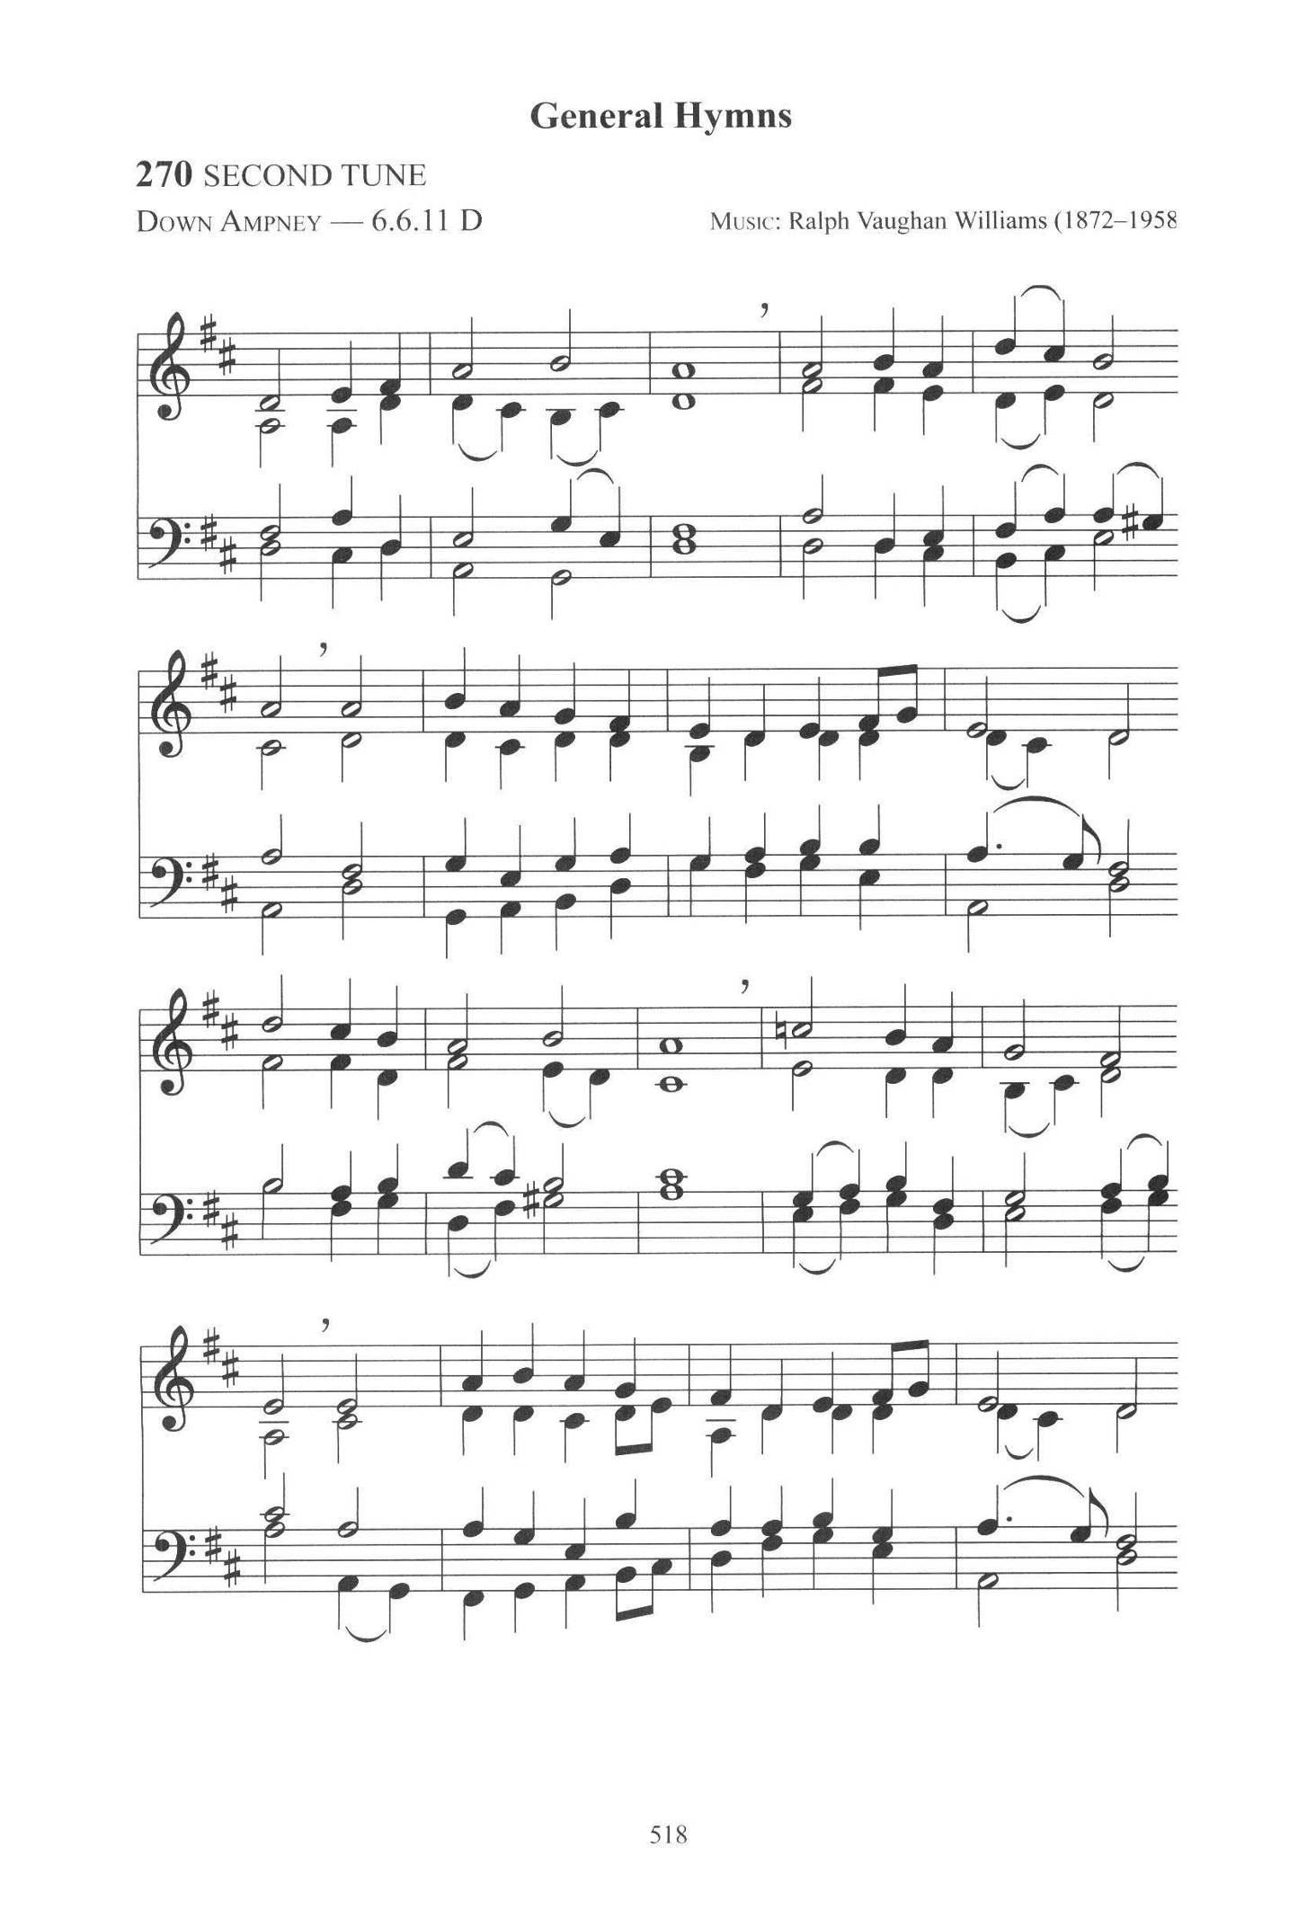

The Order of Service
PRELUDE: Come Down O Love Divine (Down Ampney)

OPENING PRAYER

Gracious God,
we gather in your presence with hearts open to your love and grace.
Quiet our minds, renew our spirits, and draw us closer to you.
May our worship glorify you. We pray in the name of Jesus Christ our Lord.
Amen.

PROCESSIONAL: O Praise ye the Lord! Praise him in the Height;
Text: Henry Williams Baker; Tune: LAUDATE DOMINUM (PARRY)

O praise ye the Lord! Praise him in the height;
rejoice in his word, ye angels of light;
ye heavens adore him by whom ye were made,
and worship before him, in brightness arrayed.

O praise ye the Lord! Praise him upon earth,
in tuneful accord, ye sons of new birth;
praise him who hath brought you his grace from above,
praise him who hath taught you to sing of his love.

O praise ye the Lord, all things that give sound;
each jubilant chord re-echo around;
loud organs, his glory forth tell in deep tone,
and, sweet harp, the story of what he hath done.

O praise ye the Lord! Thanksgiving and song
to him be outpoured all ages along:
for love in creation, for heaven restored,
for grace of salvation, O praise ye the Lord!
(Amen. Amen.)

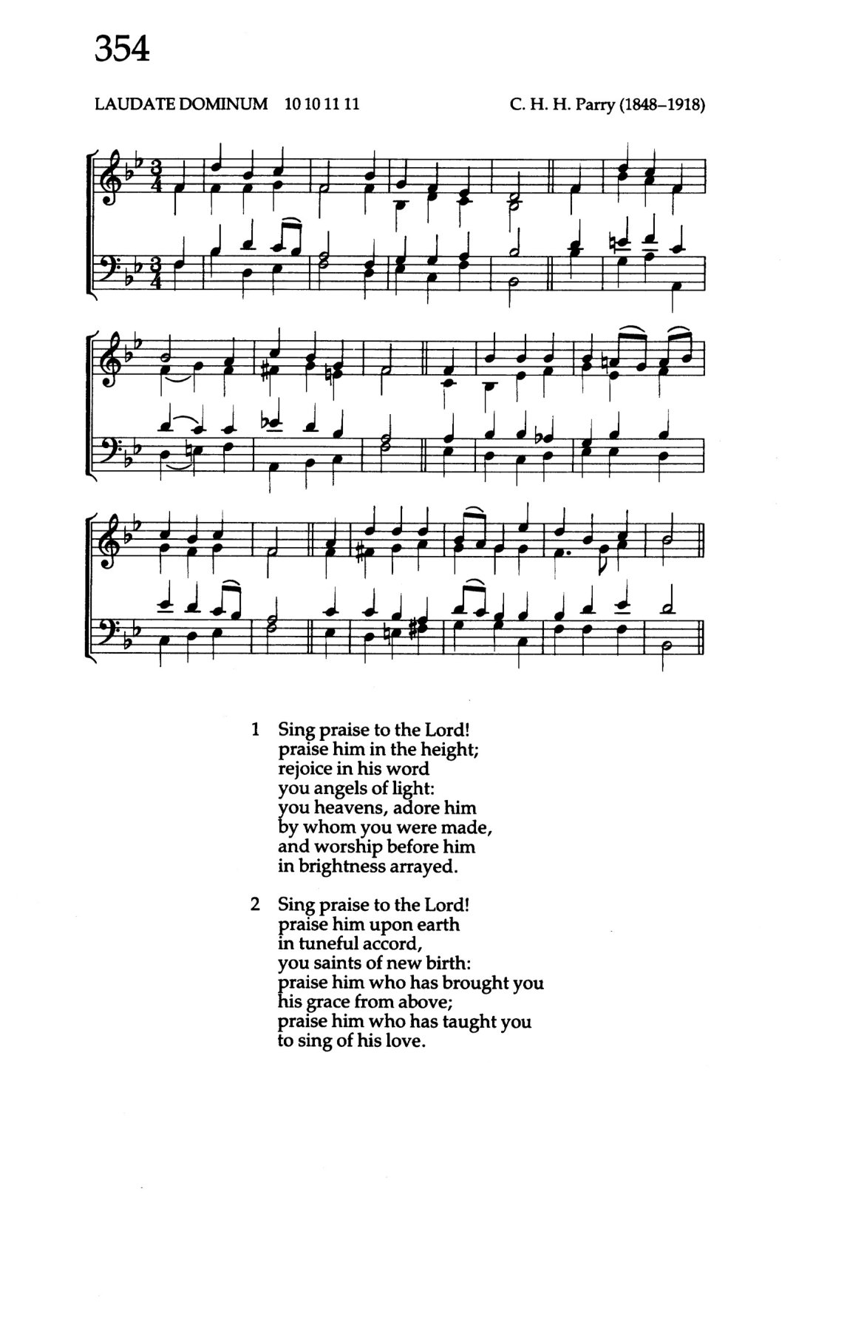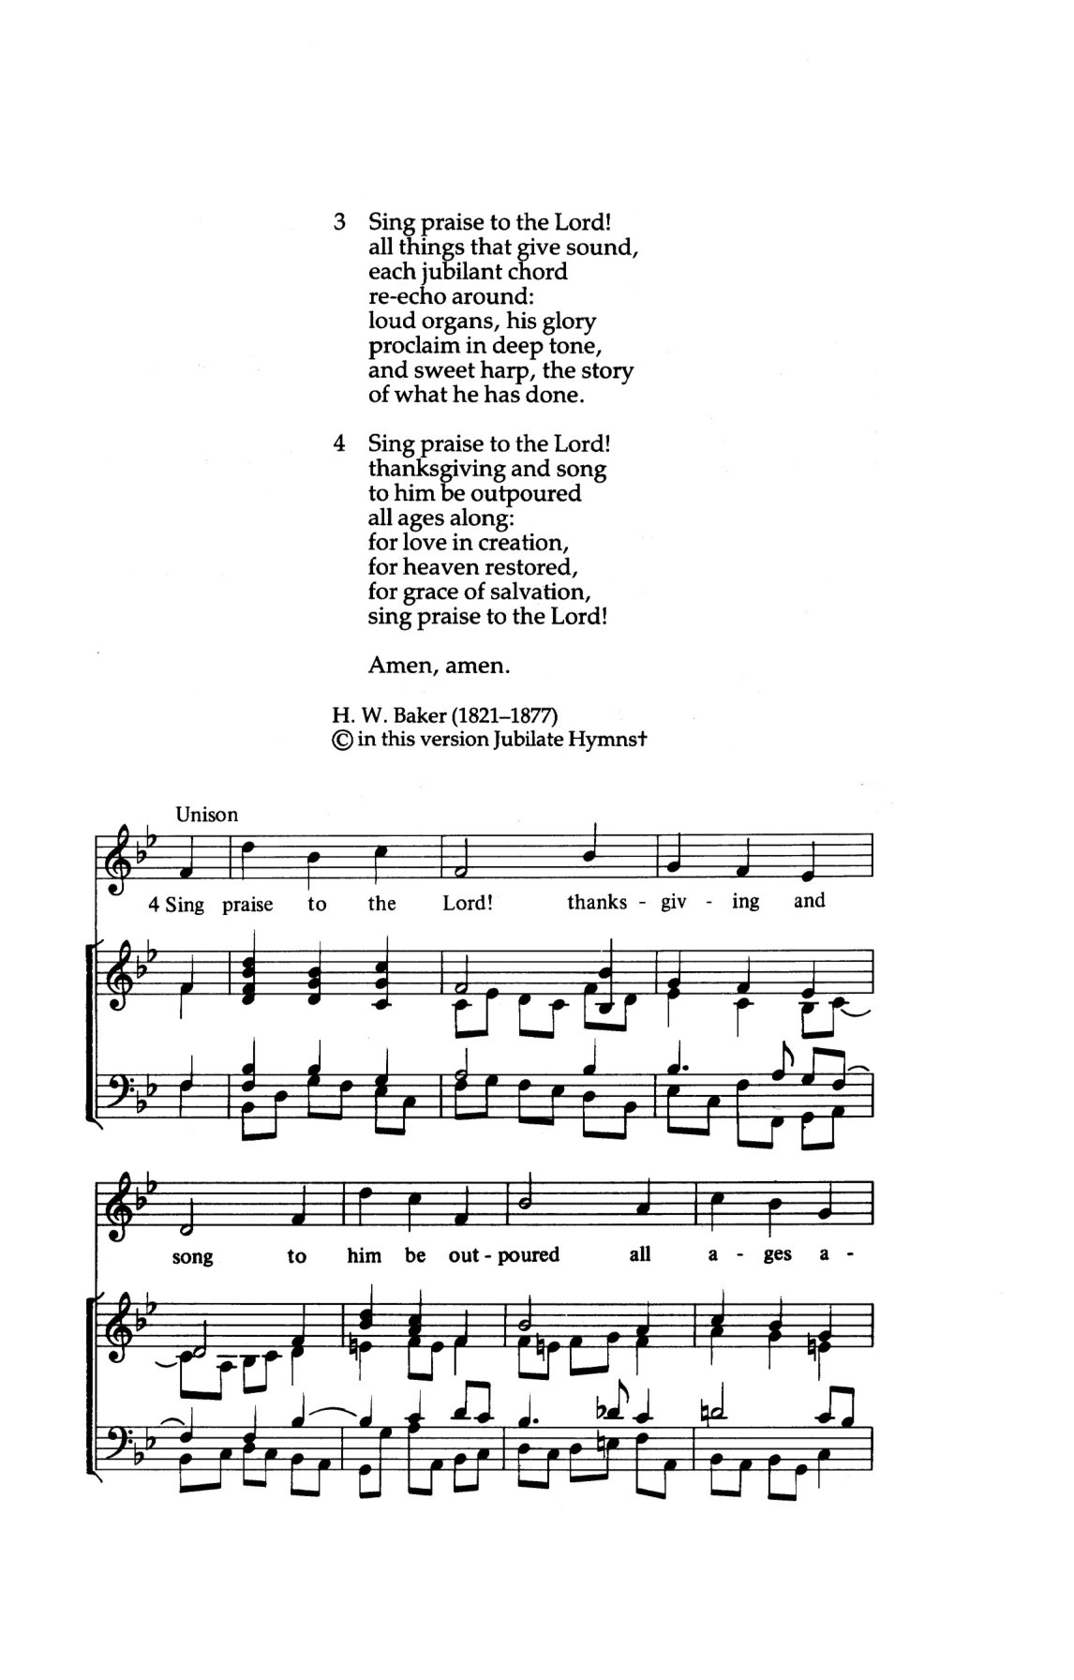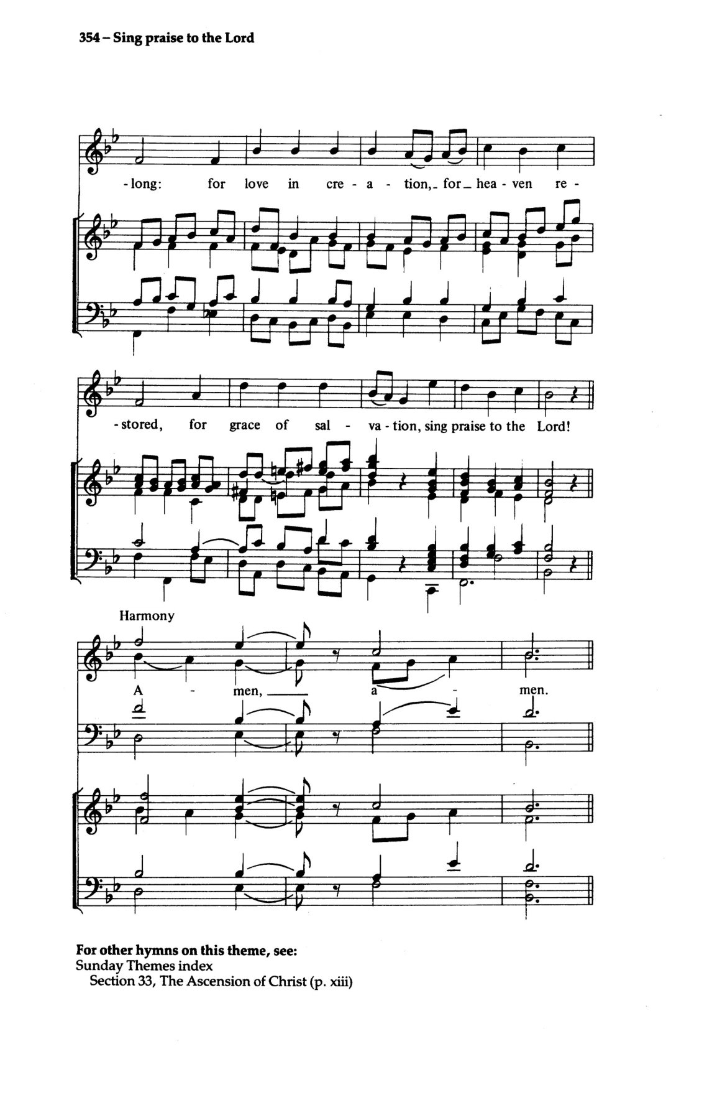
WELCOME

GREETINGS:

The grace of our Lord Jesus Christ, the love of God
and the fellowship of the Holy spirit be with you all.
And also with you.

God is with us in every season of life.
We come trusting in God’s care.

In times of joy and in times of struggle,
God hears us.

In Christ, we are welcomed and made new.
Let us worship God together. Alleluia. Amen.

THE COLLECT FOR PURITY

Almighty God,
to you all hearts are open, all desires known, and from you no secrets are hidden.
Cleanse the thoughts of our hearts by the inspiration of your Holy Spirit,
that we may perfectly love you, and worthily magnify your holy name;
through Christ our Lord. Amen.

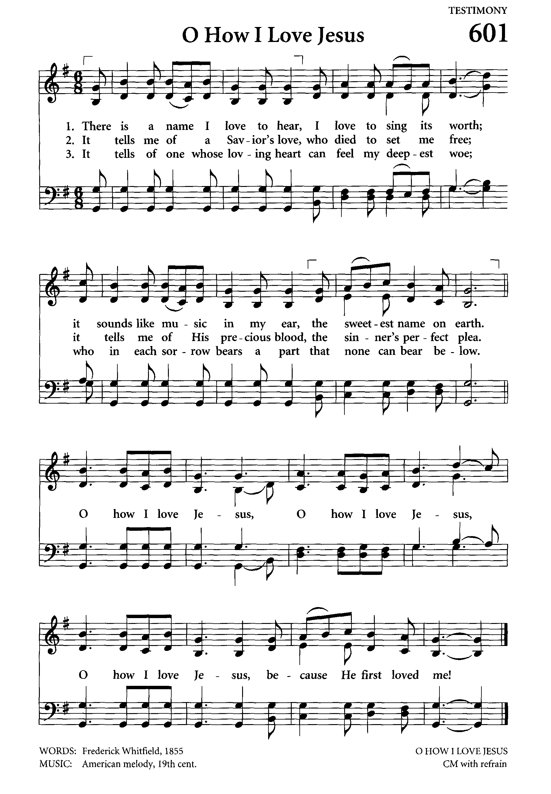
Introit: O How I Love Jesus
Text: Frederick Whitefield

There is a Name I love to hear,
I love to sing its worth;
It sounds like music in my ear,
The sweetest Name on earth.

(refrain)
Oh, how I love Jesus,
Oh, how I love Jesus,
Oh, how I love Jesus,
Because He first loved me!

It tells me of a Saviour’s love,
Who died to set me free;
It tells me of His precious blood,
The sinner’s perfect plea. (refrain)

Jesus, the Name I love so well,
The Name I love to hear:
No saint on earth its worth can tell,
No heart conceive how dear. (refrain)

THE COLLECT OF THE DAY Kenute Francis

Almighty God, you have made us for yourself,
and our hearts are restless until they find their rest in you.
May we find peace in your service, and in the world to come, see you face to face;
through Jesus Christ our Lord, who lives and reigns with you and the Holy Spirit,
one God, now and for ever.
Amen.

THE FIRST READING: Genesis 25:19-34 (David Elcock)

A Reading from the Book of Genesis

These are the descendants of Isaac, Abraham's son: Abraham was the father of Isaac, and Isaac was forty years old when he married Rebekah, daughter of Bethuel the Aramean of Paddan-aram, sister of Laban the Aramean.
Isaac prayed to the LORD for his wife, because she was barren; and the LORD granted his prayer, and his wife Rebekah conceived. The children struggled together within her; and she said, "If it is to be this way, why do I live?"
So she went to inquire of the LORD. And the LORD said to her, "Two nations are in your womb, and two peoples born of you shall be divided; the one shall be stronger than the other, the elder shall serve the younger." When her time to give birth was at hand, there were twins in her womb. The first came out red, all his body like a hairy mantle; so they named him Esau. Afterward his brother came out, with his hand gripping Esau's heel; so he was named Jacob. Isaac was sixty years old when she bore them. When the boys grew up, Esau was a skillful hunter, a man of the field,
while Jacob was a quiet man, living in tents. Isaac loved Esau,
because he was fond of game; but Rebekah loved Jacob.
Once when Jacob was cooking a stew, Esau came in from the field, and he was famished. Esau said to Jacob, "Let me eat some of that red stuff, for I am famished!" (Therefore he was called Edom.) Jacob said, "First sell me your birthright."
Esau said, "I am about to die; of what use is a birthright to me?"
Jacob said, "Swear to me first." So he swore to him, and sold his birthright to Jacob. Then Jacob gave Esau bread and lentil stew, and he ate and drank,
and rose and went his way. Thus Esau despised his birthright.

The word of the Lord
Thanks be to God

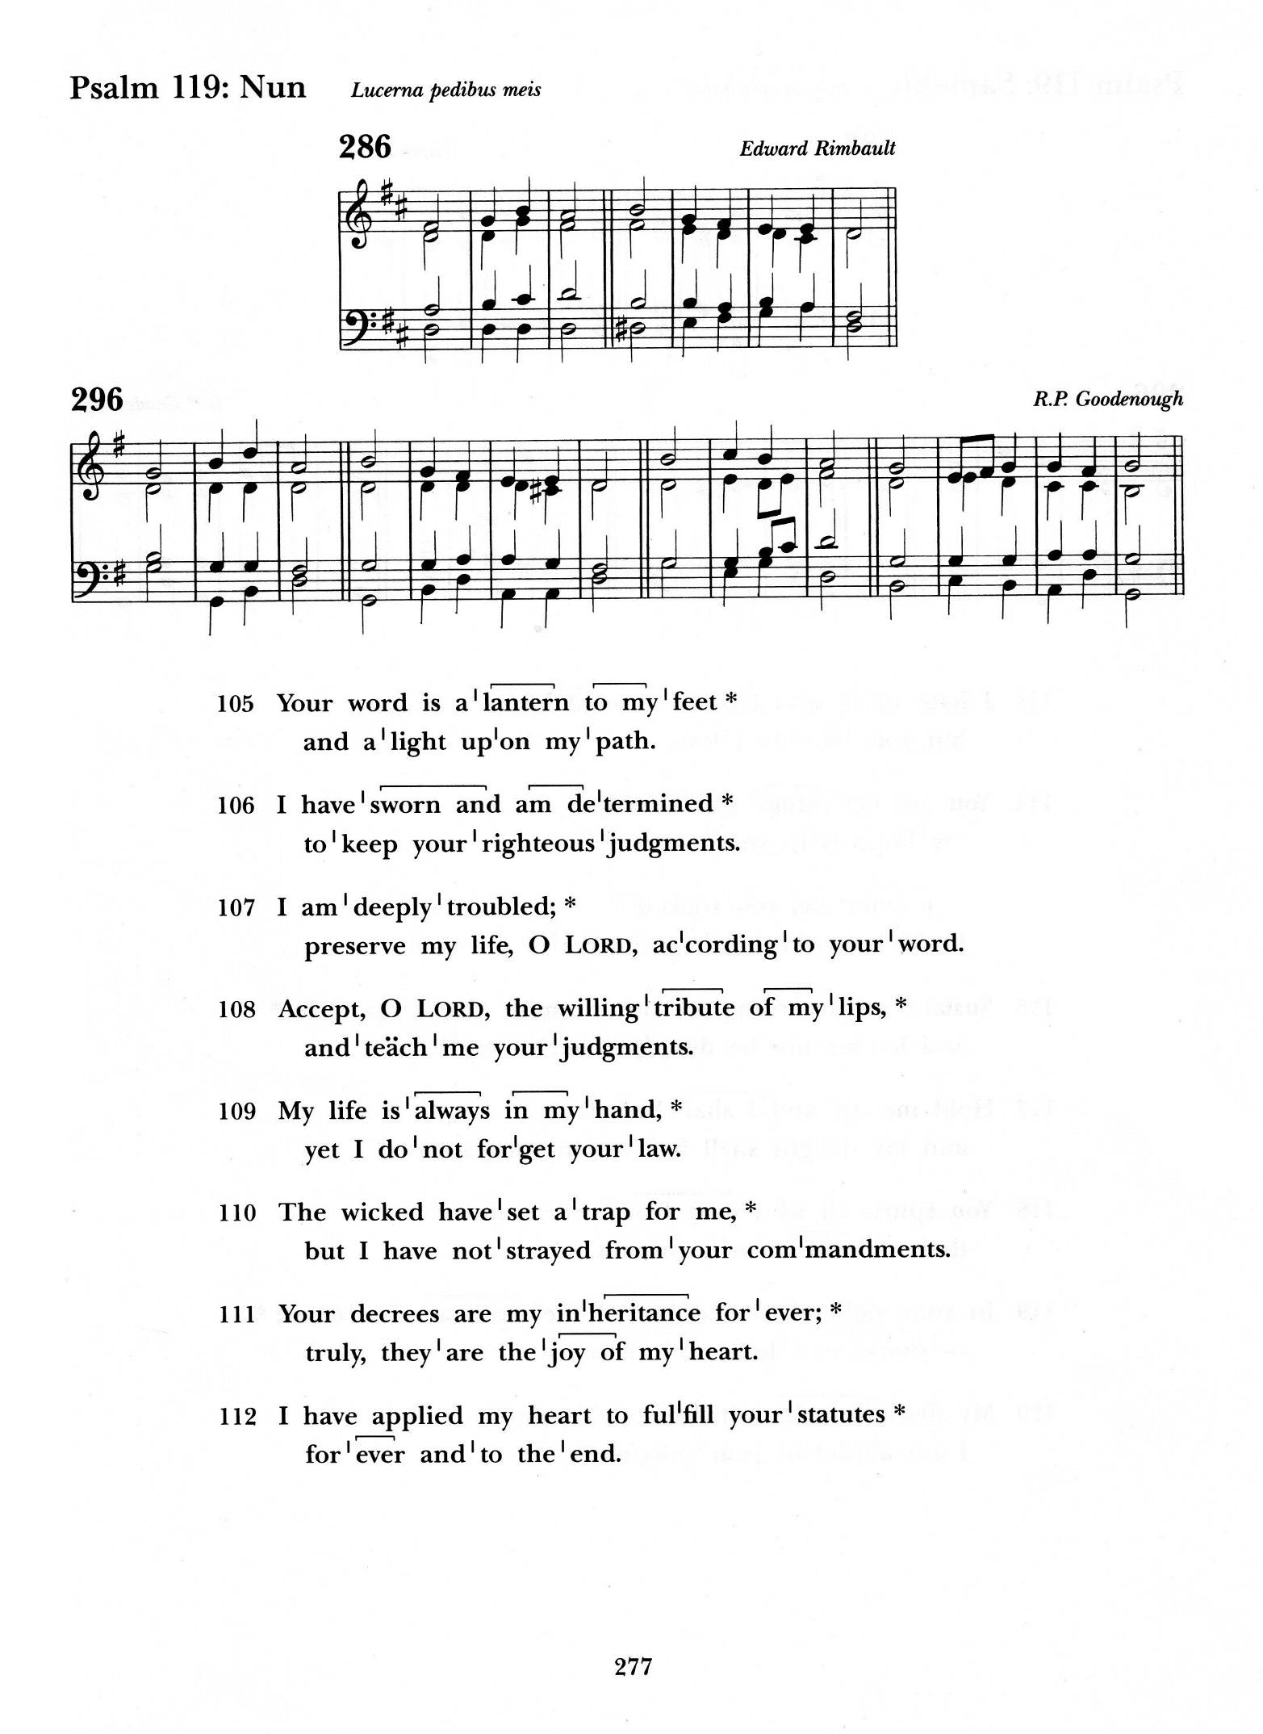
Psalm 119:105-112 (chanted)

Your word is a lantern to my feet and a light upon my path.
I have sworn and am determined to keep your righteous judgements.

I am deeply troubled; preserve my life, O Lord, according to your word.
Accept, O Lord, the willing tribute of my lips, and teach me your judgements.

My life is always in my hand, yet I do not forget your law.
The wicked have set a trap for me,
but I have not strayed from your commandments.

Your decrees are my inheritance for ever; truly, they are the joy of my heart.
I have applied my heart to fulfil your statutes for ever and to the end.

Glory to the Father, and to the Son and to the Holy Spirit;
As it was in the beginning, is now, and ever shall be. Amen.

THE SECOND READING: Romans 8:1-11 (Doreen Britton)

A Reading from the Letter of Paul to the Romans

There is therefore now no condemnation for those who are in Christ Jesus.
For the law of the Spirit of life in Christ Jesus has set you free from the law of sin and of death. For God has done what the law, weakened by the flesh, could not do:
by sending his own Son in the likeness of sinful flesh, and to deal with sin,
he condemned sin in the flesh, so that the just requirement of the law might be fulfilled in us, who walk not according to the flesh but according to the Spirit.
For those who live according to the flesh set their minds on the things of the flesh, but those who live according to the Spirit set their minds on the things of the Spirit. To set the mind on the flesh is death, but to set the mind on the Spirit is life and peace. For this reason the mind that is set on the flesh is hostile to God; it does not submit to God's law--indeed it cannot, and those who are in the flesh cannot please God. But you are not in the flesh; you are in the Spirit, since the Spirit of God dwells
in you. Anyone who does not have the Spirit of Christ does not belong to him.
But if Christ is in you, though the body is dead because of sin, the Spirit is life because of righteousness. If the Spirit of him who raised Jesus from the dead dwells in you,
he who raised Christ from the dead will give life to your mortal bodies also through his Spirit that dwells in you.

The word of the Lord
Thanks be to God

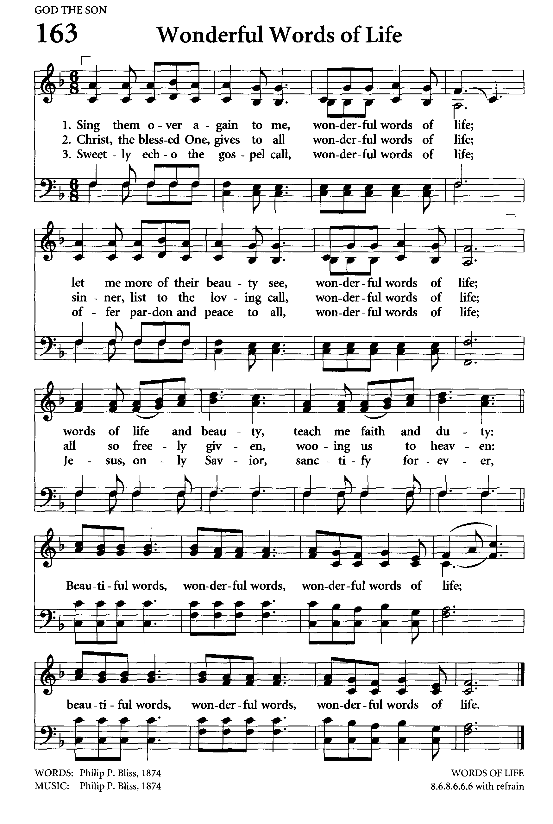
THE GRADUAL: Wonderful Words of Life
Text: Philip Bliss; Tune: WORDS OF LIFE

Sing them over again to me, Wonderful words of life;
Let me more of their beauty see, Wonderful words of life.
Words of life and beauty - Teach me faith and duty;

(refrain)
Beautiful words, wonderful words,
Wonderful words of life;
Beautiful words, wonderful words,
Wonderful words of life.

Christ, the blessed One, gives to all - Wonderful words of life;
Sinner, list to the loving call, Wonderful words of life.
All so freely given, Wooing us to heaven; (refrain)

Sweetly echo the Gospel call, Wonderful words of life;
Offer pardon and peace to all, Wonderful words of life.
Jesus, only Saviour, Sanctify forever; (refrain)

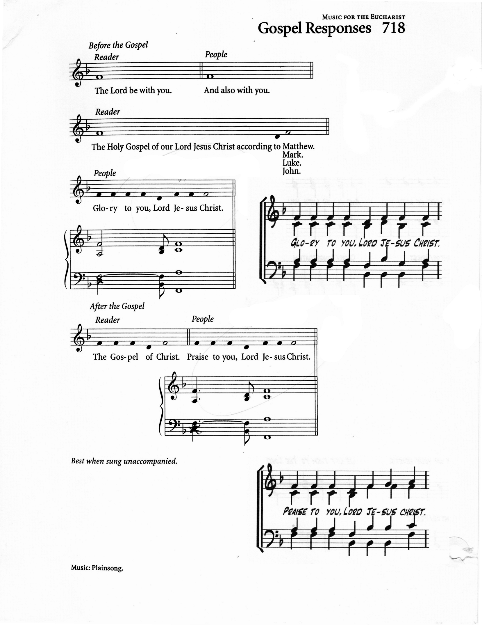
THE GOSPEL: Matthew 13:1-9, 18-23 (Archdeacon Hardy)

The Lord be with you.
And also with you.

The Holy Gospel of our Lord Jesus Christ according to Matthew
Glory to you Lord Jesus Christ

That same day Jesus went out of the house and sat beside the sea.
Such great crowds gathered around him that he got into a boat and sat there,
while the whole crowd stood on the beach. And he told them many things in parables, saying: "Listen! A sower went out to sow. And as he sowed,
some seeds fell on the path, and the birds came and ate them up.
Other seeds fell on rocky ground, where they did not have much soil, and they sprang up quickly, since they had no depth of soil. But when the sun rose, they were scorched; and since they had no root, they withered away.
Other seeds fell among thorns, and the thorns grew up and choked them.
Other seeds fell on good soil and brought forth grain, some a hundredfold,
some sixty, some thirty. Let anyone with ears listen!"
"Hear then the parable of the sower.
When anyone hears the word of the kingdom and does not understand it,
the evil one comes and snatches away what is sown in the heart;
this is what was sown on the path. As for what was sown on rocky ground,
this is the one who hears the word and immediately receives it with joy;
yet such a person has no root, but endures only for a while, and when trouble or persecution arises on account of the word, that person immediately falls away.
As for what was sown among thorns, this is the one who hears the word, but the cares of the world and the lure of wealth choke the word, and it yields nothing.
But as for what was sown on good soil, this is the one who hears the word and understands it, who indeed bears fruit and yields, in one case a hundredfold,
in another sixty, and in another thirty."

The Gospel of Christ
Praise to you Lord Jesus Christ

Gospel Acclamation: Caribbean Alleluia

THE SERMON

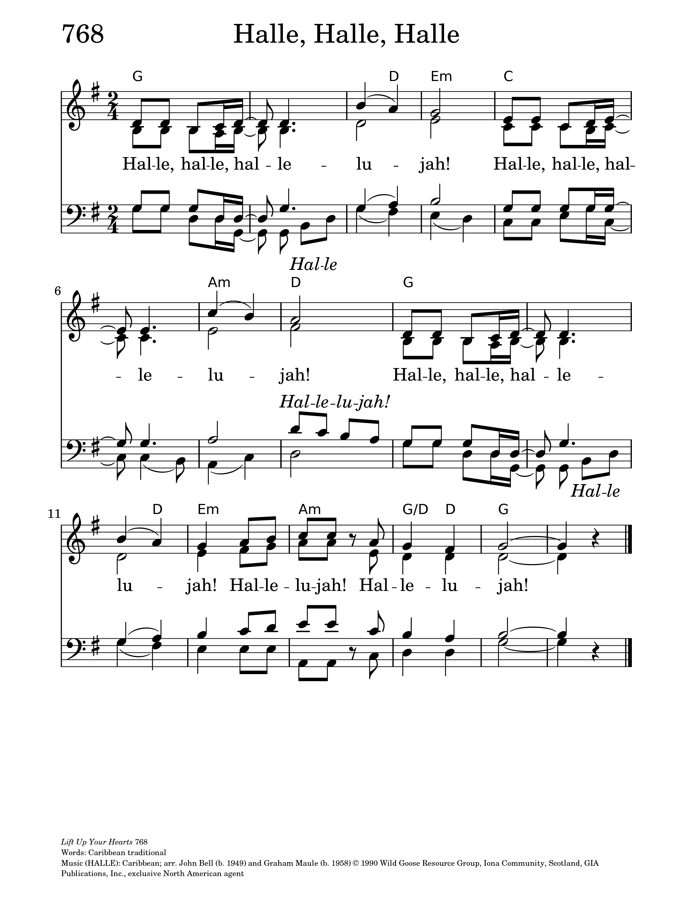
THE APOSTLES CREED:

Let us confess our faith, as we say,

I believe in God, the Father almighty, creator of heaven and earth.
I believe in Jesus Christ, his only Son, our Lord.
He was conceived by the power of the Holy Spirit and born of the Virgin Mary.
He suffered under Pontius Pilate, was crucified, died, and was buried.
He descended to the dead. On the third day he rose again.
He ascended into heaven, and is seated at the right hand of the Father.
He will come again to judge the living and the dead.
I believe in the Holy Spirit, the holy catholic Church,
the communion of saints, the forgiveness of sins,
the resurrection of the body, and the life everlasting. Amen.

PRAYERS OF INTERCESSION: (Jean Caine)

Let us pray,

All (sung): God is so good, God is so good,
God is so good, He's so good to me

He cares for me, He cares for me,
He cares for me, He's so good to me.

O God, we bring to you our prayers and supplications recognizing that prayer is not a spare wheel that one pulls out when in trouble, but rather a steering wheel that directs the right path throughout the journey. You know our needs before we ask.
Lord, have mercy
Christ, have mercy.

Draw your church together into one great company of disciples. Strengthen its mission, heal its sickness, correct its wrongs and fortify its resolve. Enlighten all bishops, priests, deacons and laity with true knowledge and understanding of your word that in their preaching and living they may declare your truth boldly and clearly.
Lord, have mercy
Christ, have mercy.

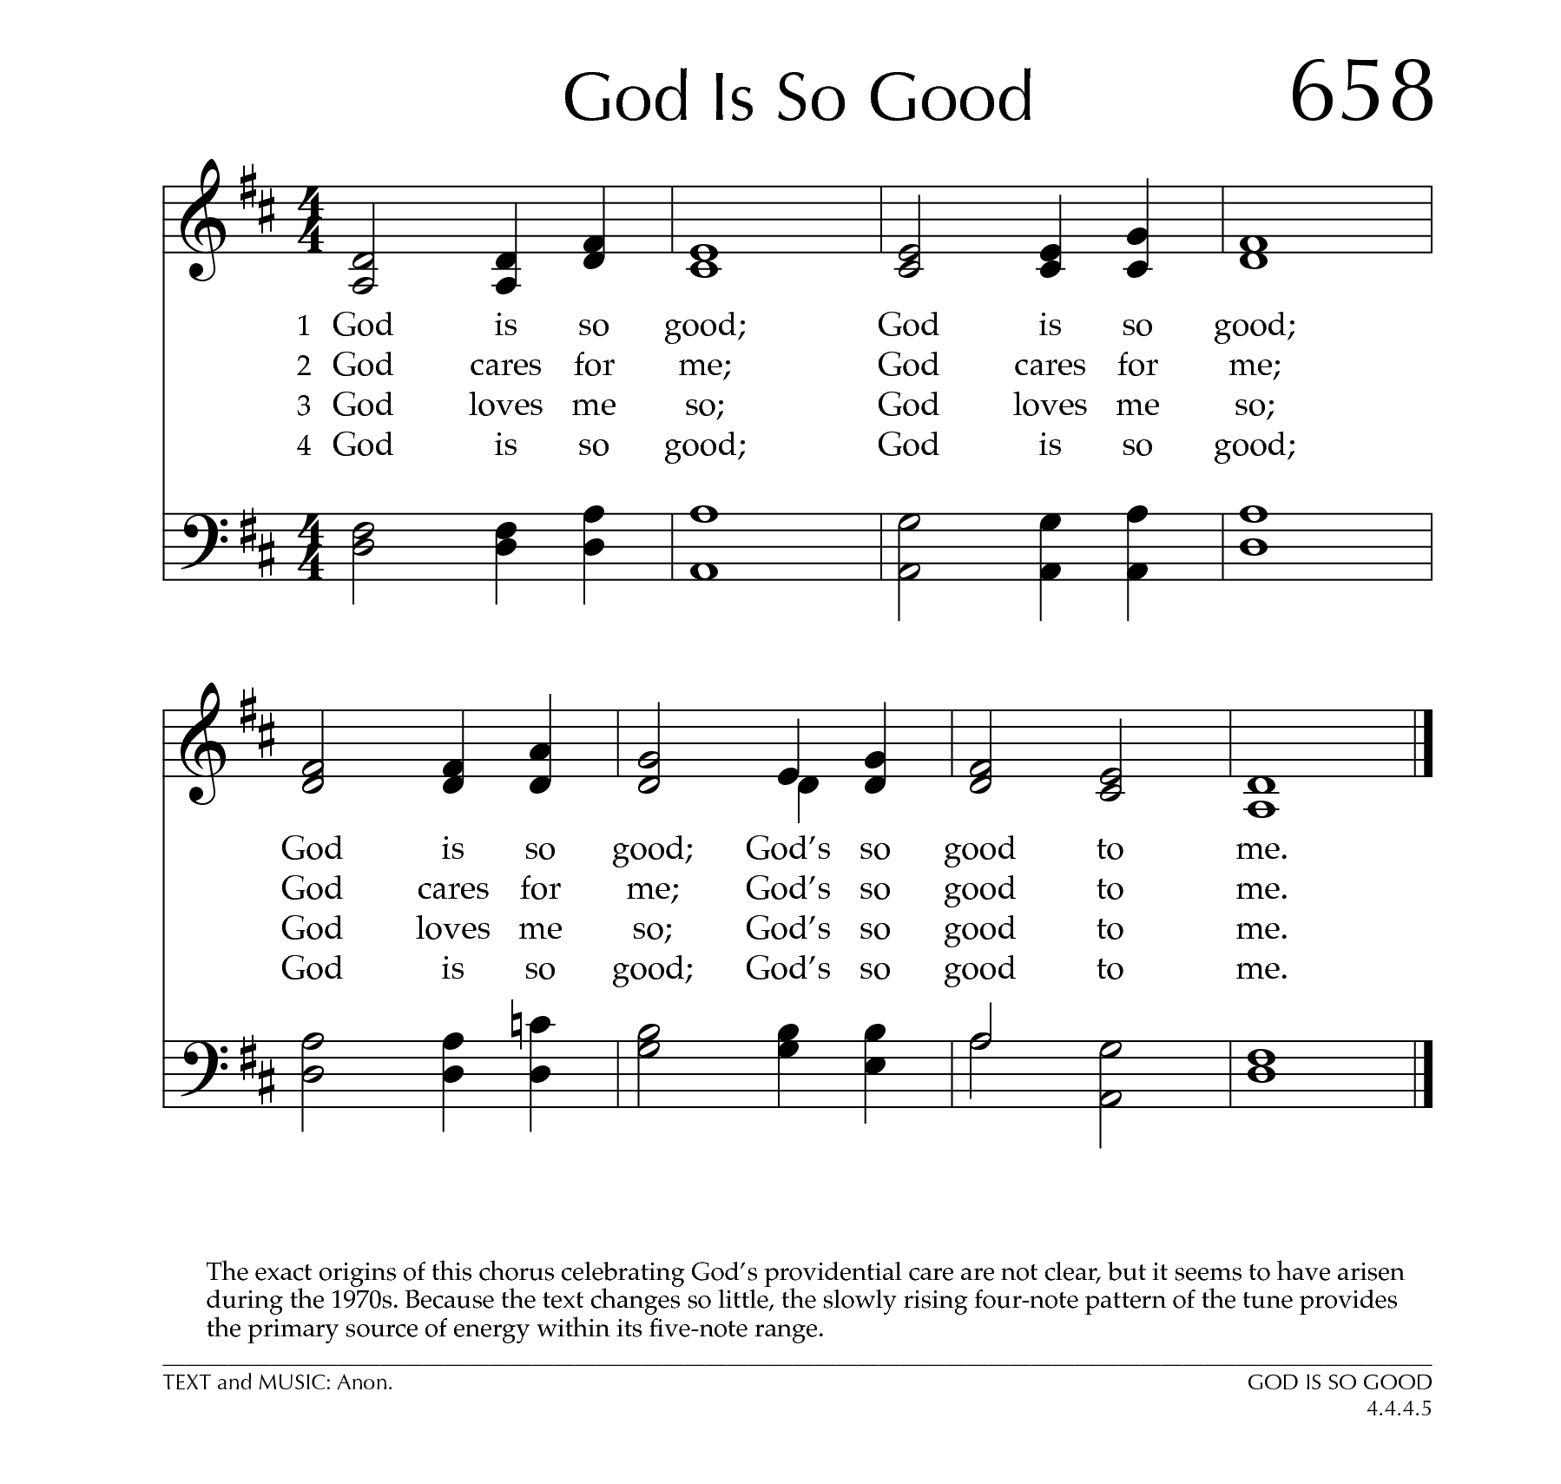
God of all, we are bound with many people in the fellowship of a commonwealth of nations. Give us we pray such unity as may enable us to promote the peace of your creation. Look with pity upon those who live with injustice, terror, and death.
Strengthen us to eliminate cruelty wherever it is found and seek equality for all.
Lord, have mercy
Christ, have mercy.

We remember before you the homeless, destitute, the sick, the aged, the lonely
and all who have none to care for them.
Heal those who are broken in body or spirit and turn their sorrows to joy.
Lord, have mercy
Christ, have mercy.

O God, whose light divides the day from night and turns the shadow of death into the morning. We remember all who served among us and are now in your nearer presence. Grant them rest eternal and their family comfort in your loving care.
Lord, have mercy
Christ, have mercy.

Drive far from us all wrong desires, incline our hearts to keep your law,
and guide our feet into the way of peace. Receive the thoughts and petitions
of our hearts, the cries, the longings and desires of our lives.
Hear and answer us as we pray through Jesus Christ our Lord.
Amen.

All (sung): God answers prayers, God answers prayers,
God answers prayers, He is so good to me.

CONFESSION:

Dear friends in Christ, God is steadfast in love and infinite in mercy;
he welcomes sinners and invites them to his table.
Let us confess our sins, confident in God’s forgiveness.

Most merciful God,
we confess that we have sinned against you in thought, word, and deed,
by what we have done, and by what we have left undone.
We have not loved you with our whole heart;
we have not loved our neighbours as ourselves.
We are truly sorry and we humbly repent.
For the sake of your Son Jesus Christ, have mercy on us and forgive us,
that we may delight in your will, and walk in your ways,
to the glory of your name. Amen.

ABSOLUTION:

Almighty God have mercy upon you, pardon and deliver you from all your sins,
confirm and strengthen you in all goodness, and keep you in eternal life;
through Jesus Christ our Lord.
Amen.

The Peace
The peace of the Lord be always with you.
And also with you.

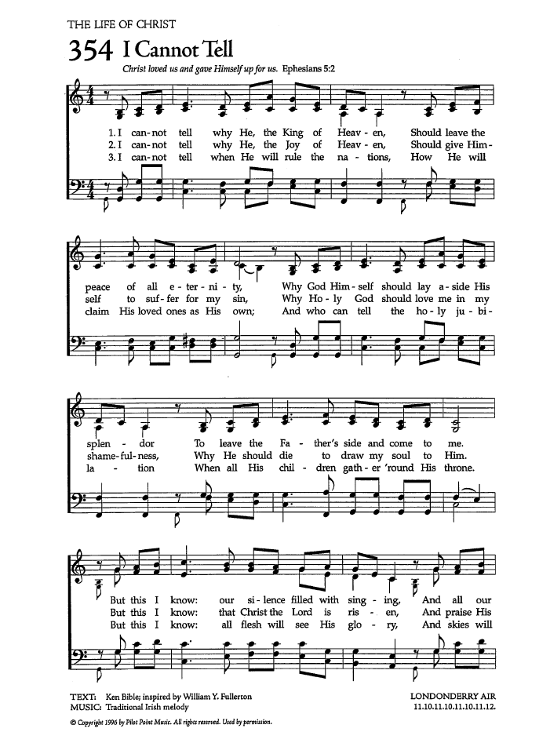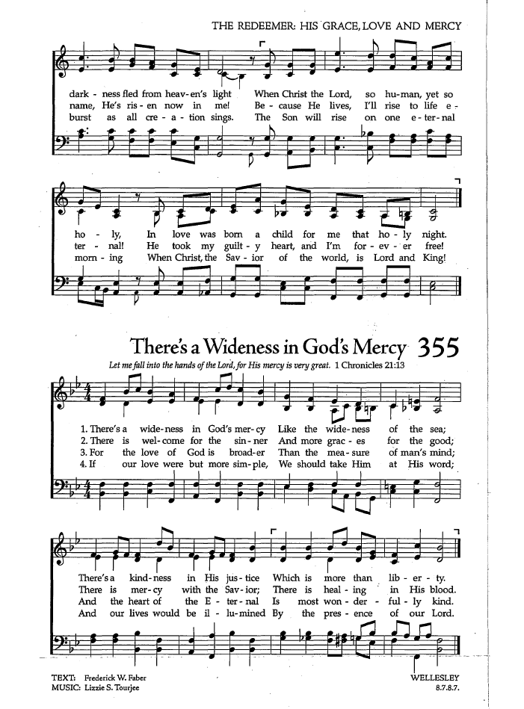
OFFERTORY: Lord of the Church
Text: Timothy Dudley-Smith; Tune: LONDONDERRY AIR

Lord of the church, we pray for our renewing:
Christ over all, our undivided aim.
Fire of the Spirit, burn for our enduing,
wind of the Spirit, fan the living flame!
We turn to Christ amid our fear and failing,
the will that lacks the courage to be free,
the weary labours, all but unavailing,
to bring us nearer what a church should be.

Lord of the church, we seek a Father's blessing,
a true repentance and a faith restored,
a swift obedience and a new possessing,
filled with the Holy Spirit of the Lord!
We turn to Christ from all our restless striving,
unnumbered voices with a single prayer:
the living water for our souls' reviving,
in Christ to live, and love and serve and care.

Lord of the church, we long for our uniting,
true to one calling, by one vision stirred;
one cross proclaiming and one creed reciting,
one in the truth of Jesus and his word.
So lead us on; till toil and trouble ended,
one church triumphant one new song shall sing,
to praise his glory, risen and ascended,
Christ over all, the everlasting King!

PRAYER OVER THE GIFTS

Father, your word creates in us a yearning for your kingdom.
Receive all we offer you this day, and keep us in your peace;
for the sake of Jesus Christ the Lord. Amen.

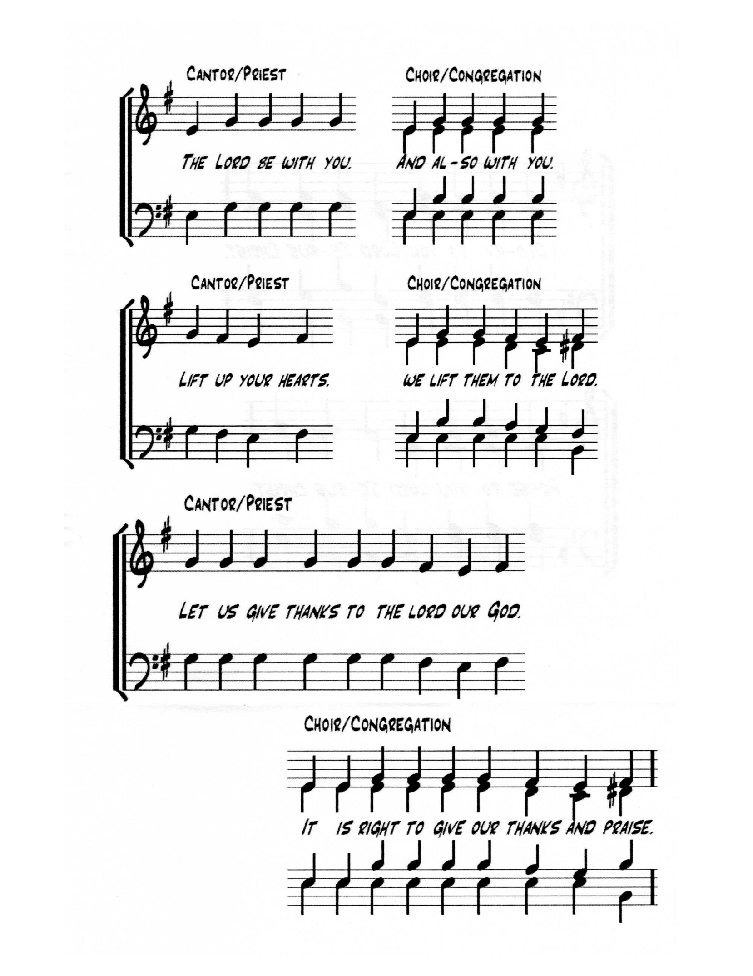
SUPPLEMENTARY EUCHARISTIC PRAYER 2

The Lord be with you.
And also with you.

Lift up your hearts
We lift them to the Lord

Let us give thanks to the Lord our God.
It is right to give our thanks and praise.

Eternal God, Source of all being,
we give you thanks and praise for your faithful love.
You call us into friendship with you and one another to be your holy people,
a sign of your presence in the world.
When those we trust betray us, unfailingly you remain with us.
When we injure others, you confront us in your love
and call us to the paths of righteousness.
You stand with the weak, and those, broken and alone, whom you have always welcomed home, making the first last, and the last first.

Therefore we raise our voices with angels and archangels,
forever praising you and singing:

Holy, holy, holy Lord, God of power and might,
heaven and earth are full of your glory.
Hosanna in the highest.
Blessed is the One who comes in the name of the Lord.
Hosanna in the highest.

Blessed are you, O Holy One:
when Hagar was driven into the wilderness
you followed her and gave her hope.
When Joseph was sold into bondage,
you turned malice to your people’s good.
When you called Israel out of slavery,
you brought them through the wilderness into the promised land.
When your people were taken into exile you wept with them
by the river of Babylon and carried them home.
Restore us, O God, let your face shine!

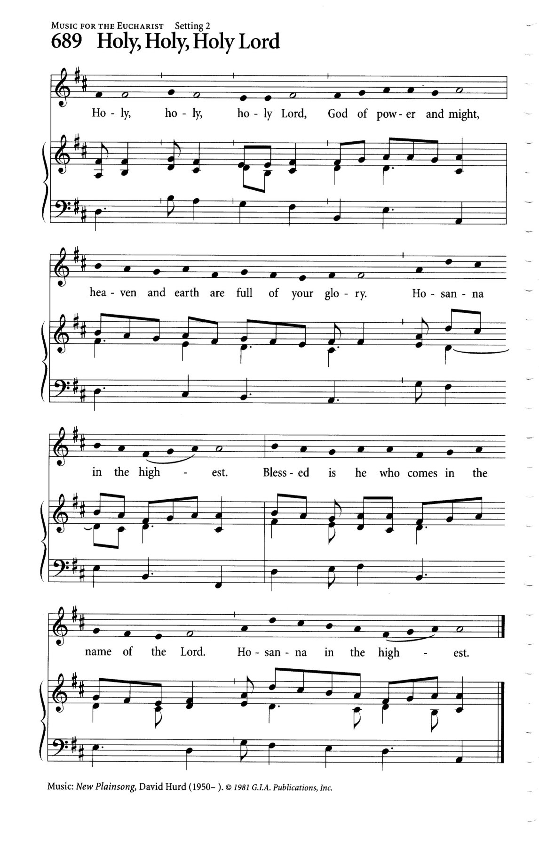
At the right time you sent your Anointed One to stand with the poor,
the outcast, and the oppressed. Jesus touched lepers, and the sick,
and healed them. He accepted water from a woman of Samaria
and offered her the water of new life.
Christ knew the desolation of the cross and opened the way
for all humanity into the redemption of your reconciling love.
On the night he was betrayed, Jesus, at supper with his friends,
took bread, gave you thanks, broke the bread, gave it to them,
and said, “Take and eat: this is my body which is given for you.
Do this for the remembrance of me.”
After supper he took the cup of wine, and when he had given thanks,
he gave it to them, and said, “Drink this, all of you:
this is my blood of the new covenant which is shed for you
and for many for the forgiveness of sins.
Whenever you drink it, do this for the remembrance of me.”

Loving and Holy One, recalling Christ’s death and resurrection, we offer you these gifts, longing for the bread of tomorrow and the wine of the age to come.

Therefore we proclaim our hope.
Dying you destroyed our death,
rising you restored our life.
Lord Jesus, come in glory.

Pour out your Spirit on these gifts that through them
you may sustain us in our hunger for your peace.
We hold before you all whose lives are marked by suffering.
When we are broken and cast aside, embrace us in your love.
Restore us, O God, let your face shine!

Through Christ, with Christ, and in Christ in the unity of the Holy Spirit,
all honour and glory are yours, O Source of all life, now and for ever.
Amen.

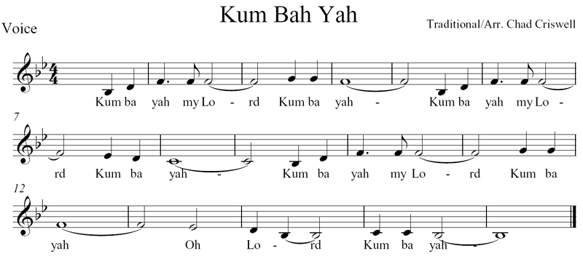

THE LORD’S PRAYER: Father God in Heaven
Text: J.E. Seddon; Tune: KUM BA YAH

And now, as our Saviour Christ has taught us, we are bold to sing.

Father God in heaven, Lord most high:
hear your children's prayer, Lord most high:
hallowed be your name, Lord most high
O Lord, hear our prayer.

May your kingdom come, here on earth;
may your will be done, here on earth,
as it is in heaven, so on earth
O Lord, hear our prayer.

Give us daily bread, day by day,
and forgive our sins, day by day,
as we too forgive, day by day
O Lord, hear our prayer.

Lead us in your way, make us strong;
when temptations come, make us strong;
save us from all sin, keep us strong
O Lord, hear our prayer.

All things come from you, all are yours
kingdom, glory, power, all are yours;
take our lives and gifts, all are yours
O Lord, hear our prayer. Amen.
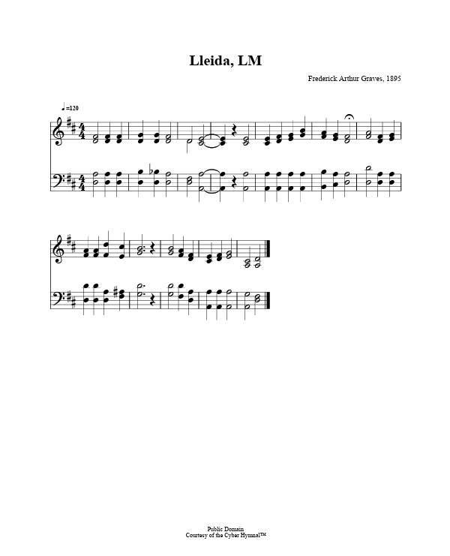
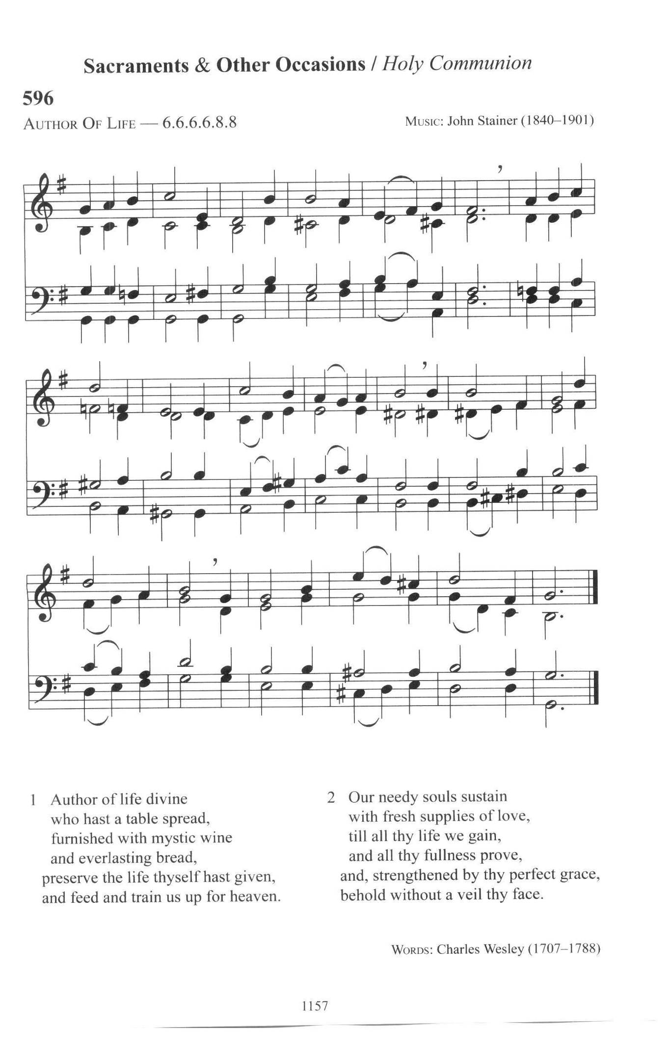
THE BREAKING OF THE BREAD

We break this bread to share in the body of Christ.
We, being many, are one body, for we all share in the one bread.

THE INVITATION

The gifts of God for the People of God
Thanks be to God.

DURING COMMUNION: Author of Life Divine
Text: Charles Wesley; Tune: AUTHOR OF LIFE

Author of life divine, who hast a table spread,
furnished with mystic wine and everlasting bread,
preserve the life Thyself hast giv'n,
and feed and train us up for heav'n.

Our needy souls sustain with fresh supplies of love,
till all Thy life we gain and all Thy fullness prove,
and strengthened by Thy perfect grace,
behold without a veil Thy face.

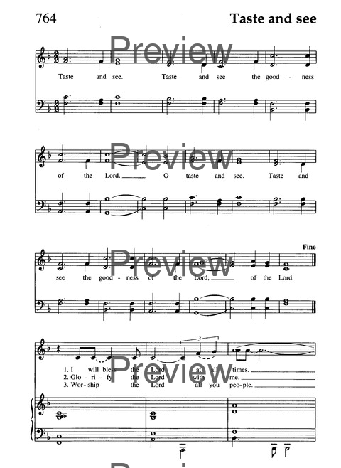
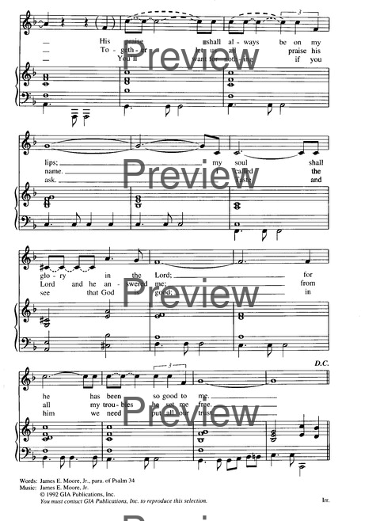
Taste and See
Text: James E. Moore; Tune: I WILL BLESS THE LORD AT ALL TIMES

Taste and see, taste and see
the goodness of the Lord.
Oh, taste and see, taste and see
the goodness of the Lord, of the Lord.

I will bless the Lord at all times.
Praise shall always be on my lips;
my soul shall glory in the Lord;
for God has been so good to me. (refrain)

Glorify the Lord with me.
Together let us all praise God’s name.
I called the Lord, who answered me;
from all my troubles I was set free. (refrain)

Worship the Lord, all you people.
You’ll want for nothing if you ask.
Taste and see that the Lord is good;
in God we need put all our trust. (refrain)

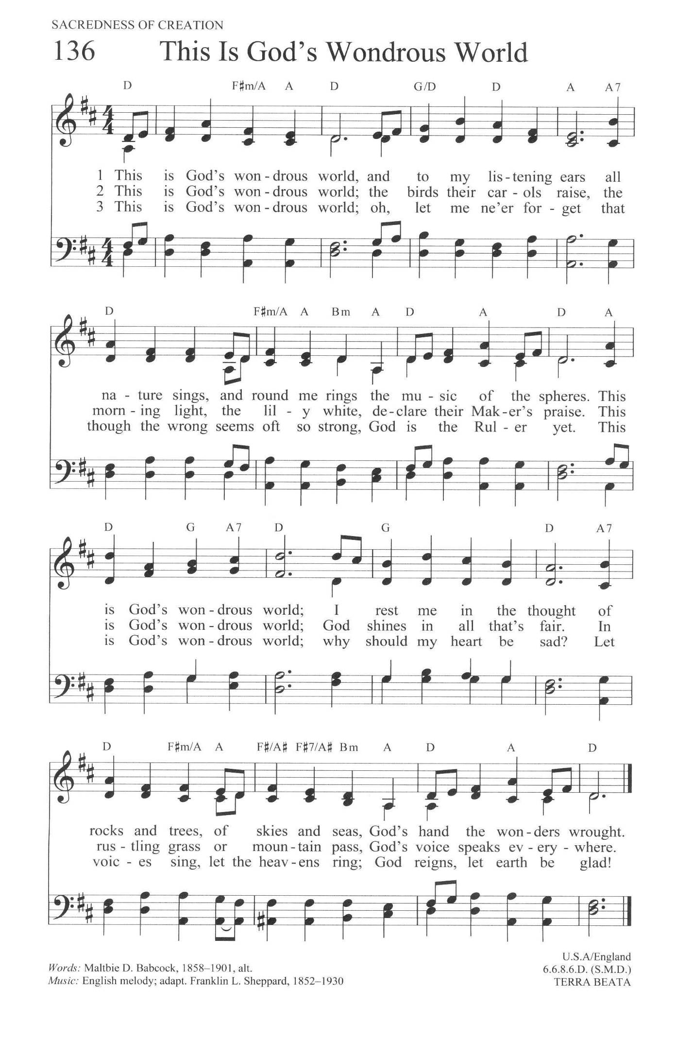
Ablutions: This Is My Father's World
Text: Maltbie D. Babcock; Music: TERRA BEATA

This is my Father's world,
And to my listening ears
All nature sings, and round me rings
The music of the spheres.
This is my Father's world:
I rest me in the thought
Of rocks and trees, of skies and seas-
His hand the wonders wrought.

This is my Father's world:
The birds their carols raise,
The morning light, the lily white,
Declare their Maker's praise.
This is my Father's world:
He shines in all that's fair;
In the rustling grass I hear Him pass,
He speaks to me everywhere.

This is my Father's world:
O let me ne'er forget
That though the wrong seems oft so strong,
God is the Ruler yet.
This is my Father's world:
Why should my heart be sad?
The Lord is King: let the heavens ring!
God reigns; let earth be glad!

PRAYER AFTER COMMUNION

Living God, in this sacrament we have shared in your eternal kingdom.
May we who taste this mystery forever serve you in faith, hope, and love.
We ask this in the name of Jesus Christ the Lord.
Amen.

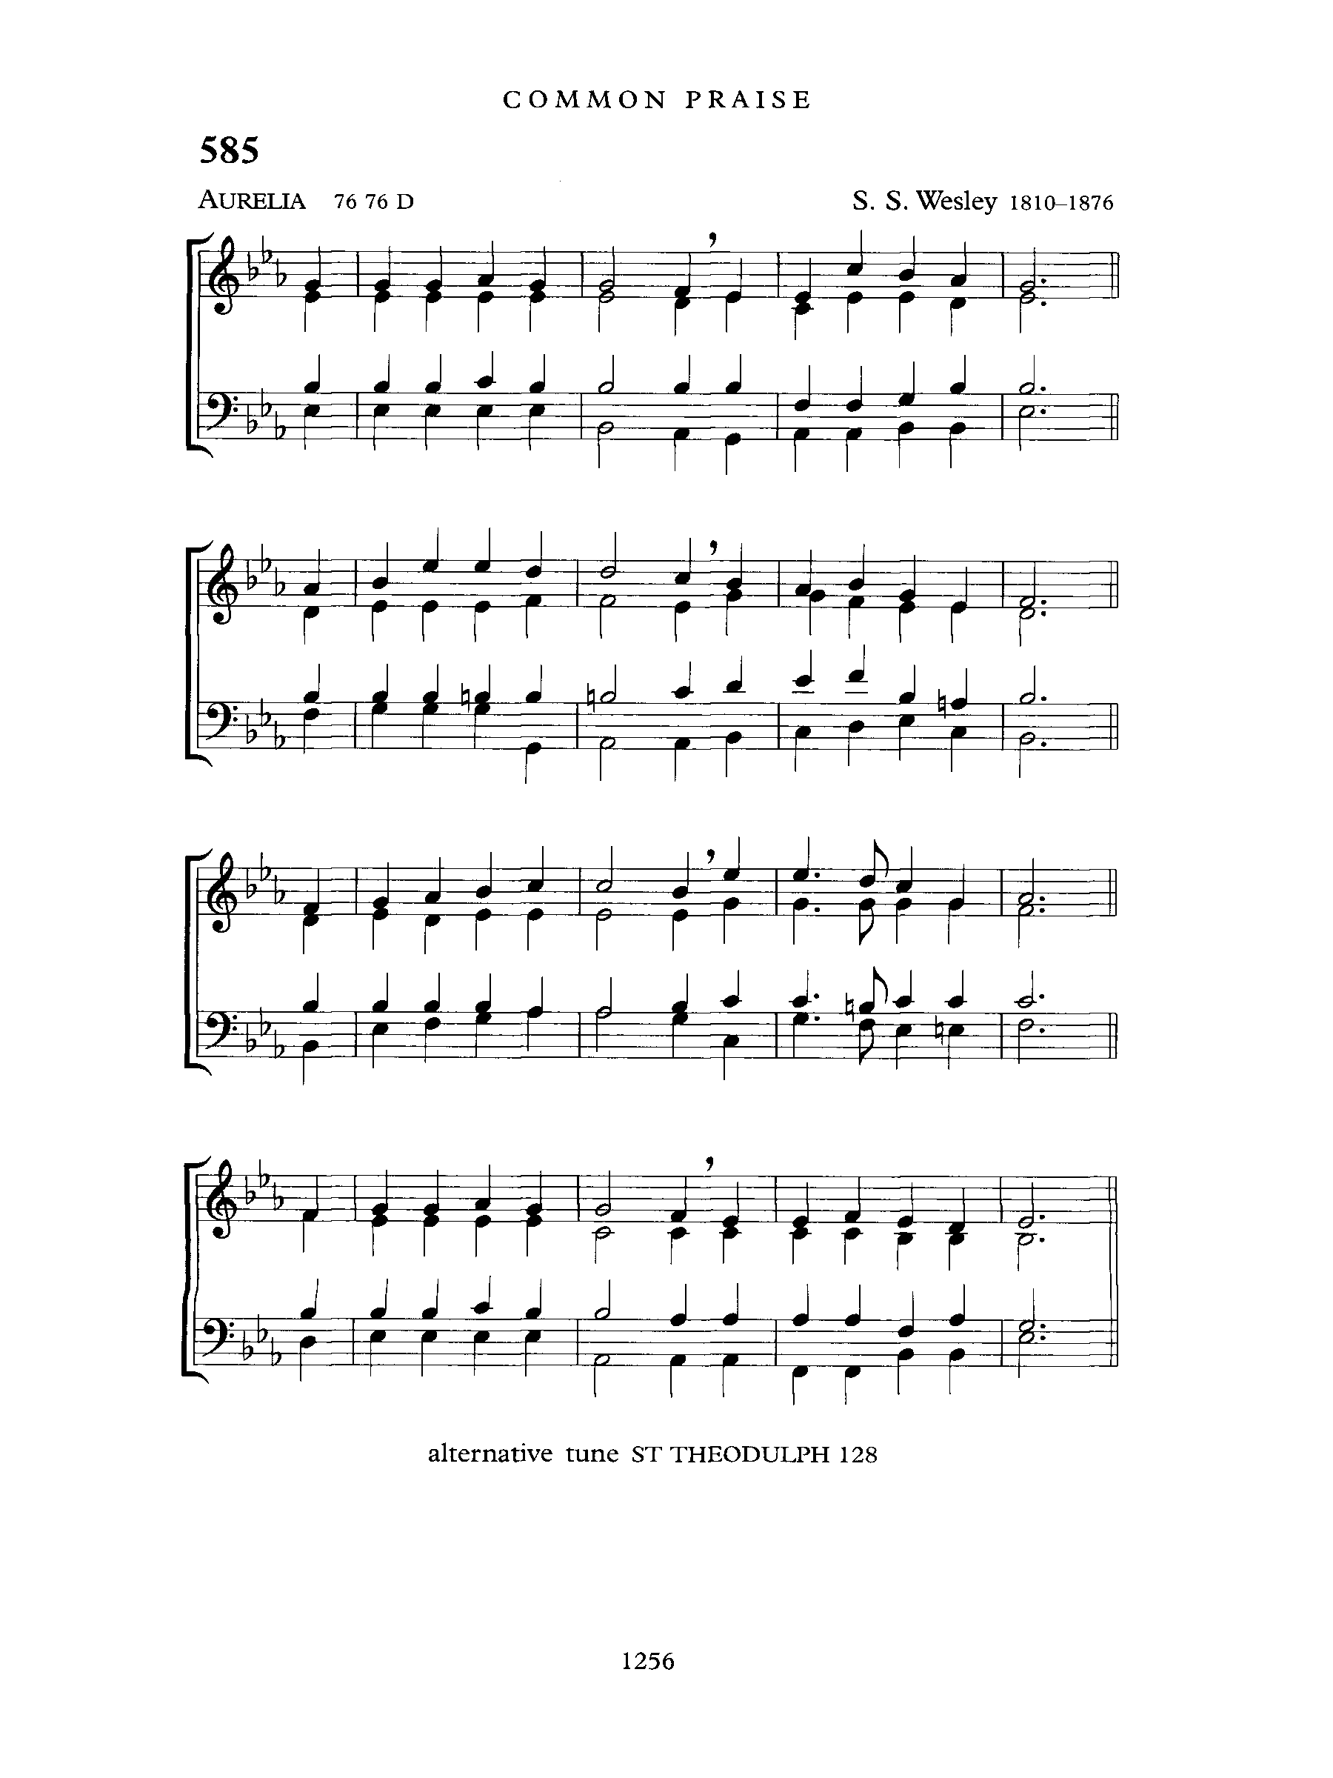
THE BLESSING
May God be the light on your path, the breeze on your back,
the music in your ears, the song on your lips,
the curiosity in your mind, the happiness in your heart, the peace in your spirit.
And the blessing of God Almighty, Father, Son and Holy Spirit
be with you now and always.
Amen.

ANNOUNCEMENTS

RECESSIONAL: O Jesus, I have Promised
Text: John E. Bode; Tune: AURELIA

O Jesus, I have promised to serve thee to the end;
Be thou forever near me, my Master and my friend;
I shall not fear the battle if thou art by my side,
Nor wander from the pathway if thou wilt be my guide.

O let me feel thee near me! The world is ever near:
I see the sights that dazzle, the tempting sounds I hear.
My foes are ever near me, around me and within;
But, Jesus, draw thou nearer, and shield my soul from sin.

O let me hear thee speaking in accents clear and still,
Above the storms of passion, the murmurs of self-will.
O speak to reassure me, to hasten or control;
O speak, and make me listen, Thou guardian of my soul.

O Jesus, thou hast promised to all who follow thee
That where thou art in glory, there shall thy servant be.
And, Jesus, I have promised to serve thee to the end;
O give me grace to follow, my Master and my friend.

THE DISMISSAL:

Followers of the Christ, Inspired by the Holy Spirit.
Serve the world God loves. Alleluia! Alleluia!
Thanks be to God. Alleluia! Alleluia!

POSTLUDE: Marching to Zion
