The Fifth Sunday in Lent

Holy Eucharist with Anointing

March 22, 2026, 10:30am

Theme: “The Season of Learning”
Subtheme: “Learning to Live Again”

Website: www.sthildasanglicanchurch.com
Church Email: info@sthildasanglicanchurch.com
Facebook: St. Hilda’s Fairbank Anglican Church

Incumbent: Fr. Kenute Francis (437-488-9657)

kenute@sthildasanglicanchurch.com

Organist: William “Bill” Khan

Crucifer: Kishmar Miller

Eucharistic Ministers: Hardy, Alleyne & Greenidge

1st Reading: Michelle McPherson

2nd Reading: Charmaine Alexander-Chin

Gospel: William Greenidge

Intercession: Hazell Coombes

Tech Team: Richard Morris

Ushers Team 2: Oscar Lewis Percy Lorde

Merlene Eastmond Isla Barnes

John Goddard Thora Layne

Jean Caine Brenda Ferary

MISSION STATEMENT
The purpose of St. Hilda’s Church is to be Christ-centered in our life and worship,
to serve lovingly those within our family and others within our reach

that the spirit of God might empower us for worship. service, education, stewardship, evangelism and pastoral care.

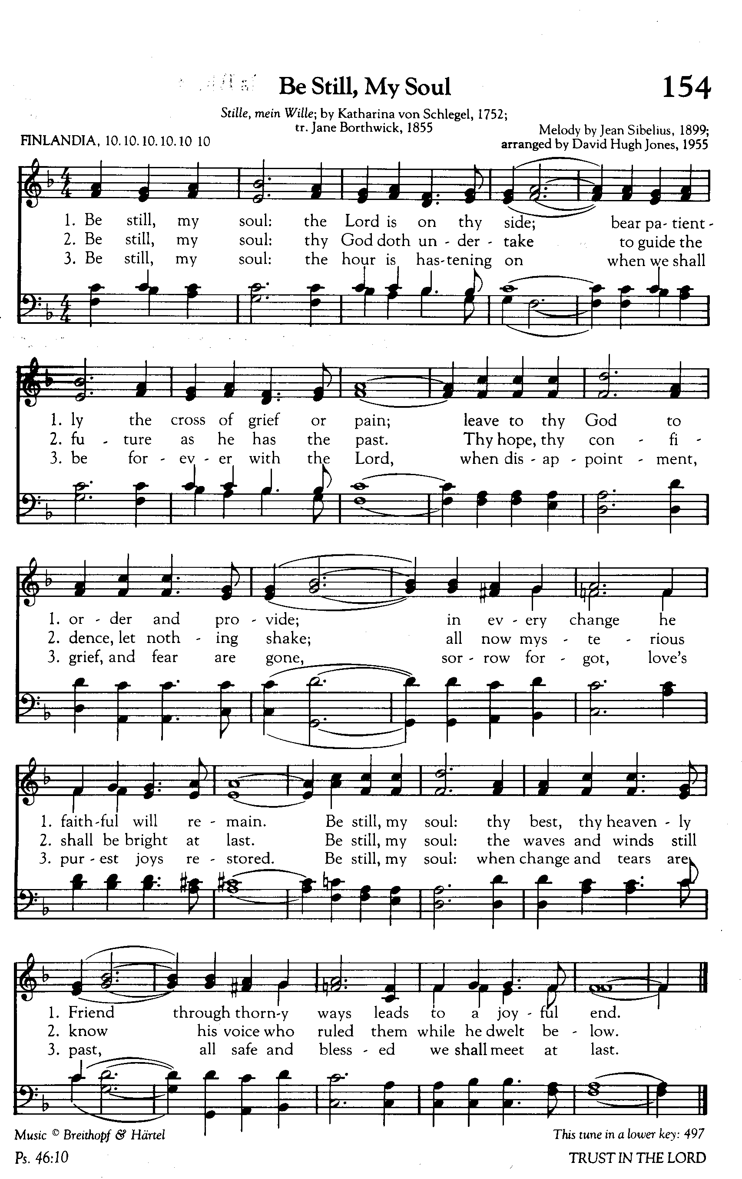

The Order of Service

PRELUDE: Be Still My Soul (FINLANDIA)

OPENING PRAYER:

Almighty God,
you bring life where there is death and hope where there is despair.
Breathe your Spirit upon us as we gather, open our hearts to your Word,
and lead us into the life you promise through Jesus Christ,
who is the resurrection and the life.
Amen.

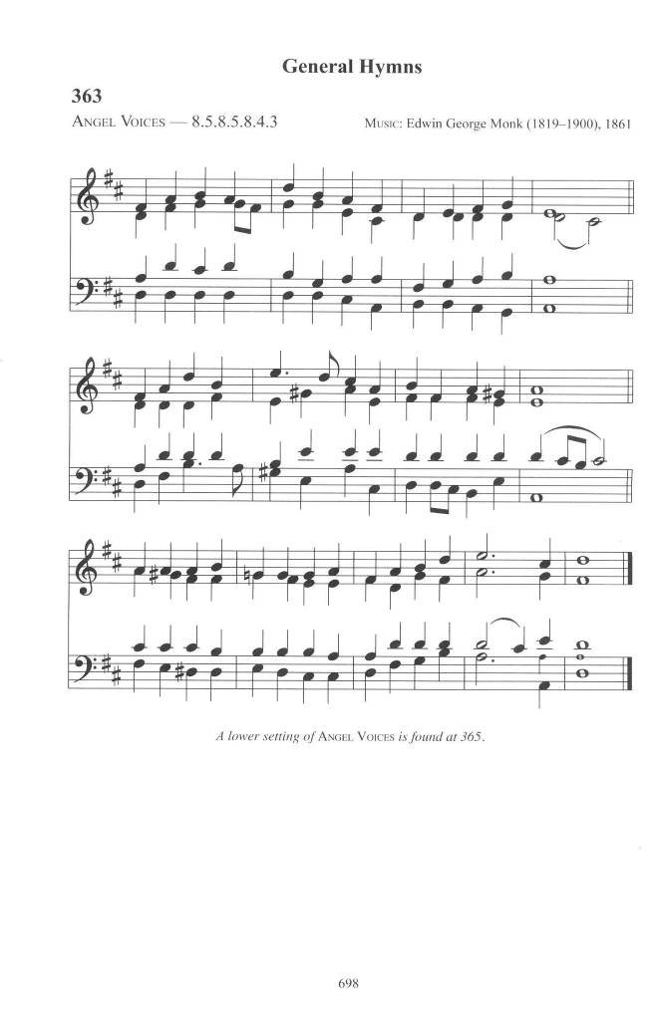
PROCESSIONAL: Angel Voices Ever Singing
Text: Francis Pratt; Tune: ANGEL VOICES

Angel voices ever singing
round Thy throne of light,
angel harps, forever ringing,
rest not day nor night;
thousands only live to bless Thee
and confess thee Lord of might.

Thou who art beyond the farthest
mortal eye can scan,
can it be that Thou regardest
songs of sinful man?
Can we feel that Thou art near us
and wilt hear us? Yea, we can.

Yea, we know Thy love rejoices
o'er each work of Thine;
Thou didst ears and hands and voices
for Thy praise combine;
craftsman's art and music's measure
for Thy pleasure didst design.

Here, great God, today we offer
of Thine own to Thee;
and for Thine acceptance proffer,
all unworthily,
hearts and minds and hands and voices
in our choicest melody.

Honor, glory, might, and merit
Thine shall ever be,
Father, Son, and Holy Spirit,
blessed Trinity:
of the best that Thou hast given
earth and heaven render Thee.

WELCOME Fr. Kenute

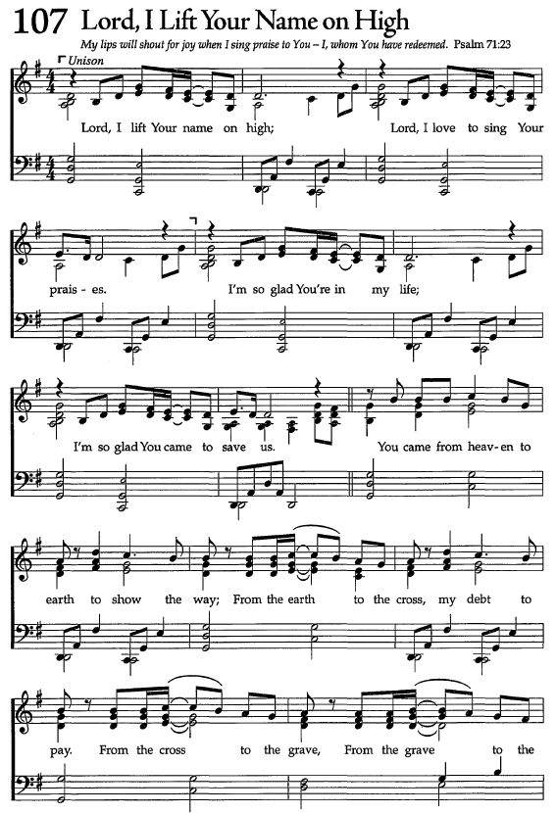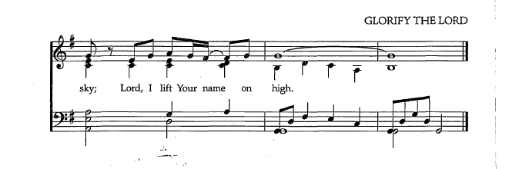
GREETING: We Praise You

The grace of our Lord Jesus Christ, the love of God
and the fellowship of the Holy spirit be with you all
And also with you

Way beyond all journeying, truth behind all mystery, life within all living -
we praise you!

Salve for every soreness, mender of every brokenness,
we praise you!

Ground of all being, judge of all nations, conscience of the universe -
we praise you!

Maker, redeemer, confessor, companion, inspirer, God beyond all names -
we praise you!

THE COLLECT FOR PURITY

Almighty God,
to you all hearts are open, all desires known, and from you no secrets are hidden.
Cleanse the thoughts of our hearts by the inspiration of your Holy Spirit,
that we may perfectly love you, and worthily magnify your holy name;
through Christ our Lord.
Amen.

INTROIT: Lord I lift Your Name on High
Text: Rick Founds

Lord I lift Your name on high
Lord I love to sing Your praises
I'm so glad You're in my life
I'm so glad You came to save us

You came from heaven to earth to show the way
From the earth to the cross, my debt to pay
From the cross to the grave, from the grave to the sky
Lord I lift Your name on high.

THE COLLECT OF THE DAY

Almighty God,
your Son came into the world to free us all from sin and death.
Breathe upon us with the power of your Spirit,
that we may be raised to new life in Christ,
and serve you in holiness and righteousness all our days;
through the same Jesus Christ, our Lord.
Amen.

THE PROCLAMATION OF THE WORD

THE FIRST READING: Ezekiel 37:1-14 (Michelle McPherson)

A reading from the Book of Ezekiel
The hand of the LORD came upon me, and he brought me out by the spirit of the LORD and set me down in the middle of a valley; it was full of bones.
He led me all around them; there were very many lying in the valley, and they were very dry. He said to me, "Mortal, can these bones live?" I answered, "O Lord GOD, you know." Then he said to me, "Prophesy to these bones, and say to them:
O dry bones, hear the word of the LORD. Thus says the Lord GOD to these bones:
I will cause breath to enter you, and you shall live.
I will lay sinews on you, and will cause flesh to come upon you, and cover you with skin, and put breath in you, and you shall live; and you shall know that I am the LORD." So I prophesied as I had been commanded; and as I prophesied, suddenly there was a noise, a rattling, and the bones came together, bone to its bone.
I looked, and there were sinews on them, and flesh had come upon them,
and skin had covered them; but there was no breath in them. Then he said to me, "Prophesy to the breath, prophesy, mortal, and say to the breath: Thus says the Lord GOD: Come from the four winds, O breath, and breathe upon these slain,
that they may live."
I prophesied as he commanded me, and the breath came into them, and they lived, and stood on their feet, a vast multitude. Then he said to me, "Mortal, these bones are the whole house of Israel. They say, 'Our bones are dried up, and our hope is lost; we are cut off completely.' Therefore prophesy, and say to them, Thus says the Lord GOD: I am going to open your graves, and bring you up from your graves, O my people; and I will bring you back to the land of Israel. And you shall know that I am the LORD, when I open your graves, and bring you up from your graves,
O my people. I will put my spirit within you, and you shall live, and I will place you on your own soil; then you shall know that I, the LORD, have spoken and will act," says the LORD.

The Word of the Lord Thanks be to God
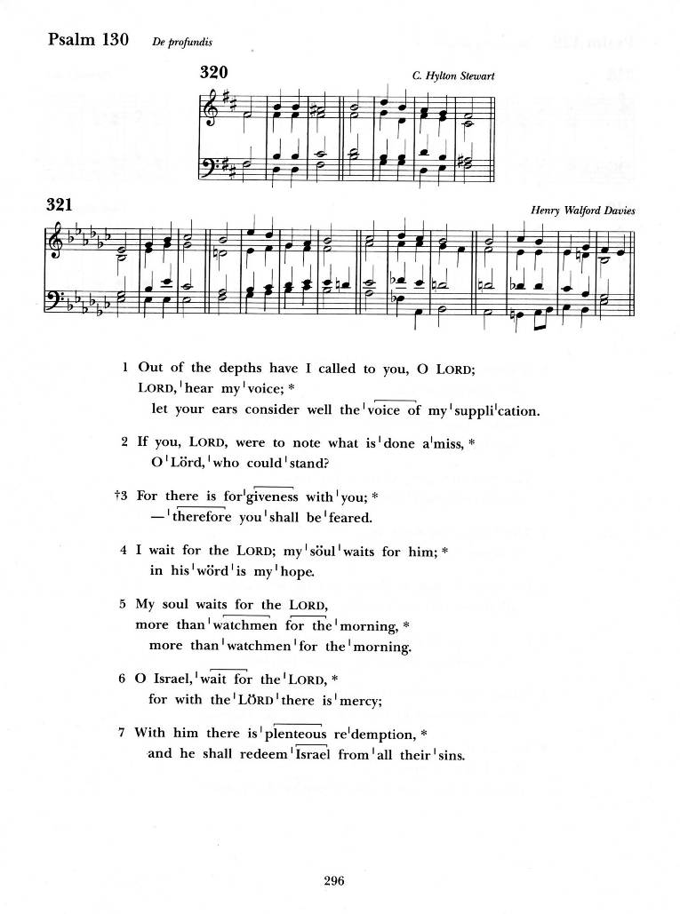
Psalm 130 (chanted)

Out of the depths have I called you, O Lord; Lord, hear my voice;
let your ears consider well the voice of my supplication.
If you, Lord, were to note what is done amiss,
O Lord, who could stand?

For there is forgiveness with you; therefore you shall be feared.
I wait for the Lord; my soul waits for him; in his word is my hope.

My soul waits for the Lord, more than watchmen for the morning,
more than watchmen for the morning.
O Israel, wait for the Lord, for with the Lord there is mercy;

With him there is plenteous redemption,
and he shall redeem Israel from all their sins.
Glory to the Father, and to the Son, and to the Holy Spirit:
as it was in the beginning, is now, and will be for ever.
Amen.

THE SECOND READING Romans 8:6-11 (Charmaine Alexander-Chin)

A reading from the letter of Paul to the Romans

To set the mind on the flesh is death, but to set the mind on the Spirit is life
and peace. For this reason the mind that is set on the flesh is hostile to God;
it does not submit to God's law-- indeed it cannot, and those who are in the
flesh cannot please God. But you are not in the flesh; you are in the Spirit,
since the Spirit of God dwells in you. Anyone who does not have the Spirit of
Christ does not belong to him. But if Christ is in you, though the body is dead because of sin, the Spirit is life because of righteousness.
If the Spirit of him who raised Jesus from the dead dwells in you,
he who raised Christ from the dead will give life to your mortal bodies also
through his Spirit that dwells in you.

The word of the Lord
Thanks be to God

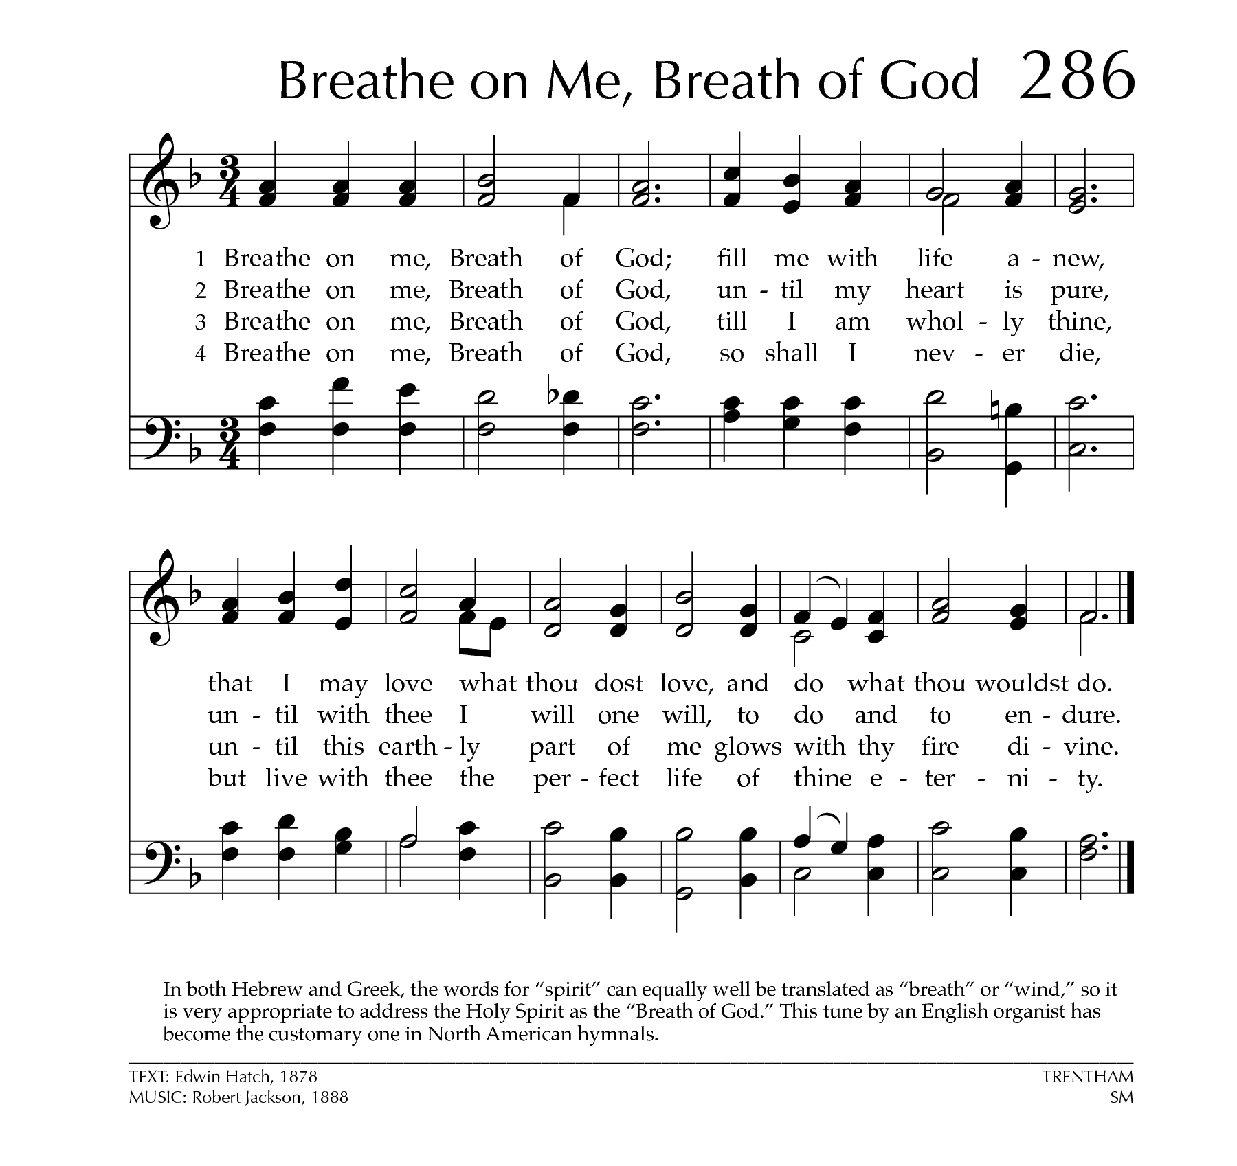
THE GRADUAL: Breathe on Me, Breath of God
Text: Edwin Hatch; Tune: TRENTHAM

Breathe on me, Breath of God,
Fill me with life anew,
That I may love what Thou dost love,
And do what Thou wouldst do.

Breathe on me, Breath of God,
Until my heart is pure,
Until with Thee I will one will,
To do and to endure.

Breathe on me, Breath of God,
Till I am wholly Thine,
Until this earthly part of me
Glows with Thy fire divine.

Breathe on me, Breath of God,
So shall I never die,
But live with Thee the perfect life
Of Thine eternity.

THE HOLY GOSPEL John 11:1-45 William Greenidge

The Lord be with you
And also with you

The Holy Gospel of our Lord Jesus Christ according to John
Glory to you, Lord Jesus Christ

Now a certain man was ill, Lazarus of Bethany, the village of Mary and her sister Martha. Mary was the one who anointed the Lord with perfume and wiped his
feet with her hair; her brother Lazarus was ill. So the sisters sent a message to Jesus, "Lord, he whom you love is ill." But when Jesus heard it, he said, "This illness does not lead to death; rather it is for God's glory, so that the Son of God may be glorified through it."
Accordingly, though Jesus loved Martha and her sister and Lazarus, after having heard that Lazarus was ill, he stayed two days longer in the place where he was. Then after this he said to the disciples, "Let us go to Judea again." The disciples said to him, "Rabbi, the Jews were just now trying to stone you, and are you going there again?" Jesus answered, "Are there not twelve hours of daylight? Those who walk during the day do not stumble, because they see the light of this world.
But those who walk at night stumble, because the light is not in them."
After saying this, he told them, "Our friend Lazarus has fallen asleep, but I am going there to awaken him." The disciples said to him, "Lord, if he has fallen asleep,
he will be all right." Jesus, however, had been speaking about his death,
but they thought that he was referring merely to sleep.
Then Jesus told them plainly, "Lazarus is dead. For your sake I am glad I was not there, so that you may believe. But let us go to him."
Thomas, who was called the Twin, said to his fellow disciples, "Let us also go,
that we may die with him." When Jesus arrived, he found that Lazarus had already been in the tomb four days.
Now Bethany was near Jerusalem, some two miles away, and many of the Jews had come to Martha and Mary to console them about their brother.
When Martha heard that Jesus was coming, she went and met him, while Mary stayed at home. Martha said to Jesus, "Lord, if you had been here, my brother would not have died. But even now I know that God will give you whatever you ask of him." Jesus said to her, "Your brother will rise again."
Martha said to him, "I know that he will rise again in the resurrection on the last day." Jesus said to her, "I am the resurrection and the life. Those who believe in me, even though they die, will live, and everyone who lives and believes in me will never die. Do you believe this?"
She said to him, "Yes, Lord, I believe that you are the Messiah, the Son of God,
the one coming into the world." When she had said this, she went back and called her sister Mary, and told her privately, "The Teacher is here and is calling for you." And when she heard it, she got up quickly and went to him.
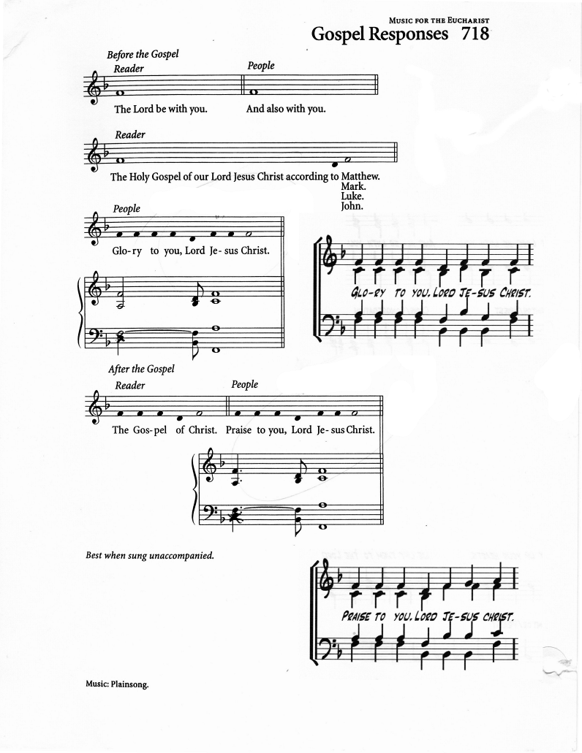
Now Jesus had not yet come to the village, but was still at the place where Martha had met him. The Jews who were with her in the house, consoling her,
saw Mary get up quickly and go out. They followed her because they thought that she was going to the tomb to weep there.
When Mary came where Jesus was and saw him, she knelt at his feet and said to him, "Lord, if you had been here, my brother would not have died."
When Jesus saw her weeping, and the Jews who came with her also weeping,
he was greatly disturbed in spirit and deeply moved. He said, "Where have you
laid him?" They said to him, "Lord, come and see." Jesus began to weep.
So the Jews said, "See how he loved him!" But some of them said, "Could not he who opened the eyes of the blind man have kept this man from dying?"
Then Jesus, again greatly disturbed, came to the tomb. It was a cave, and a stone was lying against it. Jesus said, "Take away the stone." Martha, the sister of the dead man, said to him, "Lord, already there is a stench because he has been dead four days." Jesus said to her, "Did I not tell you that if you believed, you would see the glory of God?"
So they took away the stone. And Jesus looked upward and said, "Father, I thank you for having heard me. I knew that you always hear me, but I have said this for the sake of the crowd standing here, so that they may believe that you sent me." When he had said this, he cried with a loud voice, "Lazarus, come out!" The dead man came out, his hands and feet bound with strips of cloth, and his face wrapped in a cloth. Jesus said to them, "Unbind him, and let him go." Many of the Jews therefore, who had come with Mary and had seen what Jesus did, believed in him.

The Gospel of Christ
Praise to you, Lord Jesus Christ

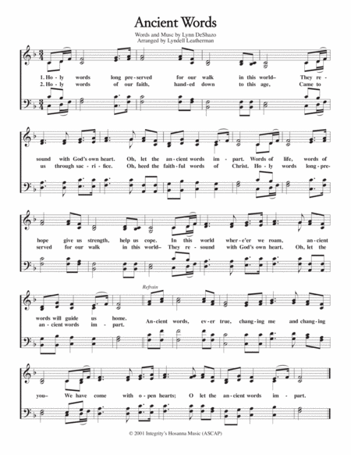
Gospel Acclamation: "Ancient Words"
(Lyrics: Michael Smith)

Holy words long preserved
For our walk in this world
They resound with God's own heart
Oh, let the ancient words impart

Words of Life, words of Hope
Give us strength, help us cope
In this world, where e'er we roam
Ancient words will guide us home

(refrain)
Ancient words ever true
Changing me and changing you
We have come with open hearts
Oh, let the ancient words impart

THE SERMON Sonia Wickham

THE APOSTLES CREED

Let us confess our faith, as we say,

I believe in God, the Father almighty, creator of heaven and earth.
I believe in Jesus Christ, his only Son, our Lord.
He was conceived by the power of the Holy Spirit and born of the Virgin Mary.
He suffered under Pontius Pilate, was crucified, died, and was buried.
He descended to the dead. On the third day he rose again.
He ascended into heaven, and is seated at the right hand of the Father.
He will come again to judge the living and the dead.
I believe in the Holy Spirit, the holy catholic Church,
the communion of saints, the forgiveness of sins,
the resurrection of the body, and the life everlasting. Amen.

LITANY OF HEALING (Hazell Coombes)

Let us pray,
God of life, breathe hope into every place that feels like a tomb.
Lord, graciously hear us.

Pour your comfort on those burdened by grief and loss,
Lord, graciously hear us.

Emancipate those trapped in anxiety, fear, despair, and those suffering from any form of sickness or disease.
Lord, graciously hear us.

Heal and set free those who endure broken relationships and wounded hearts,
Lord, graciously hear us.
Give peace and concord to communities wounded by violence, injustice, and war,
Lord, graciously hear us.

Empower your church when it becomes tired or lukewarm,
breathe your Spirit and teach us to live again.
Lord, graciously hear us.

Resurrecting God, call us out of every tomb and lead us into new life.
Lord, graciously hear us. Amen.

THE CONFESSION AND ABSOLUTION (Hazell Coombes)

Dear friends in Christ, God is steadfast in love and infinite in mercy;
he welcomes sinners and invites them to his table.
Let us confess our sins, confident in God's forgiveness.

Most merciful God,
we confess that we have sinned against you in thought, word and deed,
by what we have done and by what we have left undone.
We have not loved you with our whole heart;
we have not loved our neighbours as ourselves.
We are truly sorry and we humbly repent. For the sake of your Son Jesus Christ, have mercy on us and forgive us, that we may delight in your will,
and walk in your ways, to the glory of your name. Amen.

Absolution: (Fr. Kenute)
Almighty God have mercy upon you, pardon and deliver you from
all your sins, confirm and strengthen you in all goodness,
and keep you in eternal life; through Jesus Christ our Lord.
Amen.

The Lord’s Prayer: (Hazell Coombes)
And now, let us sum up our prayers, as Jesus taught us,

Our Father, who art in heaven, hallowed be thy Name,
Thy kingdom come, Thy will be done, on earth as it is in heaven.
Give us this day our daily bread.
And forgive us our trespasses as we forgive those who trespass against us.
And lead us not into temptation, but deliver us from evil.
For thine is the kingdom, the power, and the glory, for ever and ever. Amen.

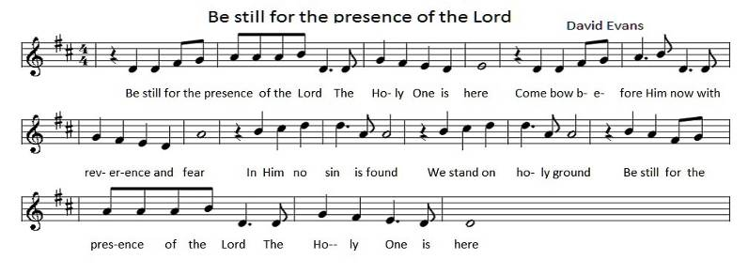

THE ANOINTING
Be still for the Presence of the Lord
Text & Music: David J. Evans

Be still for the presence of the Lord, the Holy One is here
Come bow before Him now, with reverence and fear
In Him no sin is found, we stand on holy ground.
Be still for the presence of the Lord, the Holy One is here.

Be still for the glory of the Lord, is shining all around
He burns with holy fire, with splendor He is crowned
How awesome is the sight, our radiant King of light
Be still for the glory of the Lord, is shining all around.

Be still for the power of the Lord, is moving in this place
He comes to cleanse and heal, to minister His grace
No work too hard for Him, in faith receive from Him
Be still for the power of the Lord is moving in this place.

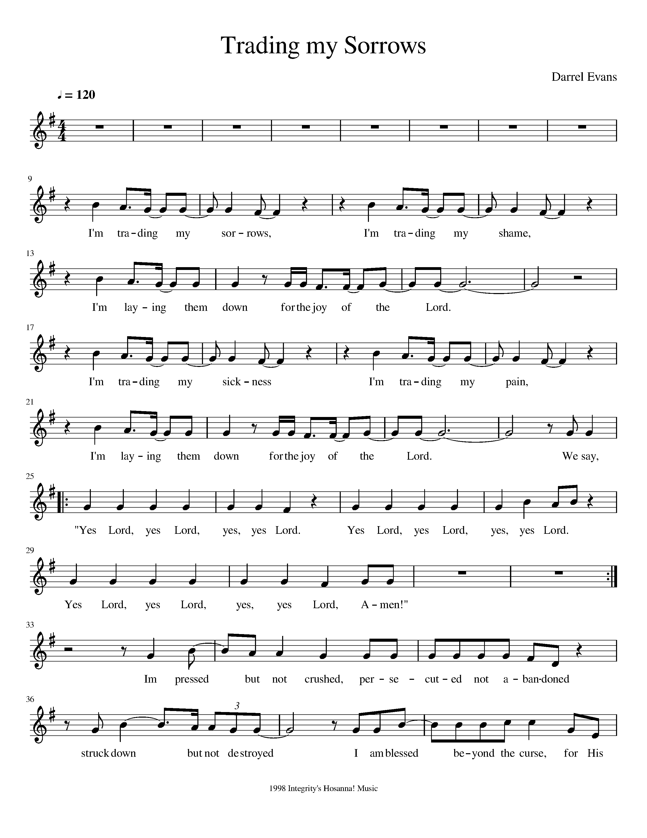
I’m Trading My Sorrows (X2)
Text & Music: Darrell Evans

I’m trading my sorrows
I’m trading my shame
I’m laying them down for the joy of the Lord
I’m trading my sickness
I’m trading my pain
I’m laying them down for the joy of the Lord

Yes Lord, yes Lord, yes yes Lord
Yes Lord, yes Lord, yes yes Lord
Yes Lord, yes Lord, yes yes Lord, Amen

God is So Good (Velna A. Ledin)

God is so good, God is so good,
God is so good, He’s so good to me!
He cares for me, He cares for me,
He cares for me, He’s so good to me!

I praise His name, I praise His name,
I praise His name, He’s so good to me!

PRAYER AFTER THE ANOINTING

Gracious God,
as we have been anointed, pour your healing Spirit upon us.
Restore what is broken, strengthen what is weak,
and raise us to new life in Jesus Christ our Lord.
Amen.

The Peace

The peace of the Lord be always with you.
And also with you.

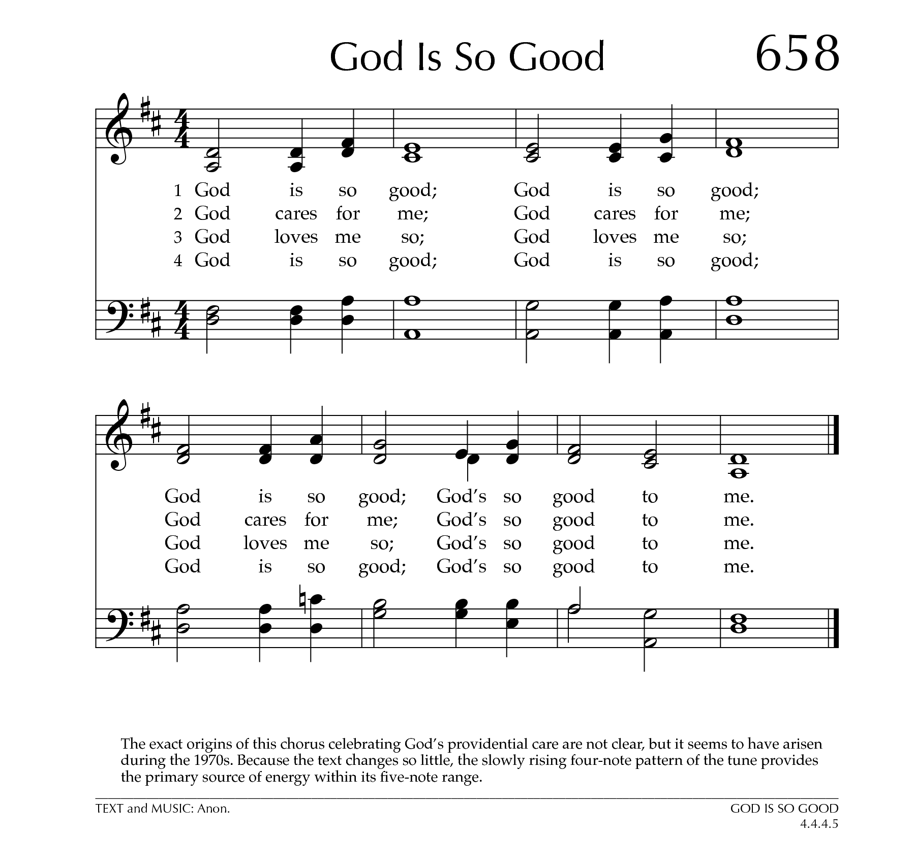
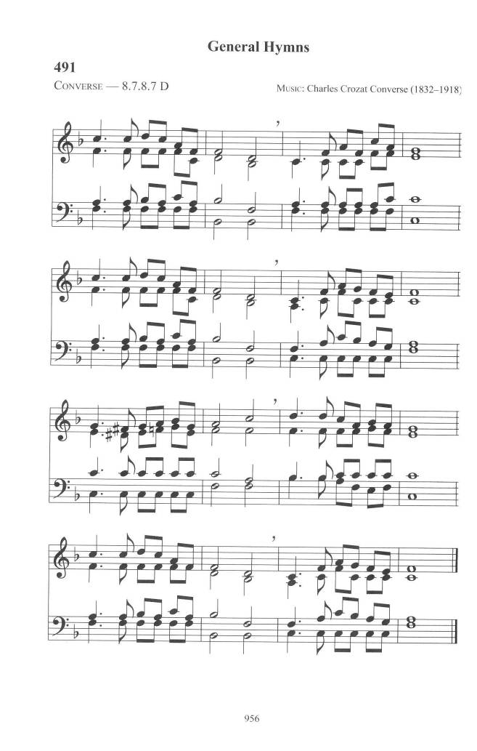
OFFERTORY: What a Friend we have in Jesus
Text: Joseph M. Scriven; Tune: CONVERSE

What a friend we have in Jesus,
All our sins and griefs to bear!
What a privilege to carry
Everything to God in prayer!
Oh, what peace we often forfeit,
Oh, what needless pain we bear,
All because we do not carry
Everything to God in prayer!

Have we trials and temptations?
Is there trouble anywhere?
We should never be discouraged—
Take it to the Lord in prayer.
Can we find a friend so faithful,
Who will all our sorrows share?
Jesus knows our every weakness;
Take it to the Lord in prayer.

Are we weak and heavy-laden,
Cumbered with a load of care?
Precious Saviour, still our refuge—
Take it to the Lord in prayer.
Do thy friends despise, forsake thee?
Take it to the Lord in prayer!
In His arms He’ll take and shield thee,
Thou wilt find a solace there.

PRAYER OVER THE GIFTS

Giver of life,
your Son has destroyed the power of death for all those who believe in him.
Accept all we offer you this day and strengthen us in faith and hope;
through Jesus Christ, the Lord of all the living.
Amen.

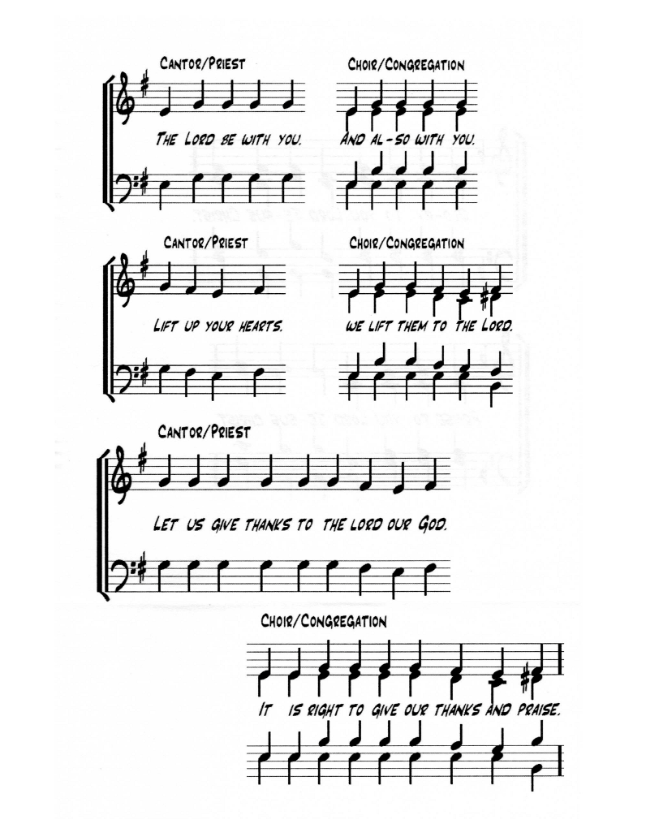
EUCHARISTIC PRAYER 5

The Lord be with you.
And also with you.

Lift up your hearts.
We lift them to the Lord.

Let us give thanks to the Lord our God.
It is right to give our thanks and praise.

We give you thanks and praise, almighty God,
for the gift of a world full of wonder, and for our life which comes from you.
By your power you sustain the universe.

GLORY BE TO GOD FOREVER. (BATTLE HYMN)

(sung) Glory be to God forever.
Glory be to God forever.
Glory be to God forever.
Forever and ever.
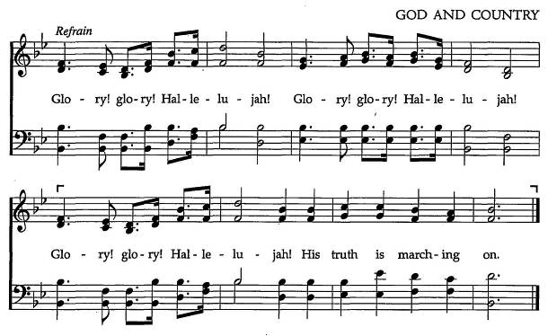

You created us to love you with all our heart,
and to love each other as ourselves,
but we rebel against you by the evil that we do.
In Jesus, your Son, you bring healing to our world
and gather us into one great family.
Therefore, with all who serve you on earth and in heaven,
we praise your wonderful name, as we sing

(sung) Holy, holy, holy Lord, God of power and might,
heaven and earth are full of your glory.
Hosanna in the highest.
Blessed is he who comes in the name of the Lord.
Hosanna in the highest.

We give you thanks and praise, loving Father,
because in sending Jesus, your Son, to us
you showed us how much you love us.
He cares for the poor and the hungry.
He suffers with the sick and the rejected.

Betrayed and forsaken, he did not strike back but overcame hatred with love.
On the cross he defeated the power of sin and death.
By raising him from the dead
you show us the power of your love to bring new life to all your people.

(sung) Glory be to God forever.
Glory be to God forever.
Glory be to God forever.
Forever and ever.

On the night before he gave up his life for us,
Jesus, at supper with his friends, took bread, gave thanks to you,
broke it, and gave it to them, saying, “Take this, all of you, and eat it:
this is my body which is given for you.”

After supper, Jesus took the cup of wine, said the blessing,
gave it to his friends, and said, “Drink this, all of you:
this is the cup of my blood, the blood of the new and eternal covenant,
which is shed for you and for many, so that sins may be forgiven.
Do this in memory of me.”
(sung) Glory be to God forever.
Glory be to God forever.
Glory be to God forever.
Forever and ever.

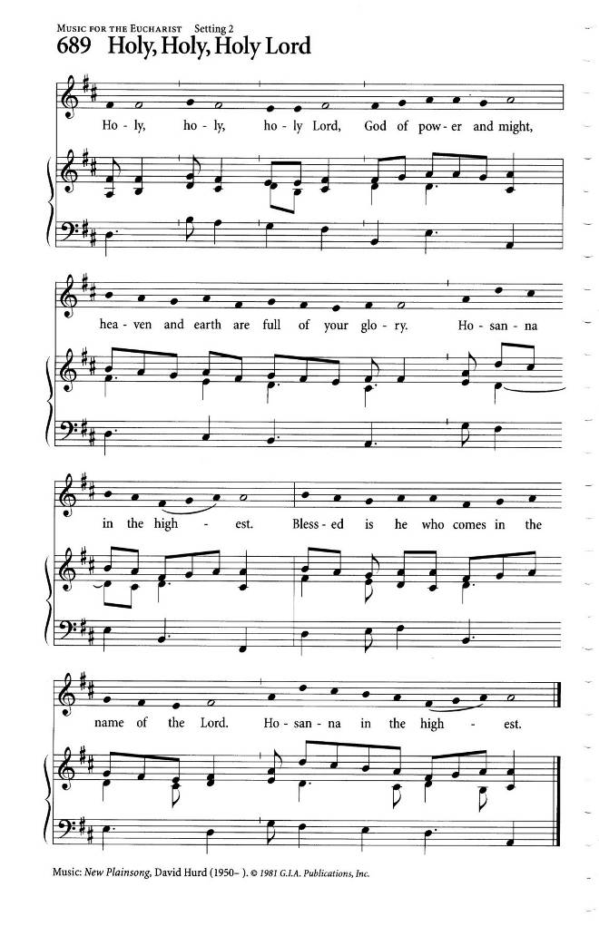
Gracious God,
with this bread and wine we celebrate the death and resurrection of Jesus,
and we offer ourselves to you in him.
Send your Holy Spirit on us and on these gifts,
that we may know the presence of Jesus in the breaking of bread,
and share in the life of the family of your children.

(sung) Glory be to God forever.
Glory be to God forever.
Glory be to God forever.
Forever and ever.

Father, you call us to be your servants;
fill us with the courage and love of Jesus,
that all the world may gather in joy at the table of your kingdom.
We sing your praise, almighty Father, through Jesus, our Lord,
in the power of the Holy Spirit, now and for ever.

(sung) Glory be to God forever.
Glory be to God forever.
Glory be to God forever.
Forever and ever. Amen.

THE BREAKING OF THE BREAD

We break this bread.
Communion in Christ’s body once broken

Let your church be the wheat which bears its fruit in dying
If we have died with him, we shall live with him;
If we hold firm, we shall reign with him.

THE INVITATION

The gifts of God for the People of God
Thanks be to God.
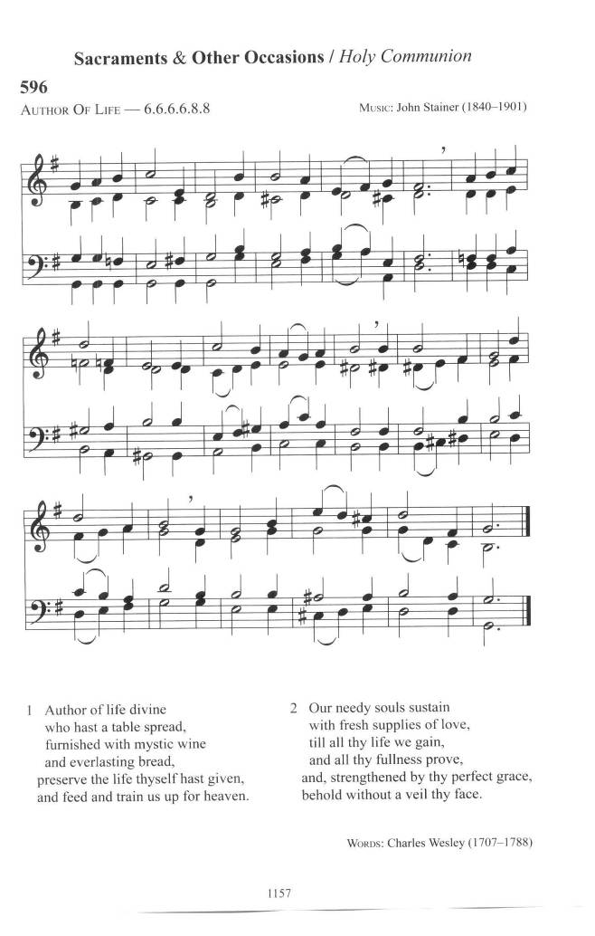
DURING COMNMUNION: Author of Life Divine
Text: Charles Wesley; Tune: AUTHOR OF LIFE

Author of life divine,
who hast a table spread,
furnished with mystic wine
and everlasting bread,
preserve the life Thyself hast giv'n,
and feed and train us up for heav'n.

Our needy souls sustain
with fresh supplies of love,
till all Thy life we gain
and all Thy fullness prove,
and strengthened by Thy perfect grace,
behold without a veil Thy face.

Here is Bread, Here is Wine
Text: Graham Kendricks; Tune: HERE IS BREAD

Here is bread, here is wine,
Christ is with us, He is with us.
Break the bread, drink the wine,
Christ is with us here.

(refrain)
In this bread there is healing,
in this cup there's life forever.
In this moment, by the Spirit,
Christ is with us here.

Here is grace, here is peace,
Christ is with us, He is with us.
Know His grace, find peace,
feast on Jesus here. (refrain)

Here we are, joined in one,
Christ is with us, He is with us.
We'll proclaim, 'til he comes,
Jesus crucified. (refrain)

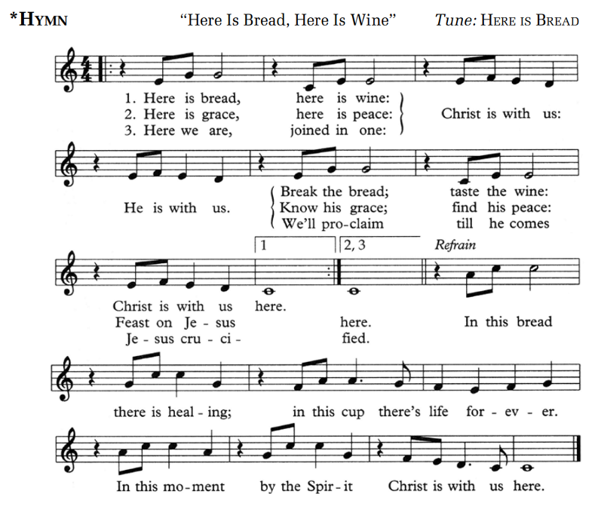
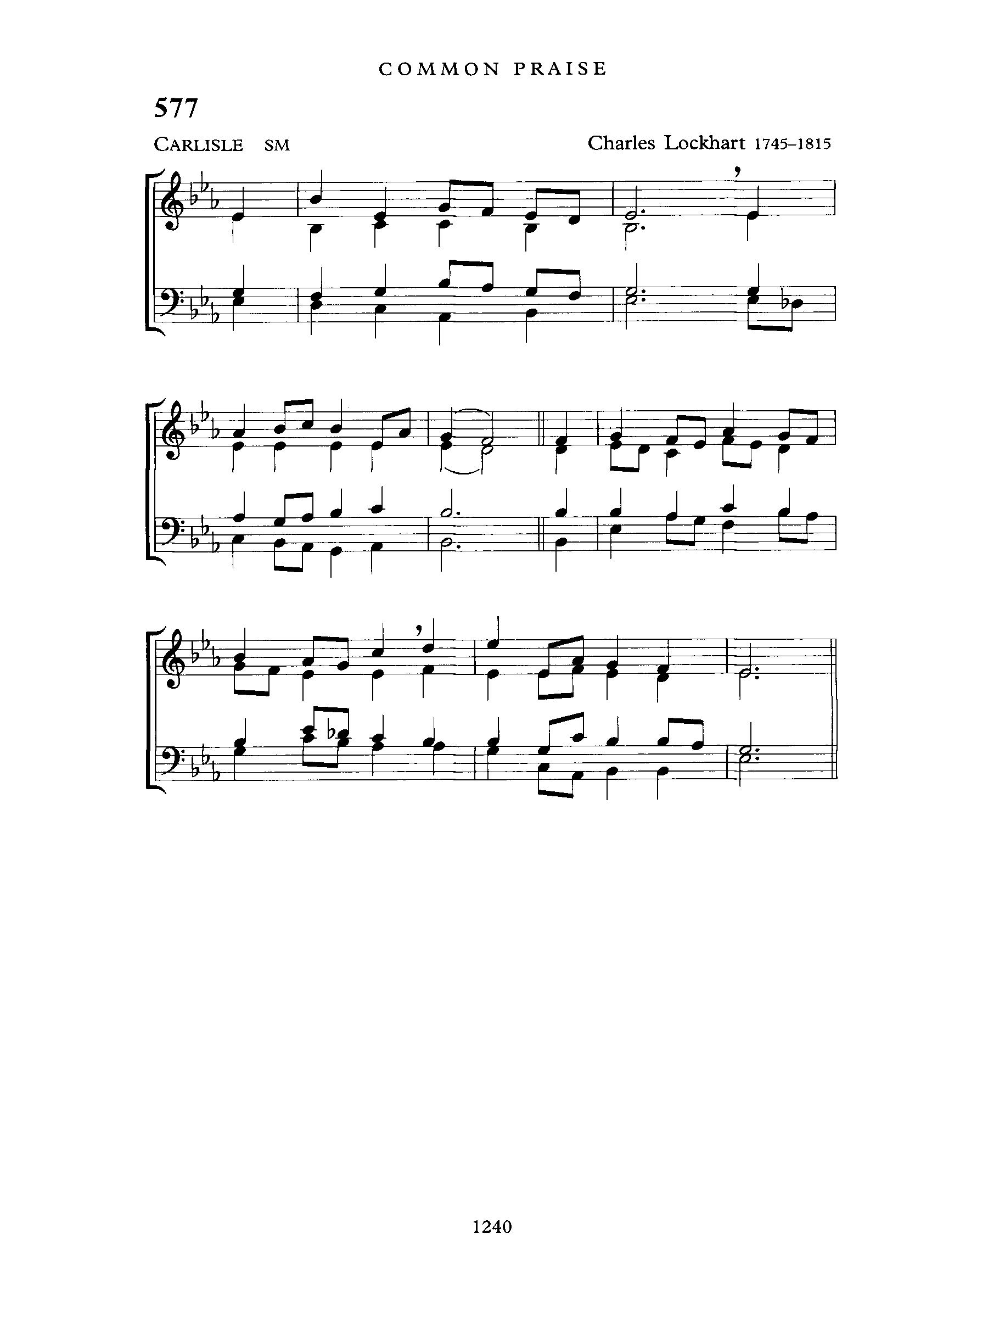
Ablutions: Revive Thy Work, O Lord
Text: Albert Midlane; Tune: CARLISLE

Revive thy work, O Lord,
thy mighty arm make bare;
speak with the voice that wakes the dead,
and make thy people hear.

Revive thy work, O Lord,
disturb this sleep of death;
quicken the smould'ring embers now
by thine almighty breath.

Revive thy work, O Lord,
create soul-thirst for thee;
and hung'ring for the Bread of Life
O may our spirits be.

Revive thy work, O Lord,
exalt thy precious name;
and, by the Holy Ghost, our love
for thee and thine inflame.

Revive thy work, O Lord,
give Pentecostal show'rs;
the glory shall be all thine own,
the blessing, Lord, be ours.

PRAYER AFTER COMMUNION

God of hope, in this eucharist we have tasted the promise
of your heavenly banquet and the richness of eternal life.
May we who bear witness to the death of your Son,
also proclaim the glory of his resurrection,
for he is Lord for ever and ever. Amen.

THE BLESSING:

Christ calls us to live again.
Go into the world with resurrected hearts and bring hope where there is despair.
And the blessing of God Almighty, the Father, the Son and the Holy Spirit,
be with you, this day and forevermore.
Amen.

ANNOUNCEMENTS

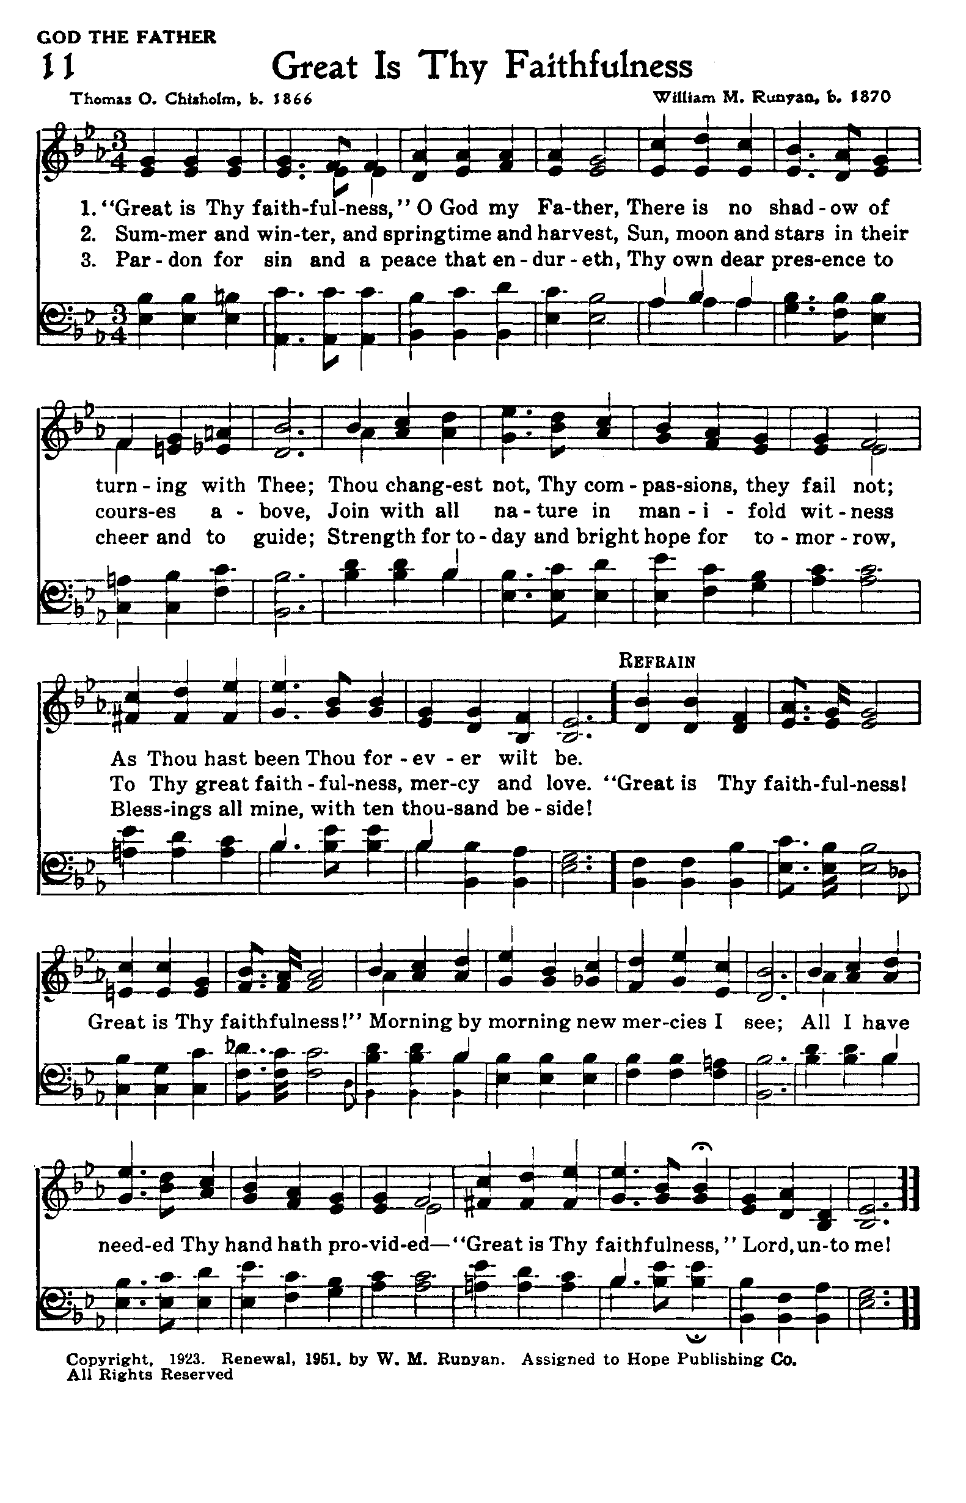
RECESSIONAL: Great is Thy Faithfulness
Text: Thomas O. Chisholm; Tune: FAITHFULNESS

Great is Thy faithfulness, O God my Father;
There is no shadow of turning with Thee;
Thou changest not, Thy compassions, they fail not;
As Thou hast been Thou forever wilt be.

(refrain)
Great is Thy faithfulness! Great is Thy faithfulness!
Morning by morning new mercies I see:
All I have needed Thy hand hath provided -
Great is Thy faithfulness, Lord, unto me!

Summer and winter and springtime and harvest,
Sun, moon, and stars in their courses above
Join with all nature in manifold witness
To Thy great faithfulness, mercy, and love. (refrain)

Pardon for sin and a peace that endureth,
Thine own dear presence to cheer and to guide,
Strength for today and bright hope for tomorrow -
Blessings all mine, with ten thousand beside! (refrain)

THE DISMISSAL

Followers of Christ, inspired by the Holy Spirit.
Serve the world God loves.
Thanks be to God.

Postlude: Oh, How I Love Jesus
