The Tenth Sunday after Pentecost (Proper 18)

Holy Eucharist

(Family Sunday/ Jamaica Independence)

August 2, 2026, 10:30am

Website: www.sthildasanglicanchurch.com
Church Email: info@sthildasanglicanchurch.com
Facebook: St. Hilda’s Fairbank Anglican Church
Telephone: 416-787-7911

Incumbent: Fr. Kenute Francis (437-488-9657)

kenute@sthildasanglicanchurch.com

Assistants: The Venerable Elizabeth Hardy

The Rev. Canon Leonard Abbah, OHC

Organist: William “Bill” Khan

Crucifer: Kishmar Miller

Eucharistic Ministers: Francis, Hardy, Alleyne, McPherson

Moderator: Kai Nedd

Welcome: Naima Roberts

1st Reading: Tessanni Philip-Brown

Psalm: Kishmar Miller

2nd Reading: Nancy Holas

Gospel: Angelica McPherson

Sermon: Sherlian Grant

Intercession: Akada Olive & Reesa Alexander-Chin

Tech Team: Gail Evans

Ushers Team 1: Jean Caine Christine Fleming

Marcia Lee Elfreda Garriques
Neville Lowe Beverley Beckford
Dione Robertson Hildred Small

The Order of Service

PRELUDE: (band) How Great is our God
Chris Tomlin

The splendor of a King, clothed in majesty
Let all the earth rejoice
All the earth rejoice
He wraps himself in Light, and darkness tries to hide
And trembles at His voice
Trembles at His voice

(refrain)
How great is our God, sing with me
How great is our God, and all will see
How great, how great is our God

Age to age He stands
And time is in His hands
Beginning and the end
Beginning and the end
The Godhead Three in One
Father Spirit Son
The Lion and the Lamb
The Lion and the Lamb. (refrain)

(bridge)
Name above all names
Worthy of our praise
My heart will sing
How great is our God. (refrain)

OPENING PRAYER (Kai Nedd)

O God, you are beyond words and description,
And your love is beyond knowledge and explanation.
Make our hearts ready to receive you.
Change us, we pray, that our lives may reflect your glory.
We rejoice in the power of your Holy Spirit.
Amen.
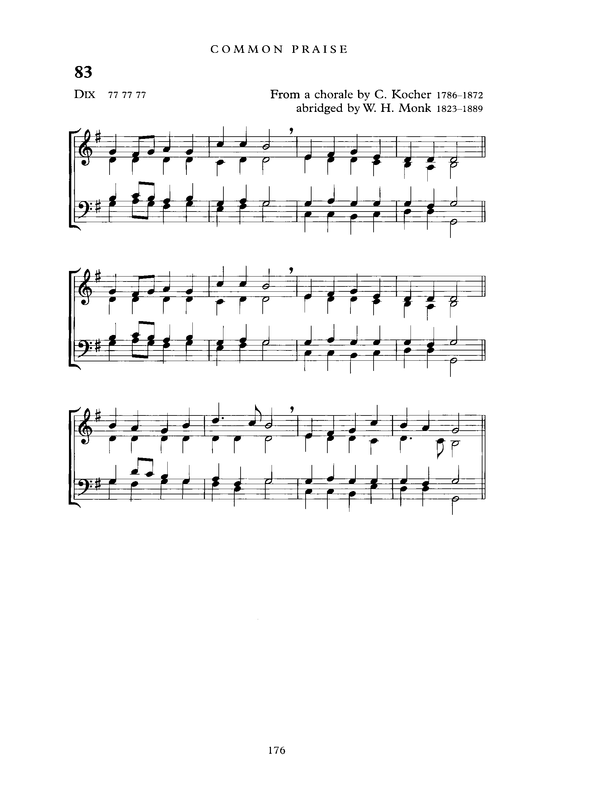
PROCESSIONAL: (organ) For the Beauty of the Earth
Text: Folliott S. Pierpoint; Tune: DIX

For the beauty of the earth,
for the glory of the skies,
for the love which from our birth
over and around us lies.

(refrain)
Lord of all, to thee we raise
this our hymn of grateful praise.

For the wonder of each hour
of the day and of the night,
hill and vale and tree and flower,
sun and moon and stars of light. (refrain)

For the joy of human love,
brother, sister, parent, child,
friends on earth, and friends above,
for all gentle thoughts and mild, (refrain)

For yourself, best gift divine,
to the world so freely given,
agent of God's grand design:
peace on earth and joy in heaven. (refrain)

WELCOME (Naima Roberts)

GREETINGS (Kai Nedd)

The grace of our Lord Jesus Christ, the love of God
and the fellowship of the Holy spirit be with you all.
And also with you.

In the beginning, before time, before people, before the world began,
God was.

Here among us, beside us, enlisting the people of earth for the purposes of heaven,
God is.
In the future, when we have turned to dust, and all has found its fulfilment,
God will be.

Not denying the world but delighting in it, and redeeming it,
through Jesus Christ, by the power of the Holy Spirit,
God was, God is, God will be.

THE COLLECT FOR PURITY (Kai Nedd)

Almighty God,
to you all hearts are open, all desires known, and from you no secrets are hidden.
Cleanse the thoughts of our hearts by the inspiration of your Holy Spirit,
that we may perfectly love you, and worthily magnify your holy name;
through Christ our Lord. Amen.

INTROIT: (band) Here I Am to Worship
Hillsong Worship

Light of the world, You stepped down into darkness
Opened my eyes, let me see
Beauty that made this heart adore You
Hope of a life spent with You

Here I am to worship, Here I am to bow down
Here I am to say that You're my God
You're altogether lovely, altogether worthy
Altogether wonderful to me.

King of all days, Oh, so highly exalted
Glorious in heaven above
Humbly You came to the earth You created
All for love's sake became poor. (refrain)

THE COLLECT OF THE DAY Kenute Francis

Let us pray.

Almighty God, your Son Jesus Christ fed the hungry with the bread of his life
and the word of his kingdom. Renew your people with your heavenly grace,
and in all our weakness sustain us by your true and living bread,
who lives and reigns with you and the Holy Spirit, one God, now and for ever.
Amen.
THE MINISTRY OF THE WORD

THE FIRST READING: Genesis 32:22-31 (Tessanni Philip-Brown)

A reading from the book of Genesis

The same night Jacob got up and took his two wives, his two maids,
and his eleven children, and crossed the ford of the Jabbok. He took them and sent them across the stream, and likewise everything that he had. Jacob was left alone; and a man wrestled with him until daybreak. When the man saw that he did not prevail against Jacob, he struck him on the hip socket; and Jacob’s hip was put out of joint as he wrestled with him. Then he said, “Let me go, for the day is breaking.”
But Jacob said, “I will not let you go, unless you bless me.” So he said to him,
“What is your name?” And he said, “Jacob.” Then the man said, “You shall no longer be called Jacob, but Israel, for you have striven with God and with humans, and have prevailed.” Then Jacob asked him, “Please tell me your name.”
But he said, “Why is it that you ask my name?” And there he blessed him.
So Jacob called the place Peniel, saying, “For I have seen God face to face,
and yet my life is preserved.” The sun rose upon him as he passed Penuel,
limping because of his hip.

The Word of the Lord
Thanks be to God

Psalm 17:1-7,16 Kishmar Miller

Hear my plea of innocence, O Lord; give heed to my cry;
listen to my prayer, which does not come from lying lips.
Let my vindication come forth from your presence;
let your eyes be fixed on justice.

Weigh my heart, summon me by night,
melt me down; you will find no impurity in me.
I give no offence with my mouth as others do;
I have heeded the words of your lips.

My footsteps hold fast to the ways of your law;
in your paths my feet shall not stumble.
I call upon you, O God, for you will answer me;
incline your ear to me and hear my words.

Show me your marvellous loving-kindness,
O Saviour of those who take refuge at your right hand
from those who rise up against them.
But at my vindication I shall see your face;
when I awake, I shall be satisfied, beholding your likeness.

Glory to God, source of all being. Eternal Word and Spirit.
As it was in the beginning, is now and will be forever. Amen.

SECOND READING Romans 9:1-5 (Nancy Holas)

A reading from the Letter of Paul to the Romans

I am speaking the truth in Christ—I am not lying; my conscience confirms it by the Holy Spirit - have great sorrow and unceasing anguish in my heart. For I could wish that I myself were accursed and cut off from Christ for the sake of my own people, my kindred according to the flesh. They are Israelites, and to them belong the adoption, the glory, the covenants, the giving of the law, the worship, and the promises; to them belong the patriarchs, and from them, according to the flesh, comes the Messiah, who is over all, God blessed forever. Amen.

The word of the Lord
Thanks be to God

THE GRADUAL: (band) Be Still, for the Presence of the Lord
Text: David J. Evans; Tune: BE STILL

Be still, for the presence of the Lord, the Holy One, is here.
Come, bow before him now, with reverence and fear.
In him no sin is found, we stand on holy ground.
Be still, for the presence of the Lord, the Holy One, is here.

Be still, for the glory of the Lord is shining all around;
he burns with holy fire, with splendour he is crowned.
How awesome is the sight, our radiant King of light!
Be still, for the glory of the Lord is shining all around.

Be still, for the power of the Lord is moving in this place,
he comes to cleanse and heal, to minister his grace.
No work too hard for him, in faith receive from him;
be still, for the power of the Lord is moving in this place.
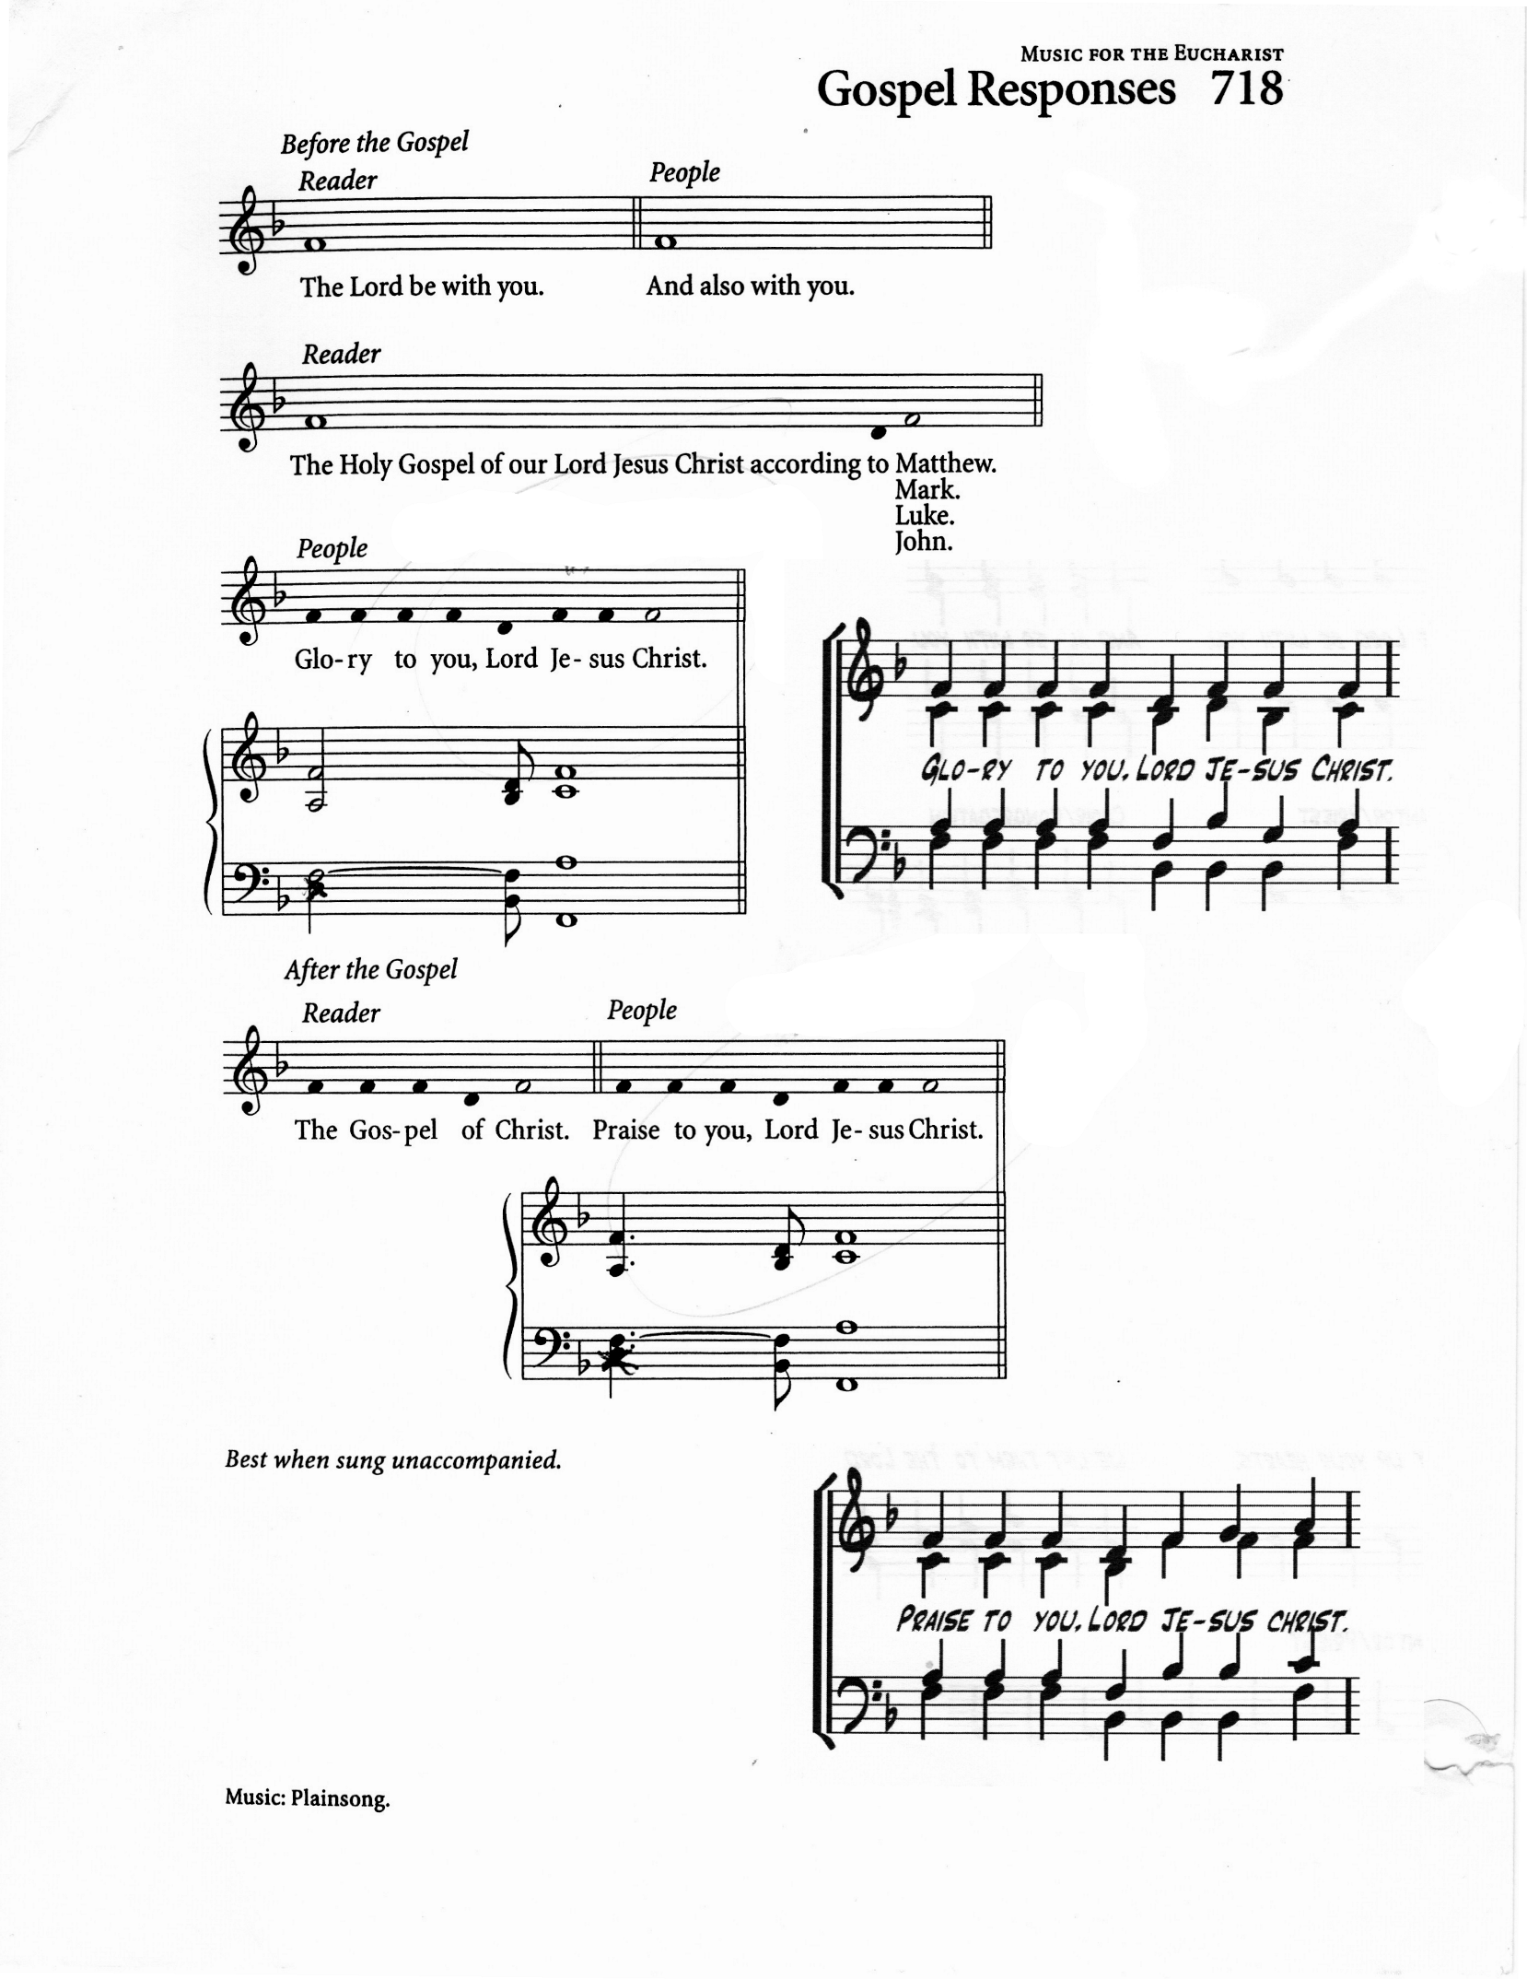
THE HOLY GOSPEL Matthew 14:13-21 Angelica McPherson

The Lord be with you
And also with you

The Holy Gospel of our Lord Jesus Christ according to Matthew
Glory to you, Lord Jesus Christ.

Now when Jesus heard this, he withdrew from there in a boat to a deserted place by himself. But when the crowds heard it, they followed him on foot from the towns. When he went ashore, he saw a great crowd; and he had compassion for them and cured their sick. When it was evening, the disciples came to him and said, “This is a deserted place, and the hour is now late; send the crowds away so that they may go into the villages and buy food for themselves.” Jesus said to them, “They need not go away; you give them something to eat.” They replied, “We have nothing here but five loaves and two fish.” And he said, “Bring them here to me.” Then he ordered the crowds to sit down on the grass. Taking the five loaves and the two fish, he looked up to heaven, and blessed and broke the loaves, and gave them to the disciples, and the disciples gave them to the crowds.
And all ate and were filled; and they took up what was left over of the broken pieces, twelve baskets full. And those who ate were about five thousand men, besides women and children.

The Gospel of Christ
Praise to you, Lord Jesus Christ

GOSPEL ACCLAMATION: Caribbean Alleluia

THE SERMON: Sherlian Grant

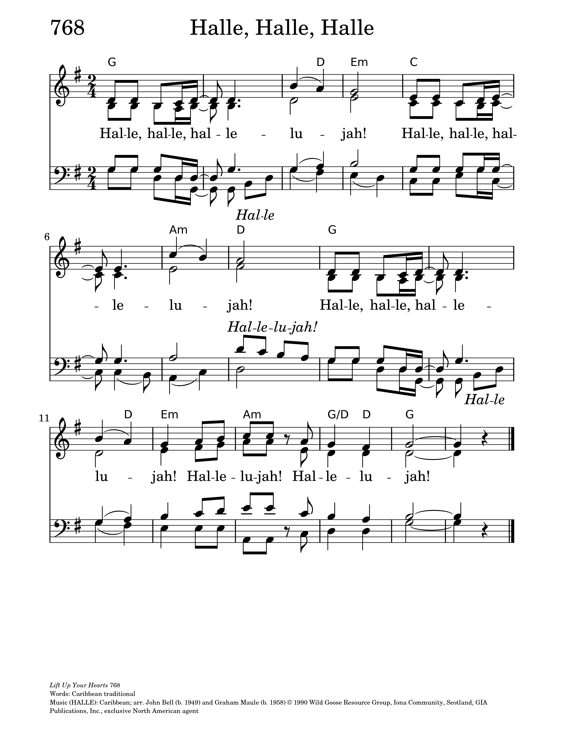
THE APOSTLES’ CREED Kai Nedd

Let us confess the faith of our baptism, as we say,

I believe in God, the Father almighty, creator of heaven and earth.
I believe in Jesus Christ, his only Son, our Lord.
He was conceived by the power of the Holy Spirit and born of the Virgin Mary.
He suffered under Pontius Pilate, was crucified, died, and was buried.
He descended to the dead. On the third day he rose again.
He ascended into heaven, and is seated at the right hand of the Father.
He will come again to judge the living and the dead.
I believe in the Holy Spirit, the holy catholic Church,
the communion of saints, the forgiveness of sins,
the resurrection of the body, and the life everlasting.
Amen.

PRAYERS OF INTERCESSION Akada Olive & Reesa Alexander-Chin)

Reesa: Let us pray,

Heavenly Father, thank you for loving us.
Thank you for feeding us every day with food, family, friendship,
and faith.
God of every generation,
All: hear our prayer.

Akada: We pray for our world especially places of conflict, unrest and war,
and those experiencing disaster whether wild fires, flooding or drought.
God of every generation,
All: hear our prayer.

Reesa: We pray for families everywhere especially our children.
Protect those who are hungry. Comfort those who are lonely.
Help those who are frightened.
God of every generation,
All: hear our prayer.

Akada: We pray for the church throughout the world, especially St Hilda’s.
Help us become people who welcome everyone. Teach us to share our gifts. May we never think that what we have is too small for God to use.
God of every generation,
All: hear our prayer.

Reesa: Today we especially remember the people of Jamaica celebrating Emancipation Day on August 1 and Independence Day on August 6.
We thank you for the courage of those who struggled for freedom from slavery and injustice.
We give thanks for Jamaica's rich heritage, vibrant culture, music, faith,
and resilient spirit. Bless all Jamaicans at home and throughout the world. Guide the nation's leaders with wisdom and integrity.
God of every generation,
All: hear our prayer.

Akada: We thank you for the faithful ministry of Bill Khan, for the gifts of music, creativity, and technology that have enriched the life of St. Hilda's. As Bill, Sarah, Lily, and Grace begin a new chapter in the Diocese of Niagara, go before and with them with your blessing.
Guide their steps, open doors of opportunity, protect them in all they do, and continue to use their gifts for the building of your kingdom.
God of every generation,
All: hear our prayer.

Reesa: We pray for those who are sick. Those in hospital, care home or at home. Those receiving treatment. Those who are grieving.
Wrap them in your love.
God of every generation,
All: hear our prayer.

Akada: Finally, feed us with your grace, fill us with your Spirit,
and send us into the world to love as Jesus loves.
In his name we pray.
All: Amen.

CONFESSION: Kai Nedd
Dear friends in Christ, God is steadfast in love and infinite in mercy;
he welcomes sinners and invites them to his table.
Let us confess our sins, confident in God’s forgiveness.

Most merciful God,
we confess that we have sinned against you in thought, word, and deed,
by what we have done, and by what we have left undone.
We have not loved you with our whole heart;
we have not loved our neighbours as ourselves.
We are truly sorry and we humbly repent.
For the sake of your Son Jesus Christ, have mercy on us and forgive us,
that we may delight in your will, and walk in your ways,
to the glory of your name.
Amen.

ABSOLUTION: Fr. Kenute

Almighty God have mercy upon you, pardon and deliver you from all your sins,
confirm and strengthen you in all goodness, and keep you in eternal life; through Jesus Christ our Lord.
Amen.

THE PEACE Kai Nedd

The peace of the Lord be always with you.
And also with you.

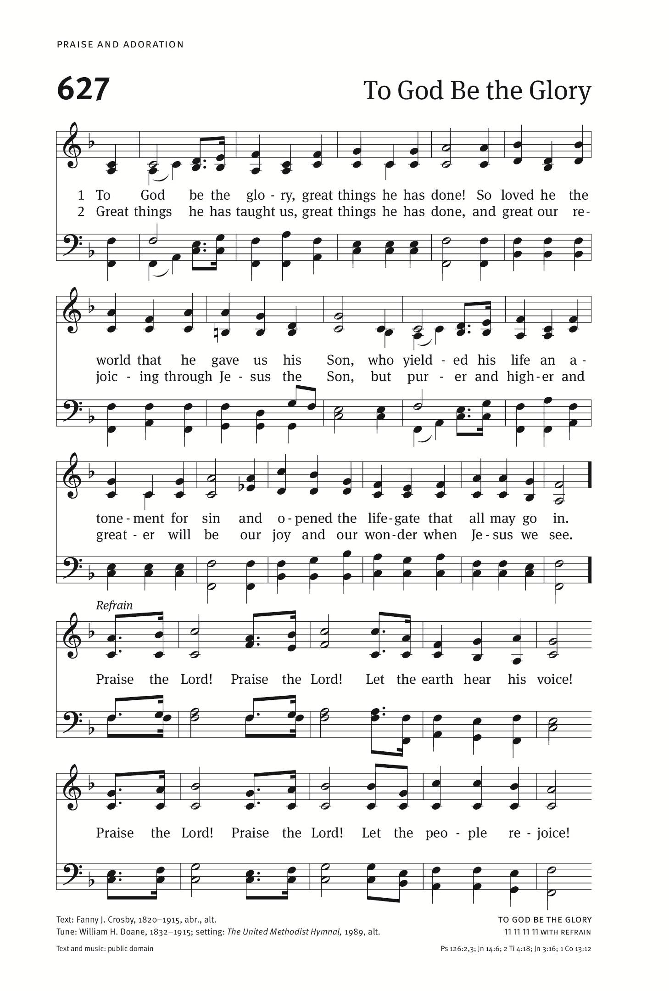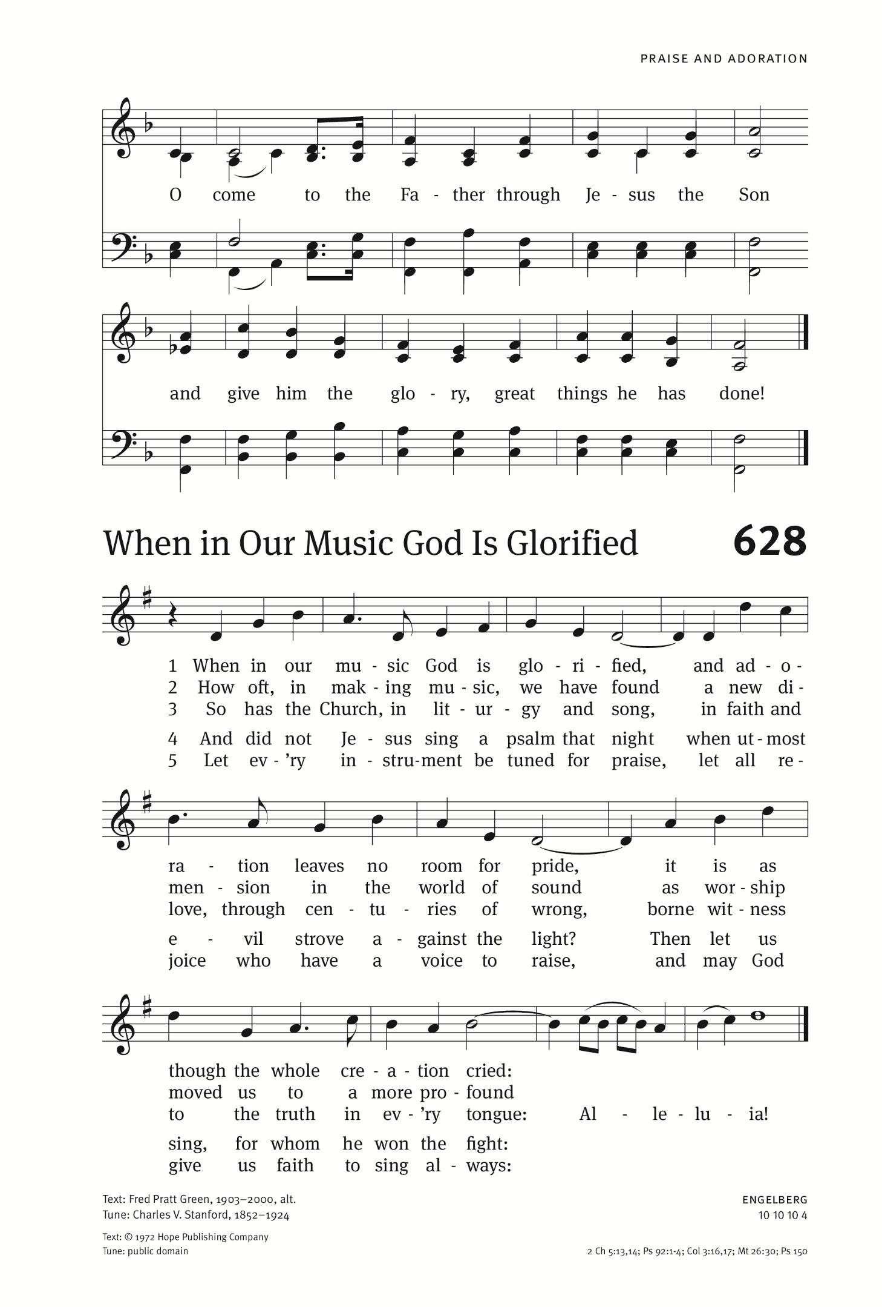
OFFERTORY: (organ) To God Be the Glory
Text: Fanny Crosby; Tune: TO GOD BE THE GLORY

To God be the glory, great things He hath done,
so loved He the world that He gave us His Son,
who yielded His life an atonement for sin,
and opened the life-gate that all may go in.

(refrain)
Praise the Lord, praise the Lord, let the earth hear His voice!
Praise the Lord, praise the Lord, let the people rejoice!
O come to the Father through Jesus the Son,
and give Him the glory, great things He hath done.

O perfect redemption, the purchase of blood,
to ev'ry believer the promise of God;
the vilest offender who truly believes,
that moment from Jesus a pardon receives. (refrain)

Great things He hath taught us, great things He hath done,
and great our rejoicing through Jesus the Son;
but purer, and higher, and greater will be
our wonder, our transport, when Jesus we see. (refrain)

PRAYER OVER THE GIFTS

God our sustainer, accept all we offer you this day,
and feed us continually with that bread which satisfies all hunger,
your Son our Saviour Jesus Christ. Amen.
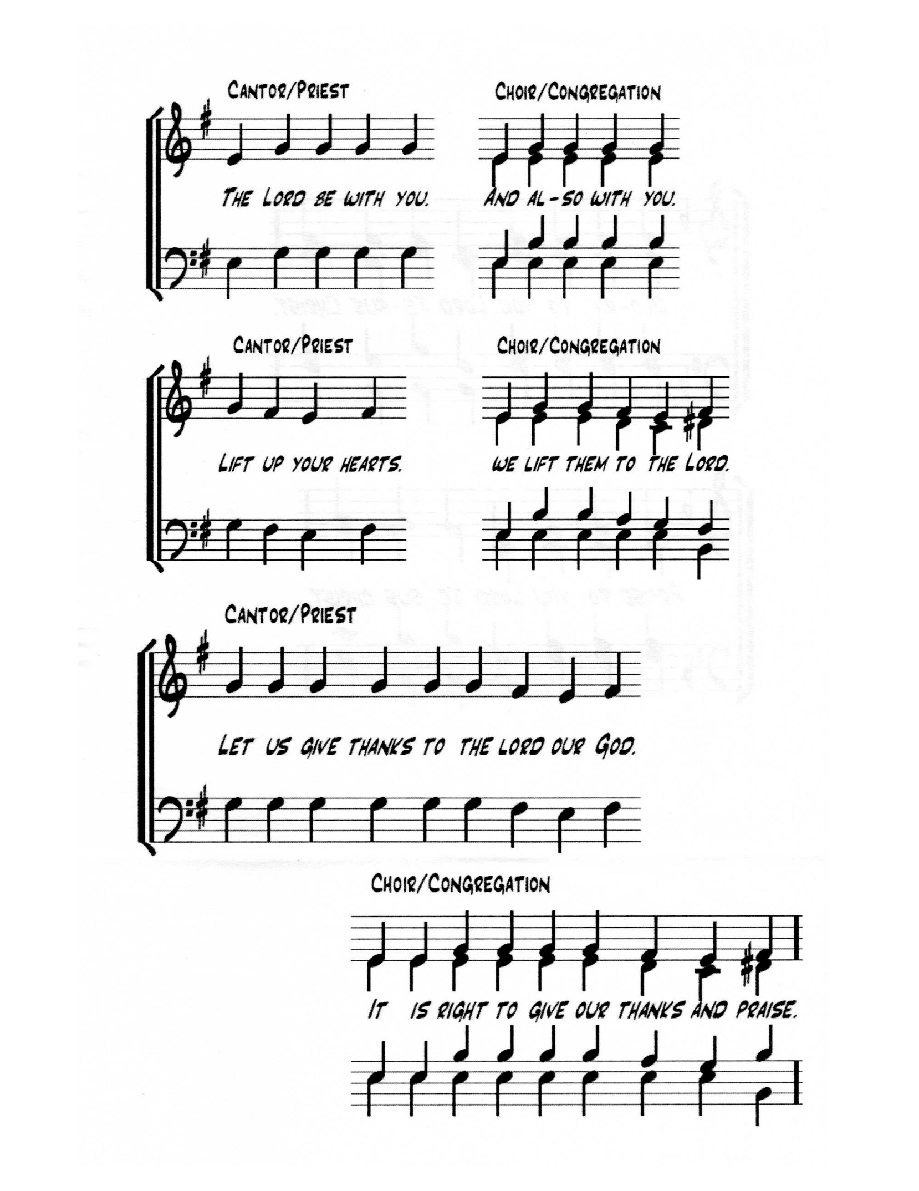
THE EUCHARISTIC PRAYER (Church of England)

The Lord be with you.
And also with you.

Lift up your hearts
We lift them to the Lord

Let us give thanks to the Lord our God.
It is right to give our thanks and praise.

It is truly right and just, our duty and our salvation,
always and everywhere to give you thanks,
holy Father, almighty and eternal God.
For though the human race is divided by dissention and discord,
Christ calls us in his death and resurrection
to embody hearts of change and his work of reconciliation.
By your Spirit you give courage to overcome fears and to seek the unity of all.
By the working of your power, hatred is overcome by love,
revenge gives way to forgiveness,
and division is transformed by mutual respect and humility.

Therefore, we give you ceaseless thanks,
and join with choirs of angels and with all the heavenly host,
to proclaim your glory in their unending song of praise:

SANCTUS: (band) Daren Evans & Everton Clarke

Holy, holy, holy, holy, Lord.
Lord, God of power and might,
heaven and earth are full, O- of your glory. X2
Holy, holy, holy, holy, Lord.

Blessed is he who comes
In the precious name of the Lord.
Hosanna upon high. Hosanna upon high
Blessed is he who comes.

We praise and bless you, loving Father, through Jesus Christ, our Lord;
and as we obey his command, send your Holy Spirit,
that broken bread and wine outpoured
may be for us the body and blood of your dear Son.

On the night before he died he had supper with his friends
and, taking bread, he praised you.
He broke the bread, gave it to them and said:
Take, eat; this is my body which is given for you; do this in remembrance of me.

When supper was ended he took the cup of wine.
Again he praised you, gave it to them and said:
Drink this, all of you; this is my blood of the new covenant,
which is shed for you and for many for the forgiveness of sins.
Do this, as often as you drink it, in remembrance of me.

So, Father, we remember all that Jesus did,
in him we plead with confidence for his sacrifice made once for all upon the cross.
Bringing before you the bread of life and cup of salvation,
we proclaim his death and resurrection until he comes in glory.

Acclamation (band) Lisa Narcisse

All: Christ has died! Alleluia!
Christ is risen! Alleluia!
Christ will come again! Alleluia!
Amen. Amen. Amen.

Bishop: Lord of all life,
help us to work together for that day when your kingdom comes
and justice and mercy will be seen in all the earth.
Look with favour on your people, gather us in your loving arms
and bring us with all the saints to feast at your table in heaven.
Through Christ, with Christ, and in Christ, in the unity of the Holy Spirit,
we worship you Father almighty in songs of everlasting praise.

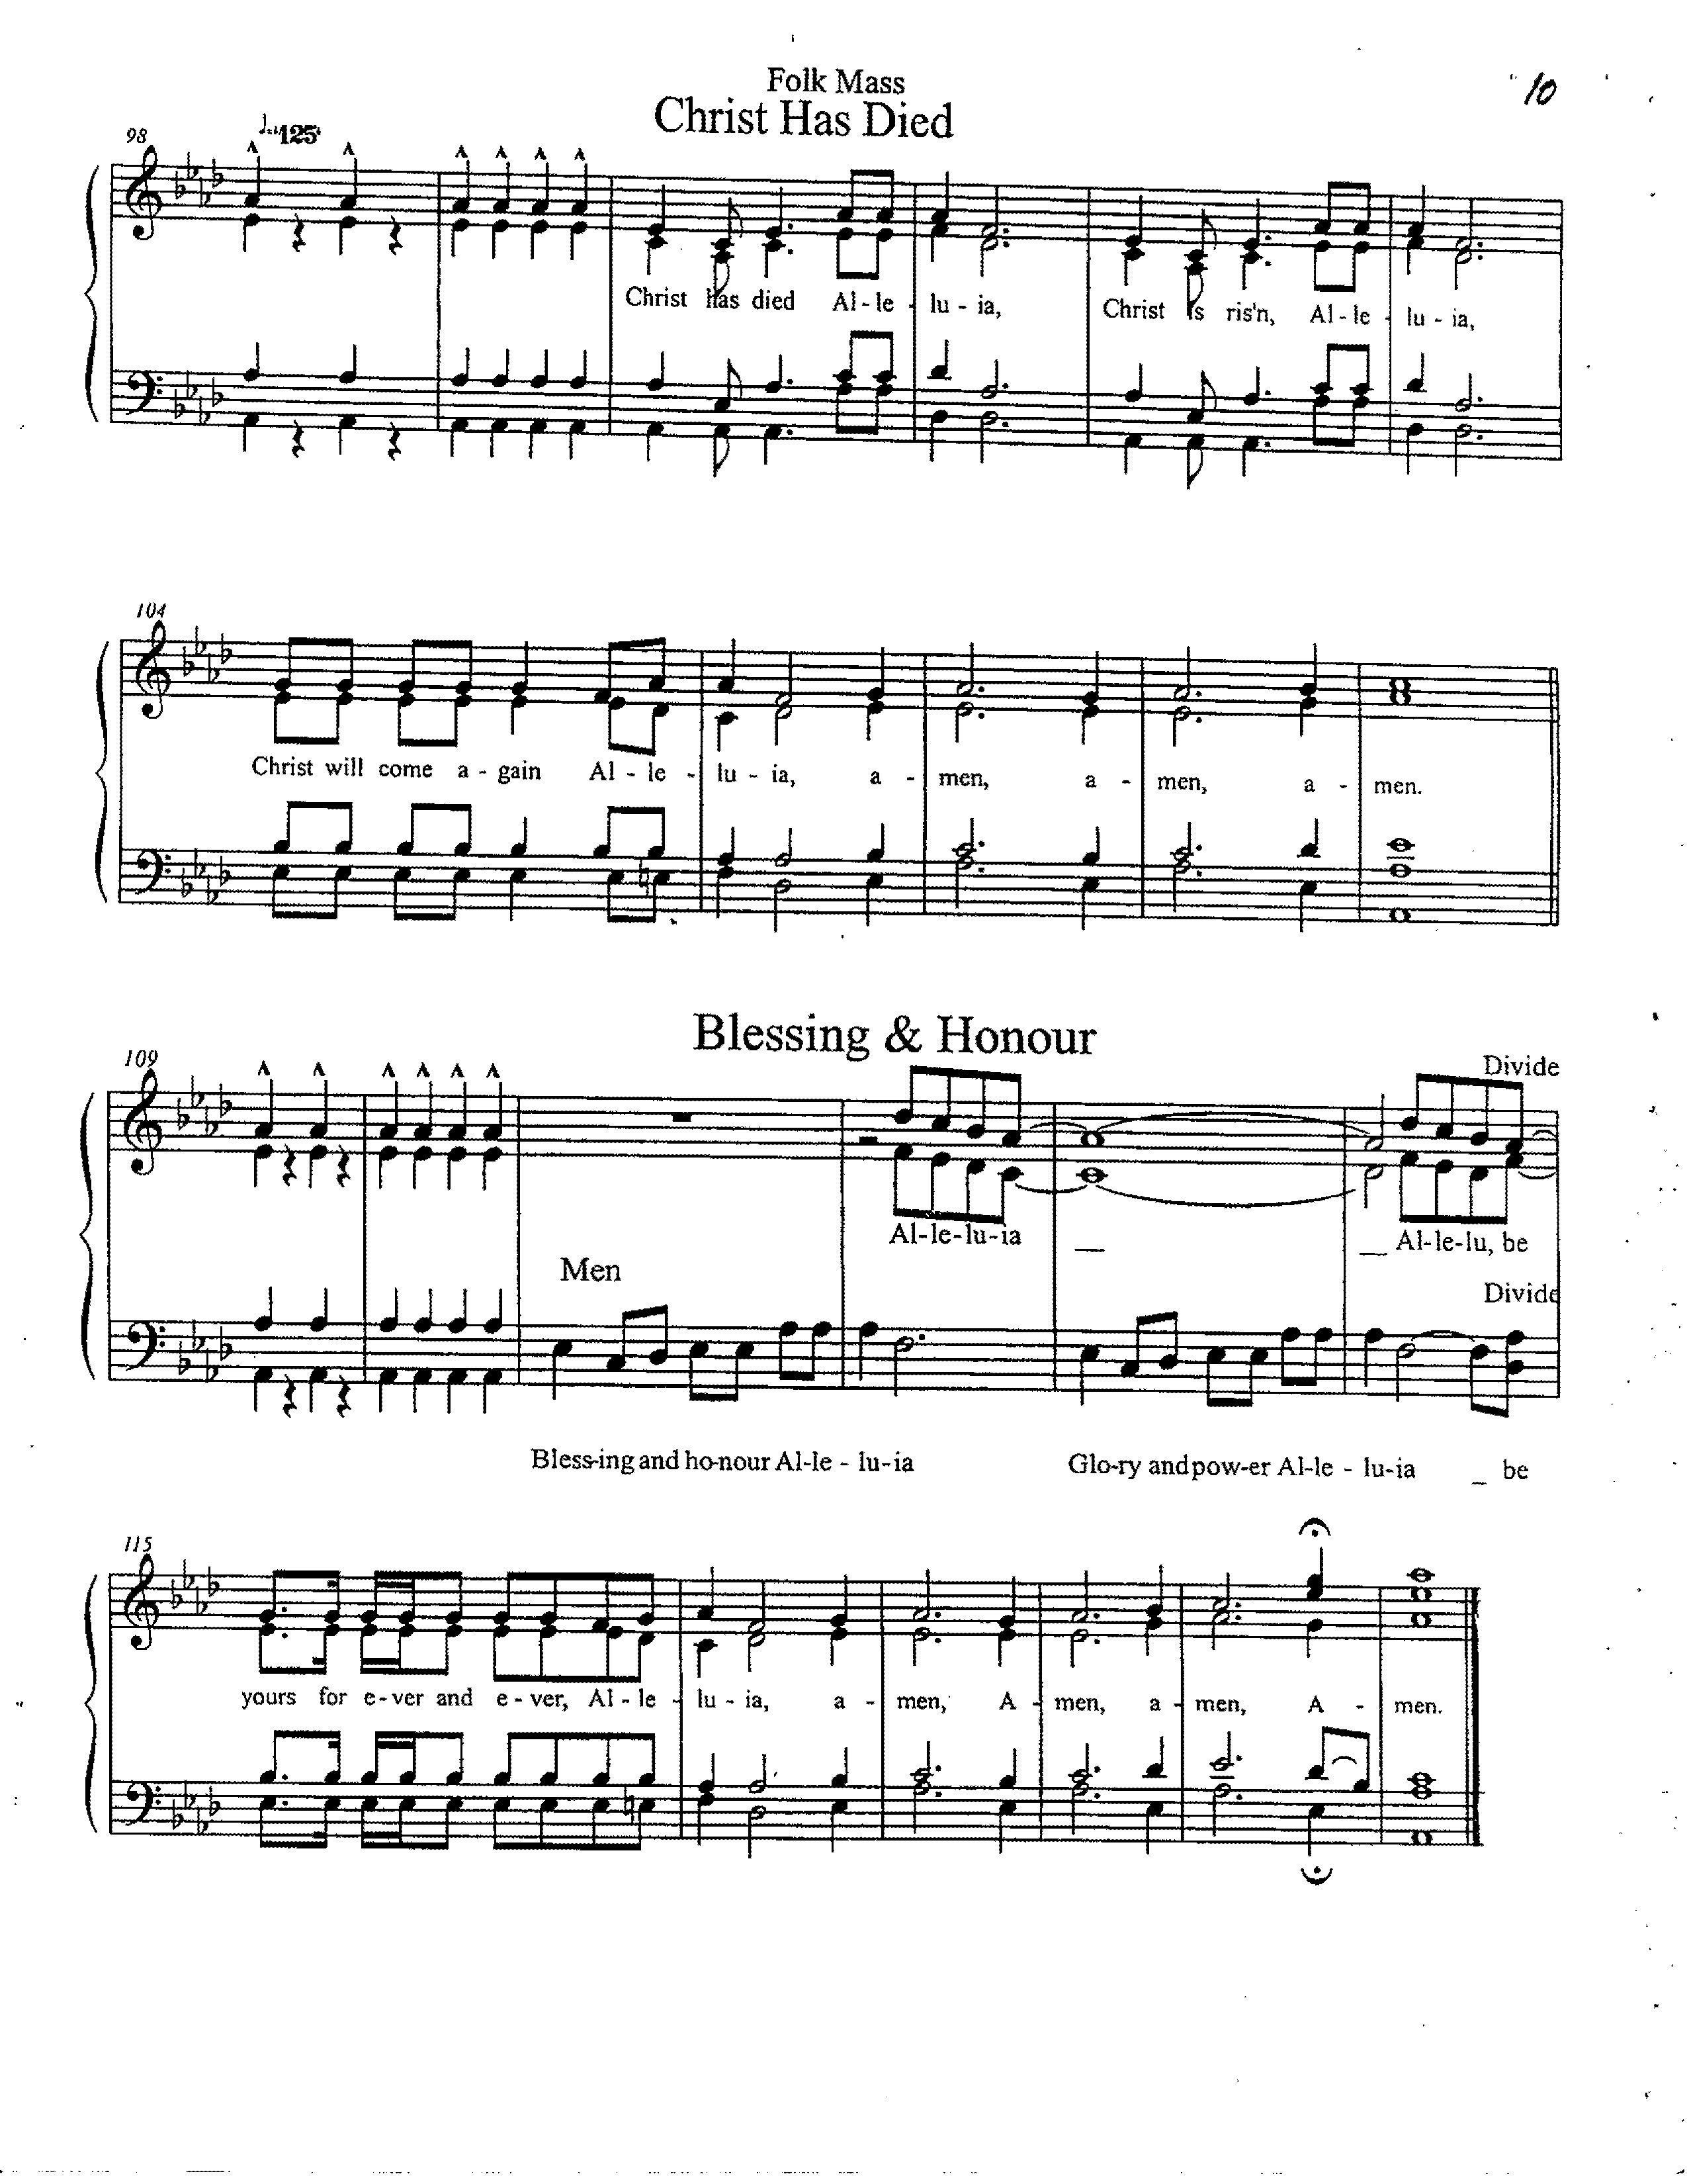
Eucharistic Doxology (band) Lisa Narcisse

(sung) Blessing and honour! Alleluia!
Glory and power! Alleluia!
Be yours forever and ever! Alleluia!
Amen. Amen. Amen. Amen.

The Lord’s Prayer (band) Matt Mayer

And now, as our Saviour Christ has taught us, we are bold to sing
(refrain)
Father, let Your Kingdom come
Father, let Your will be done X2
On Earth as in Heaven
Right here in my heart

Give us this day, our daily bread
Forgive us, forgive us
As we forgive the ones who sin against us, forgive them
And lead us not into temptation,
but deliver us from the еvil one
Let Your Kingdom come

It's Yours, it's Yours. All Yours, all Yours
The Kingdom, the power, the glory are Yours
It's Yours, it's Yours. All Yours, all Yours X2
Forever and ever, the Kingdom is Yours

Father, let Your Kingdom come
Father, let Your will be done
On earth as in heaven
Right here in my heart
On earth as in heaven
Right here in my heart. Amen.

THE BREAKING OF THE BREAD

We break this bread to share in the body of Christ.
We, being many, are one body, for we all share in the one bread.

THE INVITATION

The gifts of God for the People of God
Thanks be to God.
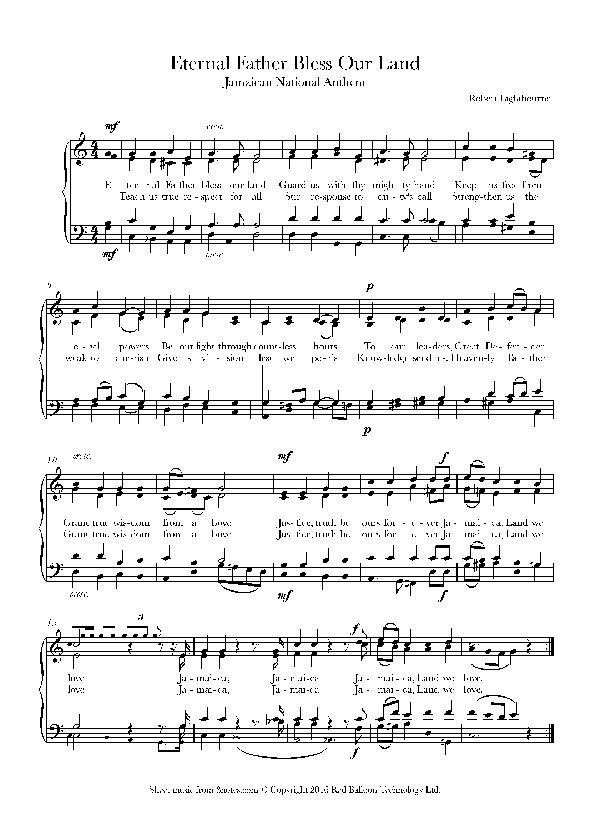
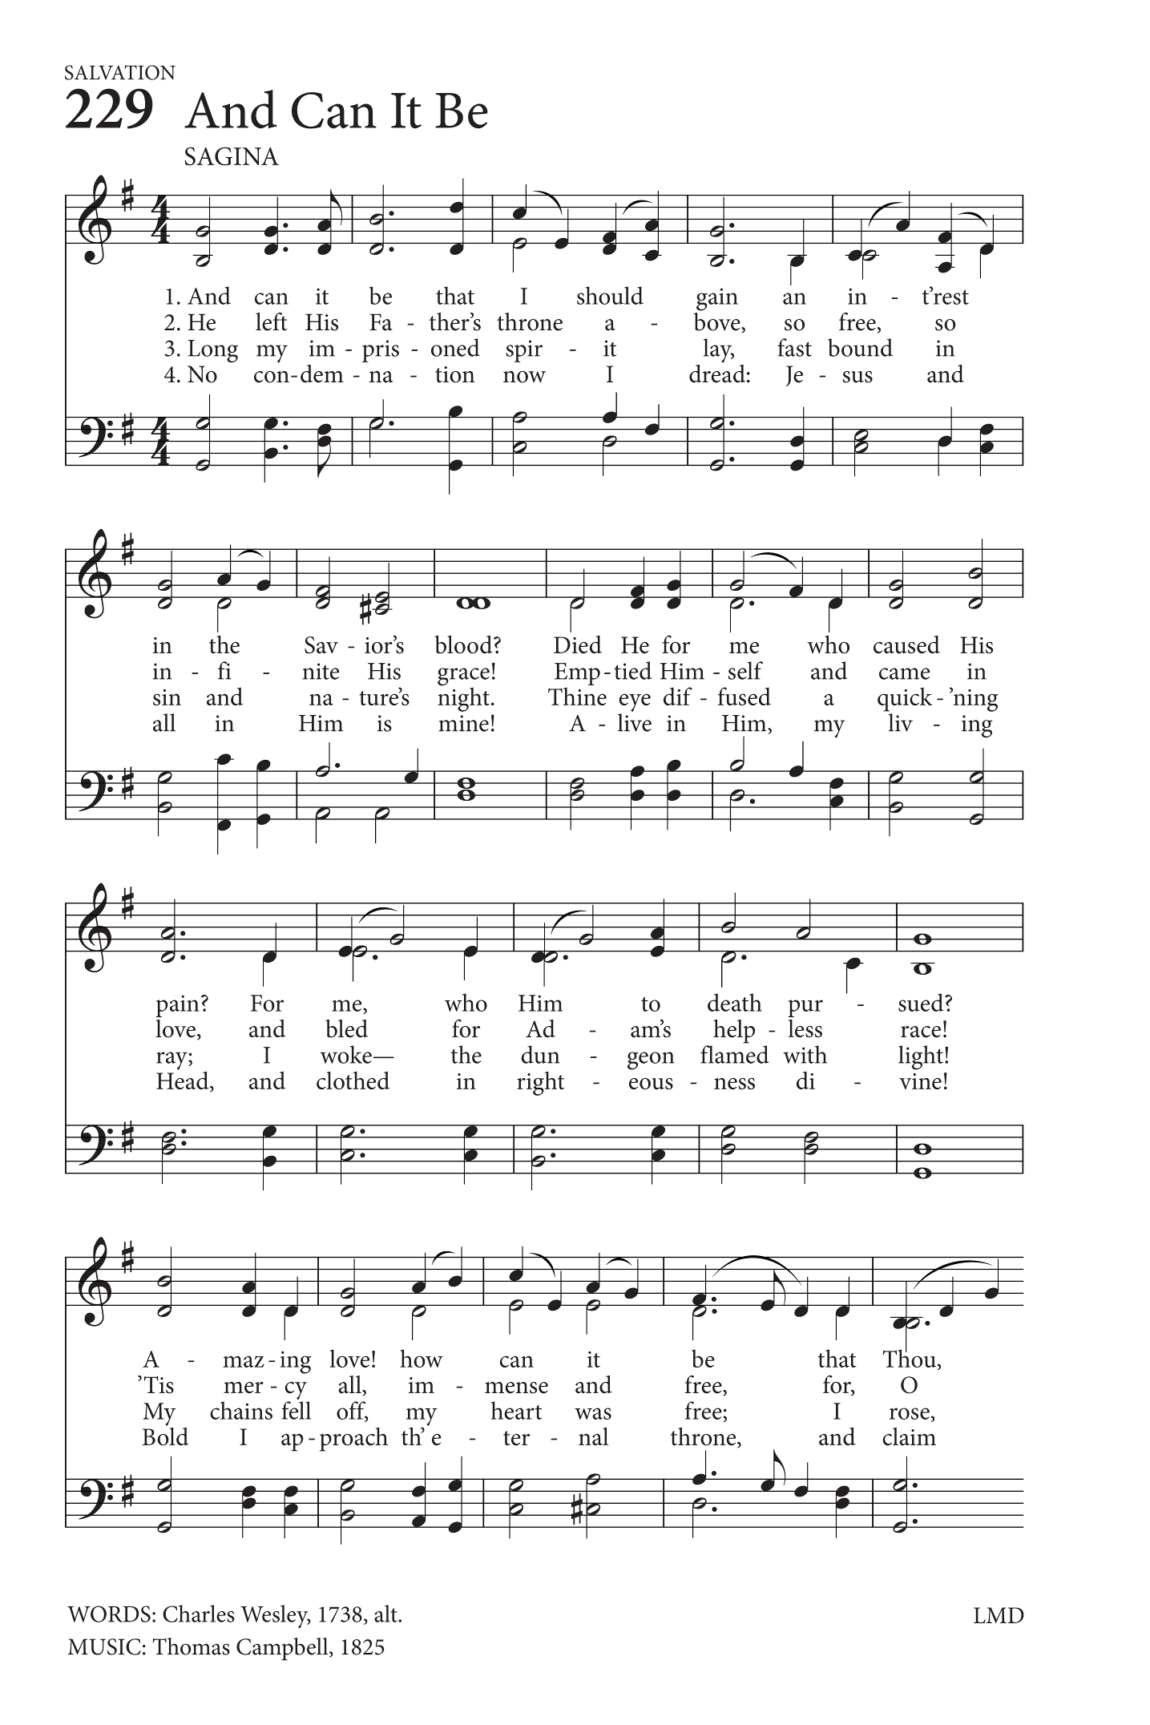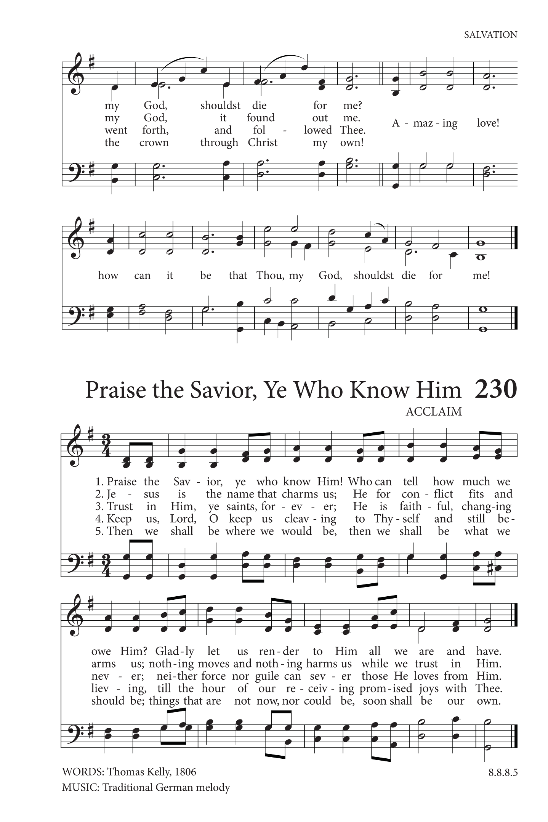
DURING COMNMUNION: (organ) And Can It Be
Text: Charles Wesley; Tune: SAGINA

And can it be that I should gain
An int'rest in the Savior's blood?
Died He for me, who caused His pain?
For me, who Him to death pursued?
Amazing love! how can it be
That Thou, my God, should die for me?
Amazing love! how can it be
That Thou, my God, should die for me!

He left His Father's throne above,
So free, so infinite His grace;
Emptied Himself of all but love,
And bled for Adam's helpless race;
'Tis mercy all, immense and free;
For, O my God, it found out me.
'Tis mercy all, immense and free;
For, O my God, it found out me.

Long my imprisoned spirit lay
Fast bound in sin and nature's night;
Thine eye diffused a quick'ning ray,
I woke, the dungeon flamed with light;
My chains fell off, my heart was free;
I rose, went forth and followed Thee.
'Tis mercy all, immense and free;
For, O my God, it found out me.

No condemnation now I dread;
Jesus, and all in Him is mine!
Alive in Him, my living Head,
And clothed in righteousness divine,
Bold I approach th'eternal throne,
And claim the crown, through Christ my own.
'Tis mercy all, immense and free;
For, O my God, it found out me.

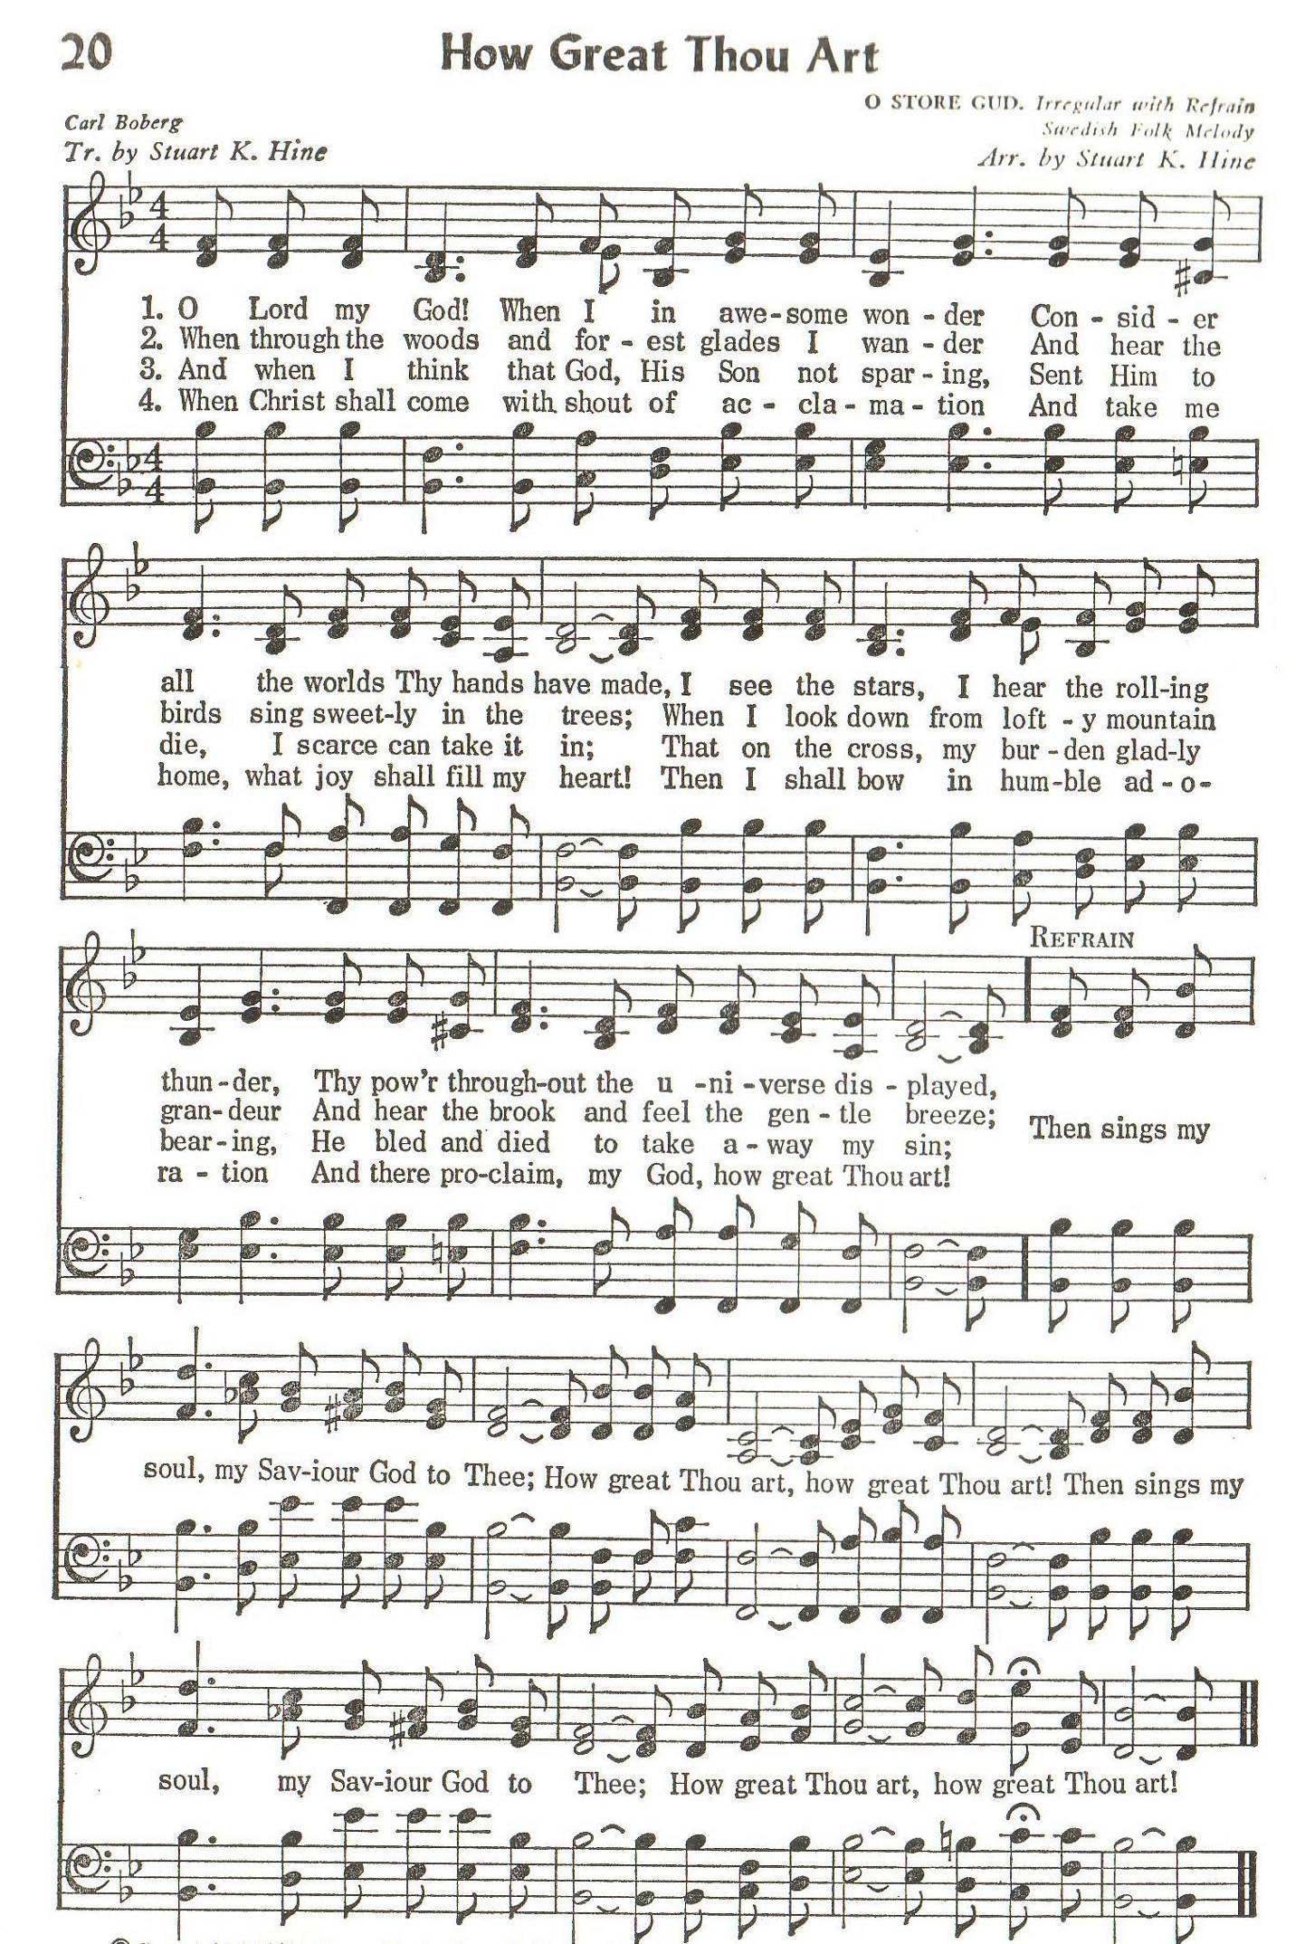
(organ) How Great Thou Art
Text: Stuart K. Hine; Tune: O STORE GUD

O Lord my God, when I in awesome wonder
Consider all the worlds thy hands have made,
I see the stars, I hear the rolling thunder,
Thy power throughout the universe displayed:

(refrain)
Then sings my soul, my Saviour God, to thee:
How great thou art! How great thou art!
Then sings my soul, my Saviour God, to thee:
How great thou art! How great thou art!

And when I think that God, his Son not sparing,
Sent him to die, I scarce can take it in,
That on the cross, my burden gladly bearing,
He bled and died to take away my sin. (refrain)

ABLUTIONS: (band) I am the Way, the King of the Victory
Text & Music: Fr. Richard Holung

I am the Way, the King of the Victory
I am the Truth, the Lord of the Harmony
I am the Light, the Light of the world to be.

(refrain)
Hosanna! I hold your hand my friend,
Hosanna! I give you strength my friend,
Hosanna! You walk the sea my friend;
We’re sailing to victory!
Sailing (sailing), sailing (sailing)
Sailing cross the river, sailing!
Sailing (Jesus), sailing (sailing)
Sailing cross the river, sailing!
Freedom (brother), freedom (sister)
Freedom in the life of Jesus.
Hosanna! I hold your hand my friend,
Hosanna! I give you strength my friend,
Hosanna! You walk the sea my friend;
We’re sailing to victory!

I am the Vine, you shall abide in Me,
I am the River, you shall be cleansed in Me,
I am the Rock, you shall have life in Me. (refrain)

I am your God, rising in victory.
I am your brother, living in flesh with thee
I am your saviour, dying on Calvary. (refrain)

PRAYER AFTER COMMUNION

God of Grace,
we have shared in the mystery of the body and blood of Christ.
May we who have tasted the bread of life live with you for ever.
We ask this in the name of Jesus Christ our Lord. Amen.

SENDING OUT Kai Nedd

Go now, holding tightly to God, sharing generously with others,
and trusting that Jesus can do extraordinary things through ordinary people.
And wherever God sends you, remember that no gift is too small
when it is placed in the hands of Christ.

THE BLESSING Fr Kenute

And the blessing of God Almighty, the Father,
the Son and the Holy Spirit, be with you, now and forever.
Amen.

ANNOUNCEMENTS

PRESENTATIONS

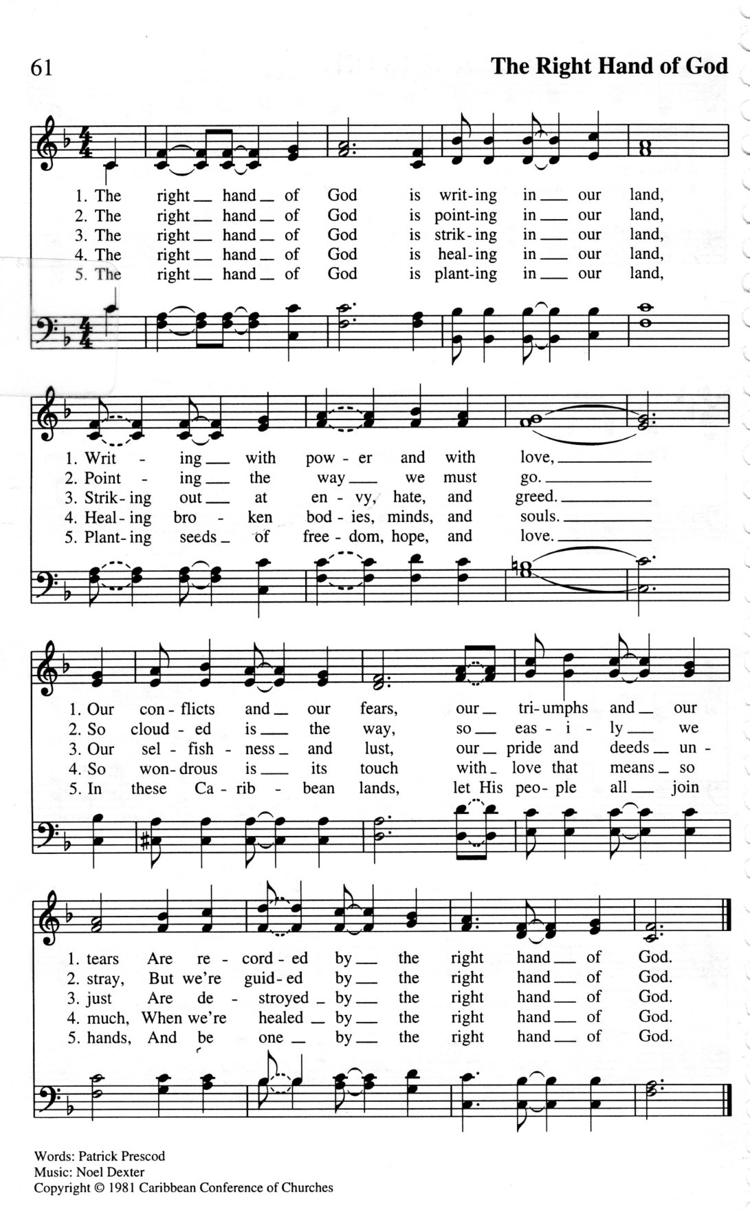
RECESSIONAL: (organ) The Right Hand of God
Text: Patrick Prescod; Tune: THE RIGHT HAND OF GOD

The right hand of God is writing in our land,
Writing with power and with love;
Our conflicts and our fears,
Our triumphs and our tears,
Are recorded by the right hand of God.
The right hand of God is pointing in our land,
Pointing the way we must go;
So clouded is the way,
So easily we stray,
But we’re guided by the right hand of God.
The right hand of God is striking in our land,
Striking out at envy, hate and greed;
Our selfishness and lust,
Our pride and deeds unjust,
Are destroyed by the right hand of God.

The right hand of God is lifting in our land,
Lifting the fallen one by one;
Each one is known by name,
And lifted now from shame,
By the lifting of the right hand of God.

The right hand of God is healing in our land,
Healing broken bodies, minds and souls;
So wondrous is its touch,
With love that means so much,
When we’re healed by the right hand of God.
The right hand of God is planting in our land,
Planting seeds of freedom, hope and love;
In these many-peopled lands,
Let his children all join hands,
And be one with the right hand of God.

THE DISMISSAL: (Kai Nedd)

Followers of Christ, Inspired by the Holy Spirit.
Serve the world God loves. Alleluia! Alleluia!
Thanks be to God. Alleluia! Alleluia!

Postlude: (band) All For Jesus
Text & Music: Ernie Smith

Jesus come today, for a poor, poor man like me
Salvation come my way, my soul set free
Jesus come for all, and we must hear His call
Open up your heart today, and let it be

(refrain)
Nuh matter if you thief, or if you dread
Of if yuh have a crown 'pon yuh head
Nuh matter if you have no heart at all
Jesus bring love for one and all
Sing it children
I for Jesus, you for Jesus
All for Jesus, fall for Jesus
Come to Jesus,
Jesus come for one He come for all

Jesus come for I, see manger where He lie
See cross where He must die, for a wretch like me
For God so loved the world, man, woman, boy and girl
He gave His Son for you, His Son for me. (refrain)

Jesus Christ today, the same as yesterday
The one, the only way, the King for me
Let it come to pass, mankind find love at last
Just as it was time past, so let it be. (refrain)

